**Real Time Data Streaming System with AWS Kinesis, Lambda Functions and a S3 Bucket**

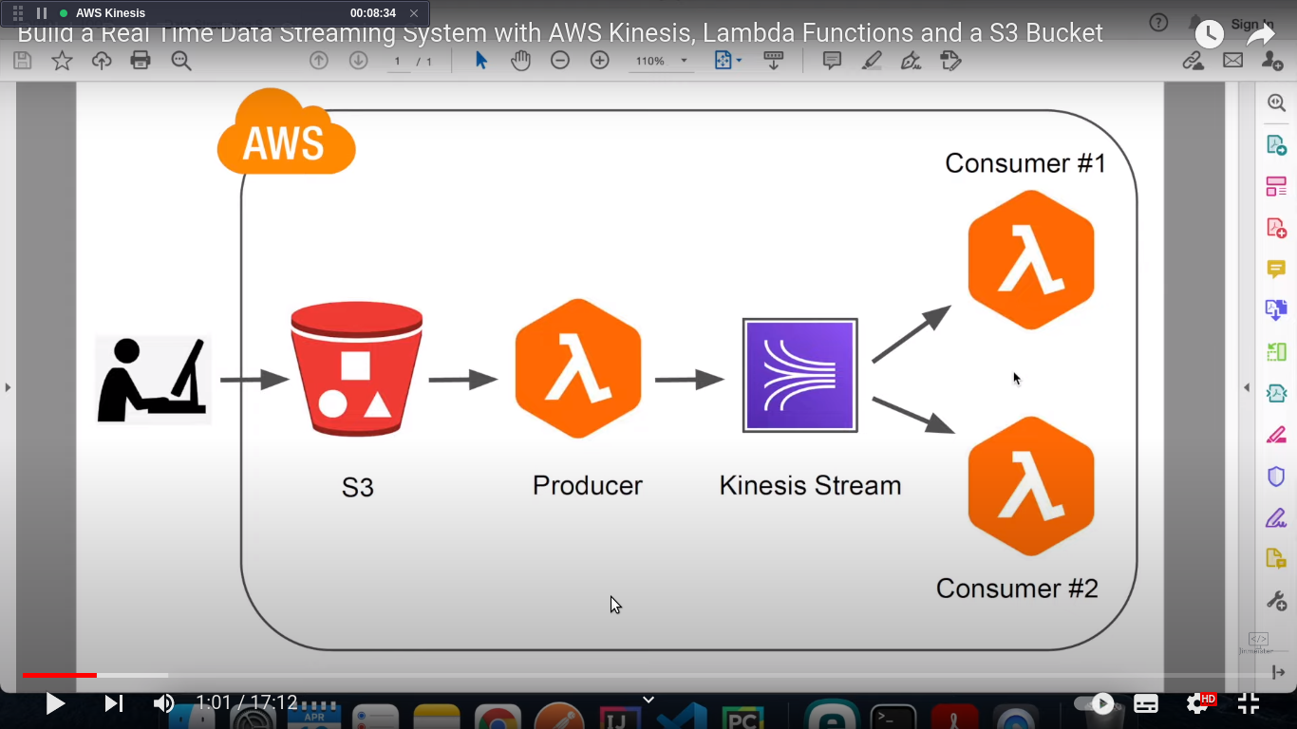

Whenever you upload a file to our S3 Bucket its going to a trigger a Lambda function which is a Data Producer that reads the file content to from the S3 Bucket & push the data to Kinesis & now we have two consumers that comsume the data from the stream and they can do diffrent things with it for example, consumer no 1 can read the data & then send an email to all the clients with the information or you can just publish your data to social media plateform and then consumer no 2 can just save the data to a database.

Go to ----> AWS console ----> choose IAM ----> click on role.

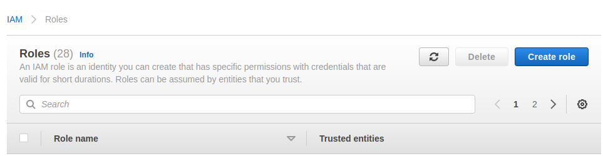

Select ---> Lambda click on next

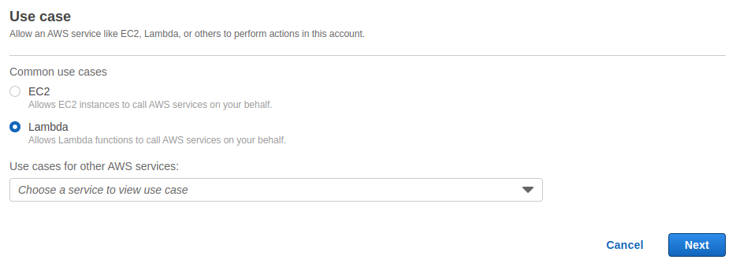Create 3 plicy

1 : AmazonKinesisFullAccess

2 : AmazonS3FullAccess

3 : CloudWatchFullAccess

Enter the role name -----> click on next.

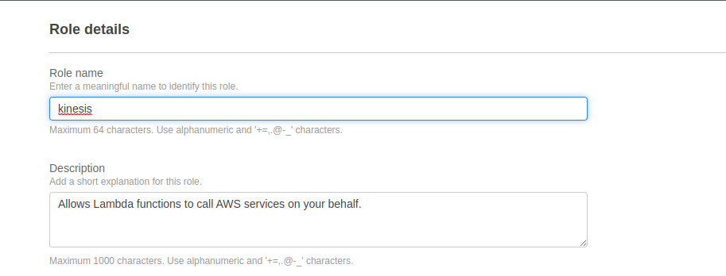

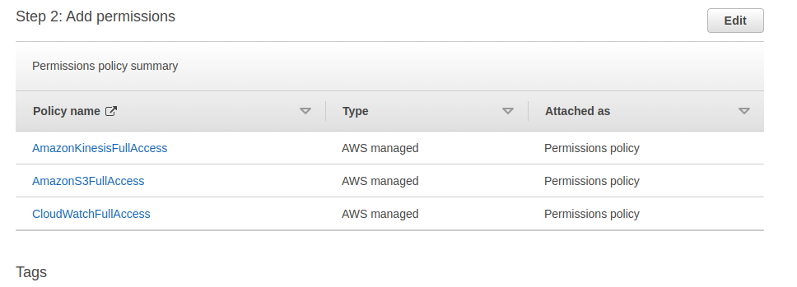

Go to AWS console select Lambda

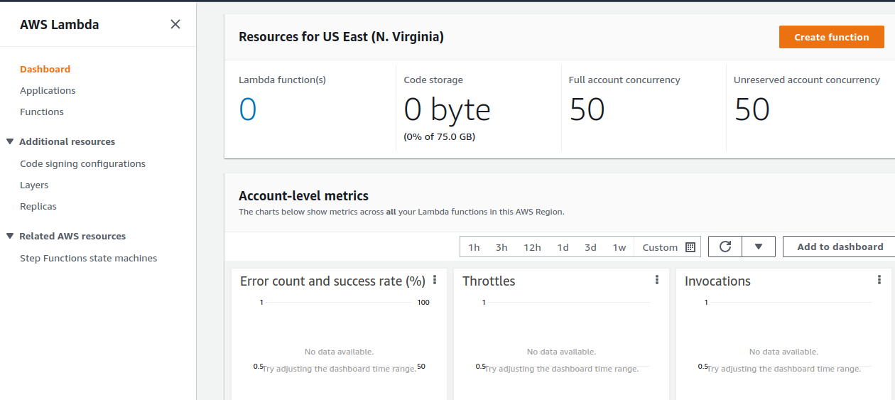

Click on create function ‘name producer’

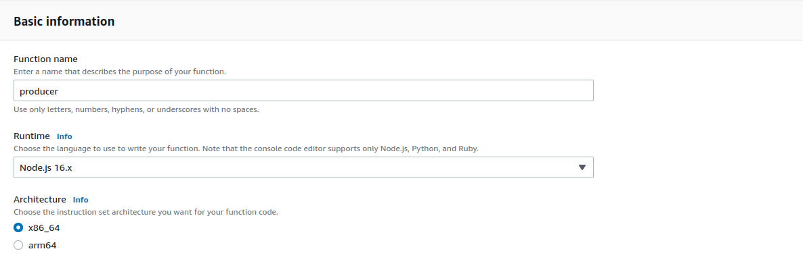

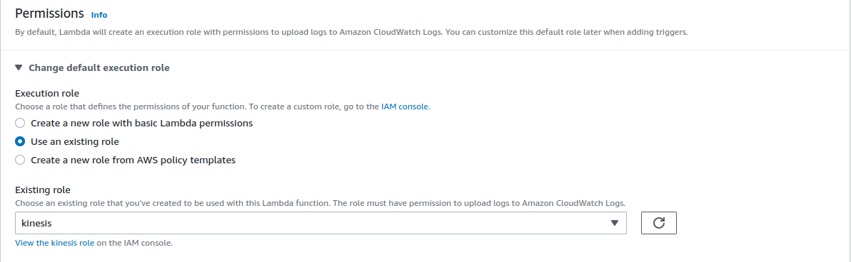

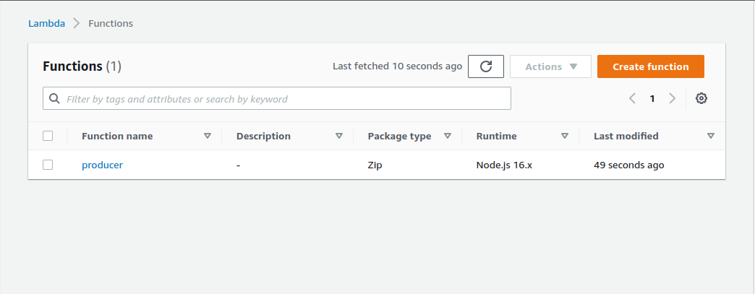

click on create another function ‘name consmer 1’

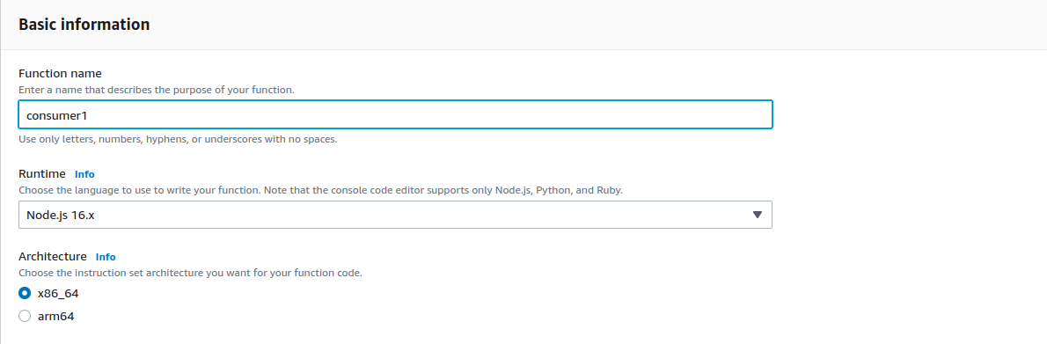

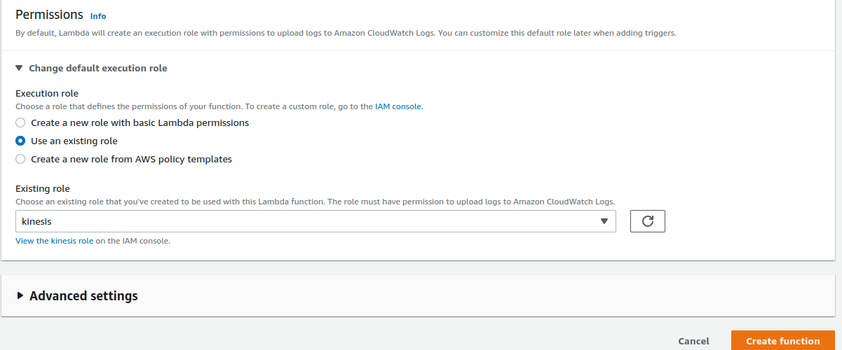

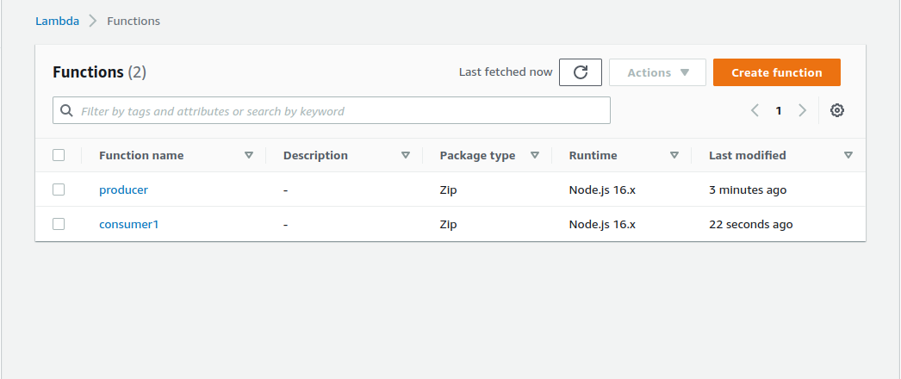

Create consumer 2 ----> click on create function.

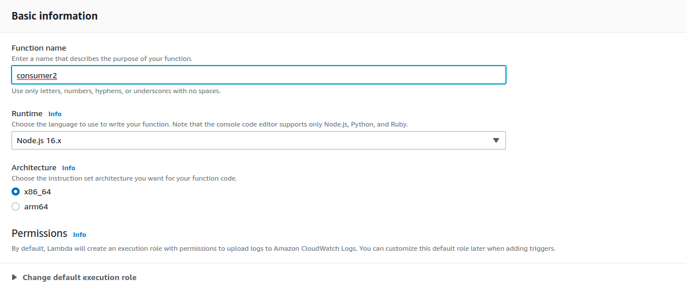

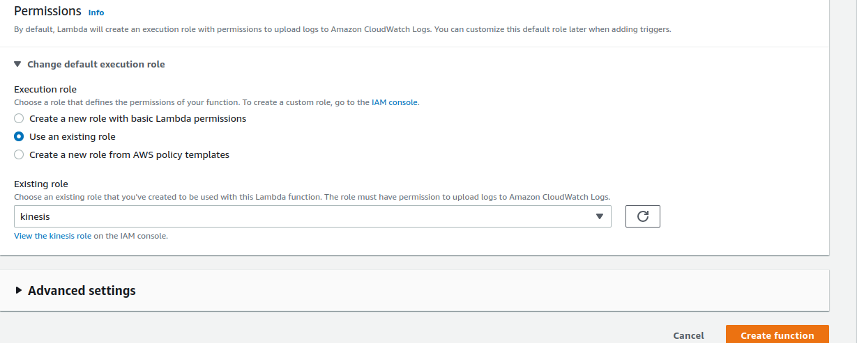

Now go to S3 bucket & create a bucket.

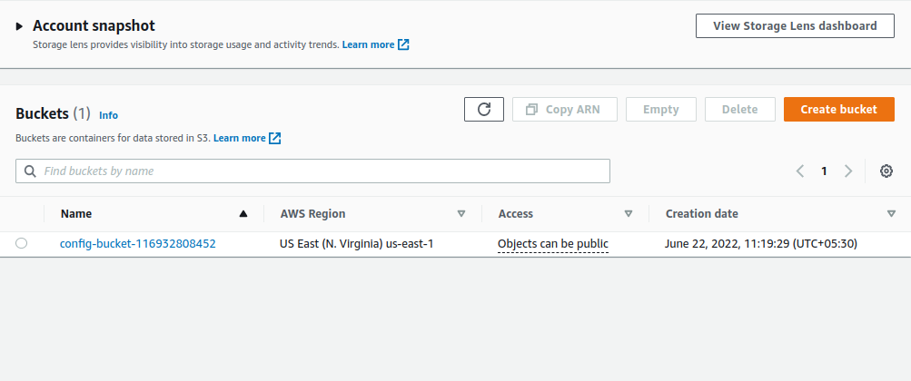

click on create bucket ----->

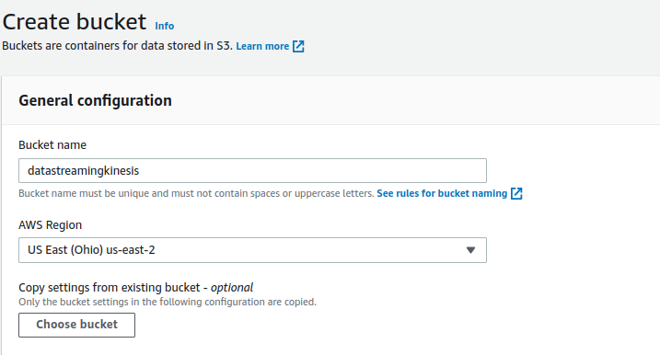

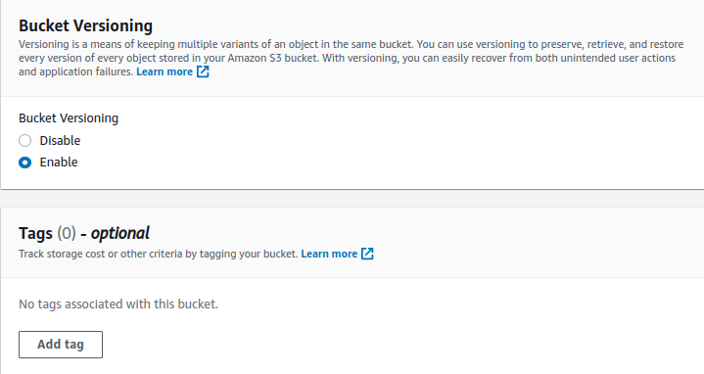

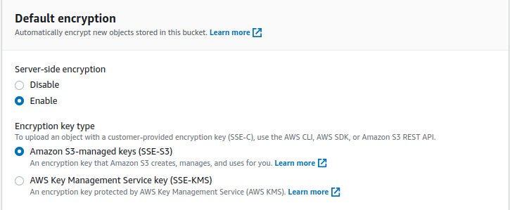

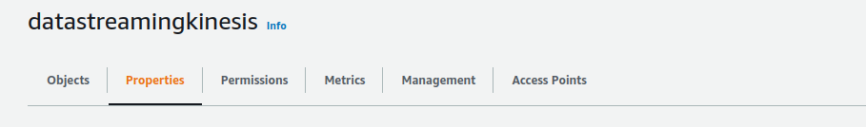

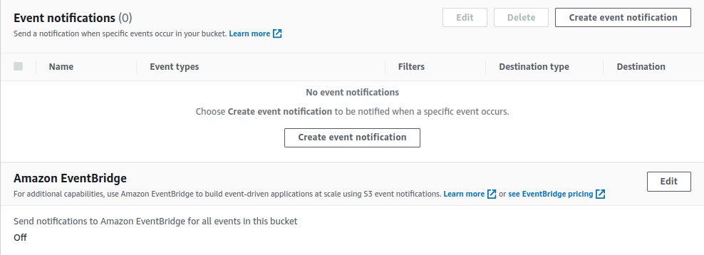

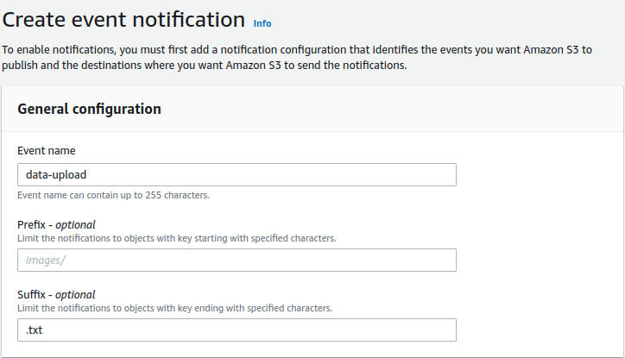

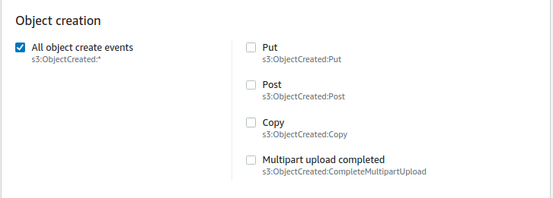

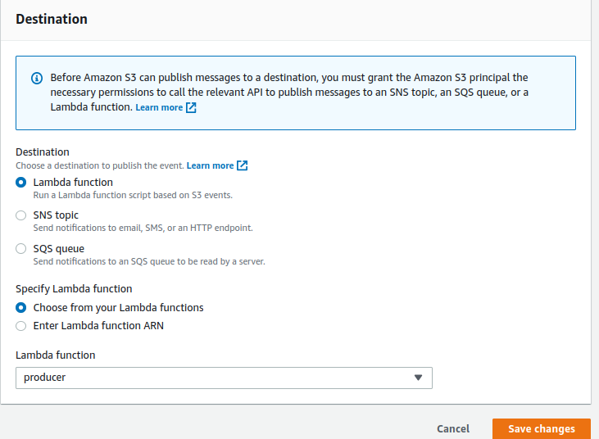

Go to Kinesis dashboard ----> select Kinesis data streams

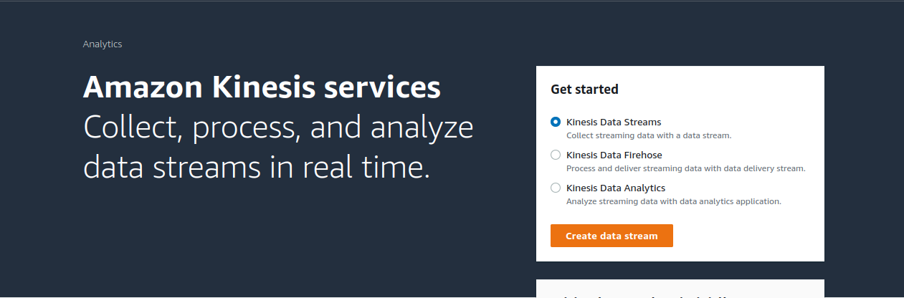

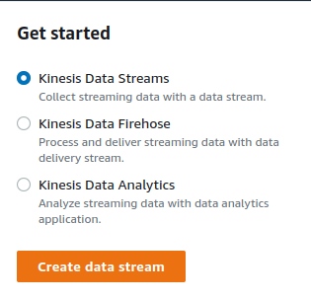

click on create data stream.

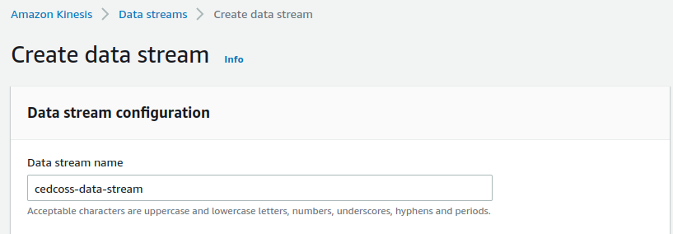

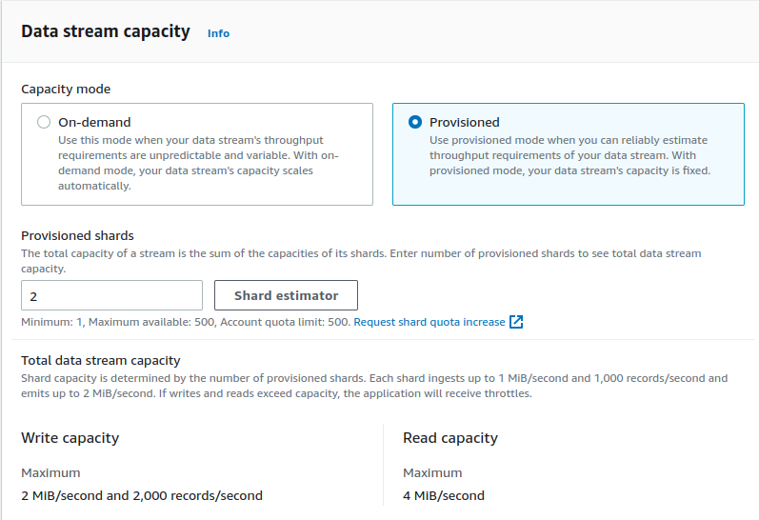

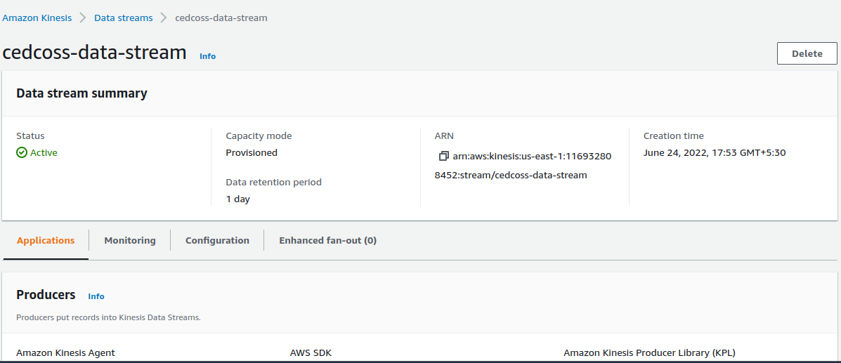

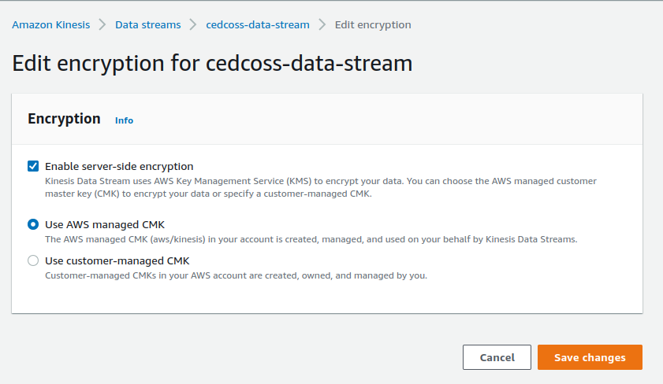

Now click on function & choose producer.

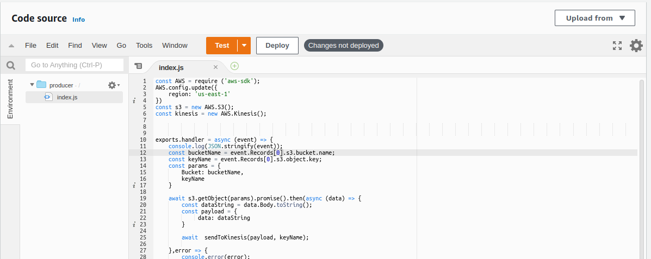  **JavaScript code for producer**

const AWS = require ('aws-sdk');

AWS.config.update({

region: 'us-east-1'

})

const s3 = new AWS.S3();

const kinesis = new AWS.Kinesis();

exports.handler = async (event) => {

console.log(JSON.stringify(event));

const bucketName = event.Records[0].s3.bucket.name;

const keyName = event.Records[0].s3.object.key;

const params = {

Bucket: bucketName,

keyName

}

await s3.getObject(params).promise().then(async (data) => {

const dataString = data.Body.toString();

const payload = {

data: dataString

}

await sendToKinesis(payload, keyName);

},error => {

console.error(error);

} )

};

async function sendToKinesis(payload, partitionKey){

const params = {

Data: JSON.stringify(payload),

PartitionKey: partitionKey,

StreamName: 'cedcoss-data-stream'

}

await kinesis.putRecords(params).then(response =>{

console.log(response);

}, error => {

console.error(error)

})

}

Click on Deploy.

Now go to consumer1 ----> click on index.js

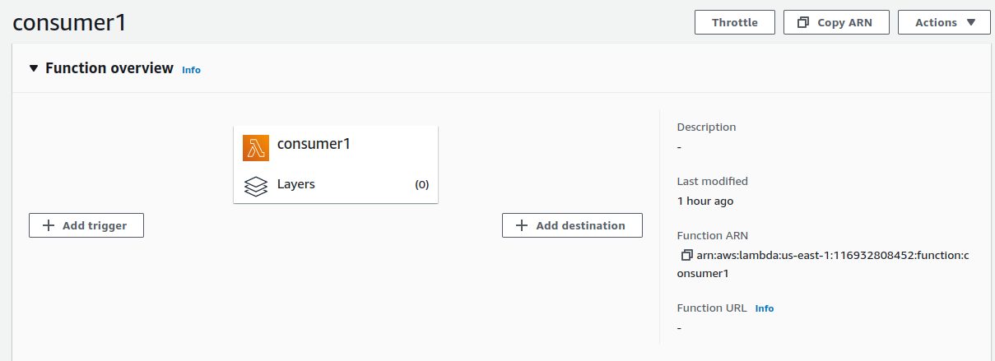

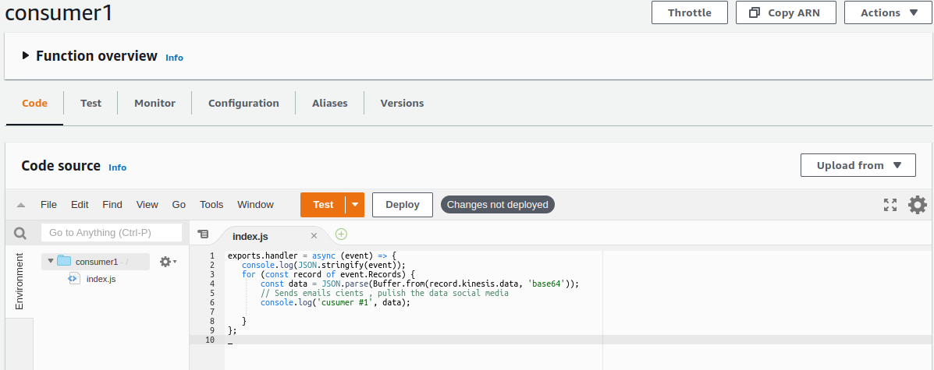

Consumer1 index.js script :

exports.handler = async (event) => {

console.log(JSON.stringify(event));

for (const record of event.Records) {

const data = JSON.parse(Buffer.from(record.kinesis.data, 'base64'));

// Sends emails cients , pulish the data social media

console.log('cusumer #1', data);

}

};

Now click on Deploy ----> Now go to Consumer2 do the same.

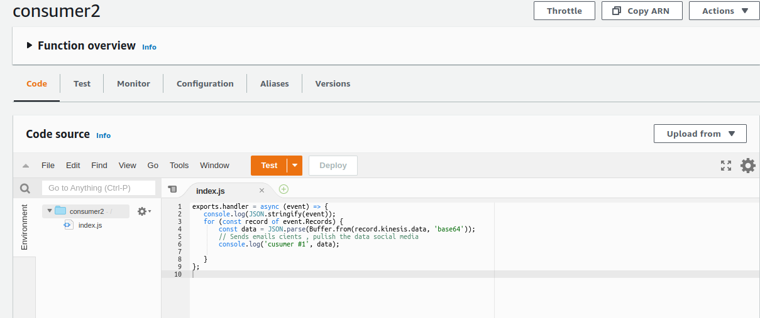

Consumer2 index.js script :

exports.handler = async (event) => {

console.log(JSON.stringify(event));

for (const record of event.Records) {

const data = JSON.parse(Buffer.from(record.kinesis.data, 'base64'));

// Sends emails cients , pulish the data social media

console.log('cusumer #1', data);

}

};

Click on Deploy. ---> Go back to consumer1 & ---> click on Add trigger

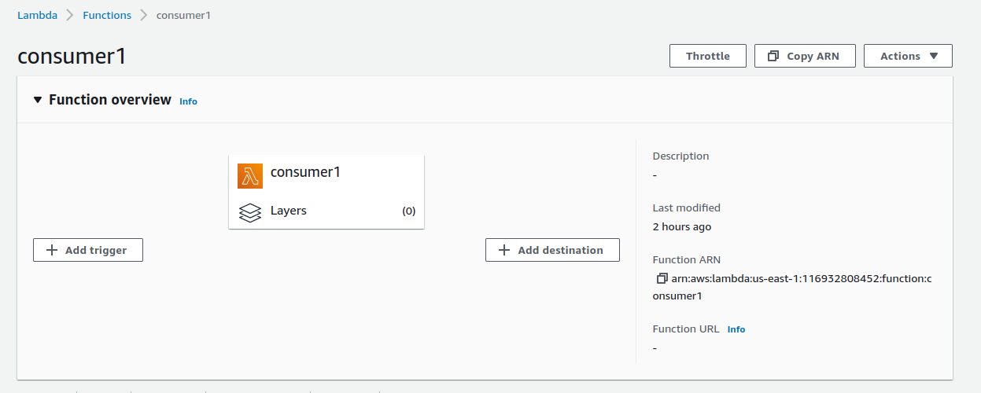

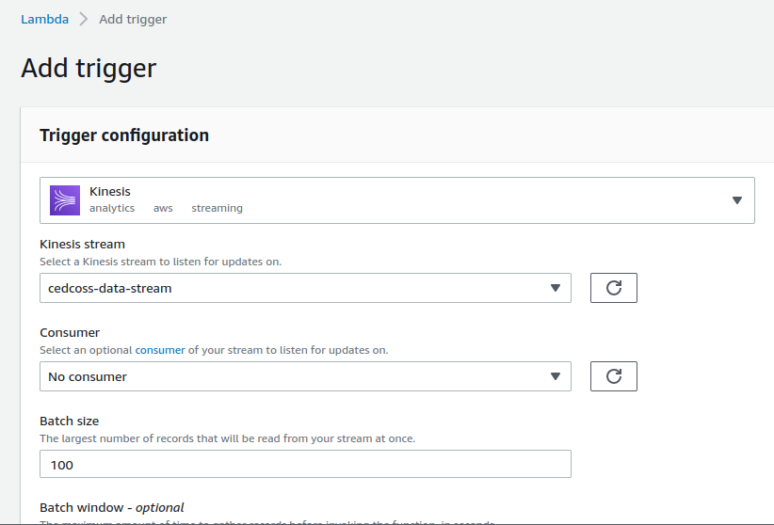

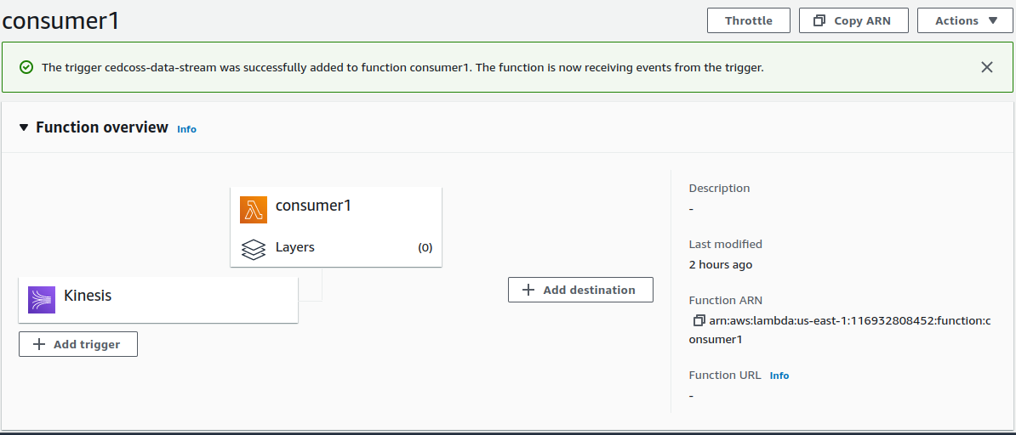

Go back to Lambda dashboard -----> click on consumer2

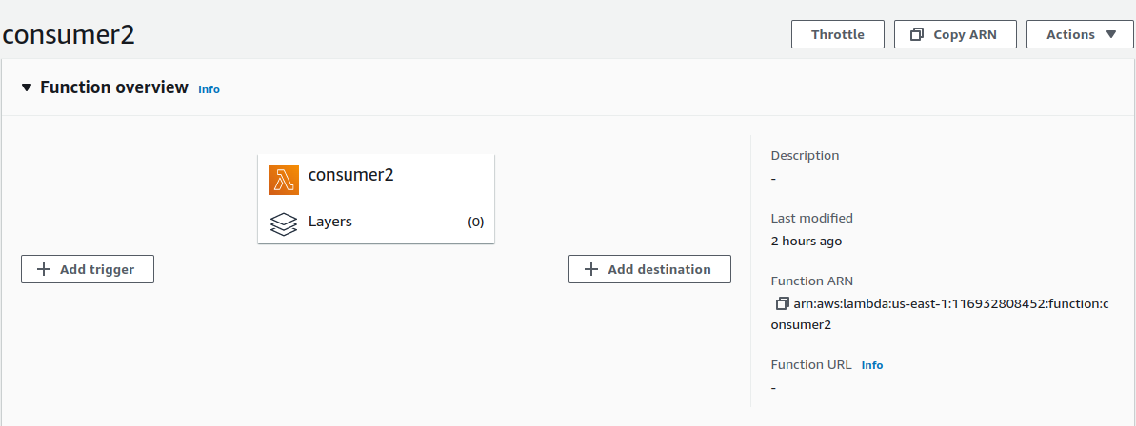

click on Add trigger ----> select Kinesis as we do our privious step with consumer1.

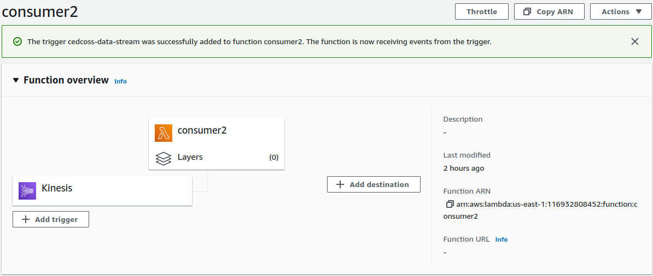

Okay, so now we have to create .txt file -----> upload it on S3 bucket.

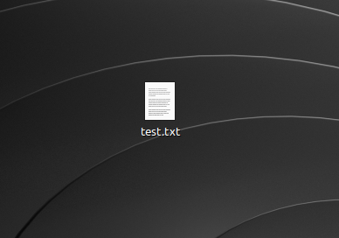

Go to S3 bucket ----> click on upload.

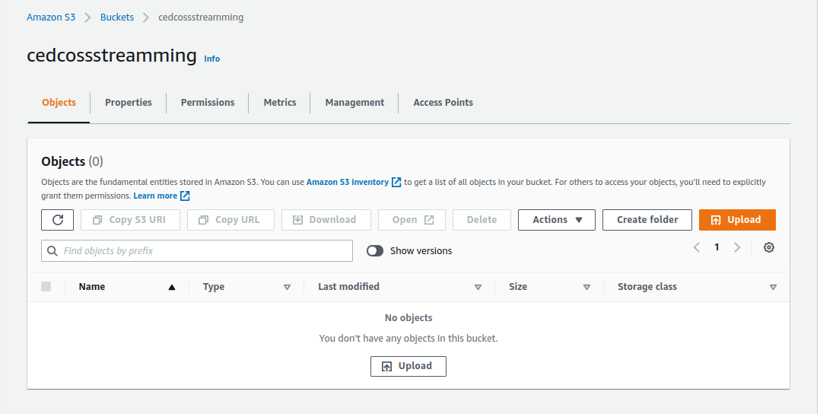

Now add file ---> click on upload file.

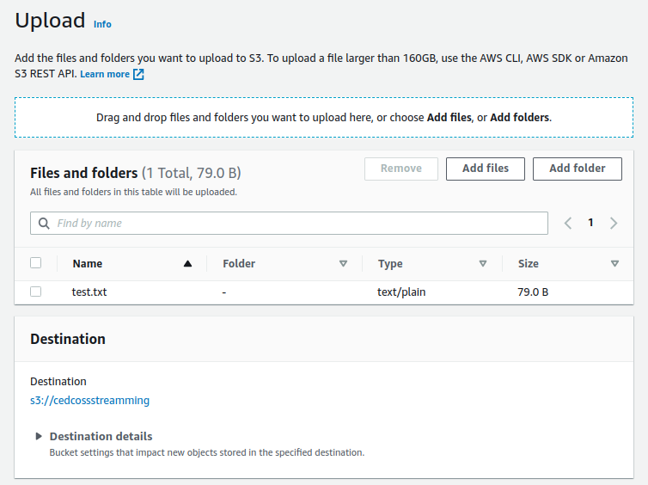

Go back to Lambda & choose ---> Producer -----> click on monitor.

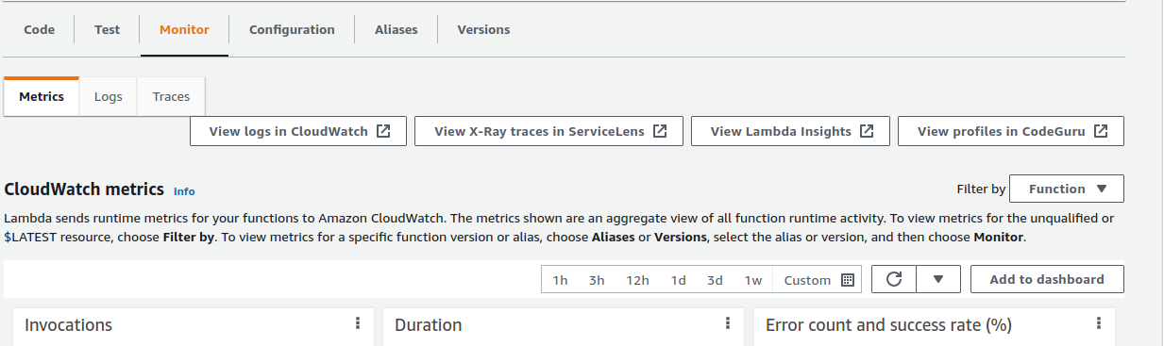

click on ------> View log in CloudWatch.

Back to ‘Producer’ /*aws/*lambda/producer/ ---> click on ‘Log Streams’

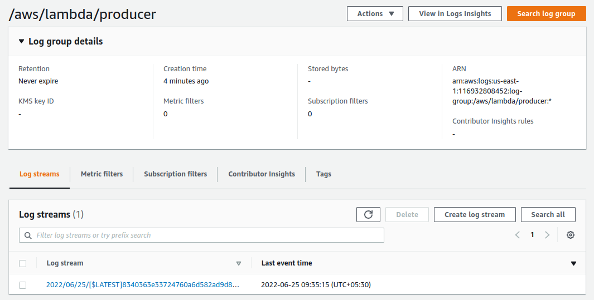

Here you can can see your log streams.

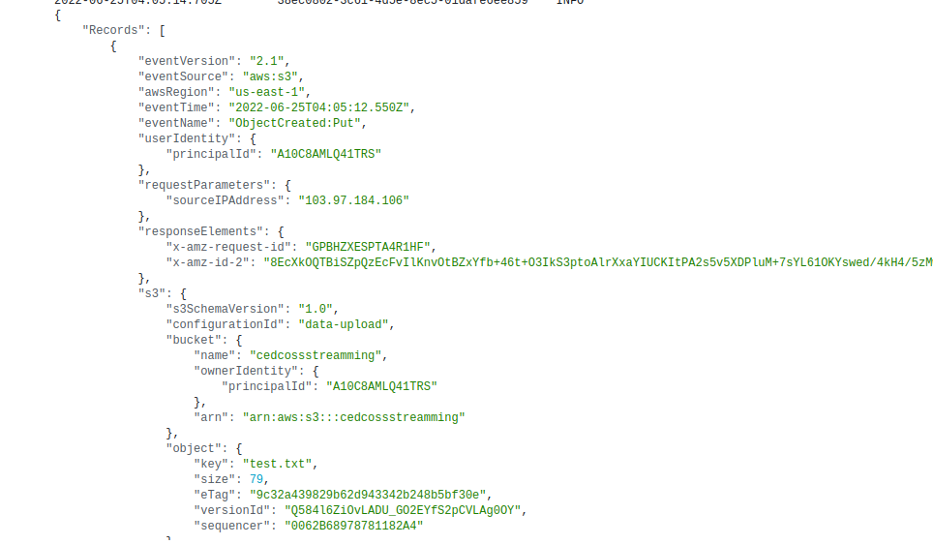

Done!