**AWS CloudTrail**

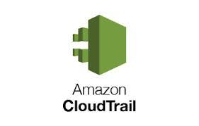

AWS CloudTrail is an AWS service that helps you enable governance, compliance, and operational and risk auditing of your AWS account. Actions taken by a user, role, or an AWS service are recorded as events in CloudTrail.

Go to AWS console ----> search AWS CloudTrail ----> Open it.

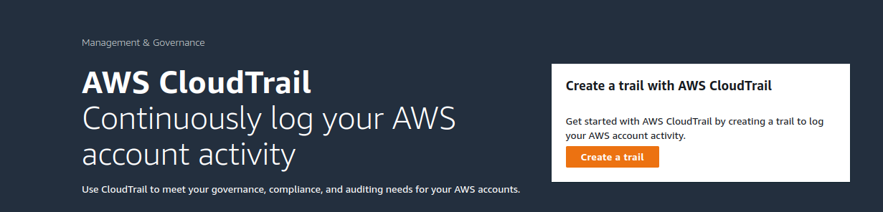

Click on create a trail --->

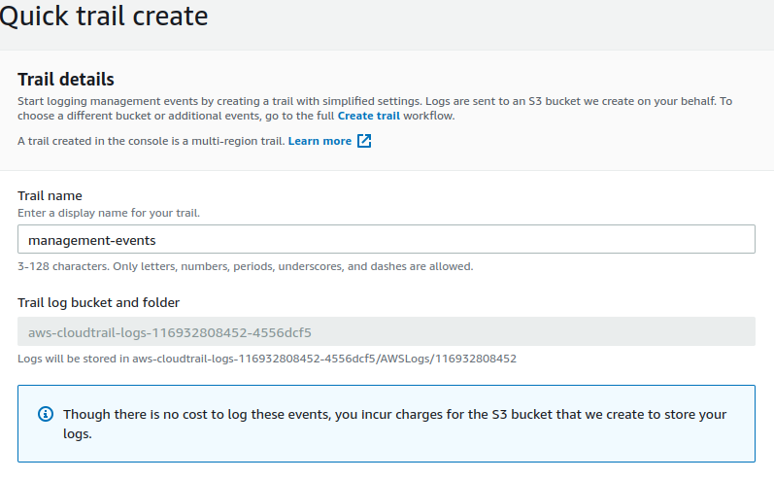

Go to S3 bucket -------> here automatically created a bucket of aws-cloudtrail

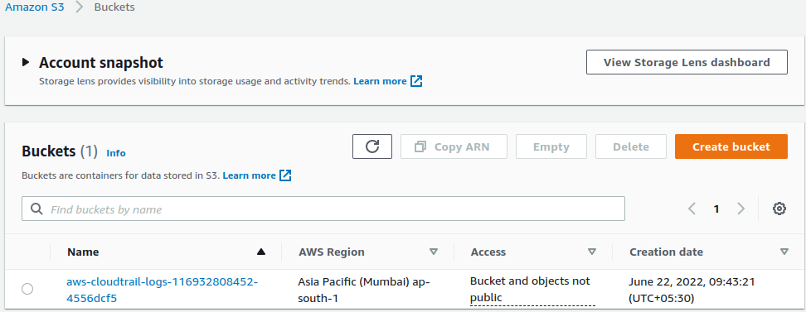

Go inside of this bucket -----> Edit Server Access Logging

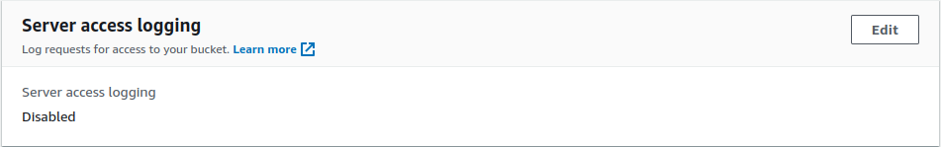

Edit the Server Access Logging ----> Disable to ----> Enable ----> In the target bucket ----> see right side a box Browse S3 ----> click on that.

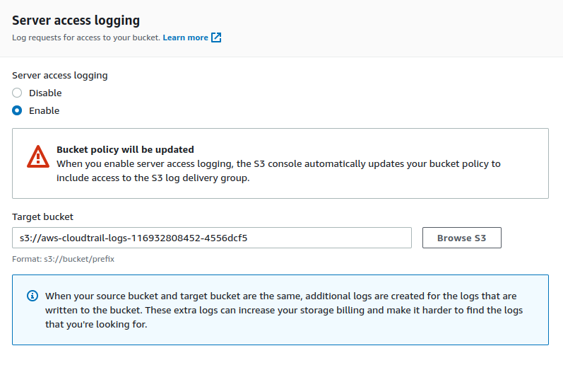

Now back to S3 Bucket Object and go inside of aws-cloudtrail ---> now here generate the aws logs.

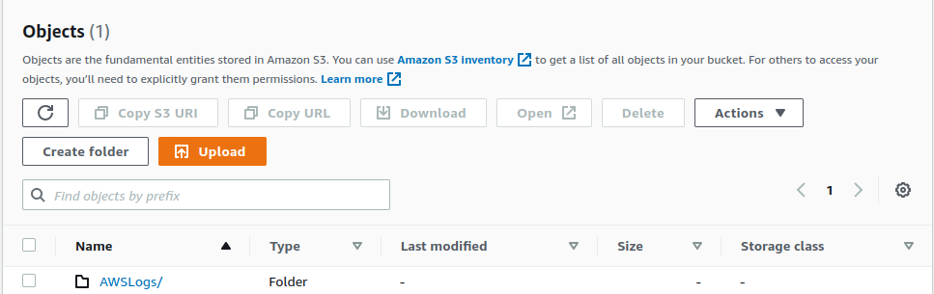

Click on AWSLogs/ cross all the folder

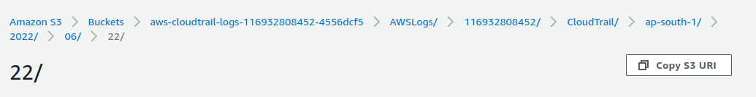

see the log files here.

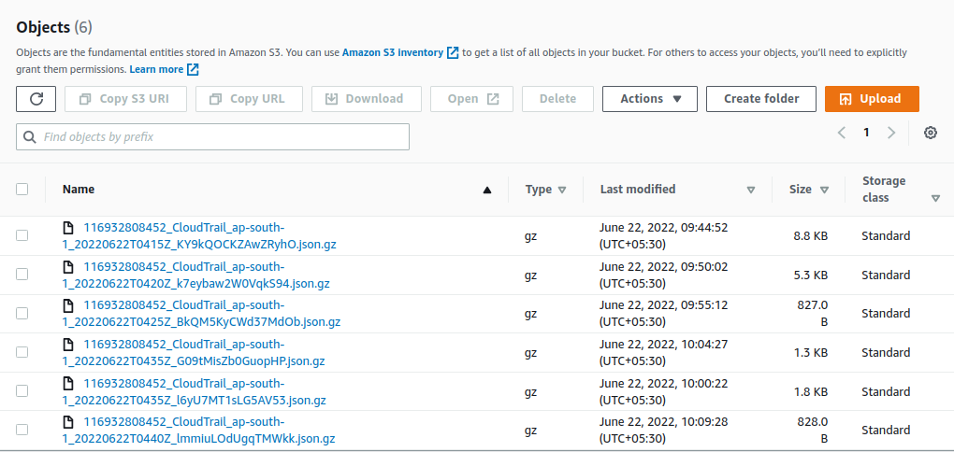

Done!