**AWS EventBridge**

Amazon EventBridge is a serverless event bus that makes it easier to build event-driven applications at scale using events generated from your applications, integrated Software as a Service (SaaS)applications, and AWS services.

Go to AWS console ----> Click on EC2 dashboard -----> Launch a EC2 instance.

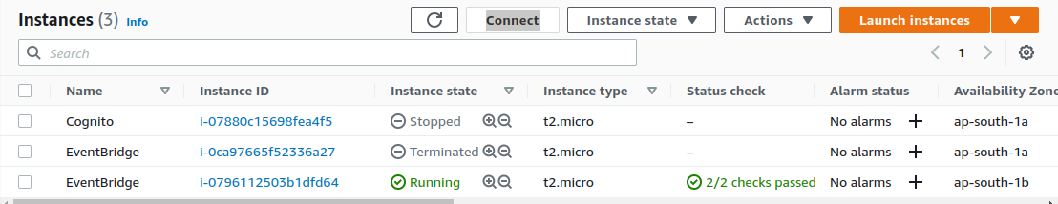

Go back to AWS console search AWS EventBridge open it.

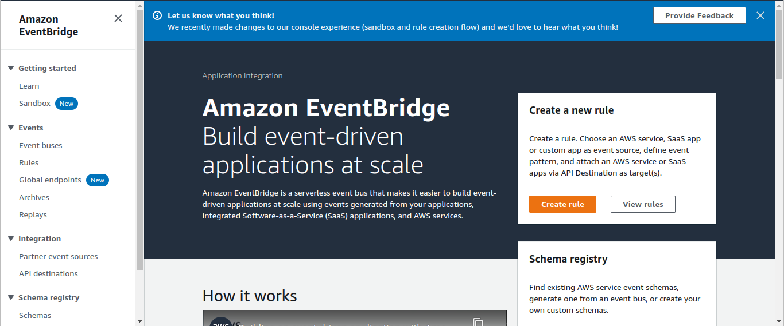

Click on create rules ----> Define ruls details.

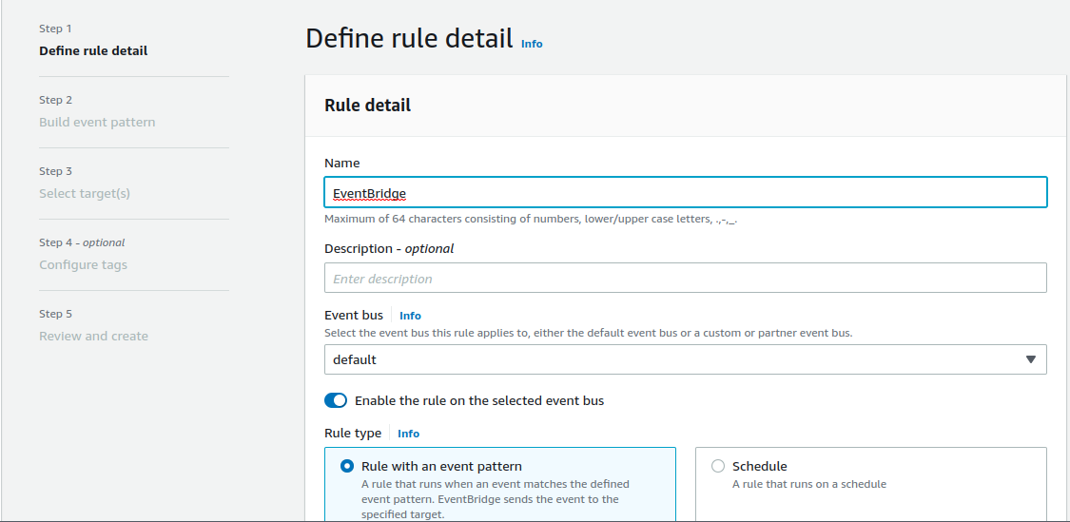

Select Build event pattern.

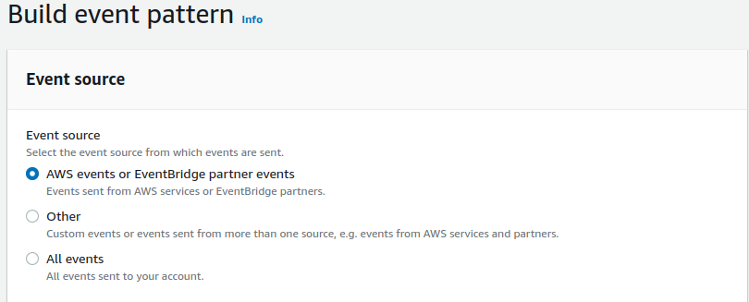

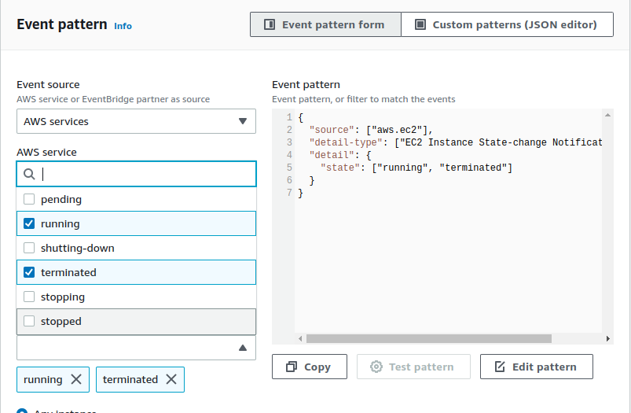

here you have to choose your instance it could be :

- any instance (including all instances)

- Specific Instance Id (am using this one) paste here that instance id.

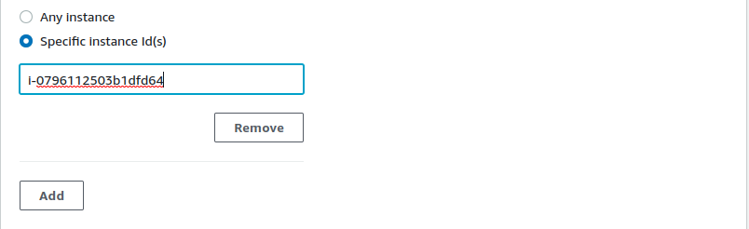

Now go to SNS (Simple Notification Service) ----> create a topic (Standard)

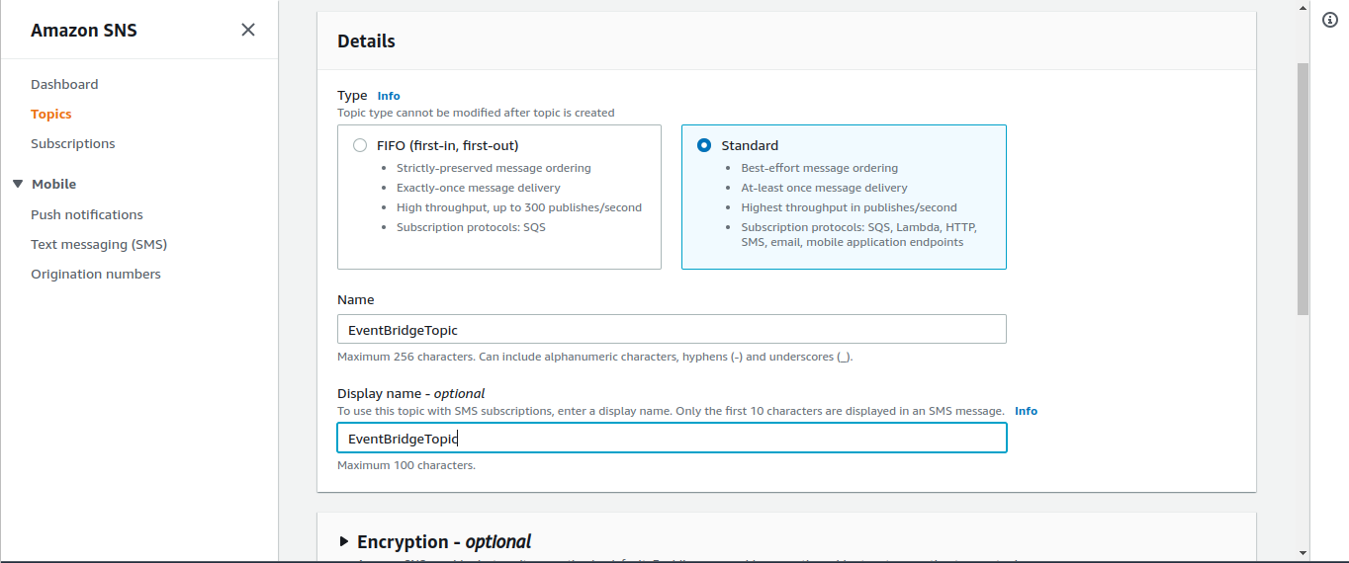

Enter topic name along with Description (Optional).

After that create a subscription..

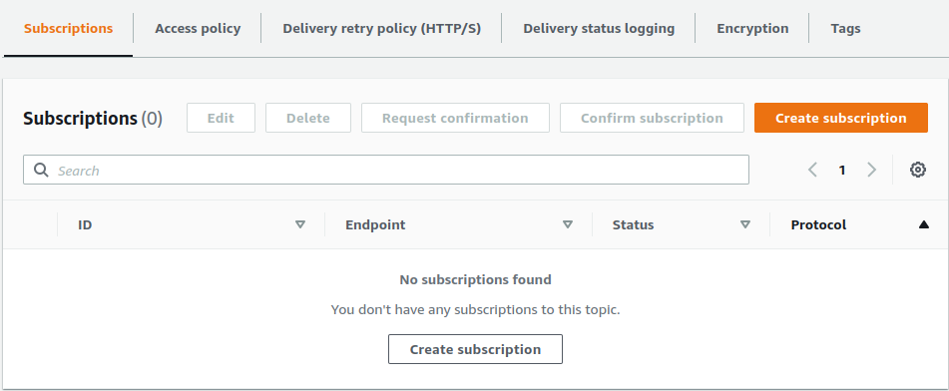

Create Topic ----> Select the topic ARN ---> In protocol type select ----> Email

after select email ---> enter your email under ----> Endpoint.

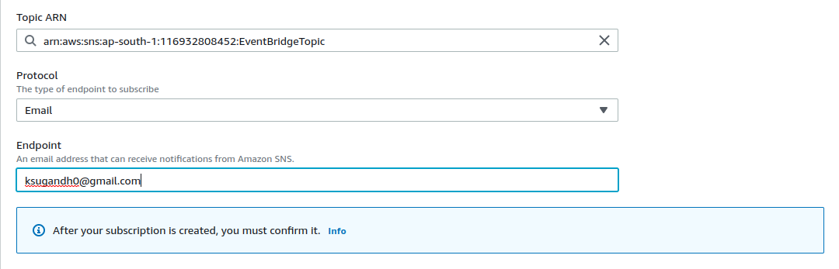

Now click on create subscription. ----> After that the status of subscription is

‘pending confirmation’

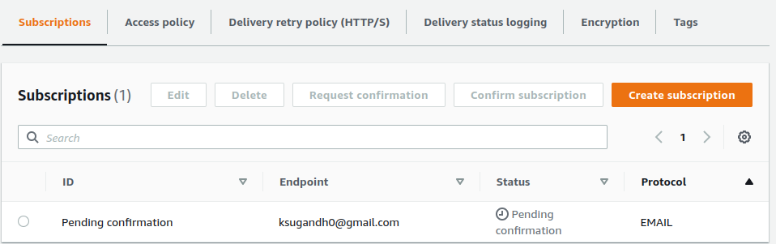

Check your respect gmail account, you have got a mail from SNS --->

click on ‘confirm or subsribe’

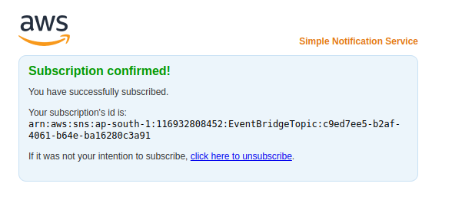

you are successfuly