**Simple Storage S3 Pre-signed URLs**

Open the AWS console select S3 (Simple Storage Service) -------> Click on create .

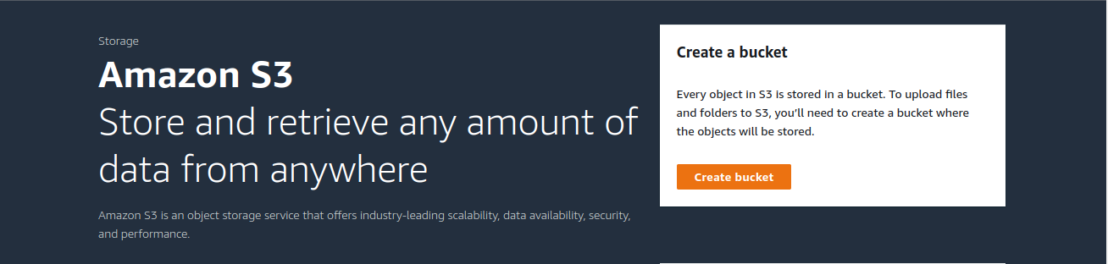

Click on create Bucket. 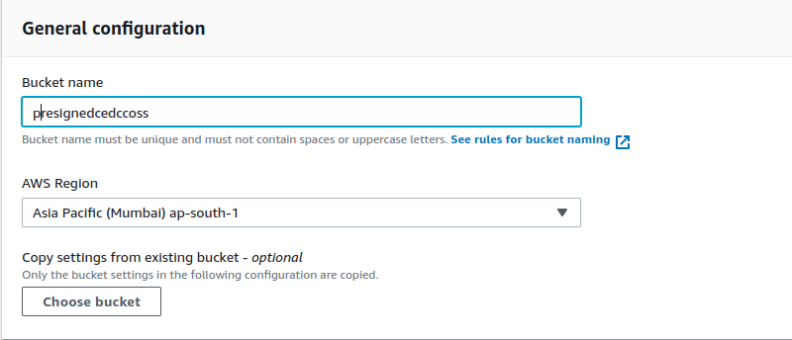

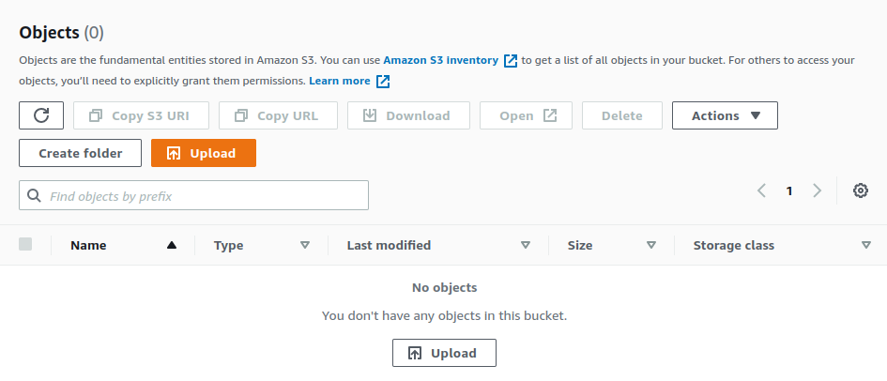

Upload a file from the local.

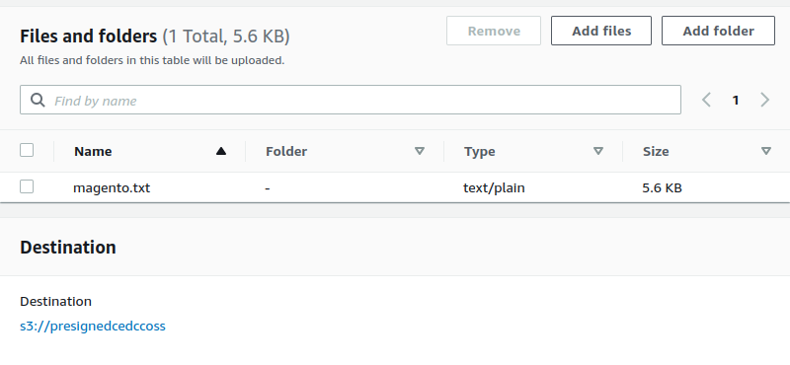

Then click on upload -----> close the popup ----> back to S3 bucket ------> Select (check) the object (uploaded file) ----> click on action ----> click on share with a presigned URL.

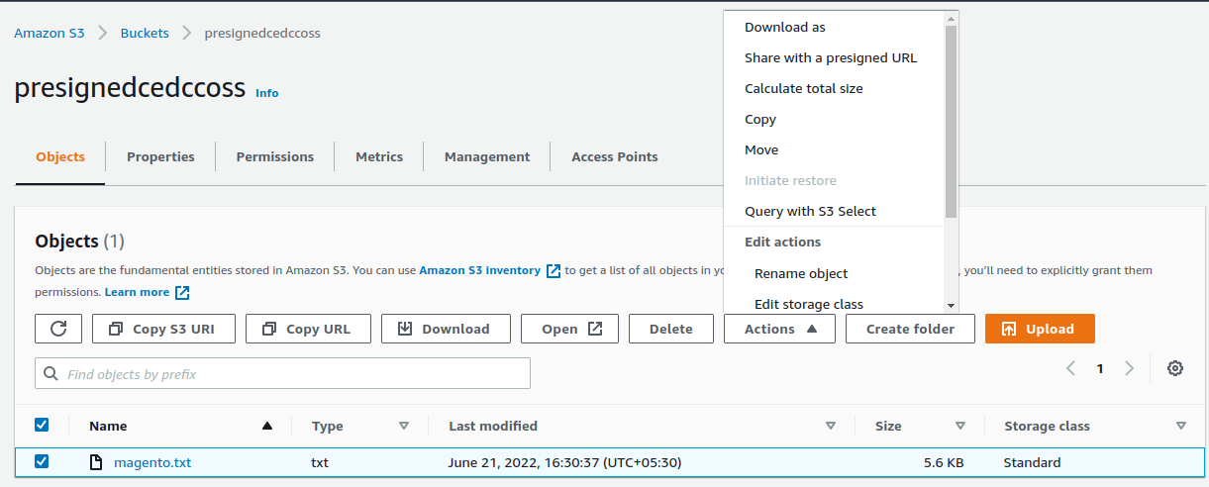

After click on the ‘share with a presigned URL option’

Presigned URLs are used to grant access to an object for a limited time

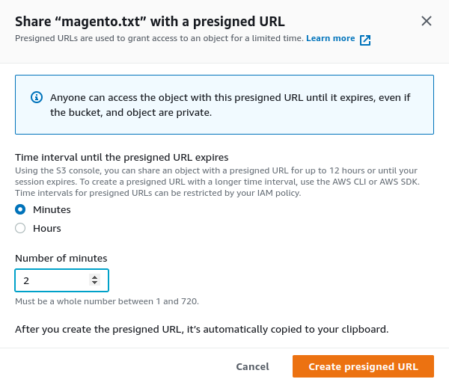



Copy presigned URL & paste it on you internet browser.

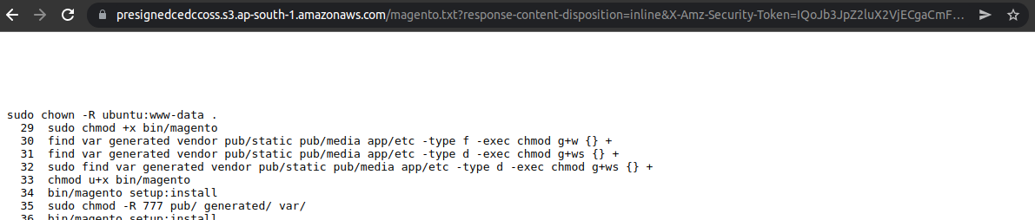

It will display only two minut

After two minut ------ > click on refresh button :

