**AWS SYSTEM MANAGER SSM**

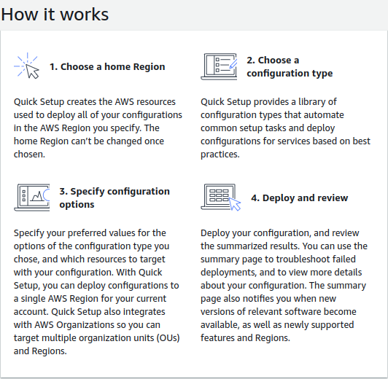

*“AWS Syetem Manger is an AWS service that you can use to view & conrol your infrastructure on AWS*

*Automate operational tasks across aws resources”*

**Prerequisite :**

Create multiple EC2 machine at once

Create IAM role with SSM permission

Attach role to EC2 machine

(Run commands or shell script on multiple EC2 machine)

First we have to create a IAM role for EC2 instances.

Go to AWS Management Console & search for IAM

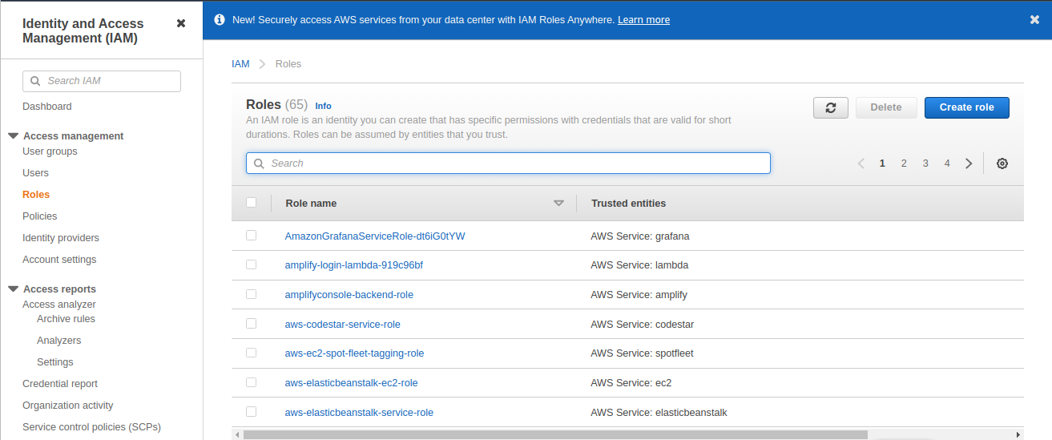

Click on roles ----> Create Role ---> Select the service role ‘EC2’

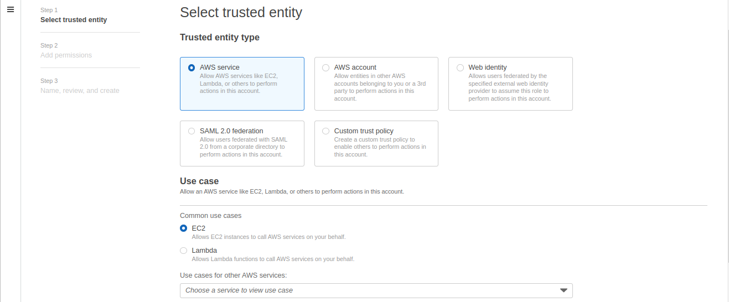

Click next ---> Add Permission ---> ‘AmazonSSMFullAccess’

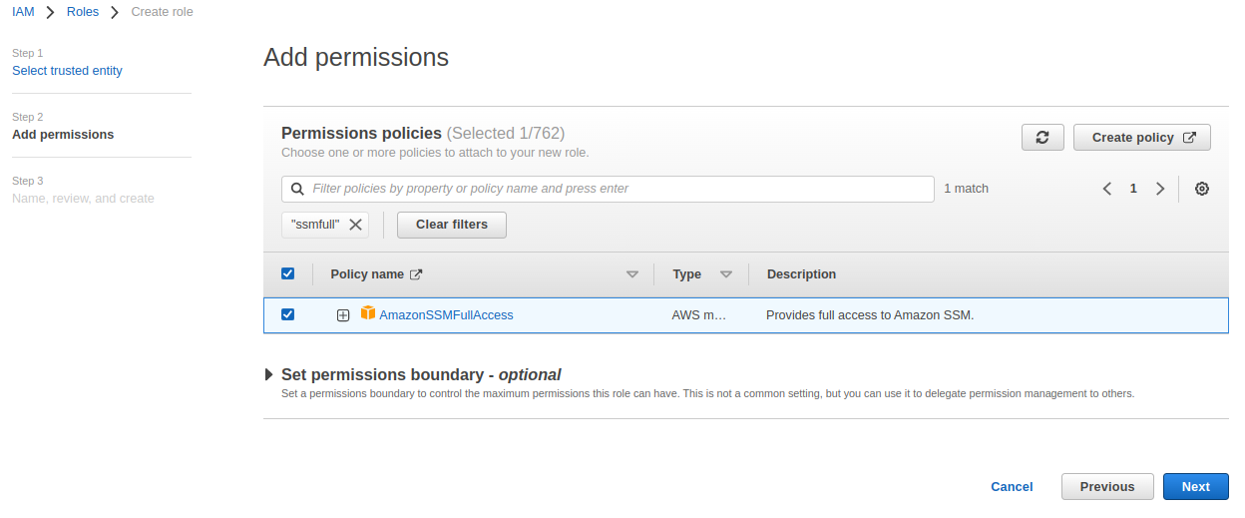

Click next ---> Enter the name & Description of the role ‘SSMRoleForEC2’

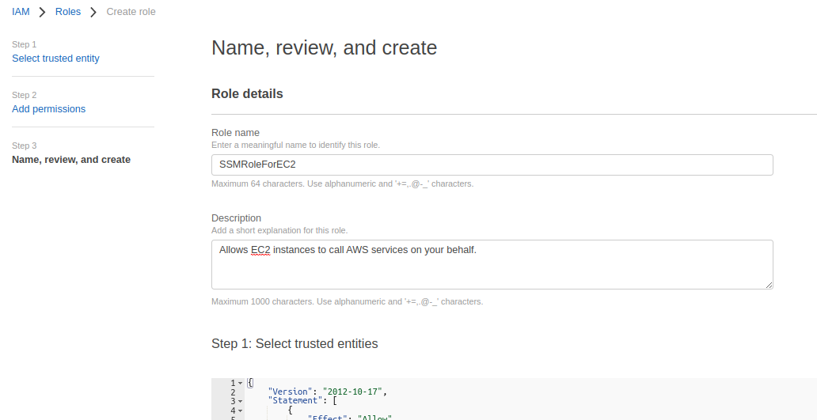

Click on create role.

Now go to EC2 Dashboard launch multiple (two) EC2 instances.

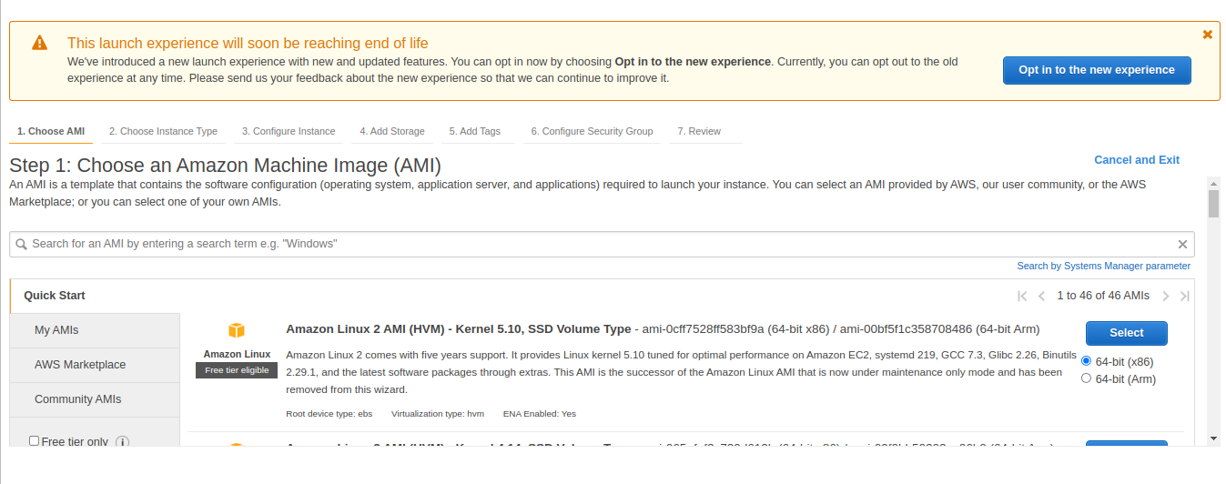

Now click on next ------> Configure instance details ----> No of instances ‘2’

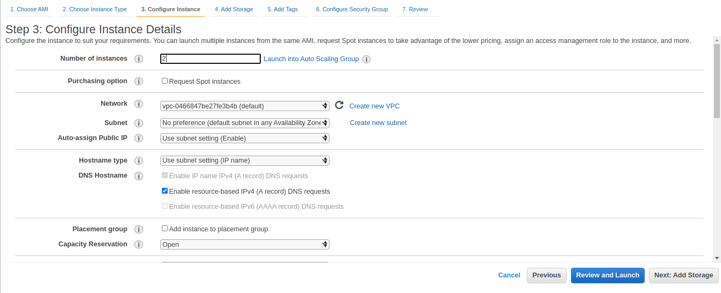

Scroll down in the IAM role option select the role that we created for our EC2 instances.

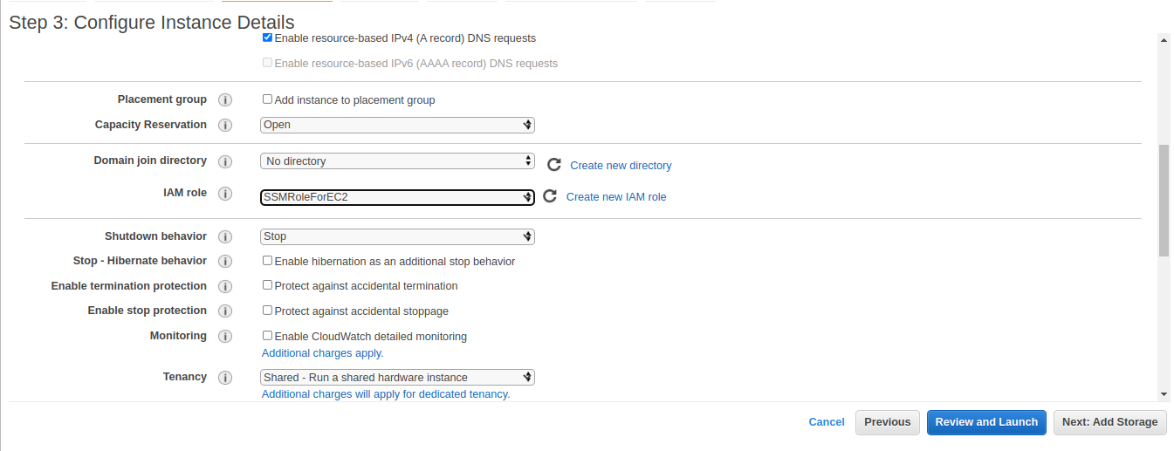 Launch the instances ---> Go to your base terminal & connect both machines

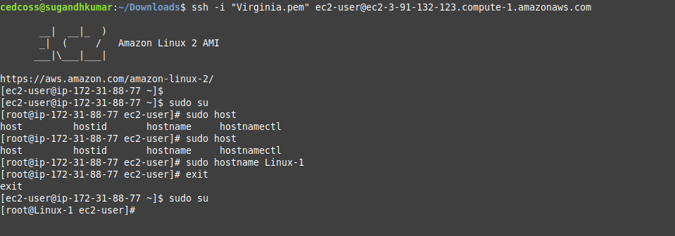Take SSH of Linux-1 machine -----> Change Hostname ‘Linux-1’

Click : Terminal ---> File ----> Click on open tab ---> take SSH other machine ‘Linux-2’

Take SSH of Linux-2 machine -----> Change Hostname ‘Linux-02’

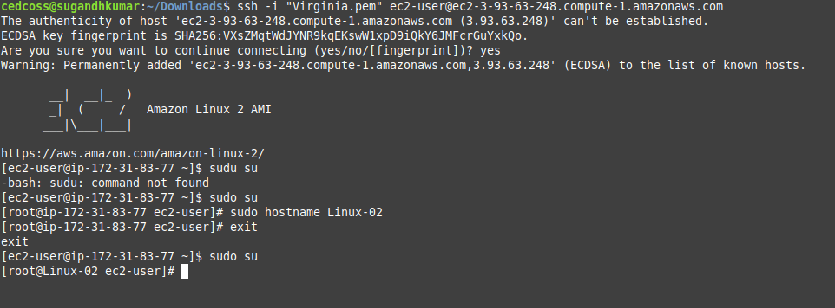

Now go to AWS console & search AWS System Manager