**AWS Event Bridge**

To create AWS Event Bridge on EC2 :

Go to EC2 dashboard create a Instance :

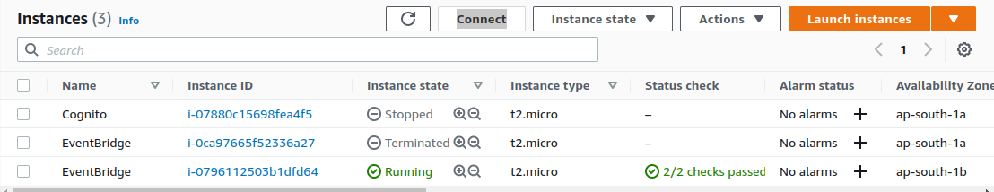

After done with it ------> Go to services search AWS EventBridge

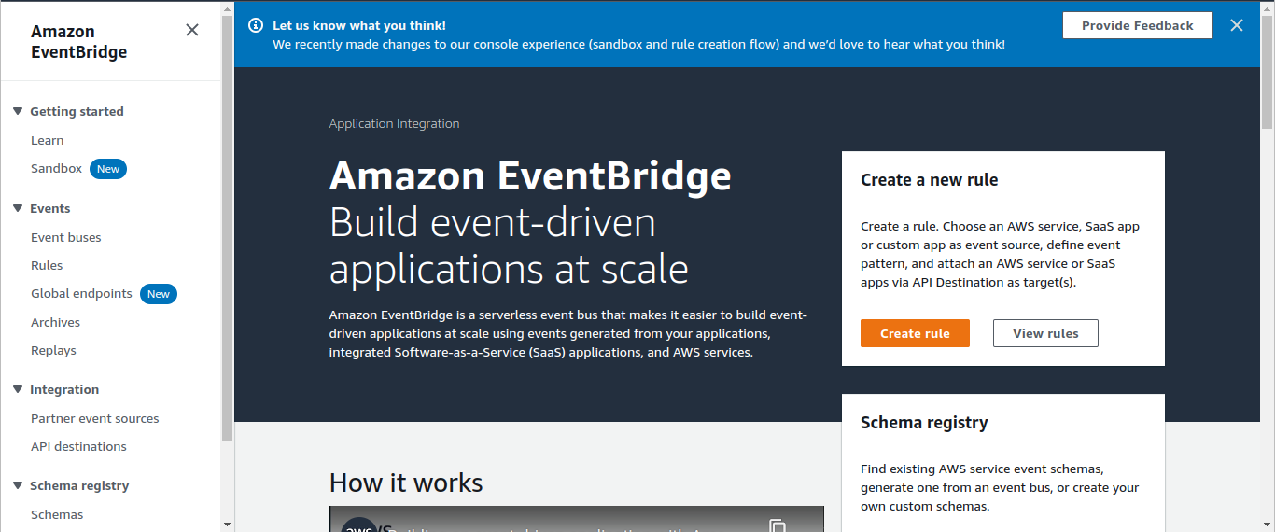

Click on create Rule

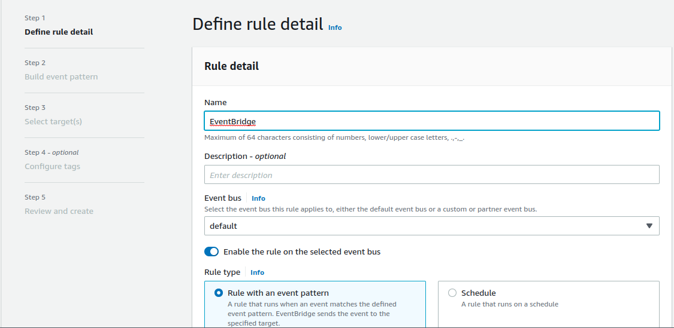

Fill the Name & Description select rule type

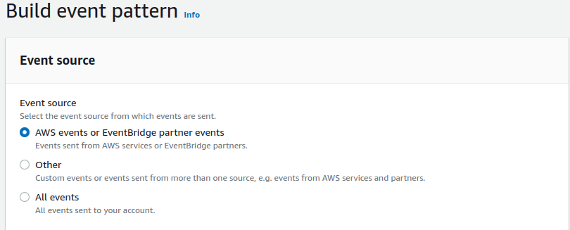Select the options according to your need.

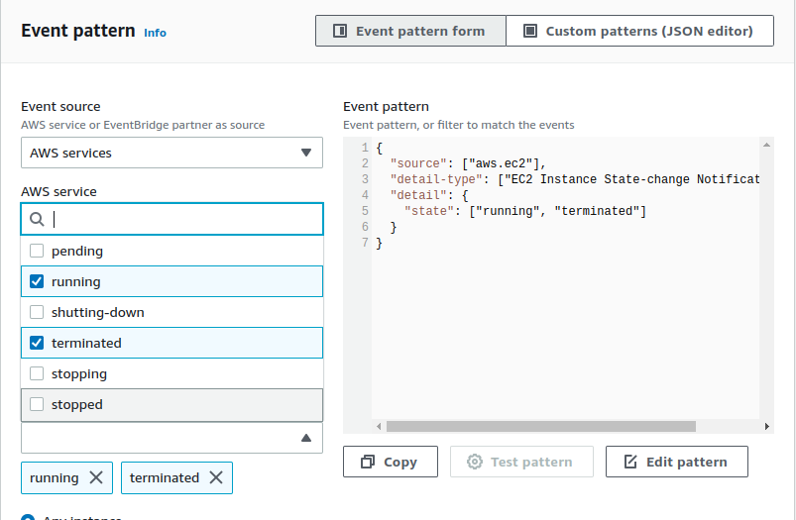

Select the Event Pattern in the AWS services you can choose any services under AWS it could be a Lambda , S3 , IAM etc.

Then select Event Type in my case iam take service EC2 so am choosen Running Or Terminated

Choose Resource here two option for you

1 : Any resource by ARN

2: Specific Resource by ARN (paste the EC2 instance ID)

Go to AWS console & search SNS (Simple Notification Service)

**Simple Notification Service**

Choose SNS (Simple Notification Service) & create topic and clcik on next step.

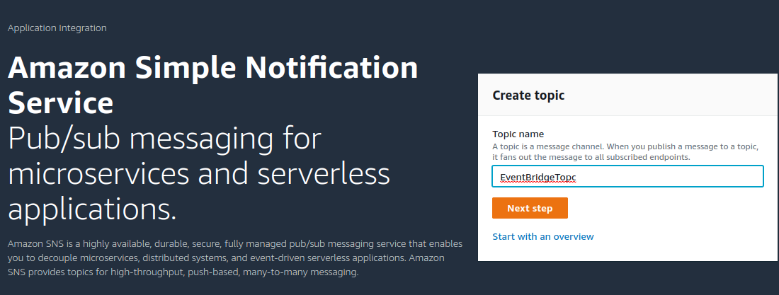

Select Standard (By Default) ----> fill the name ----> fill the display name (optional) click on create topic.

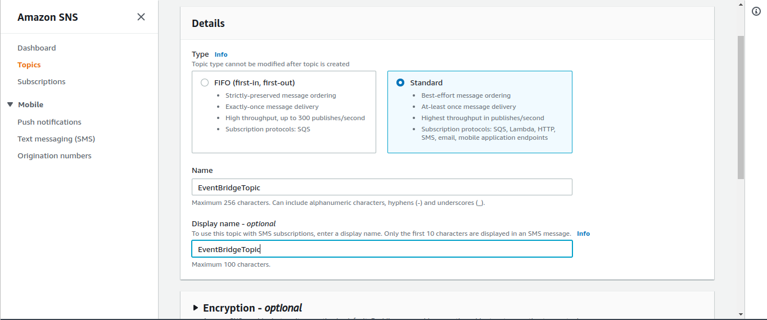

Now we have to create a subscriptions for notification of EC2 Instance state (start, stop, terminate).

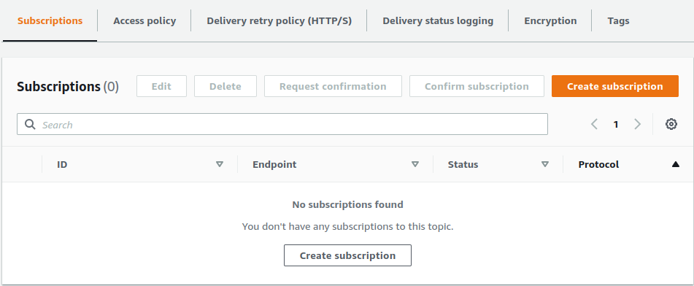

Create a Email Subscriptions for notification click on create subscriptions.

In the protocol field choose the protocol for message in my case am choosen Email

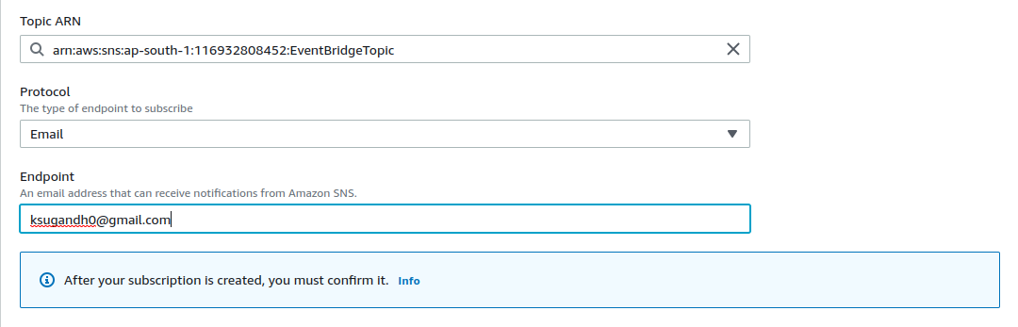

fill your email id & create on create subscriptions

Now here our subscriptions is Pending

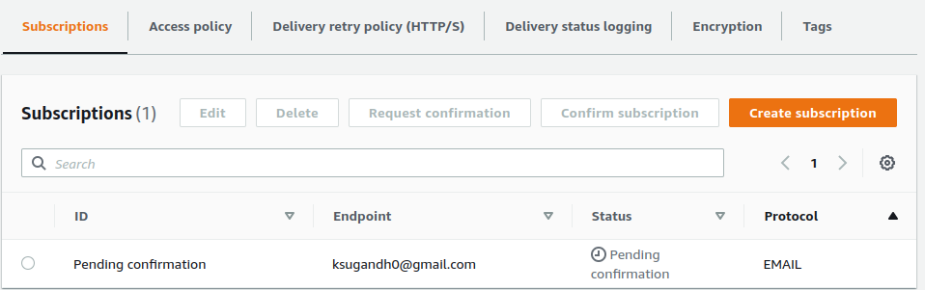

Go to registered email id you have got an email from SNS & subscribe the topic.

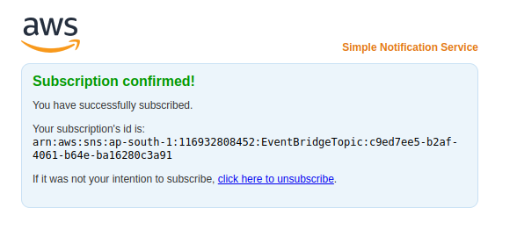Go back to SNS & check the status of subscriptions .

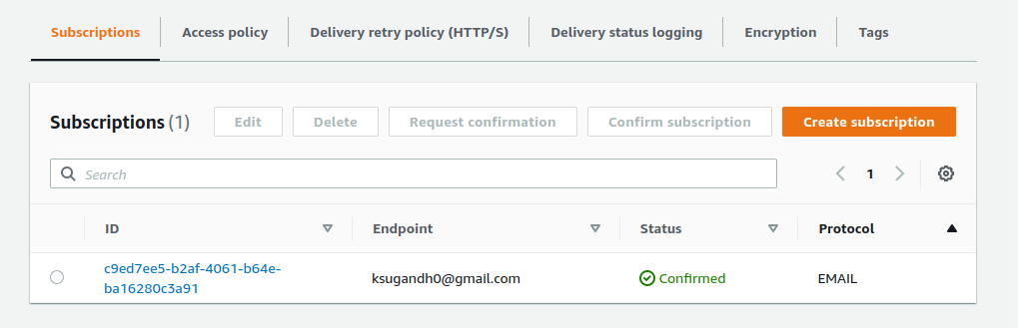Subscriptions is confirmed now.

Go back to the EventBridge and fill the required things.

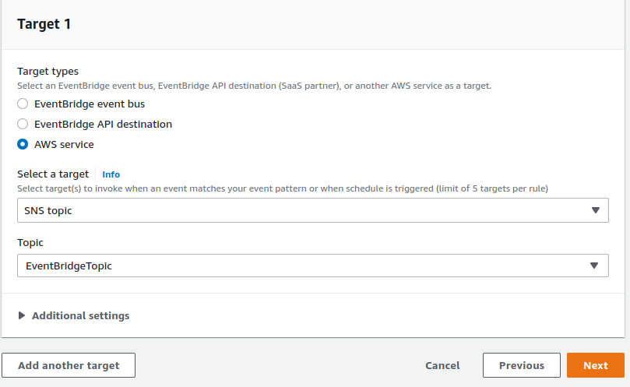

Select the SNS service & select the topic that you create on SNS ---> Click next & click on create rule

Now we have to test the EventBridge service

Go to EC2 & select instance that id configure with Event Bridge ------> click on instance state -----> select stop.



After that go to email you have a mail from SNS about stop the instance.

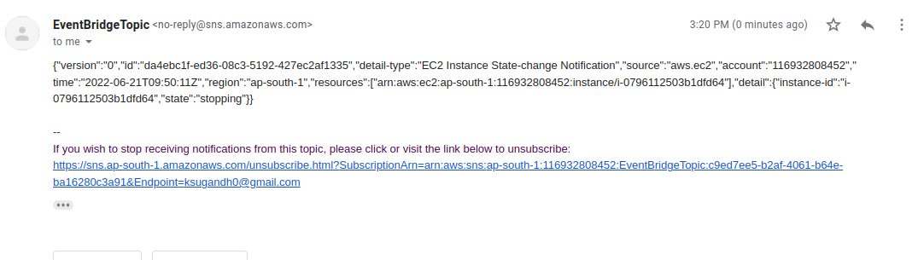

Done!