**Definition:** Classification of corn or maize plant leaf diseases

* Classify corn or maize plant leaf diseases into four classes (Blight, Common rust, Gray leaf spot, Healthy).

**Dataset Details:**

* Common Rust - 1306 images
* Gray Leaf Spot - 574 images
* Blight -1146 images
* Healthy - 1162 images
* I have divided the entire dataset into an 80:20 ratio for training and testing.

**Features Taken:**

* Pixel value as a feature (Each pixel has a value between 0 to 255).

**Algorithm Used:**

* Convolutional Neural Network (CNN)

**Result (performance parameters all)**

* Model.evaluate inbuilt function of keras sequential model.

**Difficulties facing (queries)**

* I have minimal knowledge of deep learning and have just started it. I need to know the direction in which I should work on further .

**Result screenshots**

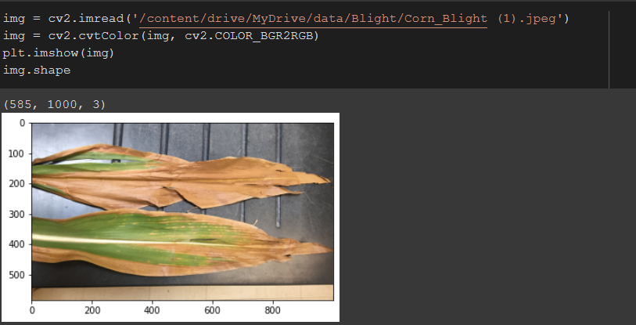

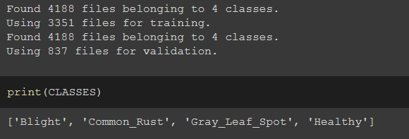

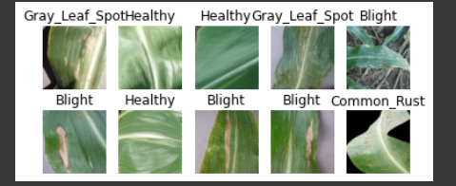

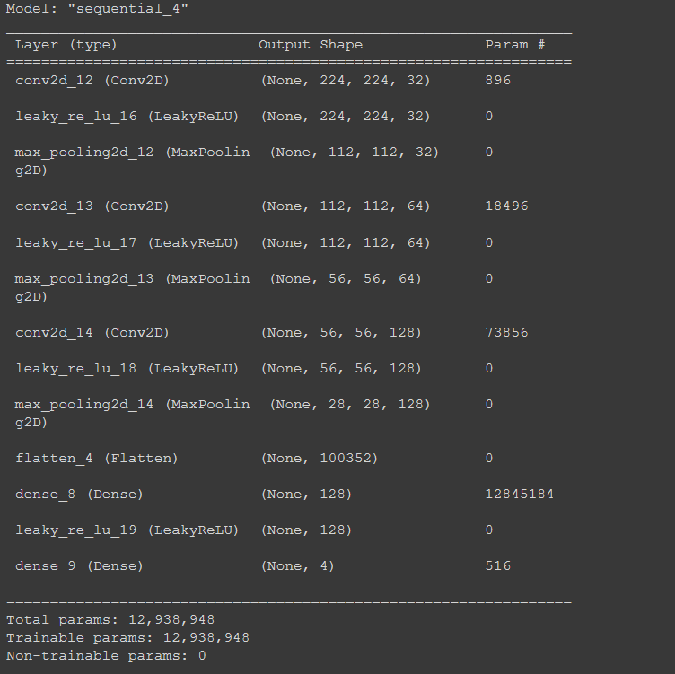

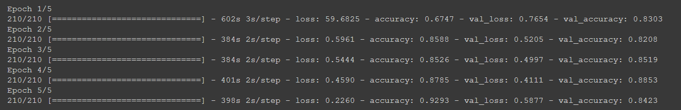

**Training and testing time along with machine hardware description**

* Using Laptop: Training time = 25 to 30 minutes. Testing Time = 2 minutes

Machine Hardware:

Laptop: Ryzen 5 4600H, NVIDIA GTX 1650 4 GB graphics card, 8 GB RAM

**Dataset Link**

<https://www.kaggle.com/datasets/smaranjitghose/corn-or-maize-leaf-disease-dataset>

**Code run in (Personal laptop/Supercomputer/google Colab etc.)**

Google Colab