

**OBJECTIVE**



Seeking a challenging position in a reputed organization where I can learn new skills, expand my knowledge, and leverage my learnings. To get an opportunity where I can make the best of my potential and contribute to the organization’s growth.

# EDUCATION

## Diploma in Information Technology

SEPT, 2021 – TO

Sevdie Institute of Management and Technology Lucknow, Pass With

75.5 %.( U.P.B.T.E)

## Intermediate

APRIL, 2018 – TO

J.B.I.C Mathura Nagar Ramgarh Sultanpur, Pass With 62.5% (U.P. Board).

## High School

MAY, 2015 – TO

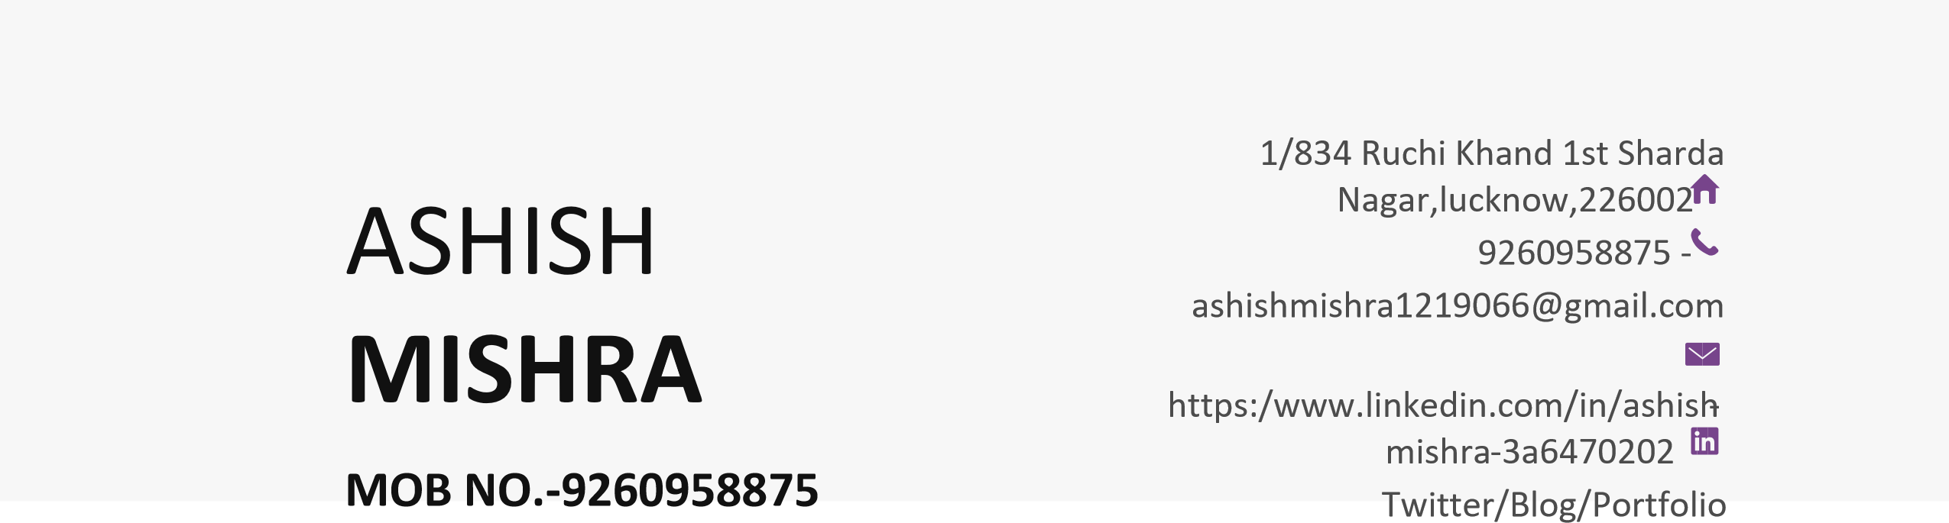Arvind B.V.M.I.C.H PUR kanaura, Pass With 70% (U.P. Board).

# EXPERIENCE

## Software Developer | Techpile Technology Pvt. Ltd., Lucknow (6 Month)

AUGUEST, 2021– TO

Techpile Technology Pvt. Ltd, Lucknow. I am Done 6 (six) Month Apprenticeship From Above Company.

## Software Developer | The Sileo Technology Private limited (12 Month)

August, 2022– TO

The Sileo Technology Pvt. Ltd**, Lucknow(Current Working).** I am Done 12 Month Working Experience From Above Company .

# Working Project

* SgCare : https://sgcareindia.com
* Vinoday: <http://vinyodaya.com/>
* Karyon: https:// karyon.organic
* Shri naman infra city :https://shrinamaninfracity.com
* ToPay: <https://toPay.live>
* YEHM: <https://yehm.co.in>
* Admin Panel :Admin.karyon.orginic
* MobliePe Admin Panel: https://web.mobilepe.co.in/Home

# SKILLS

* C Programing Language
* Confluence, Jira Software
* C# Programing Language

• ASP.NET MVC With

* CSS 3
* VisualStudio2019/22
* J-Query

• HTML 5

* Bootstrap 5

• JavaScript

* DataBaseManagementSystem(MSSQ)
* Software Methodology (Agile,

Scrum)

# TRANING-CERTIFIACTE

* Apprenticeship Training in Techpile Technology Pvt. Ltd
* Summer Training from Techpile Technology Pvt. Ltd.
* CCC from NIELET in 2015

**DATE-**

**PLACE-LUCKNOW (ASHISH MISHRA)**