An Improved FFT Jitter Decomposition Algorithm
Zhensheng Zhang¹, Secor, Tonggang Zhao^{1*}
¹School of Electronic Engineering, Beijing University of Posts and Telecommunications, Beijing, China
*zhaotg@bupt.edu.cn

Keywords: FFT, Jitter Decomposition, Random Jitter, Fitting
Abstract
Signal jitter in circuits significantly impacts system performance, and understanding its components is crucial for optimization. While traditional FFT-based jitter decomposition algorithms excel at extracting deterministic jitter information in the frequency domain, they still fall short in accurately decomposing stochastic jitter components. A new fitting method based on chi-square test is proposed to replace the traditional FFT jitter decomposition algorithm based on theoretical statistical feature calculation, which can decompose the random jitter component more accurately. The simulation results show that the improved FFT jitter decomposition algorithm can decompose the random jitter component more accurately, and the error rate is reduced to about 1%~5%.

1 Introduction
The digital circuit system is evolving by leaps and bounds, which is particularly reflected in the substantial improvement of system transmission rates. Interfaces such as PCIe, USB and DisplayPort, for instance, have already achieved a data transmission rate of the 10 Gbps level [1]. For such high-speed signals, even with the adoption of high-information encoding methods, the actual duration of each symbol period remains extremely short, often less than 1 ns, which imposes stringent requirements on signal quality in the system. Jitter refers to the short-term deviation of a digital signal from its ideal position at critical time points and is a key concept for characterizing the quality of digital signals [2]. The transmission rate of a circuit system is derived from bit error rate (BER) tests [3]. A higher transmission rate corresponds to a shorter symbol period, and under the same signal jitter conditions, a shorter symbol period entails more rigorous precision requirements for signal edges, thus usually leading to a higher bit error rate. In practice, the maximum operable transmission rate of a circuit system is determined by testing the highest transmission rate the system can achieve on the premise of meeting the specified BER requirements. Therefore, jitter is a crucial factor that limits the upper performance limit of circuit systems.

Jitter can be classified into three types: Time Interval Error (TIE), Period Jitter and Cycle-to-Cycle Jitter [4]. These three types can be converted into one another by means of difference equations, and all of them can be directly obtained based on the sampling of circuit signals, thus being collectively referred to as the Total Jitter (TJ) of a circuit system. Total Jitter is a composite concept that can be divided into Random Jitter (RJ) and Deterministic Jitter (DJ) [5]. Deterministic Jitter can be further subcategorised into Periodic Jitter (PJ), Bounded Uncorrelated Jitter (BUJ) and Data Dependent Jitter (DDJ) [6], where Data Dependent Jitter can be broken down into Inter-Symbol Interference (ISI) and Duty-Cycle Distortion (DCD) [7]. Each of these jitter components corresponds to a specific physical cause; therefore, determining the magnitude of each jitter component enables the identification of the primary factors affecting circuit signals, thereby pointing out the direction for improving circuit performance. Jitter decomposition is essentially the process of decomposing the total jitter of a system into its individual jitter components [8].
At present, the primary jitter decomposition methods include the Fast Fourier Transform (FFT) algorithm, the tail-fit algorithm, the Time Lag Correlate (TLC) algorithm, the Empirical Mode Decomposition (EMD) algorithm [9], and in recent years, with the rise of artificial intelligence, jitter decomposition algorithms combined with neural networks [10]. Each of these algorithms is designed to decompose specific components of the total jitter with distinct focuses; they feature different performance characteristics and applicable scenarios. The actual jitter decomposition is usually a combination of multiple algorithms.
FFT is a widely adopted method for analysing the frequency information of signals. It can convert a signal from the time domain to its frequency domain representation and efficiently extract the frequency components of the signal [11]. However, spectrum leakage may cause errors in the decomposed frequency information, which is typically mitigated by windowing and frequency compensation. The FFT jitter decomposition algorithm is a freque ncy-domain-based approach that leverages the FFT to efficiently and accurately extract the frequency-domain information of deterministic jitter components. Nevertheless, since the algorithm relies on theoretical derivation based on statistical characteristics to calculate RJ[12], the derivation involves numerous theoretical approximations and imposes stringent requirements on the isolated RJ spectrum. In practice, however, it is difficult for the isolated RJ spectrum to meet such theoretical requirements. As a result, the traditional FFT jitter decomposition algorithm is somewhat ineffective in decomposing random jitter components, leading to less than ideal accuracy in the actual RJ decomposition results. To address the shortcomings of the FFT jitter decomposition algorithm, this paper proposes a novel approach based on chi-square fitting. Fitting can extract valid information from the non-ideal RJ spectrum as much as possible and has the ability to optimise errors during the fitting process, which enhances the anti-interference capability of the algorithm. Consequently, the accuracy of the algorithm in RJ decomposition is significantly improved.
2 Methodology
2.1 Traditional FFT Jitter Decomposition Algorithm
Periodic jitter components are modelled as a sinusoidal model in the time domain due to their periodic occurrence characteristics [13].
${\text{J}}_{\text{PJ}}\text{(}\text{n}\text{)=}\text{P}\text{∙cos(}\frac{\text{ωn}}{{\text{f}}_{\text{s}}}\text{)}$ (1)
where P denotes the amplitude, ω the angular frequency of the signal, and $f_{s}$ the frequency of the measured signal. After an N-point Discrete Fourier Transform (DFT), its expression in the frequency domain is given by:
$\text{DFT\{}{\text{ J}}_{\text{PJ}}\text{(}\text{n}\text{)\}=}\frac{\text{PN}}{\text{2}}\text{[}\text{δ}\text{(}\text{k}\text{−}{\text{k}}_{\text{0}}\text{)+}\text{δ}\text{(}\text{k}\text{+}{\text{k}}_{\text{0}}\text{)]}$ (2)
Where ${\text{k}}_{\text{0}}\text{=}\frac{\text{ω}\text{N}}{{\text{2}\text{π}\text{f}}_{\text{s}}}$ .The FFT is a fast implementation algorithm proposed on the basis of the DFT, and the fundamental principles of the two are entirely identical. PJ corresponds to sharp peaks in the frequency spectrum, as shown in Fig. 1:

Fig. 1 Jitter single-sided amplitude spectrum
To recover PJ from the frequency spectrum, it is only necessary to identify the sharp peaks in the spectrum, locate the corresponding frequency from their horizontal coordinates, and then obtain the peak value of PJ by dividing their modulus by N/2.
Random jitter components are modelled as a Gaussian model due to the randomness of both their amplitude and occurrence time, and their probability density function (PDF) can be expressed as:
$J_{RJ}(n)=\frac{1}{\sqrt{2π}σ}e^{−\frac{{(nt_{s}−μ)}^{2}}{2δ^{2}}}$ (3)
where μ is the mean of the Gaussian distribution, $σ^{2}$ is its variance, and ${\text{t}}_{\text{s}}$ is the time interval between two adjacent sampling points.
Since RJ follows a Gaussian distribution in the statistical domain, the discrete amplitude spectrum of a Gaussian white noise sequence obeys a Rayleigh distribution with a parameter of $\sqrt{\text{N}{\text{σ}}^{\text{2}}\text{/2}}$ [14], where N is the number of sequence points. Thus, the mean and variance of the Gaussian white noise amplitude spectrum can be expressed as:
$E[ |X(k)| ]=\frac{\sqrt{πNσ^{2}}}{2}$ (4)
$D[ |X(k)|]=(1−\frac{π}{4})Nσ^{2}$ (5)
where X(k) is the frequency spectrum obtained from the N-point DFT of the RJ sequence. Therefore, the standard deviation of RJ can be calculated by taking the average of the RJ amplitude in the spectrum.
According to the Central Limit Theorem, for the RJ spectrum, 68.3% of the points fall within one standard deviation, and 99.7% within three standard deviations, which essentially covers all amplitude values of the RJ spectrum. Thus, once the standard deviation of the RJ spectrum is obtained, a threshold can be set at three times σ to distinguish the PJ and RJ spectra. Since 68.3% of the points lie within one standard deviation, sorting all spectral amplitude values in ascending order yields σ as the amplitude value at the 68.3% percentile of the total number of points. The separation threshold is then determined accordingly, enabling the extraction of the respective spectral lines of RJ and DJ from the mixed spectrum [12].
Thus, the traditional FFT jitter decomposition algorithm completes the separation of PJ and RJ. The algorithm conducts decomposition based on the theoretical derivation of the statistical distribution of RJ, which requires the formulation of certain theoretical assumptions during the derivation process—for instance, that the RJ spectrum strictly follows a Rayleigh distribution. In practice, however, the extracted RJ spectrum may contain residual traces of unseparated PJ components and interference arising from inevitable spectral leakage. These factors cause distortion of the RJ spectrum, which then fails to strictly conform to the theoretical distribution, thereby impairing the accuracy of the extracted RJ components. Meanwhile, the algorithm uses the arithmetic mean of a finite number of RJ spectrum samples to approximate the theoretical expectation; this theoretical approximation also leads to deviations between the actual results and theoretical predictions, further reducing the algorithm’s precision in RJ decomposition. Consequently, the traditional algorithm has deficiencies in the accuracy of RJ component decomposition for practical jitter analysis, and cannot meet the current demands for high-precision jitter decomposition.
2.1 Improved FFT Jitter Decomposition Algorithm
To address the shortcomings of the traditional algorithm, this paper proposes a fitting method based on the chi-square test. By performing an inverse fast Fourier transform (IFFT) on the separated RJ spectrum, time-domain fitting samples are obtained for subsequent fitting operations. Fitting can extract the original RJ information from the interfered RJ spectrum as much as possible. The fitting process has an inherent interference suppression capability, which can automatically weaken the influence of non-RJ components and reduce the masking of valid RJ information by invalid interference, thus improving the algorithm's precision in decomposing RJ components. The flow chart of the improved FFT jitter decomposition algorithm is shown in Fig. 2.
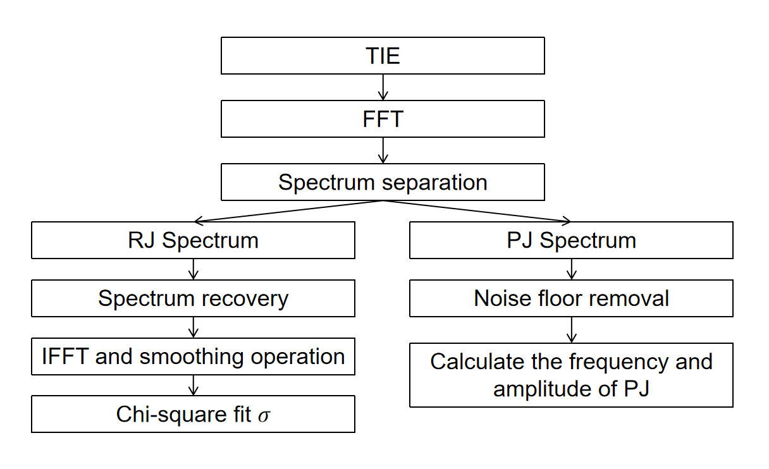
Fig.2 Improved algorithm flowchart
After separating the RJ and PJ spectra from the mixed spectrum of TJ jitter samples based on the 3σ threshold, the resulting RJ spectrum is obtained by directly eliminating the PJ spectral lines from the original spectrum, and thus lacks the inherent RJ amplitude values at the PJ frequency points. To maximize the accuracy of the decomposition results, spectral recovery is required to restore the original RJ spectrum as much as possible. The method adopted in this paper is interpolation recovery based on statistical characteristics: the mean amplitude of 10 local points around the missing frequency points is calculated to replace the amplitude values of the missing points, and the number of selected points can be flexibly adjusted according to the number of spectral points in practical decomposition. The recovered spectrum features more continuous frequency points and is closer to the original RJ spectrum, as shown in Fig. 3.

Fig 3. RJ Spectrum after Spectral Recovery
Similarly, since RJ resembles wide-frequency background noise and its frequency covers all frequency points, the amplitude of the separated PJ spectrum certainly overlaps with a small portion of the RJ amplitude, which also impairs the decomposition results of the PJ component amplitude. Thus, a preprocessing step of background noise removal is required: the amplitude of each PJ spectral line is subtracted by the amplitude of the RJ spectral line at the corresponding frequency position, where the RJ spectral line amplitude at the corresponding position is the estimated value calculated from the surrounding RJ spectrum in the previous spectral recovery step. The PJ spectrum after background noise removal is less affected by RJ and has more accurate amplitude values. Subsequently, consistent with the traditional algorithm, the amplitude of the PJ component is derived from the twofold mapping relationship between the spectral amplitude and the PJ amplitude, and the corresponding frequency point is read from the horizontal coordinate, thereby completing the decomposition of the PJ component.
The RJ spectrum after spectral recovery is subjected to an IFFT transform to convert it back into a time-domain form with an approximate Gaussian distribution. At this point, the PDF histogram of the RJ spectrum exhibits rough zigzag fluctuations in local regions and cannot be directly used for fitting, thus requiring prior smoothing. The smoothing scheme adopted in this paper is a 5th-order mean filtering scheme, whose principle can be intuitively expressed by the following equation:
$y(k)=\frac{1}{2r+1}\sum_{n=k−r}^{k+r}{x(n)}$ (6)
where y(k) is the smoothed value, x(n) the unsmoothed value, and r the smoothing order. The PDF histogram after smoothing eliminates rough zigzag fluctuations, enabling the subsequent fitting operation. Fitting is divided into first-order fitting and second-order fitting; both are based on the evaluation criteria of the chi-square test, yet adopt slightly different fitting approaches.
First-order fitting is a preliminary fitting method that can quickly determine the approximate range of the RJ standard deviation, which is considered for the timeliness of the algorithm. Based on the initially determined σ value from the previous separation of the PJ and RJ spectra, the fitting range is expanded by 50% on both sides, and the fitting step size is set to 5% of the fitting range. Since RJ is modeled as a zero-mean Gaussian distribution, the mean value is always zero. After determining the fitting range and step size, all possible σ values are traversed at the set step size, with the chi-square test adopted as the evaluation criterion. The calculation formula is given by:
$χ^{2}=\sum_{i=1}^{N}{\frac{{(x_{i}−E_{i})}^{2}}{E_{i}}}$ (7)
where ${\text{χ}}^{\text{2}}$ is the chi-square statistic, N the number of groups of observed data, i the index of the data groups, ${\text{x}}_{\text{i}}$ the actual observed value of the i-th group, and Eᵢ the theoretical expected value of the i-th group. A smaller chi-square value indicates a better fit between the fitting function and the samples, and the σ value corresponding to the minimum chi-square value is selected as the final fitting result. The flow chart for the first-order fitting operation is shown in Fig. 4.
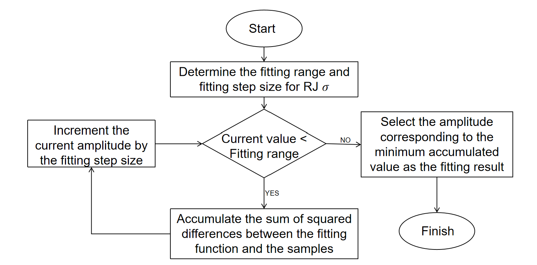
Fig 4. First-order fitting flowchart
Second-order fitting is a precise fitting method, designed to improve the accuracy of the algorithm. Taking the σ value obtained from first-order fitting as the fitting centre, second-order fitting expands the step size by 5% to both sides to derive two extended values. It is only necessary to calculate the chi-square values of these two extended values on either side, and select the σ value corresponding to the smaller chi-square value as the new fitting centre. The expansion step size is then reduced by a factor of 0.2% in each iteration, causing the two end points on either side to converge progressively towards the centre, until the expansion step size reaches the preset minimum step size of 0.001%. Owing to the dynamic reduction of the step size, second-order fitting achieves higher precision than first-order fitting. The flow chart for the second-order fitting operation is shown in Fig. 5.
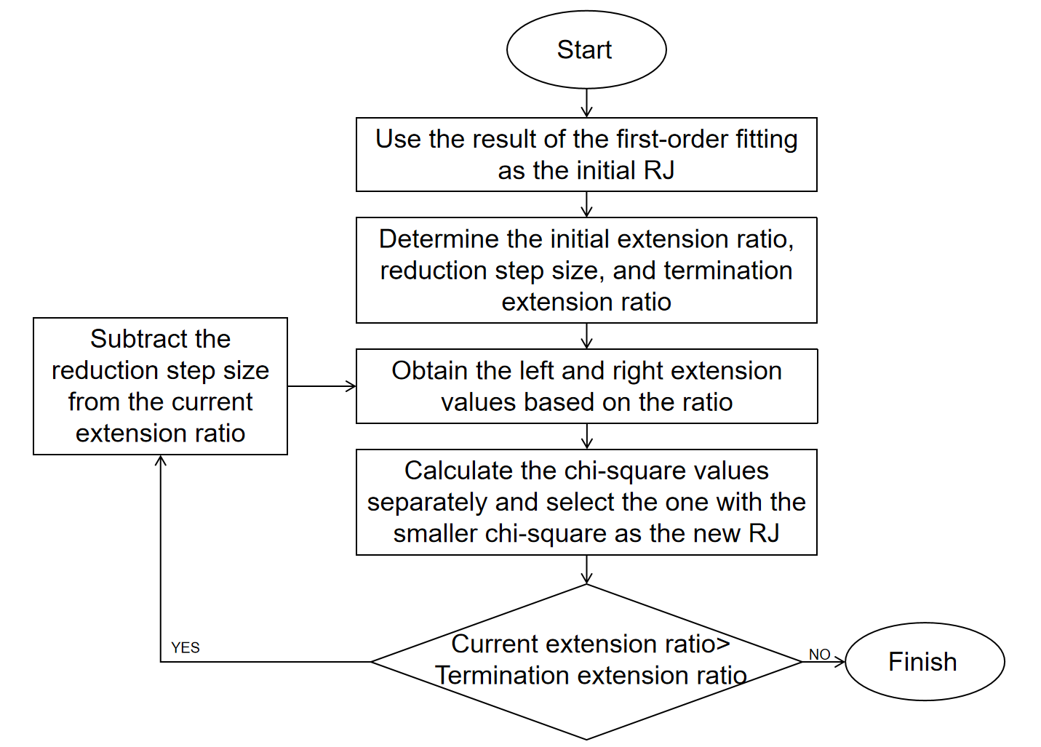
Fig 5. Second-order fitting flowchart
Fig. 6 shows the final fitting results. It can be seen that the fitted Gaussian distribution curve matches well with the PDF histogram of the RJ samples after IFFT, and the information of the RJ components can be effectively extracted from the samples.

Fig 6. Fitting Result Plot
3 Results
To verify the effectiveness of the improved algorithm, simulation experiments are designed for the algorithm’s accuracy in this paper to compare the jitter decomposition accuracy of the traditional and improved algorithms. The data used in the experiments is simulated TIE data generated by superimposing a sine wave on Gaussian noise, which is a type of jitter that mainly reflects the jitter edges of signals [15]. The number of samples exerts a significant influence on the accuracy of jitter decomposition algorithms; thus, the experiments will vary the number of sample points to investigate the jitter decomposition performance of the two algorithms under different conditions.
Experimental sample parameters: RJ standard deviation σ = 5 ps, PJ amplitude P = 3 ps, frequency f = 6 MHz, PJ2 amplitude ${\text{P}}_{\text{2}}$ = 5 ps, frequency ${\text{f}}_{\text{2}}$ = 3 MHz. TIE sample frequency ${\text{f}}_{\text{s}}$ = 30 MHz.
Table 1 Accuracy test result
 | FFT |  |  |  |  | Improved FFT
Sample size | $σ$/ps | P/ps | f/MHz | $P_{2}$/ps | $f_{2}$/MHz | $σ$/ps | P/ps | f/MHz | $P_{2}$/ps | $f_{2}$/MHz
500 | 3.82 | 3.29 | 6.00 | 5.43 | 3.00 | 5.27 | 3.33 | 6.00 | 5.36 | 3.03
1000 | 5.79 | 2.88 | 6.01 | 5.12 | 3.00 | 5.15 | 2.90 | 6.00 | 4.91 | 3.00
2000 | 4.57 | 2.86 | 6.00 | 4.93 | 3.02 | 4.88 | 3.11 | 6.00 | 4.92 | 3.00
4000 | 5.55 | 3.05 | 6.00 | 5.10 | 3.00 | 5.09 | 2.93 | 5.98 | 5.07 | 2.99
8000 | 4.55 | 3.06 | 6.00 | 5.06 | 3.00 | 5.04 | 2.98 | 6.00 | 5.05 | 3.00

As shown in Table 1, since both algorithms separate frequency points directly from the spectrum obtained by FFT, they can both extract the jitter frequency information with high accuracy. An analysis of the PJ amplitudes decomposed by the two algorithms reveals that the improved FFT algorithm yields slightly more accurate results than the traditional one. This is because the background noise of the RJ spectrum itself has low energy, and eliminating such effects brings about a less pronounced improvement in PJ decomposition accuracy. Meanwhile, as can be seen from Fig. 7, the improved FFT jitter decomposition algorithm yields a significantly smaller RJ decomposition error across different numbers of sample points. This demonstrates that fitting makes fuller use of the information from jitter sample data compared with theoretical statistical calculation, leading to more accurate RJ decomposition. Under the sample point conditions tested in the experiments, the RJ error rate is reduced to approximately 1%–5%.

Fig 7. RJ Decomposition error rate bar chart

4 Conclusion
The traditional FFT jitter decomposition algorithm suffers from low accuracy in RJ decomposition. In this paper, the original algorithm is improved based on the chi-square fitting approach. Experimental results show that the improved algorithm achieves a significant enhancement in the accuracy of RJ decomposition results, which helps the FFT jitter decomposition algorithm become a better choice for practical jitter decomposition applications.
5 Acknowledgements
This work is supported by the National Key Research and Development Program of China (2022YFF0707104).
6 References
[1] Lv, Y.J.: 'Statistical Eye Diagram Analysis of High-Speed Links Under the Influence of Jitter and Crosstalk'. Master's thesis, Xidian University, Xi'an, China, 2023.
[2] Wang, Y.X., Su, T.: 'Waveform expansion method for measuring digital circuit jitter', Electronic Measurement Technology, 2022, 45, (5), pp.26–32.
[3] Pan, W., Gao, Z., Fang, S., et al.: 'A software error compensation method for equivalent-time sampling oscilloscopes'. Proc. Int. Symp. Test Autom. & Instrum. (ISTAI 2024), 2024.
[4] Wang, B.C.: 'Design of oscilloscope eye diagram and jitter analysis software'. Master's thesis, Xidian University, Xi'an, China, 2023.
[5] Chen, X.L., Gao, E.H., Liu, T.: 'A BER measurement-based method for constructing an eye diagram', Journal of Electronic Measurement and Instrumentation, 2024, 38, (3), pp.219–229.
[6] Ren, N.: 'Research on jitter decomposition technology for high-speed serial link signal'. Master's thesis, University of Electronic Science and Technology of China (UESTC), Chengdu, China, 2022.
[7] Jiao, L.Y.: 'Design of eye diagram and jitter analysis module for serial analyzer'. Master's thesis, University of Electronic Science and Technology of China (UESTC), Chengdu, China, 2024.
[8] Wu, T.: 'Research on key technologies of jitter in high-speed serial communication signals'. Master's thesis, University of Science and Technology of China, Hefei, China, 2023.
[9] Li, C.Y., Tian, S.L., Yang, K.J., et al.: 'Research on EMD-based anomaly signal capture method in high-speed data acquisition system', Chinese Journal of Scientific Instrument, 2024, 45, (12), pp.98–106.
[10] Ren, N., Fu, Z.M., Zhou, D.D., et al.: 'Jitter decomposition meets machine learning: 1D-convolutional neural network approach', IEEE Communications Letters, 2021, 25, (6), pp.1911–1915.
[11] Li, H., Wang, H.J., Xiao, L., et al.: 'Generation and implementation of high-speed parallel digital modulation signals', Chinese Journal of Scientific Instrument, 2023, 44, (2), pp.110–118.
[12] Ma, L.: 'Research on FFT-based jitter analysis and separation method'. Master's thesis, Xidian University, Xi'an, China, 2011.
[13] Lei, W.W.: 'Time and frequency domain analysis and research of jitter'. Master's thesis, University of Electronic Science and Technology of China (UESTC), Chengdu, China, 2021.
[14] Wu, W.J.: 'Jitter separation and analysis based on time and frequency domain'. Master's thesis, Xidian University, Xi'an, China, 2011.
[15] Yin, Z.Y.: 'High-speed serial data processing and analysis with equivalent-time sampling'. Master's thesis, North University of China (NUC), Taiyuan, China, 2024.

