Please write a module in a .c and a .h file format, which generates an output result in response to the varying input and output conditions as described in the graph below:

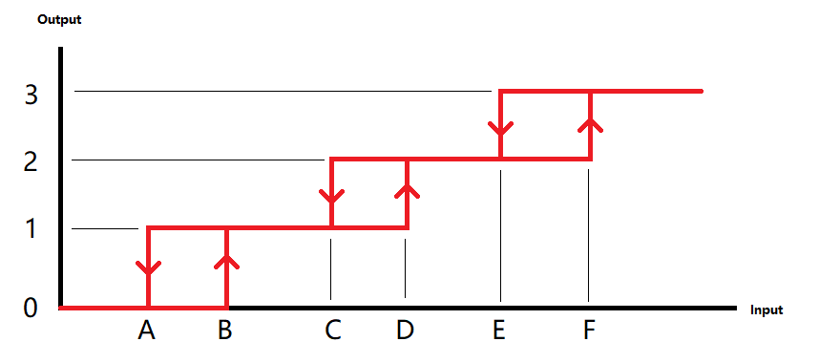

The outputs should only be 0-3.

The points A-F are configurations that are bound to be in the range of 0-1000.

All input, output and points A-F are integers.

I.e. When the current state is 2 and the new input is between point B and point C, the new output state should be 1.

When the current state is 2 and the new input is less than A, the new output state should be 0.

The module should contain at least a function that takes one integer input and output an integer.