SMART BUS TRACKING SYSTEM

A Service-Oriented Approach
Service Oriented Architecture - Final Project Paper
Student(s) | Era Sela,Diellza Jusufi
Course | Service Oriented Architecture
Institution | South East European University
Academic Year | 2025 / 2026
Submission Date | 11 June 2026
GitHub Repository | https://github.com/EraSela/BusTrackingSystem-SOA

Abstract
This project presents the design and implementation of a smart bus tracking and reservation system using a service-oriented architecture. It addresses uncertainty about bus locations and arrival times, manual or unreliable seat reservation processes, and limited communication between passengers, drivers, and administrators. The solution combines an ASP.NET Core 8 Web API, a React and Vite client, PostgreSQL, Entity Framework Core, JWT authentication, and GPS data supplied by a SIM808-compatible tracking device. The backend is divided into controllers, services, repositories, DTOs, entities, and mapping components. It supports role-based access for Passenger, Driver, and Admin accounts; trip-centered scheduling; route and driver assignment; seat reservations with database-level duplicate prevention; QR-code check-in; live and historical bus positions; pickup ETA calculation; and automatic delay and pickup notifications. The API is documented with Swagger and includes Docker and Render deployment configuration. Fifteen xUnit tests cover important controller, service, and repository behavior. The resulting system demonstrates how service-oriented principles, dependency injection, clear contracts, and layered responsibilities can produce a maintainable transportation platform with useful real-time behavior.

1. Introduction

1.1 Background and Motivation
Public transportation is essential for travel between cities and regions, but passengers often receive limited information about vehicle location, expected arrival, seat availability, and reservation status. Transport operators also need a reliable way to assign buses, routes, drivers, and GPS devices to scheduled journeys. The project was motivated by the opportunity to combine these functions in one secure platform rather than treating tracking and reservation as separate systems.
The Bus Tracking System uses a browser-based client and a REST API to connect passengers, drivers, administrators, and GPS hardware. Passengers can reserve a seat for a specific trip and pickup point, monitor live positions, obtain an ETA, and receive notifications. Drivers manage only their assigned trips and validate passenger QR codes. Administrators manage users, buses, trips, and operational history.

1.2 Problem Statement
- Passengers lack dependable real-time information about active buses and pickup arrival times.
- Seat reservations require concurrency-safe duplicate prevention for each scheduled trip.
- Buses, drivers, routes, and GPS devices must not be assigned to overlapping trips.
- Different user roles need separate permissions for management, reservations, tracking, and verification.

1.3 Project Objectives
- Implement JWT authentication with Passenger, Driver, and Admin authorization.
- Provide REST endpoints for users, buses, routes, trips, reservations, locations, notifications, and GPS ingestion.
- Associate every GPS location with the active trip identified by a device ID.
- Prevent duplicate seat reservations and support QR-based passenger check-in.
- Calculate pickup ETA and create delay or proximity notifications.
- Test critical controller, service, and repository behavior.

2. Related Work

2.1 Existing Solutions
Google Maps Transit provides route planning and, where agency data is available, real-time departure information. Moovit and Transit provide similar passenger-oriented route, alert, and vehicle information across many locations. These applications have broad coverage and polished interfaces, but they depend on external agency feeds and do not provide a custom operational backend for one transport provider's buses, drivers, seat inventory, QR verification, and GPS device assignment.

2.2 Novelty of the Approach
This project combines transport administration, trip scheduling, passenger reservations, hardware GPS ingestion, live mapping, ETA calculation, QR validation, and notifications in one application. GPS records are accepted only when the supplied DeviceId belongs to an active trip. Reservations are tied to a specific trip rather than only a bus or date, and a unique database index prevents the same seat from being assigned twice on that trip. The service layer also rejects overlapping assignments for buses, drivers, and GPS devices.

3. Tools and Technologies
Category | Technology / Version
Backend | ASP.NET Core Web API, .NET 8
Database | PostgreSQL
ORM | Entity Framework Core 8.0.26; Npgsql 8.0.11
Authentication | JWT Bearer tokens; BCrypt password hashing
Mapping / API docs | AutoMapper 12; Swagger / Swashbuckle 8.1.4
Frontend | React 19.2.5; Vite 8; React Router; Axios
Map / UI | Leaflet, React Leaflet, Tailwind CSS
Testing | xUnit 2.5.3; Moq 4.20.72; EF Core InMemory
Cloud | Render for the API and PostgreSQL; Vercel for the frontend
Version control | Git and GitHub
Development tools | Visual Studio 2022, VS Code, Swagger UI

3.1 Architecture Overview
The React client sends HTTP requests to ASP.NET Core controllers. Controllers expose the API contract and delegate application rules to services. Services coordinate validation, authorization based on JWT claims, calculations, and repository operations. Repository interfaces isolate Entity Framework Core queries and PostgreSQL persistence. AutoMapper converts between entities and DTOs, while dependency injection in Program.cs connects each interface to its implementation.
Request flow: React Client -> REST Controller -> Service -> Repository -> Entity Framework Core -> PostgreSQL. GPS hardware follows a second entry path through POST /api/gps/receive, after which the same service and repository layers associate the reading with an active trip.

4. System Design

4.1 Entity-Relationship Diagram
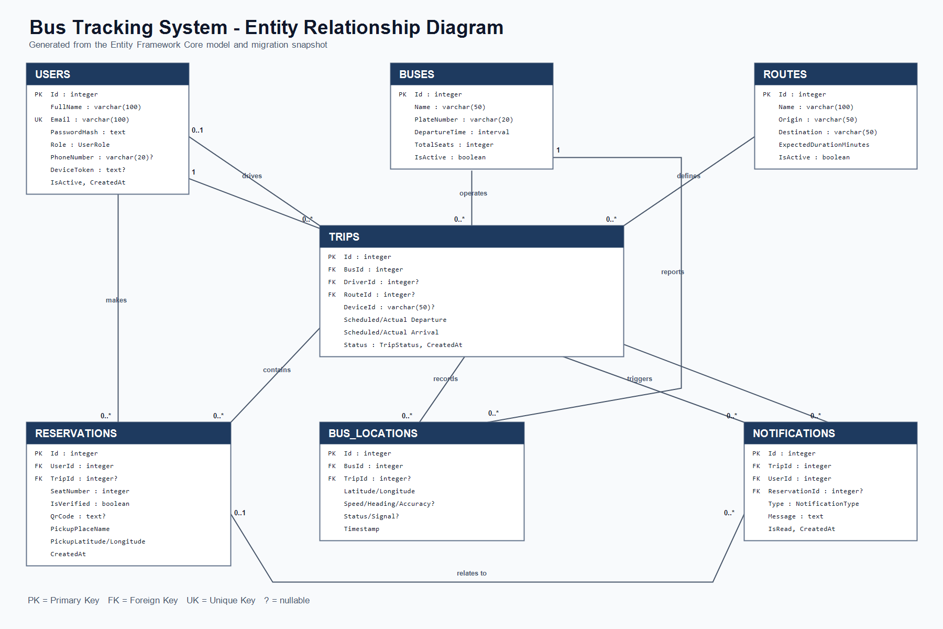
The database contains Users, Buses, Routes, Trips, Reservations, BusLocations, and Notifications. A bus has many trips and location records. A route can define many trips, while each trip may have one assigned driver. A user can make many reservations and a trip can contain many reservations. The Reservations table references TripId, not BusId; the bus is reached through Trip. Bus locations require a bus and may reference a trip. Notifications require a user and trip and may reference a reservation. Users.Email is unique, and the pair (TripId, SeatNumber) is unique when TripId is present.

4.2 User Interface
The React application contains login and registration pages, a live Leaflet map, trip and reservation pages, passenger notifications, QR verification, admin bus management, admin user management, and informational pages. Client-side protected routes check token validity, while the backend remains the authoritative authorization layer.

5. Implementation

5.1 API Endpoints
Method | Route | Access | Purpose
POST | /api/auth/register | Public | Register a Passenger account
POST | /api/auth/login | Public | Authenticate and return a JWT
GET | /api/users | Admin | List users
GET | /api/users/{id} | Admin | Get one user
POST | /api/users | Admin | Create a user with an assigned role
PUT | /api/users/{id} | Admin | Update a user
DELETE | /api/users/{id} | Admin | Delete a user
GET | /api/buses | Passenger/Driver/Admin | List buses
GET | /api/buses/{id} | Passenger/Driver/Admin | Get one bus
POST | /api/buses | Admin | Create a bus
PUT | /api/buses/{id} | Admin | Update a bus
DELETE | /api/buses/{id} | Admin | Delete a bus
GET | /api/routes | Authenticated | List active routes
GET | /api/trips | Passenger/Driver/Admin | List visible trips; drivers see assigned trips
GET | /api/trips/{id} | Passenger/Driver/Admin | Get one visible trip
GET | /api/trips/bus/{busId} | Passenger/Driver/Admin | List trips for a bus
GET | /api/trips/bus/{busId}/active | Passenger/Driver/Admin | Get the bus's active trip
GET | /api/trips/completed | Admin | List completed trips
POST | /api/trips | Admin | Schedule a trip
PUT | /api/trips/{id}/status | Assigned Driver/Admin | Start, complete, or cancel a trip
DELETE | /api/trips/{id} | Admin | Delete a trip
GET | /api/reservations | Admin | List all reservations
GET | /api/reservations/my | Passenger | List the current passenger's reservations
GET | /api/reservations/{id} | Owner/Admin | Get a reservation
POST | /api/reservations | Passenger | Reserve a seat and generate a QR code
DELETE | /api/reservations/{id} | Owner/Admin | Delete a reservation
GET | /api/reservations/qr/{qrCode} | Assigned Driver/Admin | Read an active-trip reservation by QR
POST | /api/reservations/verify | Assigned Driver/Admin | Check in a passenger by QR
GET | /api/notifications | Admin | List all notifications
GET | /api/notifications/my | Passenger | List the current passenger's notifications
PUT | /api/notifications/{id}/read | Passenger owner | Mark a notification as read
GET | /api/locations/{busId} | Driver/Admin | List locations for a bus
GET | /api/locations/latest/{busId} | Passenger/Driver/Admin | Get the latest bus location
GET | /api/locations/live | Passenger/Driver/Admin | List current live bus locations
GET | /api/locations/history/{busId}?from=&to= | Admin | Get location history for a date range
GET | /api/locations/eta/reservation/{reservationId} | Reservation owner/Admin | Calculate ETA to the pickup point
POST | /api/gps/receive | Public device endpoint | Receive and validate a GPS reading

5.2 Authentication and Authorization
Registration hashes passwords with BCrypt and always creates a Passenger account. Administrative user creation is handled separately by the protected users endpoint. Login verifies the password and account status, then issues an HMAC-SHA256 JWT valid for eight hours. The token contains the user's ID, name, email, and role. ASP.NET Core validates issuer, audience, expiration, and signature. Protected requests send the token as Authorization: Bearer <token>.
Role attributes protect controller actions, and services add ownership rules that attributes alone cannot express. For example, passengers can access only their own reservations and ETA values, drivers can manage only trips assigned to them, and QR verification is restricted to the assigned driver or an administrator.

5.3 Business Logic Highlights
- Trip scheduling validates an active bus, active Driver account, active route, and non-empty GPS DeviceId.
- ScheduledArrival is calculated from ScheduledDeparture plus the route's ExpectedDurationMinutes.
- Bus, driver, and GPS device assignments are rejected when their scheduled time ranges overlap.
- Trip transitions are limited to valid state changes among Scheduled, Delayed, InProgress, Completed, and Cancelled.
- A departure more than five minutes late marks the trip Delayed and generates one delay notification per reservation.
- Reservation creation validates trip status, departure time, bus availability, seat range, and trip-seat uniqueness before generating a GUID QR code.
- GPS readings are validated and stored only when DeviceId identifies an InProgress or Delayed trip.
- Distance is calculated with geographic coordinates; ETA uses the latest reading and measured or fallback speed.
- PickupTenMinutesAway and PickupAlreadyPassed notifications are de-duplicated by trip, user, reservation, and type.

5.4 Repository Layer
Repository interfaces and implementations exist for User, Bus, Route, Trip, Reservation, BusLocation, and Notification. Services depend on these interfaces and are registered with scoped lifetimes in Program.cs. Entity Framework Core repositories use eager loading where DTOs or rules require related users, buses, routes, trips, or reservations. This separation makes service tests mockable and repository queries independently testable with EF Core InMemory.

5.5 Unit Testing
The test project contains 15 xUnit tests across ReservationServiceTests, ReservationRepositoryTests, TripServiceTests, BusLocationServiceTests, BusLocationRepositoryTests, and ControllerTests. Moq isolates services and controllers; EF Core InMemory tests repository behavior. Covered scenarios include successful and duplicate reservations, QR verification, trip arrival calculation and resource assignment, driver-specific trip visibility, trip start transitions, GPS processing with and without an active trip, location persistence and ordering, and controller responses.
Verification on 11 June 2026 completed successfully: 15 tests passed, 0 failed, and 0 were skipped. The test run also produced build warnings for nullable-reference analysis and mixed Entity Framework Core relational package versions; these do not currently fail the suite but should be cleaned up.

6. Deployment and DevOps

6.1 Render and Vercel Deployment
The backend is prepared for Docker deployment on Render through the root render.yaml Blueprint. The Blueprint creates a free web service and PostgreSQL database in Frankfurt, generates a JWT secret, supplies the private database URL, checks /health, and applies Entity Framework migrations when the API starts. The React/Vite frontend is prepared for Vercel with a production API environment variable and an SPA rewrite for React Router. Secrets are supplied by the hosting platforms rather than committed to source control.

6.2 CI/CD Pipeline
The repository contains .github/workflows/ci.yml. On pushes and pull requests to main, GitHub Actions restores, builds, and tests the .NET solution, then installs, lints, and builds the React frontend. Render is configured with autoDeployTrigger: checksPass so the API deploys only after GitHub checks pass. Vercel automatically builds and deploys the frontend from the main branch.

6.3 Live Application URL
Backend deployment target: Render. The final onrender.com URL is generated when the Blueprint is created.
Frontend deployment target: Vercel. VITE_API_BASE_URL must be set to the Render API URL followed by /api; the final vercel.app URL is generated during deployment.

7. GitHub and Team Collaboration

7.1 Repository Structure
Repository: https://github.com/EraSela/BusTrackingSystem-SOA
Path | Contents
/BusTrackingAPI/BusTrackingAPI | ASP.NET Core API, controllers, services, repositories, DTOs, entities, mappings, middleware, migrations, and configuration
/BusTrackingAPI/BusTrackingAPI.Tests | xUnit service, repository, and controller tests
/bus-tracking-frontend/bus-tracking-frontend | React/Vite client, pages, components, authentication utilities, API client, assets, and Leaflet map
/docs | Project paper and ER diagram

7.2 Team Contribution
Team Member | Responsibilities | Contribution
Era Sela | Backend API, database model, authentication, authorization, trip and reservation rules, GPS/SIM808 processing, tests, Swagger, Render backend deployment, integration | 50%
Diellza Jusufi | React frontend, navigation and role-aware views, reservation and notification UI, map and trip pages, admin pages, frontend testing, documentation and presentation support | 50%

8. Discussion

8.1 Does the System Solve the Problem?
The implementation addresses the identified problems at the application level. Live and latest location endpoints reduce uncertainty about active buses. ETA is calculated for a passenger's own pickup point from recent trip GPS data. A trip-seat unique index and service validation prevent duplicate seat assignment. Administrators manage operational data, drivers see and update only assigned trips, and passengers own their reservations and notifications. GPS data is not accepted without a matching active trip, which keeps tracking records connected to a valid journey.

8.2 Challenges and Solutions
The main integration challenge was associating a hardware DeviceId with the correct journey. The solution was to assign the device when scheduling a trip and accept GPS records only for an active trip with that identifier. PostgreSQL timestamp handling required UTC normalization, so service methods convert scheduling and status times to UTC. Concurrent seat booking required more than an application check; the database unique index provides a final guarantee. Testing different layers required separate approaches, using Moq for isolated business behavior and EF Core InMemory for query and persistence behavior.

9. Conclusion and Future Work

9.1 Conclusion
The project delivers a service-oriented bus tracking and reservation platform with secure role-based access, trip-centered scheduling, route and resource assignment, live GPS ingestion, seat reservations, QR check-in, ETA calculation, passenger notifications, and automated tests. Its layered organization keeps HTTP concerns, business rules, persistence, and transfer models separate, making the codebase easier to test and extend.

9.2 Limitations
- The GPS ingestion endpoint is anonymous and identifies devices only by DeviceId; production use should add device authentication or signed requests.
- The final Render and Vercel URLs are assigned during account setup and therefore cannot be recorded until the first deployments complete.
- Free Render services can sleep when inactive, and the free PostgreSQL database is temporary.
- ETA uses straight-line distance and current or fallback speed rather than road routing and traffic.
- The API uses AllowAll CORS and should use an explicit production origin policy.

9.3 Future Work
- Add authenticated GPS devices and rate limiting for the receive endpoint.
- Introduce road-network and traffic-aware ETA calculation.
- Add email, SMS, or push delivery for stored notifications.
- Extend the GitHub Actions pipeline with deployment smoke tests and dependency scanning.
- Deploy the frontend with environment-specific API configuration.
- Add online payments, analytics, route stops, and operational dashboards.

10. References
Microsoft. ASP.NET Core documentation. https://learn.microsoft.com/aspnet/core/
Microsoft. Entity Framework Core documentation. https://learn.microsoft.com/ef/core/
Microsoft. Authentication and authorization in ASP.NET Core. https://learn.microsoft.com/aspnet/core/security/
Render. Render documentation. https://render.com/docs/ Vercel. Vercel documentation. https://vercel.com/docs/
PostgreSQL Global Development Group. PostgreSQL documentation. https://www.postgresql.org/docs/
React. React documentation. https://react.dev/
Vite. Vite documentation. https://vite.dev/
Leaflet. Leaflet documentation. https://leafletjs.com/
xUnit.net. xUnit documentation. https://xunit.net/
Moq. Moq repository. https://github.com/devlooped/moq

Appendix A - Main Enumerations and Constraints
- UserRole: Passenger, Driver, Admin.
- TripStatus: Scheduled, Delayed, InProgress, Completed, Cancelled.
- NotificationType: Delay, PickupTenMinutesAway, PickupAlreadyPassed.
- Unique constraints: Users.Email; Reservations(TripId, SeatNumber) when TripId is not null; Notifications(TripId, UserId, ReservationId, Type).
- Delete behavior: deleting a bus cascades to its trips and locations; deleting a user cascades to reservations and notifications; trip deletion is restricted by reservations and locations; deleting a reservation sets Notification.ReservationId to null.

