IN4343 – Lab 1

Casper van Wezel (4209192) & Erwin de Haan (4222814) – 2017-03-11

# Part 1

## Basic questions

1a. The timer frequency is 1024 Hz.

1b. The periods of the tasks are:

* BlinkYellow 1024
* BlinkGreen 512
* BlinkRed 0

2. The Yellow has highest priority (5). After that the Red task (4), and finally the green task (3).

3. The yellow and the green led are actually toggled (Port 5-6 and Port 5-5).

4. All interrupt handlers are equal when there is a same number of tasks, the more tasks there are the more work it needs to do. When a task is triggered, if also executes t->Taskf() (the task function) this can also take a variable time.

## Start-up behavior

5. The LED on Port 5 pin 6, probably Yellow, is changed first (to ON, after the init).

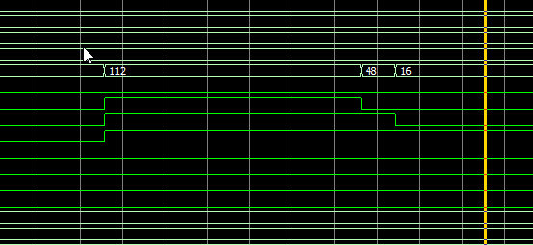

Yellow  
Green  
Red

6. The BlinkRed function is discarded, the E_WRONGPAR value is returned by RegisterTask. In my trace the BlinkGreen function is triggered after 1500ms, as seen in the interrupt numbers.

7. The execution does not fit in one Timer period.

8. There can be 32 pending interrupts (as per Table 7 of the manual), the lowest 16 addresses are accessible to regular program code. These are each a priority, higher address means higher prio. New interrupts that arrive will “overwrite” the pending interrupt bit, the manual is not clear as to whenever the ISR address is replaced or not.

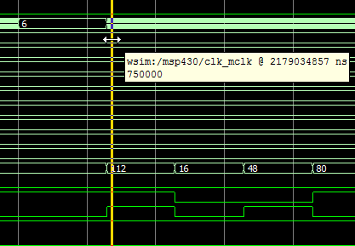

intr_num

Yellow  
Green  
Red

# Part 2

9. Yellow is changed first, due to the highest prio. (See 2.)

10. BlinkRed is indeed discarded.

11a. Startup takes 3.5 ms.

11b. All hardware systems need to be initialized, some flash data is copied to RAM.

12. Difference between the first two intr_num high parts is 0.577 ms – 0.455 ms = 0.122 ms.

13. The time used for an “empty” interrupt handler, is 0.455 ms. This means about 47% is spent on timer interrupt processing.

14a. The measured jitter (stddev) is 8.5 us. The maximum jitter is 26.3 us.

14b. The clock inaccuracies come from the executions of system functions.

15. The execution time of CountDelay(60000) is about 0.6398 seconds.

16a. In the wave forms it takes about 1213 us.

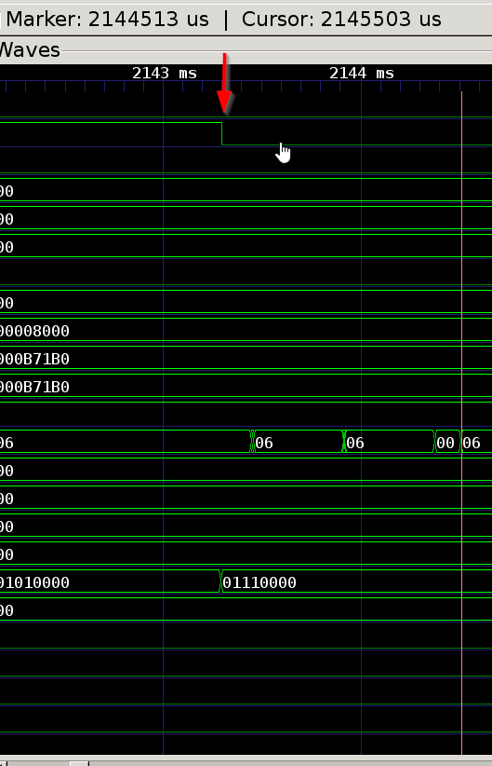

16b. That interrupt handler is delayed by almost 638 ms (That is the period of the CountDelay(60000) function and one extra period plus a tiny amount of time after the CountDelay execution.

17. C_ih> (n+1)*T_clk

18. About 654 interrupts are lost.