Calender Sheet
Student Selector:
=IFERROR(VLOOKUP($A$1, {ID2Name!B2:B, ID2Name!A2:A}, 2, FALSE), "")

Dates formatter:
=FILTER(Raw_Reciepts!B18:B, Raw_Reciepts!A18:A = $B$1)

Calender Generation:
=ARRAYFORMULA(
LET(
base, IFERROR(DATEVALUE($B$2), TODAY()),
first, DATE(YEAR(base), MONTH(base), 1),
offset, WEEKDAY(first,2)-1,
seq, SEQUENCE(6,7,1,1)-1,
daynum, seq - offset + 1,
IF((daynum<1)+(daynum>DAY(EOMONTH(first,0))),,
DATE(YEAR(first), MONTH(first), daynum)
)
)
)
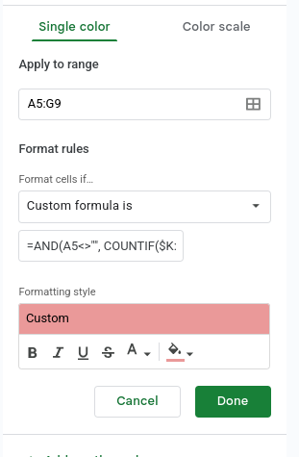
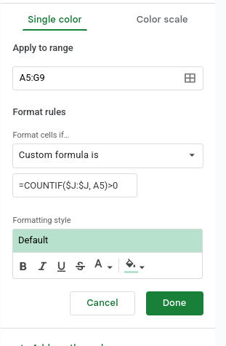

Generated Dates:

date generators:
={"Class Date";
LET(
start, DATEVALUE(Important_Dates!A2),
finish, DATEVALUE(Important_Dates!B2),
hol, IFERROR(FILTER(Important_Dates!C2:C, Important_Dates!C2:C>=start, Important_Dates!C2:C<=finish), ),
IF(OR(start="", finish=""), ,
ARRAYFORMULA(
WORKDAY.INTL(
start-1,
SEQUENCE( NETWORKDAYS.INTL(start, finish, "0000011", hol) ),
"0000011",
hol
)
)
)
)}

Data Analysis:
={"UID"; FILTER(ID2Name!A2:A, ID2Name!A2:A<>"")}
=ARRAYFORMULA({"Names"; IF(A2:A="", "", VLOOKUP(A2:A, ID2Name!A:B, 2, FALSE))})
=ARRAYFORMULA({"Days Missed"; IF(A2:A <> "", TODAY() - Generated_Dates!A2 + 1 - C2:C, "")})
=ARRAYFORMULA({"Number of Hours"; IF(A2:A <> "", SUMIF(Raw_Reciepts!A:A, A2:A, Raw_Reciepts!E:E), "")})
=ARRAYFORMULA({"Risk Percentage"; IF(A2:A <> "", 1- (E2:E/(TODAY() - Generated_Dates!A2 + 1)/6), "")})
=MEDIAN(E2:E)
=AVERAGE(E2:E)
=MAX(E2:E)

