Sang Pham

CS350 – Fall 2017 – Technology Plan

**Framework Selection:**

|  |  |  |  |  |
| --- | --- | --- | --- | --- |
|  | **Popularity** | **Future** | **Community** | **Expertise** |
| **ASP (.NET)** | *Market share on March 2017: 34%  Microsoft platform, a straight application framework, successful ventures, developed great websites. | -Web API  -Extremely scalable languages  -Fast development with pre-coded options  -Can be used to build AR/VR applications using Unity.  -Google joins .NET foundation.  -Cross platform of .NET -> .NET developers can build almost any kind of app they want. | -ASP.NET community is comprised of dedicated developers -> less support contributors that post or answer questions on forums.  -Mostly get supports from Microsoft community.  -Communities, forums are updated frequently. | -Paid Microsoft platform  -A challenge to work with ASP (.NET) framework, but more problem to solve, more fun. |
| **PHP** | *Market share on March 2017: 57%  The world most used and popular language on the Internet with millions of dedicated PHP web apps development companies. Developed great websites | -Extremely scalable languages  -Number of online support groups.  -Unable to predict PHP in the future because even though it ruled the market when there was no easier alternative. For example: one major problem of PHP is hosting websites. Regular shared web hosting services can host PHP out of the box but if using other languages, it is a must to buy dedicated server hosting – installing their own web server in business privately held server. | - MailChimp, Facebook are written in PHP  -Very large pool of developers that support its sources.  -Many forums receive post regularly | -Free open source platform  -Easy to find tutorials and quite understandable languages. |
| **C#** | -sibling of Visual Basic.NET. Stay in the top second 3 after Java, C, C++, rapidly growing fast.  -General purpose object-oriented programming language.  -Run on .NET framework.  -Seem easy to understand more than JAVA. | -can be written in any editor  -open source now  -compatible with Windows, Mac, and Linux OS.  -Can be used to build pretty any apps.  -Supports all IDEs  -Much more improvements.  -It’s still evolving | -quite several communities, forums, especially getting support from Microsoft community. | -more clean, easier to understand than other languages. Very useful to build app or website. |

Note: * Market share comparison between Ruby on Rails, ASP.NET, and PHP

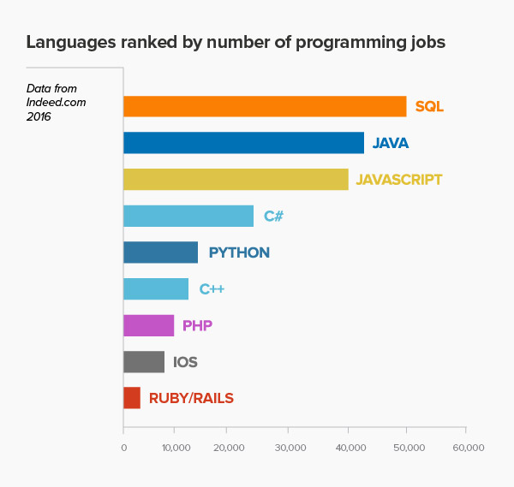

**Tools to Use:**

* IDE : ASP.NET
* Version control : Bitbucket/GitHub
* Programming language : C#
* Code libraries : .NET framework
* Design tools : Visual Studio
* Hosting : localhost
* Testing framework : Web browsers

**Cost of Learning:**

|  |  |  |  |  |  |  |  |
| --- | --- | --- | --- | --- | --- | --- | --- |
|  | **ASP.NET** | **Bitbucket/GitHub** | **C#** | **.NET framework** | **Visual Studio** | **Localhost** | **Web browsers** |
| **Hours** | < 100 | >= 100 | >= 100 | < 100 | >= 100 | < 100 | >= 100 |
| **Tools Cost (Hours)** | +20 |  |  | +20 |  | +20 |  |
| **Hours Total** | +60 | | | | | | |