### Wpływ parametru uczenia na szybkość uczenia przy uczeniu wzorcami.

### Funkcja unipolarna

Liczba powtórzeń: 10 000

Zakres wag: (-1 ; 1)

|  |  |  |  |  |  |  |  |  |  |  |
| --- | --- | --- | --- | --- | --- | --- | --- | --- | --- | --- |
| Experiment | 1 | 2 | 3 | 4 | 5 | 6 | 7 | 8 | 9 | 10 |
| Learning rate | 0.1 | 0.2 | 0.3 | 0.4 | 0.5 | 0.6 | 0.7 | 0.8 | 0.9 | 1 |
| Epochs | 9 | 7 | 6 | 6 | 6 | 6 | 6 | 6 | 6 | 6 |

Liczba powtórzeń: 10 000

Zakres wag: (-1 ; 1)

|  |  |  |  |  |  |  |  |  |  |  |
| --- | --- | --- | --- | --- | --- | --- | --- | --- | --- | --- |
| Experiment | 1 | 2 | 3 | 4 | 5 | 6 | 7 | 8 | 9 | 10 |
| Learning rate | 0.1 | 1.1 | 2.1 | 3.1 | 4.1 | 5.1 | 6.1 | 7.1 | 8.1 | 9.1 |
| Epochs | 9 | 7 | 6 | 6 | 6 | 6 | 6 | 6 | 6 | 6 |

### Funkcja bipolarna

Liczba powtórzeń: 10 000

Zakres wag: (-1 ; 1)

|  |  |  |  |  |  |  |  |  |  |  |
| --- | --- | --- | --- | --- | --- | --- | --- | --- | --- | --- |
| Experiment | 1 | 2 | 3 | 4 | 5 | 6 | 7 | 8 | 9 | 10 |
| Learning rate | 0.1 | 0.2 | 0.3 | 0.4 | 0.5 | 0.6 | 0.7 | 0.8 | 0.9 | 1 |
| Epochs | 9 | 6 | 6 | 6 | 6 | 6 | 6 | 6 | 6 | 6 |

Liczba powtórzeń: 10 000

Zakres wag: (-1 ; 1)

|  |  |  |  |  |  |  |  |  |  |  |
| --- | --- | --- | --- | --- | --- | --- | --- | --- | --- | --- |
| Experiment | 1 | 2 | 3 | 4 | 5 | 6 | 7 | 8 | 9 | 10 |
| Learning rate | 0.1 | 1.1 | 2.1 | 3.1 | 4.1 | 5.1 | 6.1 | 7.1 | 8.1 | 9.1 |
| Epochs | 9 | 6 | 6 | 6 | 6 | 6 | 6 | 6 | 6 | 6 |

### Wpływ zakresu początkowych wag na szybkość uczenia przy uczeniu wzorcami.

### Funkcja unipolarna

Zakres: (-weight_limit ; weight_limit)

Liczba powtórzeń: 10 000

Parametr uczenia: 0.2

|  |  |  |  |  |  |  |  |  |  |  |
| --- | --- | --- | --- | --- | --- | --- | --- | --- | --- | --- |
| Experiment | 1 | 2 | 3 | 4 | 5 | 6 | 7 | 8 | 9 | 10 |
| Weight limit | 0.1 | 0.2 | 0.3 | 0.4 | 0.5 | 0.6 | 0.7 | 0.8 | 0.9 | 1 |
| Epochs | 6 | 6 | 6 | 6 | 6 | 6 | 6 | 6 | 6 | 6 |

Liczba powtórzeń: 10 000

Parametr uczenia: 0.2

|  |  |  |  |  |  |  |  |  |  |  |
| --- | --- | --- | --- | --- | --- | --- | --- | --- | --- | --- |
| Experiment | 1 | 2 | 3 | 4 | 5 | 6 | 7 | 8 | 9 | 10 |
| Weight limit | 0.1 | 1.1 | 2.1 | 3.1 | 4.1 | 5.1 | 6.1 | 7.1 | 8.1 | 9.1 |
| Epochs | 6 | 7 | 9 | 12 | 15 | 19 | 21 | 25 | 27 | 31 |

### Funkcja bipolarna

Zakres: (-weight_limit ; weight_limit)

Liczba powtórzeń: 10 000

Parametr uczenia: 0.2

|  |  |  |  |  |  |  |  |  |  |  |
| --- | --- | --- | --- | --- | --- | --- | --- | --- | --- | --- |
| Experiment | 1 | 2 | 3 | 4 | 5 | 6 | 7 | 8 | 9 | 10 |
| Weight limit | 0.1 | 0.2 | 0.3 | 0.4 | 0.5 | 0.6 | 0.7 | 0.8 | 0.9 | 1 |
| Epochs | 6 | 6 | 6 | 6 | 6 | 6 | 6 | 6 | 6 | 6 |

Liczba powtórzeń: 10 000

Parametr uczenia: 0.2

|  |  |  |  |  |  |  |  |  |  |  |
| --- | --- | --- | --- | --- | --- | --- | --- | --- | --- | --- |
| Experiment | 1 | 2 | 3 | 4 | 5 | 6 | 7 | 8 | 9 | 10 |
| Weight limit | 0.1 | 1.1 | 2.1 | 3.1 | 4.1 | 5.1 | 6.1 | 7.1 | 8.1 | 9.1 |
| Epochs | 6 | 6 | 6 | 6 | 6 | 6 | 7 | 7 | 8 | 9 |

## Adaline

### Uczenie

Liczba powtórzeń: 10 000

Zakres wag: (-1 ; 1)

|  |  |  |  |  |  |  |  |  |  |  |
| --- | --- | --- | --- | --- | --- | --- | --- | --- | --- | --- |
| Experiment | 1 | 2 | 3 | 4 | 5 | 6 | 7 | 8 | 9 | 10 |
| Treshold | 0.1 | 0.2 | 0.3 | 0.4 | 0.5 | 0.6 | 0.7 | 0.8 | 0.9 | 1 |
| Epochs | 22 | 18 | 15 | 13 | 12 | 10 | 9 | 9 | 8 | 7 |

|  |  |
| --- | --- |
| Rysunek 1 – próg 1 | Rysunek 2 - próg 0.5 |
| Rysunek 3 - próg 0.25 | Rysunek 4 - próg 0.1 |

Najlepsza uzyskana prosta dla Adaline

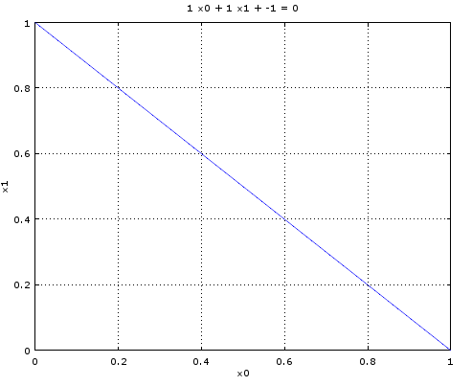

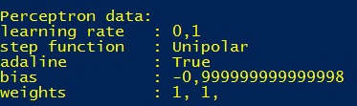

W niedużym przybliżeniu jest to idealne odwzorowanie funkcji