AIR UNIVERSITY ISLAMABAD
AI Project Design and Development (AI-316)
Lab 01: Foundations of AI Engineering & Project Setup
Name: Eraj Jamil
Roll No: 231208
Lab Instructor: Farhan Zafar
GitHub Repository: https://github.com/erajjamil137/aipdd_lab01

Task 1: GitHub-Ready AI Repository Directory Structure Setup

Python setup script (setup_project.py)
from pathlib import Path

folders = [
"data/raw",
"data/processed",
"models",
"notebooks",
"src",
"configs",
"logs",
]

for f in folders:
p = Path(f)
p.mkdir(parents=True, exist_ok=True)
(p / ".gitkeep").touch() # lets Git track empty folders

gitignore = """# Python
__pycache__/
*.py[cod]
*.egg-info/
build/
dist/

# Jupyter Notebook checkpoints
.ipynb_checkpoints/

# Virtual environments
.venv/
venv/
aipdd_env/

# Binary model weights
*.pt
*.onnx
*.h5

# OS / editor files
.DS_Store
Thumbs.db
.vscode/
"""

Path(".gitignore").write_text(gitignore)
print("Project structure created.")

Script run and directory tree

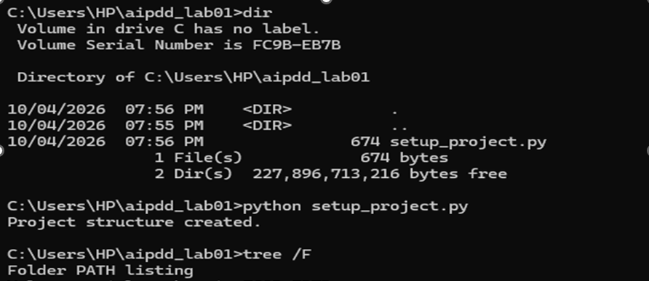Task 2: Virtual Environment Management & Package Pinning

Commands used
python -m venv aipdd_env
aipdd_env\Scripts\activate.bat
python -m pip install --upgrade pip
pip install numpy opencv-python matplotlib ultralytics jupyter
pip freeze > requirements.txt

requirements.txt
anyio==4.15.1
argon2-cffi==25.1.0
argon2-cffi-bindings==26.1.0
arrow==1.4.0
asttokens==3.0.2
async-lru==2.3.0
attrs==26.1.0
babel==2.18.0
beautifulsoup4==4.15.0
bleach==6.4.0
certifi==2026.7.22
cffi==2.1.1
charset-normalizer==3.5.2
colorama==0.4.6
comm==0.2.3
contourpy==1.4.0
cycler==0.12.1
debugpy==1.8.22
defusedxml==0.7.1
executing==2.2.1
fastjsonschema==2.22.2
filelock==4.0.10
fonttools==4.66.1
fqdn==1.6.0
fsspec==2026.9.0
h11==0.16.0
httpcore==1.0.9
httpx==0.28.1
idna==3.20
ipykernel==7.4.0
ipython==9.17.1
ipython_pygments_lexers==1.1.1
ipywidgets==8.1.9
isoduration==20.11.0
jedi==0.20.0
Jinja2==3.1.6
json5==0.15.0
jsonpointer==3.1.1
jsonschema==4.26.0
jsonschema-specifications==2025.9.1
jupyter==1.1.1
jupyter-console==6.6.3
jupyter-events==0.12.1
jupyter-lsp==2.3.1
jupyter_builder==1.2.3
jupyter_client==8.10.0
jupyter_core==5.9.1
jupyter_server==2.21.1
jupyter_server_terminals==0.5.4
jupyterlab==4.6.4
jupyterlab_pygments==0.3.0
jupyterlab_server==2.28.1
jupyterlab_widgets==3.0.17
kiwisolver==1.5.1
lark==1.3.1
MarkupSafe==3.0.4
matplotlib==3.11.2
matplotlib-inline==0.2.2
mistune==3.3.4
mpmath==1.3.0
nbclient==0.11.0
nbconvert==7.17.1
nbformat==5.11.1
nest-asyncio2==1.7.3
networkx==3.7
notebook==7.6.3
notebook_shim==0.2.4
numpy==2.5.3
nvidia-ml-py==13.615.71
opencv-python==5.0.0.93
packaging==26.3
pandocfilters==1.5.1
parso==0.8.7
pillow==12.3.0
platformdirs==4.12.3
polars==1.44.2
polars-runtime-32==1.44.2
prometheus_client==0.26.0
prompt_toolkit==3.0.53
psutil==7.2.2
pure_eval==0.2.4
pycparser==3.0
Pygments==2.21.0
pyparsing==3.3.3
python-dateutil==2.9.0.post0
python-json-logger==4.2.0
pywinpty==3.0.5
PyYAML==6.0.3
pyzmq==27.2.0
referencing==0.37.0
requests==2.34.2
rfc3339-validator==0.1.4
rfc3986-validator==0.1.1
rfc3987-syntax==1.1.0
rpds-py==2026.6.3
Send2Trash==2.1.0
setuptools==84.0.0
six==1.17.0
soupsieve==2.10
stack-data==0.6.3
sympy==1.14.0
terminado==0.18.1
tinycss2==1.5.1
torch==2.14.1
torchvision==0.29.1
tornado==6.5.10
traitlets==5.16.1
typing_extensions==4.16.0
tzdata==2026.5
ultralytics==8.4.172
ultralytics-platform==0.1.79
ultralytics-thop==2.2.2
uri-template==1.3.0
urllib3==2.8.0
wcwidth==0.9.1
webcolors==25.10.0
webencodings==0.6.1
websocket-client==1.9.2
widgetsnbextension==4.0.16

Task 3: Git Version Control Initialization & Branch Strategy

Commands used
git init -b main
git config user.name "Eraj Jamil"
git config user.email "YOUR_EMAIL@example.com"
git add .gitignore setup_project.py data models notebooks src configs logs
git commit -m "Initial commit: project structure and .gitignore"
git checkout -b feature/lab01-setup
git add requirements.txt
git commit -m "Add pinned requirements.txt"
git checkout main
git merge --no-ff feature/lab01-setup -m "Merge feature/lab01-setup into main"

git status and git branch
C:\Users\Eraj\aipdd_lab01>git status
On branch main
nothing to commit, working tree clean

C:\Users\Eraj\aipdd_lab01>git branch
feature/lab01-setup
* main

git log --oneline
C:\Users\Eraj\aipdd_lab01>git log --oneline
<hash> (HEAD -> main) Merge feature/lab01-setup into main
<hash> (feature/lab01-setup) Add pinned requirements.txt
<hash> Initial commit: project structure and .gitignore

Branch history (git log --oneline --graph --all)

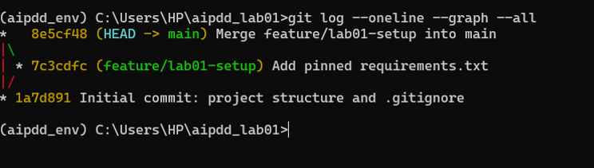

Task 4: Jupyter Environment Configuration & Interactive Notebook Setup

Active kernel: Python (aipdd_env)

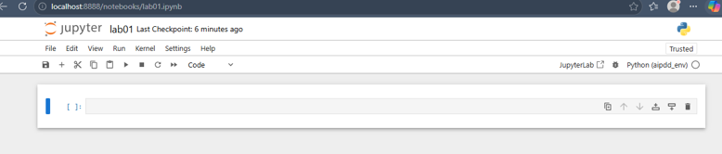Library imports and version printouts

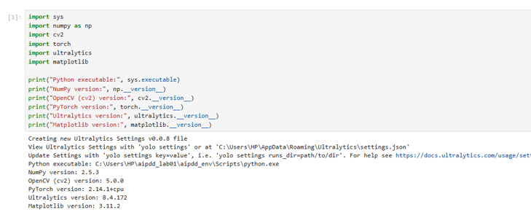

Task 5: Project Objectives & Requirements Documentation in Markdown
Rendered Markdown cover page in lab01.ipynb:
[Paste your screenshot of the rendered Markdown cell here]

