## Figure 1: Changing impermeant anion concentration sets local cell volume with changing electrical properties of the dendrite

To assess the impact of increased impermeant anion concentration in a dendritic compartment we employed a 9-compartment model linked with electrodiffusion. Between 120s and 240s, the concentration of impermeant anions ([X]) was increased at a fixed rate of xxx without changing the charge of impermeant anions. This manipulation only occurred in compartment 8, as shown in schematic 1.

Figure 1A shows the addition of impermeant anions in compartment 8, while impermeant charge was kept constant in all compartments (top left and top middle panes). The effect of adding impermeant anions resulted in compartment swelling as a result of the increased osmotic gradient across the membrane. The proportional volume increase was such as to equalize impermeant anion concentrations across all the compartments (seen in lower left heatmap).

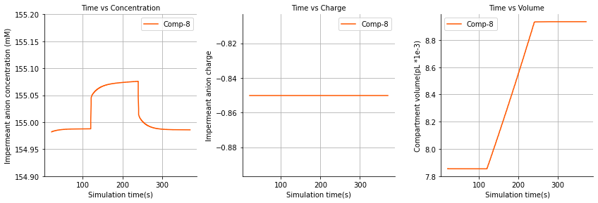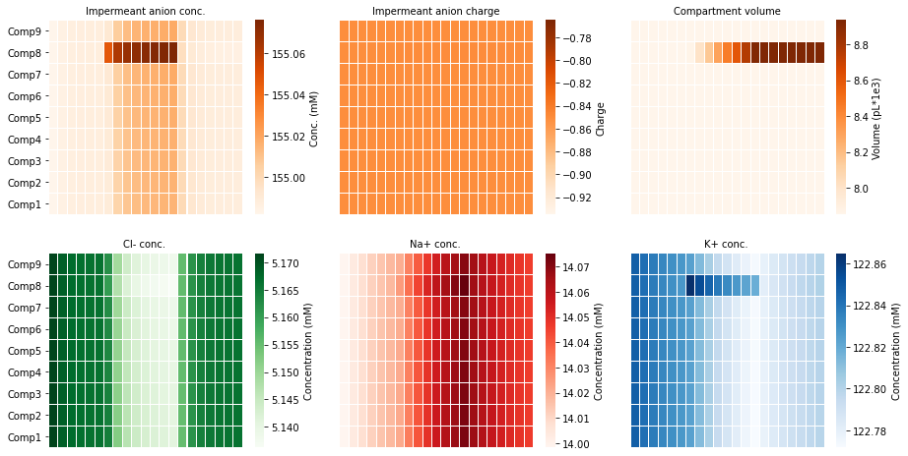

The concentrations of permeant ions (Cl, Na, K) were affected by the change in impermeant anion concentration (Figure 1B).

The concentration of impermeant anions in adjacent compartments also increased likely due to net changes related to other ions.

Figure 1A – Increased impermeant anion concentration in compartment 8 leads to local compartment swelling while other compartments remain unchanged.

Figure 1B – Increased impermeant anion concentration in compartment 8 leads to unchanged ionic driving forces and thus no change to the excitability of the dendrite.