**RESULTS #2**

A single simulation was isolated and examined closely to understand the biophysical changes occurring in a dendrite when impermeant anion charge is decreased. In the chosen simulation, a model with 9 identical cylindrical shaped compartments each connected along its longitudinal axis to adjacent compartments was used. Ion channel fluxes and membrane potential were scaled based on the ratio of compartment surface area to volume to reflect the changes that occur with cell swelling/shrinking. The multicompartment model was placed within an extracellular bath containing fixed ion concentrations, while electrodiffusion was employed to model ionic movement across the cell membrane as well as between compartments. Impermeant anion charge started at a baseline of z = - 0.85 in all compartments. In compartment 8 the impermeant anion charge was decreased to z = -1.25 in a linear fashion between 120s – 180s during the simulation (Fig. 2A). Note that absolute osmoles of impermeant anions were not changed in any of the compartments.

## 2.1 Local changes to impermeant anion charge (z) alters local compartment volume

Impermeant anion charge reduction in compartment 8 resulted in a local increase in intracellular tonicity. The osmotic difference between the intra-compartmental and extracellular space resulted in water flowing into the cell and a swelling of compartment. Unlike sodium, potassium, and chloride, impermeant anions could not move between adjacent compartments. This mass restricts the influx of water from dissipating throughout the multicompartment model. Due to the swelling of the cell the concentration of impermeant anions dropped proportionally in compartment 8 (Fig2A).

**Figure 2A: Impermeant anion charge alters local compartment volume with proportional changes to impermeant anion concentration**

**Left pane:** Impermeant anion charge was changed from z=-0.85 to z=-1.2 between 120s and 180s only in compartment 8.

**Middle and right pane:** Compartment 8 volume and impermeant anion concentration changes proportionally to the change in impermeant anion charge in compartment 8. No significant changes are seen in any other compartments.

## 2.2 Local changes to impermeant anion charge (z) create a non-isopotential neuron with no changes to ionic driving force

Reducing the impermeant anion charge from -0.85 to -1.25 led to a decrease in the membrane potential (Vm) of compartment 8 (Figure 3B). The ionic reversal potentials for chloride, sodium and potassium also shifted downwards in direct proportion to Vm. The proportional shift of both Vm and the ionic reversal potential results in a maintenance of the same ionic driving force throughout the duration of the simulation. Notably, the driving forces in compartment 8 were also identical to the driving forces in the other compartments. The implication thereof is that even though there is a local compartment along the dendrite with an altered membrane potential the excitability of the dendrite should theoretically be uniform across compartments.

The change in membrane voltage could be a result of a) changes in ratios of the net ionic sum (Na + K – Cl +zX); b) changes in the area scaling constant (Ar) which scales Vm based on the compartment volume to area ratio; or c) a combination of the above factors.

**Figure 2B: Impermeant anion charge sets local membrane potential, ionic reversal potential and ionic concentration without changing driving force. Area scaling is applied to the membrane potential.**

Impermeant anion charge was changed from z=-0.85 to z=-1.2 between 120s and 180s.

**Top row:** Membrane potential and ionic reversal potential shift permanently only in the compartment manipulated (compartment 8).

**Middle row:** No permanent change to the ionic driving forces as membrane and ionic potentials in manipulated compartment change in proportion to other compartments.

## 2.3 Local changes to impermeant anion charge (z) results in local changes to ionic concentrations

For a constant driving force to be maintained a proportional change to the ionic reversal potential is needed. Ionic reversal potential is determined by the ratio of intra-compartmental ionic concentration to extracellular concentration. Considering that the extracellular bath was held at constant concentration, the intracellular concentration of each ion had to change. In the top three panes of Figure 3D, it is shown that the concentrations of chloride, sodium, and potassium all shown permanent change respectively.

In the middle panes the transmembrane fluxes in compartment 8 and compartment 4 (manipulated versus non-manipulated compartments) were compared to identify if changes to the transmembrane were underpinning the concentrations changes seen for each ion. There appears to be a change in the amount being fluxed through individual channels in compartment 8, however the nett flux (the sum of the inward and outward flux) is balanced. The changes in ion flux across the membrane in compartment 8 were due to area scaling of the channel fluxes.

As there was no nett flux across the membrane changes to ion channels were not responsible for the concentration changes observed, instead changes between compartments (because of electrodiffusion) was likely causing the changes in ion concentration and ionic reversal potentials that allow for a constant ionic driving force. The lower panes of Figure 3D show how respective electrodiffusive changes during the manipulation of impermeant anions created concentration changes in compartment 8 which were not observed in other compartments. Once the charge of impermeant anions stabilized at -1.25, there was no further ionic flux between compartments and the system reached a steady state.

Ultimately, we have shown that electrodiffusion results in ionic microdomains where local impermeant anion charge is manipulated. This results in a non-isopotential neuron as the local membrane potential changes in a single compartment, while the ionic driving forces remain constant due to proportional changes to ionic reversal potentials that are established through the non-uniform ion flux between compartments.

**Figure 2C: Ionic concentration changes in compartment 8 are a result of electrodiffusive changes as opposed to transmembrane changes.**

Impermeant anion charge was changed from z=-0.85 to z=-1.2 between 120s and 180s only in compartment 8.

**Top row:** Ionic concentrations of chloride, sodium and potassium show permanent changes only in the compartment 8.

**Middle row:** Comparison between transmembrane fluxes of each ion in the manipulated compartment (coloured) versus a control compartment (black). The flux through each ion channel changes in compartment 8 however the nett (inward versus outward) flux remains constant.

**Bottom row:** Depiction of the electrodiffusive changes that occur during the simulation. In compartment 8 there is a change in ion flux coming into compartment 8 which is not occurring in the other compartments. This difference is likely underpinning the concentration changes that are observed.

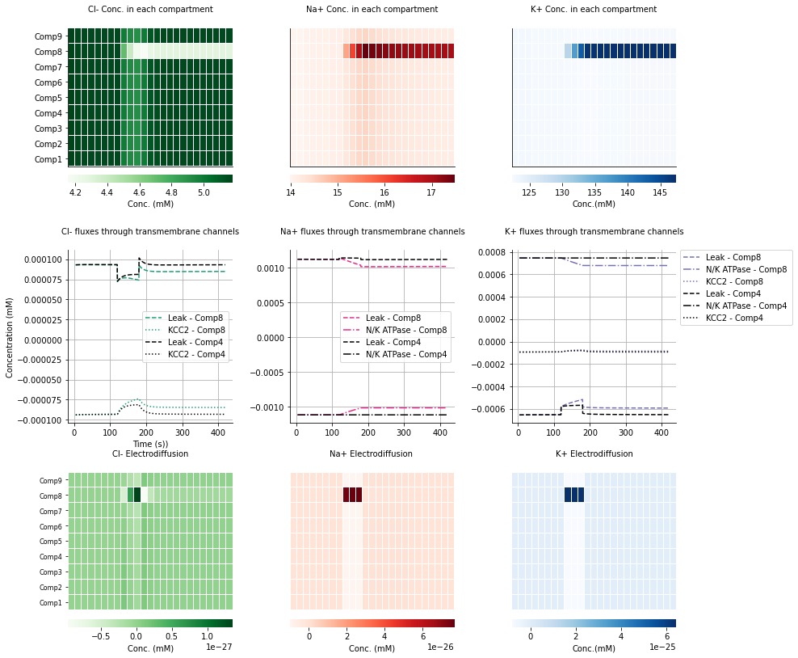

**SUPPLEMENTARY FIGURE WITH AREA SCALINGOFF**

**Figure 2C: Impermeant anion charge sets local membrane potential, ionic reversal potential and ionic concentration without changing driving force. Area scaling is not applied to the membrane potential.**

Impermeant anion charge was changed from z=-0.85 to z=-1.2 between 120s and 180s.

**Top row:** Membrane potential and ionic reversal potential shift permanently only in the compartment manipulated (compartment 8).

**Middle row:** No permanent change to the ionic driving forces as membrane and ionic potentials in manipulated compartment change in proportion to other compartments.

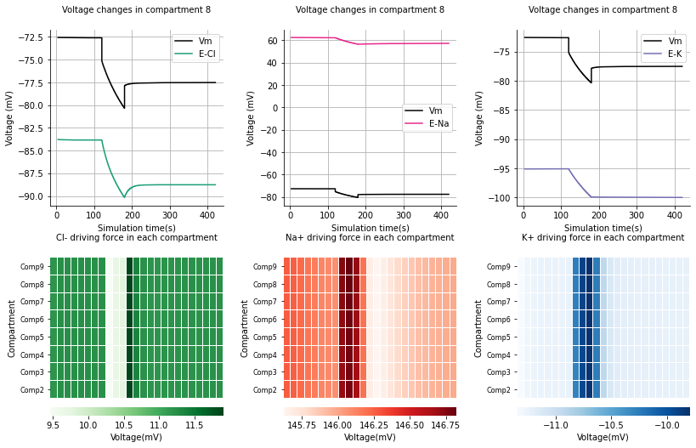

To discern whether the ionic sum or the area scaling were responsible for the changes to the reversal potential, the same experiment where z was changed from -0.85 to -1.25 in compartment 8 was performed however this time with area scaling not applied to the membrane potential (Fig3C). Clearly there were no differences in the membrane potentials of compartment 8 whether the area scale was present or not. This meant that changes to the ionic sum must be occurring to achieve changes in membrane potential that are proportional to the ionic reversal potentials in compartment 8.