Introduction

# Cellular architecture and electrical properties of neurons

## Building blocks of the brain

Neurons are the functional units of the brain. The 1012 neurons in the human nervous system act symphonically to process information that produces the cognitive functions humans are capable of.1 Neurons receive multiple inputs, integrate, transform them, and produce an output in the form of an electrical signal directed towards other neurons. Although there are a variety of neuronal morphologies, all neurons have a shared meta-structure which allows them to act as functional units (shown in schematic A below).

The soma (cell body), of the neuron contains the nucleus and surrounding cytoplasm that encases neuronal organelles. The synthesis of proteins and other macromolecules that act to provide structural and functional integrity occurs predominantly in the soma. Furthermore, the soma acts as a receptive area for synaptic inputs to the neuron.

Emerging from the soma are primary dendrites which have several distal arborizations with specific morphologies unique to certain neuronal populations (surface area, number of branches etc.).2 The proximal portion of the dendrite is a cytoplasmic extension of the soma with a similar density of endoplasmic reticula and ribosomes. As the dendrite branches further, the diameter of the dendritic branch narrows with lesser amounts of cellular organelles present. Moreover, dendritic spines (pedunculated cytoplasmic extensions along the length of dendrites) act as regions for predominantly excitatory input1 and early signal processing.

Should the summation of incoming inputs reach a threshold, the neuron fires an action potential down its axon. Unlike the soma and dendrite, axons do not have cellular organelles capable of synthesising macromolecules. The axon is narrow with a uniform diameter along its length that acts to transmit the output from the cell body towards other neurons. The axon from one neuron synapses onto the dendrite or soma of another forming the synapse, the microanatomical basis for signal transfer.

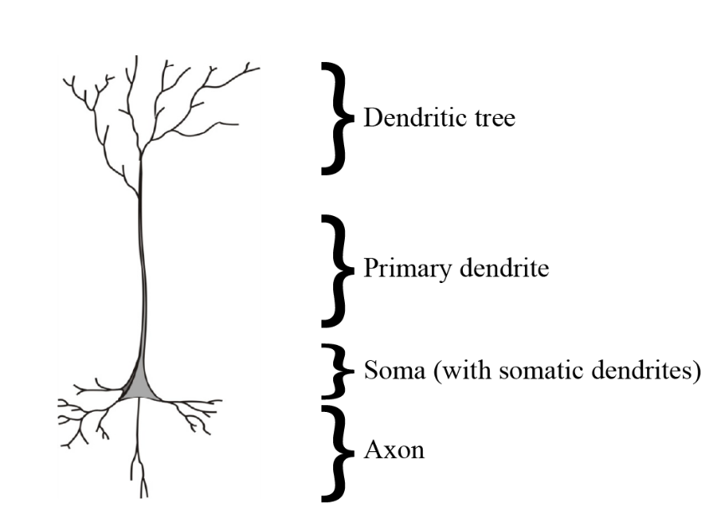

Schematic A – Structural elements of a neuron

## Neural signal propagation

Synapses are the interface between two communicating neurons where integration between chemical and electrical signals occur allowing for the flow of information. An activated pre-synaptic neuron will release chemical neurotransmitters into the synaptic cleft which bind to transmembrane receptor proteins on the post-synaptic neuron. This neurotransmitter-receptor interaction results in a conformational change to the receptor protein such that it can act as a channel for rapid ion flux between the extracellular environment and the neuron.

The magnitude and direction of ionic flux determines the effect of neurotransmission on the post-synaptic membrane. The ionic motion across the membrane can either cause an excitatory signal by increasing the membrane potential (depolarizing) or an inhibitory signal by decreasing the membrane potential (hyperpolarizing). Excitatory and inhibitory signalling is tightly controlled to provide precise neural communication. Understanding the homeostatic mechanisms regulating excitatory and inhibitory balance is critical as dysfunction in these mechanisms provide the basis for neurological disorders.

## Ionic homeostasis in neurons and the Nernst Potential

Ionic homeostasis is the ability for of cell to have stable ionic concentrations and adjust to external changes through self-regulating control mechanisms. Uniform ionic concentrations ensures that most neurons remain at rest, while only specific neurons are activated. Ionic homeostasis is maintained by a semipermeable cell membrane that acts as a gatekeeper for most ionic fluxes.

Ionic motion across a semipermeable membrane is governed by several forces. *Diffusion* refers to the movement of ions from a region of high ionic concentration to a region of low concentration. Water movement follows ionic flux across the membrane via *osmosis* such that the osmoneutrality is maintained. Lastly, *drift* is the flux of charged molecules that occurs due the local electrical field. These electrical forces set up electroneutrality across the membrane such that there is a balance of positive and negative charges on either side. The net flux of ions therefore is a combination of both chemical and electrical forces.

The *Nernst-Planck Equation* (NPE) (equation 1.1) is used to calculate the net flux for a particular ion. The equation makes use of the Einstein Relation which states that fluxes of diffusion and drift are additive in the same medium. Therefore, the NPE combines Ohm’s Law for Drift and Fick’s Law of Diffusion to calculate the net flux or current for a particular ion.

(1.1)

In (1.1), *I* is the current, *µ* the ionic mobility constant for a particular ion, *z* the valence of the ion, *NA* is Avogadro’s number, *F* is Faraday’s constant, [*C*] is the ionic concentration, *V* is the voltage, *x* is the distance between the potentials, *R* is the universal gas constant and *T* is the temperature. The negative sign in both terms indicate that the direction of current flow is opposite to the concentration/voltage gradients.

In steady state (resting) conditions, the net flux (*I*)for an ion is equal to zero. Therefore, equation (1.1) can be rearranged and solved for V, referred to as the *Nernst Equation* (1.2). The Nernst potential, also known as the equilibrium potential or reversal potential for a particular ion, is the voltage across the membrane (V*m*) at which the electrical forces balance the osmotic forces3.

(1.2)

In (1.2), *Eion* is the reversal potential for a particular ion, [*ion*]*o*is the concentration of the ion outside the membrane (extracellularly) and [*ion*]*i* is the intracellular ion concentration. The Nernst Equation provides the reversal potential for a single ion, however, cannot determine the potential of the entire membrane.

## Membrane potential and ionic driving forces

Two traditional ways have been used to calculate the resting membrane potential (V*m*), the “charge-sum” and “charge-difference” approach. The “charge-sum” approach entails setting the summation of the currents to equal zero (which becomes a differential equation that is solvable4. The solution however requires the initialization values to be known. The “charge-difference” method5 provides the same solution for Vm, without requiring initialization values, by utilizing the formula for capacitance (. Charge (*q*) is the difference between the extracellular and intracellular charges. A neuron existing in a neutral extracellular environment will have an extracellular charge of zero while the sum of the internal concentration and valences are required to calculate the intracellular charges by multiplying the net charge by Faraday’s constant (F) to convert mol to coulombs.

(1.3)

In the charge-difference equation, [*Na*+]*i* represents sodium concentration, [*K*+]*i* is the potassium concentration, [*Cl*-]*i* is the chloride concentration. [*X*-]*i* refers to the concentration of impermeant anions, with a valency of *z.*

The membrane potential (*Vm*)of a neuron at rest lies within the range of - 62 to - 75mV, indicating that the internal environment of the neuron contains more negative charges than the external environment. Concentration of ions also differ across the membrane as shown in table 1. The driving force (DF) of an ion is equal to the difference between the membrane potential and its equilibrium potential (*Vm* -*Eion*) and is the net force acting on the ion at rest. To calculate the ionic current for a particular ion (*Iion*) across the membrane due to its driving force Ohm’s law can be used (I = V/R), shown in equation (1.4).

The inverse of resistance (1/R), conductance (*gion*), is typically preferred in neuroscience as it intuitively relates to how easily an ion can cross the membrane. This is determined by the number and proportion of open ion channels at a given time. Altered membrane conductances to specific ions at discrete time intervals provides increasing complexity to neuronal dynamics and provides the basis for synaptic modelling. At rest neuronal membranes are highly permeable to K+ and Cl- and far less permeable to cations such as Na+ and Ca2+. The table below shows that ion concentrations do not equilibrate across the membrane at rest leading to a resting electrochemical gradient.

(1.4)

|  |  |  |  |
| --- | --- | --- | --- |
| Ion | Intracellular  concentration (mM) | Extracellular concentration  (mM) | Equilibrium  potential (Eion)  (mV) |
| Sodium (Na+) | 5-15 | 145 | 90.7 - 61.1 |
| Potassium (K+) | 140 | 5 | - 89.7 |
| Chloride (Cl-) | 4 | 110 | - 89 |

## Maintenance of membrane potential and cell volume

Neurons create an electrochemical gradient to establish a non-zero resting membrane potential required for current flow. This is achieved by two main mechanisms, active transport and the Donnan equilibrium1.

Active transport refers to membrane proteins that act as pumps capable of moving ions against their electrochemical gradients in exchange for energy in the form of ATP. The sodium-potassium ATPase, the most crucial active transport mechanism, pumps three sodium ions out of the neuron in exchange for two potassium ions which enter the cell. The fewer number of positive charges inside the neuron results in a resting membrane potential which is negative. The metabolic energy currency, ATP, is hydrolysed for the pump to function. Neurons which are no longer metabolically active do not produce ATP leading to a loss of the electrochemical gradient critical to neuronal functioning.

In addition to active transport, a non-zero membrane potential can be established by the Donnan equilibrium. The Donnan equilibrium is the electrochemical gradient resulting from intracellular impermeant anions. Some anions such as SO4- and other intracellular proteins and molecules are not able to cross the cell membrane and thus cause a charge differential. Such anions are passively distributed in neurons and exert their effect on the membrane without consuming ATP. Impermeant anions affect more permeable ions by drawing in K+ and expelling Cl- helping to create the major concentration differences observed across the membrane. The Donnan Potential6 is the potential caused by Donnan forces described by the equation (1.5)

(1.5)

*R, T* and *F* are constants mentioned above, *z* is the valence of the impermeant ion, *ρ* the charge density, and *c* the molar concentration. The charge density is the product of the charge multiplied by Faraday’s constant (*ρ = Q*·*F*). Appreciating the distribution, concentration, and charge of impermeant anions is of importance to understand the electrical properties of neurons.

# Impermeant anions

## Properties of impermeant anions.

The three major anion species in the brain are chloride (Cl-), bicarbonate (HCO3-), and impermeant anions(IA). Impermeant anions refers to a heterogenous milieu of macromolecules unable to traverse the cell membrane. These include sulphates (SO4-), phosphates (PO4-), phosphorylated molecules such as ribonucleotides, metabolic end products and other intracellular proteins (such as actin and tubulin) and which are negatively charged at physiological pH. 7,8,9The core IA properties of functional importance are 1) concentration, 2) charge, and 3) distribution.

Of the three main intracellular anions, HCO3- ion concentrations are relatively fixed to maintain physiological pH within a narrow range of 7.35 to 7.45. Chloride and IA on the other hand can have significantly varied concentrations. To ensure electroneutrality in the neuron the concentrations of Cl and IA are intrinsically linked and increases to one anion generally necessitates a decrease in the other.

The average charge of impermeant anions is another variable of importance. There are approximately 500 protein types in the CNS (contributing to the milieu of IA), with the majority having an isoelectric point (pI) less than a pH of 7 10. Therefore, at physiological pH most proteins will donate protons and exist as a weak base with a negative charge. The charge of IA likely varies on the local pH and abundance of phosphate among other factors. The impact of local variations in the charge of impermeants is under-researched, however has functional importance in neurons.

Another understudied subject in neurophysiology is the distribution of IA and its influence on signalling. As the cellular machinery for protein synthesis is distributed non-uniformly throughout dendrites and the soma it is likely that proteins are heterogeneously distributed in cytoplasm of neurons. Moreover, macromolecules can move within the neuron due to cytoplasmic transport mechanisms.

Extracellularly, sulphate groups attached to proteoglycans are an impermeant anionic species forming the scaffold of the extracellular matrix. Proteoglycan manipulation has been shown to affect cell volume, membrane potential and neuronal excitability.

## Inhibitory signalling and impermeant anions

* Rely heavily on Fraser and Huang 2004

Anions, in particular Cl- and IA, play a crucial role in inhibitory signalling in the brain. Synaptic inhibition is vital for producing precise oscillations in neural activity allowing for neural coding while also preventing widespread excitation in recurrently connected neural pathways.11 Aberrant inhibition is implicated in a wide variety of neurological disorders including seizures12,13, schizophrenia14 and spasticity15. To better understand and treat these conditions a clear knowledge of the homeostatic control mechanisms for inhibitory signalling is needed.

Gamma-aminobutyric acid (GABA) is the primary inhibitory neurotransmitter in the CNS which exerts its effects through GABAA receptors that are permeable to Cl- (and to a lesser extent HCO3-).16 The GABA reversal potential (EGABA) is determined primarily by Cl- concentration differences between the internal and external environments. The difference between EGABA and the membrane potential (Vm) reflects the driving force and underpins the function of GABAergic signalling.

The inward flux of Cl- through GABAA offers a power mechanism of inhibition in the brain if the intracellular Cl- concentration remains low.12 Minor increases in Cl- concentrations can lead to paradoxical Cl- extrusion through GABAA receptors and a paradoxical depolarizing current leading to pathological excitatory activity.17 Appreciating the determinants of Cl- concentration is critical as minor concentration differences can result in major functional implications in the brain.

There are two schools of thought regarding what sets up chloride concentration gradients and hence the GABA reversal potential (EGABA) and subsequent driving forces - transmembrane cation-chloride cotransporters (CCCs)18 or impermeant anions.

Experimental work on murine brain slices performed in the Stalely lab by Glykys et al.7 suggested that IA play a more important role in establishing neuronal chloride concentration as CCC inhibition only had minor effects on Cl-, while significant changes were observed when altering the balance between intracellular and extracellular IA concentration.

Contrasting findings from the Raimondo lab19 showed that IA can contribute to Cl- concentration but have a negligible effect on chloride driving. Moreover, both experimental and computational models performed in the Raimondo lab highlight the fact that CCCs are the major determinant of chloride driving force.

It is postulated that perhaps the observed effects by Glykys et al.7 may be due to modifications to the mean charge of IA because of staining methods used and perfusion of organic acids used for Cl- imaging.

Not only are the mechanisms establishing EGABA unclear, but there is also significant variance in EGABA recordings in interneurons onto a single pyramidal cell. In a summary of 20 published studies, there was EGABA variance of ±25mV spanning the domain of EGABA functions from hyperpolarizing to shunting to depolarizing.9

Theoretically such a variance of EGABA can only occur with a variance in intracellular Cl-. Indeed, the Staley laboratory has recently shown using novel experimental methods that Cl- microdomains (subcellular regions of varied Cl- concentrations) exist and correlate with regions of varied EGABA. How there can be varied intracellular chloride concentrations along a single dendrite remains unclear.

The hypotheses for the cause of subcellular chloride variance are mirror those for the Cl- gradient controversy. Either there are varied intra and inter-neuronal distributions and quantities of CCCs or IA. According to Rahmati (2021)9, CCC variance does not closely correlate with the variance of EGABA. Moreover, it is known that there can be subcellular variance in distribution of IA due to microtubule-based protein trafficking along dendrites as well as scattered protein synthesis20,21.

A computational model developed in the Raimondo lab has been developed to investigate this phenomenon. Dusterwald et al19 showed that changes to IA average charge can affect EGABA. Moreover, it was shown that due to changes in Vm the Cl- driving force did not change, therefore questioning the functional implications that varied EGABA assumes. Although theoretically plausible, there are no experimental or computational studies showing how heterogenous subcellular distribution of IA can result in Cl- microdomains and variances in EGABA. This study aims to extend the model proposed by Dusterwald et al19 to answer this question and assess the functional significancze.

The Gibbs-Donnan effect describes the broad implications impermeant anions have on cellular compartments enclosed by a semi-permeable membrane22,23. As impermeant anions are trapped intracellular they require cations of equal net ionic charge to move intracellularly to ensure electroneutrality. This will bring water into the cell via osmosis and subsequently dilute the intracellular compartment. The concentration gradient of permeant anions will then also be driven inwards. This repetitive cycle would ultimately lead to uncontrolled cell swelling and bursting if not for active sodium extrusion via Na-K-ATPases. Another possible cellular strategy could be to pump water out of the cell however there is no evidence of aquaporins or similar structures in neurons.

Computational simulations developed by Dusterwald et. al19 tested the above hypotheses by adding impermeant anions in single and multicompartment neuronal models and explored their effects on the electrical and osmotic properties of dendrites..

Similar effects were demonstrated in a multicompartmental model, however the changes to the driving force were further diminished due to the impact on the sodium ion concentrations (and therefore the Na-K-APTase pump rate).

## Impermeant anions and osmotic regulation

In both the single and multicompartment simulations, impermeant anion concentrations were key determinants of cell/compartment volumes. Similarly changing the average charge of impermeant anions had a persistent impact on cell volume.

As impermeant anions had significant effect on cell volumes it was postulated that adding impermeant anions in the apical portions of the dendrites may mimic the increases in cell size of a growth cone. This too was shown in simulations by Dusterwald et al19 thus illustrating the potential ability of impermeant anions to grow neuronal processes, and it may be possible that neurons could use the transport and tethering of impermeant anions to grow or modify the volume of neuronal compartments. Speculatively, the interaction between impermeant anions and electrical fields may also contributes to plasticity through the development of dendritic spines.

## Impermeant anions in disease

Seizure disorders are strongly linked to imbalances in chloride homeostasis, and since impermeant anions regulate intracellular chloride, dysfunction of such proteins may lead to a more excitable neuronal network.

Impermeant anions are implicated in the pathogenesis of several neurological disorders.

As physiological osmotic balance in the brain is highly regulated by impermeant anions, in cerebral oedema it is likely that impermeant anions play a role in the pathophysiological processes as well. After a stroke or a traumatic brain injury (TBI) the brain swells leading to an increase in intracranial pressure (ICP). High ICPs result in the paradoxical occlusion of blood vessels leading to worsening ischaemia. Ischaemia leads to further swelling which compresses the brain leading to more cell death in a self-perpetuating and destructive manner.

The transition from ischaemia to swelling can be partially attributed to the impact of impermeant ions. When ATP (adenosine triphosphate) is depleted in ischaemia, the sodium-potassium pumps fail leading to an inability to pump cations out of the cell. Impermeant anions drive the inward movement of cations via the Donnan osmotic pressure. This flow causes water to enter the cell and result in cell swelling. Although there are other hypotheses to explain the swelling in ischaemia, it is likely that impermeant anions are perpetuating the pathological processes that are occurring24.

Impermeant anions also contribute to the pathology seen in several neurodegenerative disorders, most prominently are the Tauopathies where Tau protein is one of the hallmarks of several diseases including Alzheimer’s Disease. The Tau protein begins as a soluble intracellular protein but as it becomes phosphorylated and bundled together with microtubules these proteins become insoluble and thus are trapped within the intracellular compartment. The clinical progression from short term memory loss to executive dysfunction in Alzheimer’s Disease closely mirrors the accumulation and spread of Tau proteins through specific brain regions (described by Braak’s staging)25.Tau proteins can also accumulate in glial cells and play a role in Progressive Supranuclear Palsy (PSP) and Corticobasal Degeneration (CBD), while increased Tau proteins in astrocytes have been linked to aging.

Several other neurodegenerative disorders are also characterised by subcellular protein build up. In Parkinson’s Disease intracellular alpha-synuclein deposition and is correlated to disease progression and symptomatology. Similarly, in Pick’s Disease, Pick bodies can be found inside neurons. Extracellular protein deposition also occurs in Huntington’s disease, Multiple Sclerosis, Spinocerebellar Ataxia and Transmissible Spongiform Encephalopathy (the most common being Jakob-Creutzfeldt disease)26.

Novel insights into the pathogenesis and treatment of such conditions may arise by investigating the role of impermeant anions in neurons.

## Studying impermeant anions

Experimental methods to study the impact of impermeant anions in physiological and diseased states is challenging.

Single cell RNA sequencing provides cell-type specific information regarding the type and quantity of mRNA transcripts giving indirect insight into the protein composition of a single cell however it is unable to determine the precise subcellular location of the proteins produced nor give insight into the post-translational modification and electrophysiological significance of such proteins.

A novel solution to this problem is the use of Multiplexed Protein Maps (MPMs)21. The 4i indirect immunofluorescence protocol combines utilizes protein specific labelled antibodies and computer vision to identify the subcellular location of proteins and nucleic acids in single cells, as well as determine whether they are phosphorylated or not, and what phase of the cell cycle they are occurring in. This protocol provides high spatial resolution however has limitations due to fluorescent artefacts, challenges of antibody specificity, and time costs to conduct such experiments.

Computational models of dendrites can overcome many of the challenges of laboratory-based methods to understanding the functional implications of impermeant anions in neurons.

Variations in the valence and concentration of local impermeant anions may result in difference in the electrical field leading to non-isopotential compartments. Computational models often assume a fixed charge and concentration for impermeant anions in both the intra and extracellular environments, however in reality these parameters may vary.

Although some work has been done to explore the osmotic and electrical effects of impermeant anions there are still many unanswered questions. It remains unknown whether spatial inhomogeneities in the distribution of impermeant anions plays a role in neural function. Moreover, the impact of impermeant anions in an electrodiffusion based model has not yet been adequately explored. In my thesis I will investigate this unknown territory whilst also considering the effect of impermeant anions in disease processes.

Redistribution of chloride intracellulary on fast time scales … See Doyon pg 2

# Modelling dendrites

* ? The need to model neurons computationally

## Modelling dendrites

Several mathematical/theoretical models have been proposed to predict neural functioning, each of which balance detail with abstraction. On one extreme black-box models focus solely on the input, processing, and output (functional) aspects of neurons while ignoring the role structural morphology plays. These models are useful trying to predict neuronal spiking frequencies based on varied inputs for example.

Contrastingly, detailed morphological models most accurately account for neuronal morphology such as dendritic branching patterns and axonal geometries. Unusual dendritic morphologies are present in disorders such as Down’s syndrome, senile dementias, and epilepsy1 , therefore when attempting to study such conditions these more detailed models may be more appropriate. However, not all aspects of morphology are necessary for understanding the dynamics of a single neuron and efforts to incorporate detailed structure may be redundant27. Equivalent circuit multi-compartmental models strike a balance between detail and abstraction.

## Equivalent circuit models and Cable Theory

Equivalent circuit models liken the core electrical properties of neurons to electronic components in a circuit, with each component in the circuit representing an electric property of the neuron.

The semipermeable plasma membrane is modelled as a capacitor based on the dielectric properties of the membrane with ion accumulating on either side of it. The capacitance of most neuronal membranes is approximately 1µF/cm2.1

Ion channels both permit and prevent ions crossing the membrane thus are modelled as resistors with variable conductances for specific ions. The conductances of these channels can vary with time and voltage, for instance at a synaptic junction when neurotransmitters bind causing post-synaptic ion channels allow ionic flux.

Internal resistance (*ri*) is the resistance to the flow of ions due to the cytoplasm (and intraneuronal structures) along the length of the dendrite. The dendrite length (*x*) and cross-sectional area (*A*) are the determinants of the internal resistance (thin and long neurons having the greatest the internal resistance). An internal resistivity constant (*rL*) is used as a scaling factor and is usually in the range of 1-3kΩ mm. Dendrites that are long and thin are termed electronically compact, and it is assumed that they have relatively constant internal resistance and thus a constant membrane potential along the length of the dendrite (isopotential)28.The formula below is used to calculate the internal resistance of a length of dendrite.

(1.5)

Lastly, the driving force of a particular ion is modelled as a battery as this provides the potential difference that sets up ion flow.

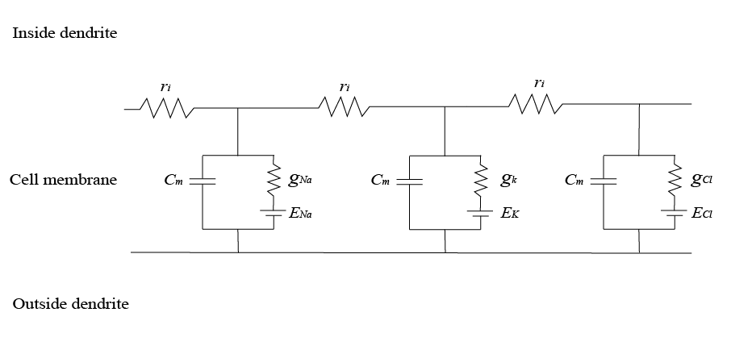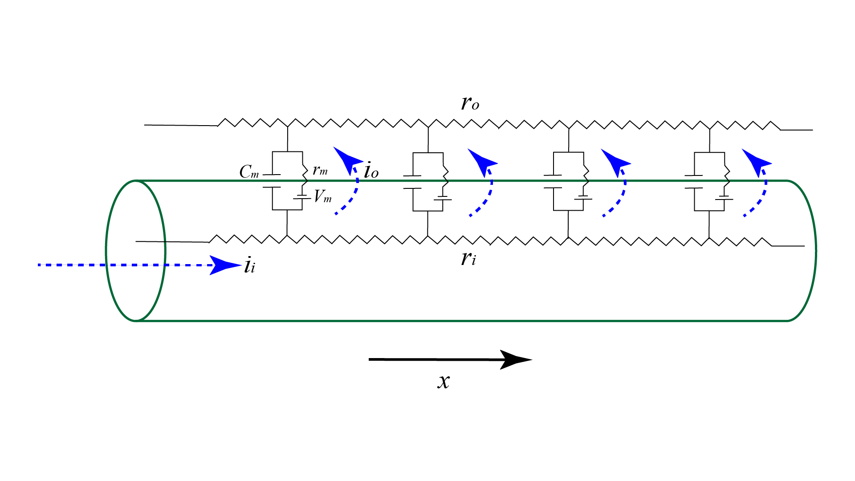

Electrical representation of the relationship between the equivalent circuit model and Cable Theory. Cm = Membrane capacitance, Vm = membrane voltage, rm = membrane resistance, ri = internal (axial) resistance, ro = outward resistance , ii = inward current, io= outward current, gna = conductance for sodium, gk= conductance for potassium, gcl = conductance for chloride, Ena = Sodium reversal potential, Ek = potassium reversal potential, Ecl = chloride reversal potential.

Cable Theory is a model which compares dendritic (or axonal) segments to electrical cables that can carry current along their length.

Four assumptions of resting neurons are made in Cable Theory:1

1. The membrane resistance and capacitance (*rm* and *Cm*) are constant at all points along the dendrite.
2. Internal resistance (*ri*) is constant throughout the dendrite.
3. Current flows only in the longitudinal direction along the length of the cable (*x*). Radial current flow is therefore assumed to be zero.
4. Extracellular resistance (*ro*) is assumed to be negligible.

## Non-isopotential neurons and other limitations of Cable Theory

There are however instances where equivalent circuit models and Cable Theory do not provide good descriptions due to their inherent limitations. One major limitation of Cable Theory is that it considers the equilibrium potential of each ionic species as being constant 29. Across large spatial scales the reversal potentials are relatively stable, thus the assumption that the transmembrane concentration gradient of each ion can be considered constant is relatively sound and provides similar predictions as can be gathered from experiment30. In smaller spaces however, such as in dendritic spines, there are rapid ionic fluxes within a compartment. Therefore, the ionic reversal potentials can fluctuate. In such instances modelling ionic reversal potentials as a constant parameter is inappropriate.

A second limitation of traditional neural models is that they do not appreciate the role of impermeant anions in signal processing. Impermeant anions are negatively charged molecules (e.g. proteins, nucleic acids, metabolites etc.) existing inside or outside of cells, but which cannot traverse the cell membrane. Such molecules contribute to the electrical and osmotic properties of the neuron but their role in the signal propagation is under investigated and remains unknown.

When impermeant anions are added to a multicompartmental model, a third limitation may occur. That is, in Cable Theory individual compartments are considered isopotential (equal membrane potential)31. By adding impermeant anions with different average charge in the various compartments it is likely they will become non-isopotential. If the neuron was indeed non-isopotential, this might have implications on the signal propagation properties of the neuron, although this is not yet known.

Furthermore, a train of action potentials onto a neuron there can be a persistent alteration of GABAergic signalling, a phenomenon underlying inhibitory plasticity.32 This is thought to arise from rapid changes in intracellular Cl- flux.33 The rapid movement of ions within the intracellular space is not accounted for in traditional neural models and in order to study these changes computationally alternate more detailed models (such as electrodiffusion based models) that can account for ion flux on narrow spatiotemporal scales are required.34

## Electrodiffusion based models

An electrodiffusion based approach is necessary to evaluate the influence of impermeant anions on neural signal processing. Electrodiffusion, calculated with the Nernst-Plank equation, encompasses ionic movement resulting from electric fields (drift), as well as the movement of ions along their concentration gradients (diffusion) 3536,36,37. Incorporating these two aspects simultaneously in discrete spatiotemporal locations allows ionic reversal potentials to be dynamic and hence addresses the first limitation of *‘traditional’* neural models. Alan Hodgkin, one of the pioneers in the field of neuronal modelling, makes the following analogy: “*diffusion is like a hopping flea… electrodiffusion is like a flea that is hopping in a breeze”*  38*.* A detailed understanding of both the electrochemical diffusive properties of ions and the respective electric fields *(“breeze”)* which surround them is therefore needed to model this phenomenon.

A recent review of Electrodiffusion by Savtchenko et al.39 distinguishes three major sources of electric fields. Firstly, fields because of electric current flow also referred to local field potentials or extracellular currents. Such currents are not accounted for in Cable Theory. Secondly, fields occurring due to the heterogeneity in the distribution of membrane ion channels causing net submembrane currents, and thirdly, fields across the synaptic cleft. In electrodiffusion ionic currents affect the field, and likewise, the electric field affects ionic currents.

Calculating the detailed interaction between the field and current allows for the simultaneous and precise determination of ionic concentrations at discrete moments in space and time37; such dynamic values are not accessible in Cable Theory. Qian and Sejnowski35 developed one of the first electrodiffusion based models and compared it to Cable Theory. They found that in settings of rapid ionic flux and thin dendritic processes (<0.1 um) significant errors were made in the predictions of membrane potentials and concentrations when the Cable Theory was used relative to their one-dimensional electrodiffusion based model.

Another finding by Qian and Sejnowski35 provides further evidence that electrodiffusion based models can help advance neuroscientific theory. They showed that due to electro-diffusive properties inhibitory inputs which synapse on dendritic spines are ineffective. This provides a partial explanation to the mystery of why most synaptic input onto spines is excitatory. Savtchenko et al39 also speculate that electro-diffusive phenomena influence synaptic plasticity at dendritic spines40.

Despite the promises of electrodiffusion based models, modelling in this highly dynamic, non-linear, and intricate fashion requires significant computational power. This stumbling block prevented neuroscientists from adopting electrodiffusion models, however with the computational resources now publicly available, the computations involved can be performed in a few hours as opposed to days or weeks. The rapid development in computing power which enables electrodiffusion based modelling has opened the door for neuroscientists to properly explore the influences of impermeant anions on neural signalling

# Rationale

Equivalent circuit models and Cable Theory are means of modelling neural signal propagation but are limited in that they cannot make accurate predictions in areas of rapid ionic fluxes (e.g., dendritic spines). Moreover, they do not account for impermeant anions; molecules whose effect on signal propagation remains unknown. Both rapid ionic fluxes and impermeant anions contribute to diseases which can’t be adequately modelled with current strategies. Electrodiffusion based models allow for accurate, albeit computationally expensive, predictions in instances where traditional models are limited. In this MSc I propose constructing an electrodiffusion based model to investigate the impact impermeant anions have on the isopotential status of neurons and the implications this will have on neural signalling. Once developed this model will allow me to advance neuroscientific theory regarding the role of impermeant anions and may further provide important mechanistic explanations of disease processes.

# Aims and Objectives

The overall aim of my thesis is to develope a biophysically accurate computational neuronal model incorporating electrodiffusion to investigate the influence of impermeant anions on the electrical and information processing properties of neurons.

The objectives are as follows:

1. To develop a computational tool to dynamically model ion homeostasis, volume regulation and electrical changes that occur within a neuron
   1. Create a single compartmental model
   2. Create a multicompartmental model incorporating the properties of diffusion and electrical drift
   3. Create a tool to visualize the changes to the ionic concentrations, electrical properties, and cell volume within each compartment as these properties vary with time
2. Investigate the effect of impermeant anions on the isopotential status of neurons.
3. Investigate how excitatory or inhibitory synaptic input is modified by the presence of impermeant anions.
4. Investigate the impermeant anions have on information processing (action potential generation).
5. Explore how any observed effects may be relevant to disease processes.

1. Johnston, D. & Wu, S. M. *Foundations of cellular neurophysiology*. (MIT Press, 1995).

2. Hammond, C. *CELLULAR AND MOLECULAR NEUROPHYSIOLOGY FOURTH EDITION*. www.elsevierdirect.com/rights (2015).

3. Coombs, J. S., Eccles, J. C. & Fatt, P. The Specific Ionic Conductances And The Ionic Movements Across The Motoneuronal Membrane That Produce The Inhibitory Post-Synaptic Potential. *J. Physiol. (I955)* **30**, 326–373.

4. Düsterwald, K. M. & Raimondo, J. v. *Exploring the determinants of chloride homeostasis in neurons using biophysical models Anti-Plagiarism Declaration*. (2018).

5. Fraser, J. A. & Huang, C. L. H. A quantitative analysis of cell volume and resting potential determination and regulation in excitable cells. *Journal of Physiology* **559**, 459–478 (2004).

6. Fatin-Rouge, N., Milon, A., Buffle, J., Goulet, R. R. & Tessier, A. Diffusion and partitioning of solutes in agarose hydrogels: The relative influence of electrostatic and specific interactions. *Journal of Physical Chemistry B* **107**, 12126–12137 (2003).

7. Glykys, J. *et al.* Local Impermeant Anions Establish the Neuronal Chloride Concentration. *Science* **343**, 665–670 (2014).

8. Burton, R. F. The Composition of Animal Cells: Solutes Contributing to Osmotic Pressure and Charge Balance. *Comparative Biochemistry* **76**, 663–671 (1983).

9. Rahmati, N. *et al.* Unique actions of gaba arising from cytoplasmic chloride microdomains. *Journal of Neuroscience* **41**, 4967–4975 (2021).

10. Gianazza, E. & Righetti, P. SIZE AND CHARGE DISTRIBIJIION OF MACROMOLECULES IN LIVING. *Journal of Chromatography* **193**, 1–8 (1980).

11. Doyon, N., Vinay, L., Prescott, S. A. & de Koninck, Y. Chloride Regulation: A Dynamic Equilibrium Crucial for Synaptic Inhibition. *Neuron* **89**, 1157–1172 (2016).

12. Ben-Ari, Y., Khalilov, I., Kahle, K. T. & Cherubini, E. The GABA excitatory/inhibitory shift in brain maturation and neurological disorders. *Neuroscientist* vol. 18 467–486 (2012).

13. Alfonsa, H. *et al.* The contribution of raised intraneuronal chloride to epileptic network activity. *Journal of Neuroscience* **35**, 7715–7726 (2015).

14. Hyde, T. M. *et al.* Expression of GABA signaling molecules KCC2, NKCC1, and GAD1 in cortical development and schizophrenia. *Journal of Neuroscience* **31**, 11088–11095 (2011).

15. Boulenguez, P. *et al.* Down-regulation of the potassium-chloride cotransporter KCC2 contributes to spasticity after spinal cord injury. *Nature Medicine* **16**, 302–307 (2010).

16. Kalia, K. Ionic basis of GABAA receptor channel function in the nervous system. *Progress in Neurobiology* **42**, 489–537 (1994).

17. Raimondo, J. v., Richards, B. A. & Woodin, M. A. Neuronal chloride and excitability — the big impact of small changes. *Current Opinion in Neurobiology* vol. 43 35–42 (2017).

18. Kahle, K. T. *et al.* K-Cl cotransporters, cell volume homeostasis, and neurological disease. *Trends in Molecular Medicine* vol. 21 513–523 (2015).

19. Dusterwald, K. M. *et al.* Biophysical models reveal the relative importance of transporter proteins and impermeant anions in chloride homeostasis. 1–30 (2018).

20. Koleske, A. J. Molecular mechanisms of dendrite stability. *Nature Reviews Neuroscience* **14**, 536–550 (2013).

21. Gut, G., Herrmann, M. D. & Pelkmans, L. Multiplexed protein maps link subcellular organization to cellular states. *Science* **361**, (2018).

22. Kay, A. R. How cells can control their size by pumping ions. *Frontiers in Cell and Developmental Biology* **5**, 1–14 (2017).

23. Blaustein, M., Kao, J. & Matteson, D. *Cellular Physiology and Neurophysiology*. (2012).

24. Elkin, B. S., Shaik, M. A. & Morrison, B. *Fixed negative charge and the Donnan effect: A description of the driving forces associated with brain tissue swelling and oedema*. *Philosophical Transactions of the Royal Society A: Mathematical, Physical and Engineering Sciences* vol. 368 (2010).

25. Goedert, M., Eisenberg, D. S. & Crowther, R. A. Propagation of Tau Aggregates and Neurodegeneration. *Annual Review of Neuroscience* **40**, 189–210 (2017).

26. Schaffert, L. N. & Carter, W. G. Do post-translational modifications influence protein aggregation in neurodegenerative diseases: A systematic review. *Brain Sciences* **10**, 1–37 (2020).

27. Herz, A. V. M., Gollisch, T., Machens, C. K. & Jaeger, D. Modeling single-neuron dynamics and computations: A balance of detail and abstraction. *Science* vol. 314 80–85 (2006).

28. Dayan, P. & Abbott, L. F. *Theoretical neuroscience : computational and mathematical modeling of neural systems*. (Massachusetts Institute of Technology Press, 2001).

29. Lopreore, C. L. *et al.* Computational modeling of three-dimensional electrodiffusion in biological systems: Application to the node of Ranvier. *Biophysical Journal* **95**, 2624–2635 (2008).

30. Markram, H. *et al.* Reconstruction and Simulation of Neocortical Microcircuitry. *Cell* **163**, 456–492 (2015).

31. Keener, J. & Sneyd, J. *Mathematical Physiology I: Cellular Physiology 2nd Edition*. (2009).

32. Fiumelli, H., Cancedda, L. & Poo, M. M. Modulation of GABAergic transmission by activity via postsynaptic Ca 2+-dependent regulation of KCC2 function. *Neuron* **48**, 773–786 (2005).

33. Brumback, A. C. & Staley, K. J. Thermodynamic regulation of NKCC1-mediated Cl- cotransport underlies plasticity of GABAa signaling in neonatal neurons. *Journal of Neuroscience* **28**, 1301–1312 (2008).

34. Doyon, N. *et al.* Efficacy of synaptic inhibition depends on multiple, dynamically interacting mechanisms implicated in chloride homeostasis. *PLoS Computational Biology* **7**, (2011).

35. Qian, N. & Sejnowski, T. J. An electro-diffusion model for computing membrane potentials and ionic concentrations in branching dendrites, spines and axons. *Biological Cybernetics* **62**, 1–15 (1989).

36. Ellingsrud, A. J., Solbrå, A., Einevoll, G. T., Halnes, G. & Rognes, M. E. Finite Element Simulation of Ionic Electrodiffusion in Cellular Geometries. *Frontiers in Neuroinformatics* **14**, 1–18 (2020).

37. Solbrå, A. *et al.* A Kirchhoff-Nernst-Planck framework for modeling large scale extracellular electrodiffusion surrounding morphologically detailed neurons. *PLoS Computational Biology* **14**, 1–26 (2018).

38. Koch, C. *Biophysics of Computation Information Processing in Single Neuron*. *The Brain & Neural Networks* vol. 11 (2004).

39. Savtchenko, L. P., Poo, M. M. & Rusakov, D. A. Electrodiffusion phenomena in neuroscience: A neglected companion. *Nature Reviews Neuroscience* **18**, 598–612 (2017).

40. Trappenberg, T. *Fundamentals of computational neuroscience*.