# 1) Impermeant anion concentration changes

## 1.1 Changing impermeant anion concentration sets local compartment volume with fixed electrical properties of the dendrite

A multicompartmental model consisting of 9 identical cylindrical compartments linearly arranged in the longitudinal direction was used to evaluate the impact of changing impermeant anion (IA) concentration in a single compartment. The compartments were linked via electro-diffusion and were surrounded by an extracellular bath with fixed ion concentration. The concentration of IAs, “[X] “, in compartment number 8 was increased at a fixed rate of 300mM/min between 120 -140s whilst keeping the average charge (valence) of IAs in all compartments constant (z = - 0.85) (Schematic 1). The timestep used was 10-6 s, in line with other multi-compartment simulations.

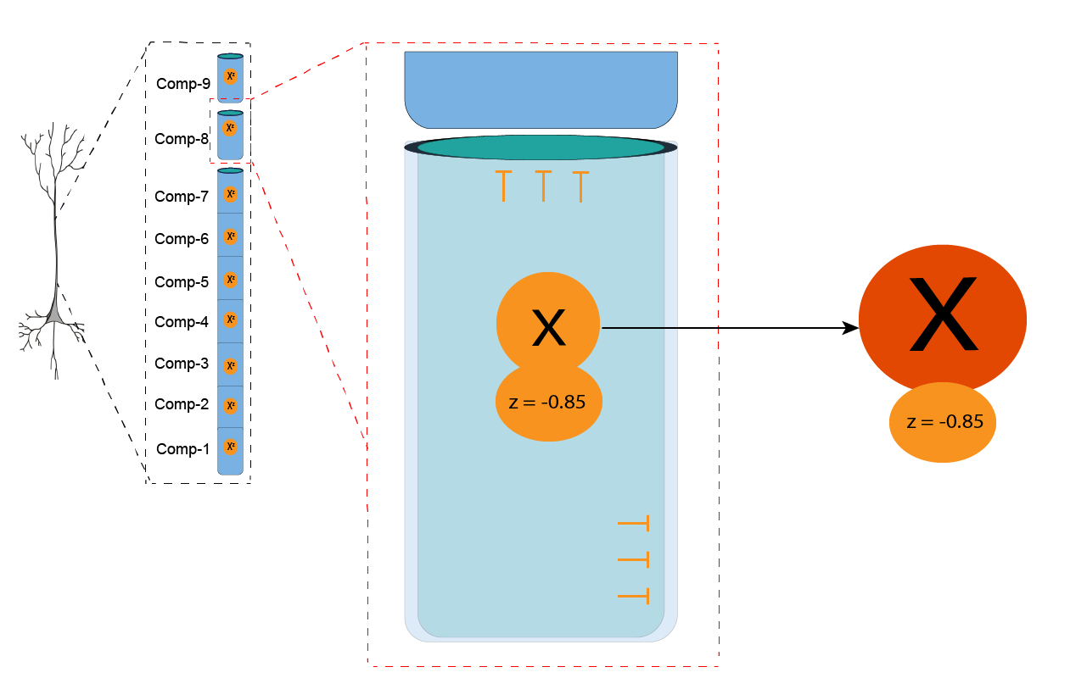

**Schematic 1:** Impermeant anion concentration altered in compartment 8, while impermeant anion charge (z) is held constant.

In the top row of Figure 1A below, shown in orange, IA concentration, charge, and volume for compartment 8 is plotted against simulation time. Following the addition of IAs to compartment 8 there was an increase by approximately 7mM (pane 1) while the average valence of IAs remained constant (pane 2). The IA concentration returned to steady state once the addition was removed. To ensure this return to steady state concentration the volume of compartment 8 increased permanently (pane 3)

A comparison between all compartments with respect to IA concentration, valence and volume across simulation time is displayed in the middle row. Although the concentration of IAs was manipulated only in compartment 8, there were uniform changes in the concentration of IAs in all the other compartments likely due to small volume changes occurring due to the movement of ions (pane 1). Only the volume of compartment 8 showed an increase due to the addition of IAs which persisted beyond the manipulation period and subsequently reached a new higher equilibrium volume.

Lastly, the concentrations of the permeant ions (Cl, Na, and K) were compared between compartments across simulation time. Although there were transient changes in permeant anion concentrations in all compartments during the addition of IAs, once this addition ceased the concentrations of all permeant ions returned to their state values as predicted by the analytical solution for single compartment models. As the volume changed in compartment 8 it is expected that the absolute molar quantity of permeant anions would differ from steady state.

**Figure 1A** – Increased impermeant anion (IA) concentration in compartment 8 between 120-180s results in persistent local change in compartment volume whilst permeant anion concentrations in all compartments return to steady state values following IA manipulation.

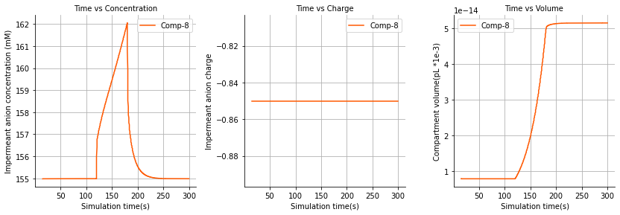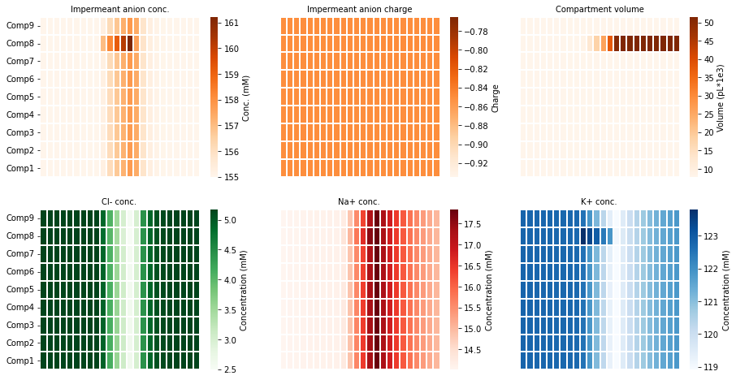

Next, we sought to evaluate how the addition of IAs may alter the electrical properties of the dendrite (Figure 1B) using the same simulation described above.

In the top row the membrane potential (Vm) is compared to the ionic reversal potentials for compartment 8 across simulation time. The addition of IAs into compartment 8 resulted in a more negative charges in the compartment and hence a decrease in the membrane potential for the compartment. To maintain electrical and osmolar homeostasis during the addition of IAs, there were transient shifts in the concentrations of permeant ions resulting in changes to their respective reversal. As the volume equilibrated and ionic concentrations returned to steady state values (as seen in Figure 1A), the membrane potential and ionic equilibrium potentials also returned to steady state following the termination of IA addition.

Although IAs were only manipulated in compartment 8 there were near identical changes in all the compartments with respect to membrane potentials (second row). As the compartments are linked via electro-diffusion, changes in one compartment affect the electric field across the longitudinal axis of the dendrite. This result is expected as in Figure 1A it was shown that the permeant anion concentration changes in all the compartments mimic the changes seen in compartment 8 where the manipulation occurred. Similarly, the ionic reversal potentials across the dendritic compartments showed near identical changes (third row).

The changes observed to the membrane potential and ionic reversal potentials meant that there was a change to the respective ionic driving forces during the manipulation of impermeant anions. The changes were again in proportion to across the length of the dendrite and returned to steady state values once the addition of IAs ceased. Therefore, local addition of impermeant anions does not change the steady state excitability of the dendrite.

**Figure 1B** – Increased impermeant anion concentration in compartment 8 leads to unchanged ionic driving forces and thus no change to the excitability of the dendrite.

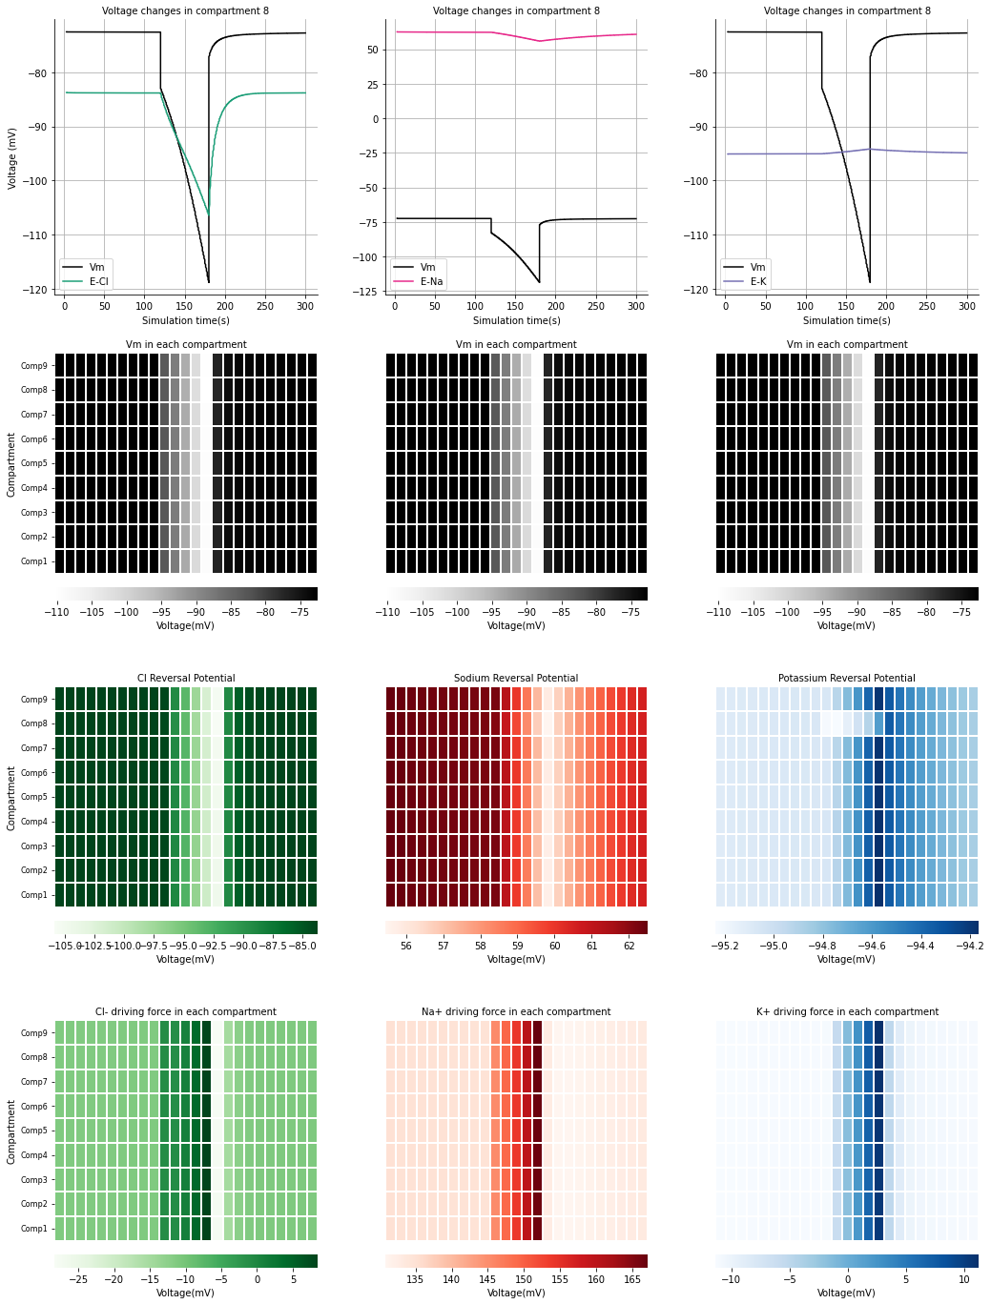

# 2) Impermeant anion charge changes

We next evaluated the local and dendrite-wide impact changing impermeant anion average charge in one compartment may have. An identical 9 compartment model was used (as in Figure 1). The multicompartment model was placed within an extracellular bath containing fixed ion concentrations, while electrodiffusion was employed to model ionic movement across the cell membrane as well as between compartments. Impermeant anion charge started at a baseline of z = - 0.85 in all compartments. In compartment 8 the impermeant anion charge was decreased to z = -1.25 in a linear fashion between 120s – 180s during the simulation (Schematic 2). Note that absolute osmoles of impermeant anions were not changed in any of the compartments.

**Schematic 2:** Impermeant anion charge is manipulated in compartment 8 from -0.85 gradually to -1.25.

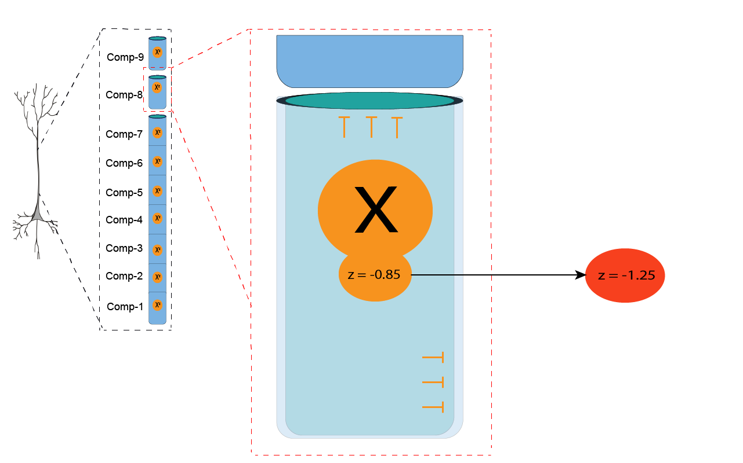

## 2.1 Local changes to impermeant anion charge (z) alters local compartment volume and permeant ion concentrations

Impermeant anion charge reduction in compartment 8 resulted in a local increase in intracellular osmotic pressure with resultant swelling of compartment (Figure 2A, top row). The compartment volume remained persistently elevated even after the IA charge manipulation ceased. Impermeant anion concentration in compartment 8 decreased proportionally to the increase in compartment volume. There were no volume changes in adjacent compartments and hence there were changes to IA concentrations in these compartments (Figure 2A, middle row).

To compensate for the increased intracellular negative charges in compartment 8 there were respective increased concentrations of sodium and potassium ions, and decreased concentrations of chloride (Figure 2A, bottom row). Once the impermeant anion charge manipulated ended at 180s, the concentrations of these permeant ions remained fixed at a new equilibrium. In the adjacent compartments there were no such changes to permeant anion concentrations. Therefore, it appears that local impermeant anion charge sets local permeant ion concentrations.

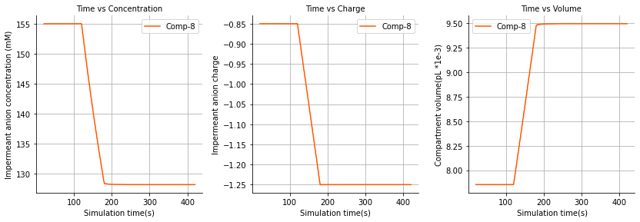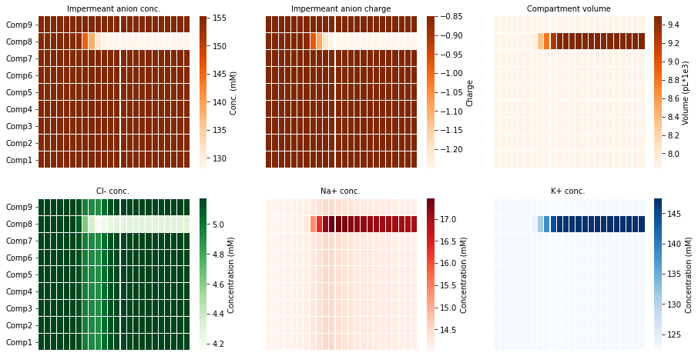

**Figure 2A: Impermeant anion charge alters local compartment volume with proportional changes to impermeant anion concentration**

**Left pane:** Impermeant anion charge was changed from z=-0.85 to z=-1.2 between 120s and 180s only in compartment 8.

**Middle and right pane:** Compartment 8 volume and impermeant anion concentration changes proportionally to the change in impermeant anion charge in compartment 8. No significant changes are seen in any other compartments.

## 2.2 Local changes to impermeant anion charge (z) create a non-isopotential neuron with no changes to ionic driving force

Reducing the IA charge from -0.85 to -1.25 led to a decrease in the membrane potential (Vm) of compartment 8 (Figure 2B, top row). The ionic reversal potentials for chloride, sodium and potassium also shifted downwards in direct proportion to Vm. The proportional shift of both Vm and the ionic reversal potential results in a maintenance of the same ionic driving force throughout the duration of the simulation. Notably, the driving forces in compartment 8 were also identical to the driving forces in the other compartments (Figure 2B, bottom row). The implication thereof is that even though there is a local compartment along the dendrite with an altered membrane potential the excitability of the dendrite should theoretically be uniform across compartments.

The change in membrane voltage could be a result of a) changes in ratios of the net ionic sum (Na + K – Cl +zX); b) changes in the area scaling constant (Ar) which scales Vm based on the compartment volume to area ratio; or c) a combination of the above factors.

**Figure 2B: Impermeant anion charge sets local membrane potential, ionic reversal potential and ionic concentration without changing driving force. Area scaling is not applied to the membrane potential.**

Impermeant anion charge was changed from z=-0.85 to z=-1.2 between 120s and 180s.

**Top row:** Membrane potential and ionic reversal potential shift permanently only in the compartment manipulated (compartment 8).

**Middle row:** No permanent change to the ionic driving forces as membrane and ionic potentials in manipulated compartment change in proportion to other compartments.

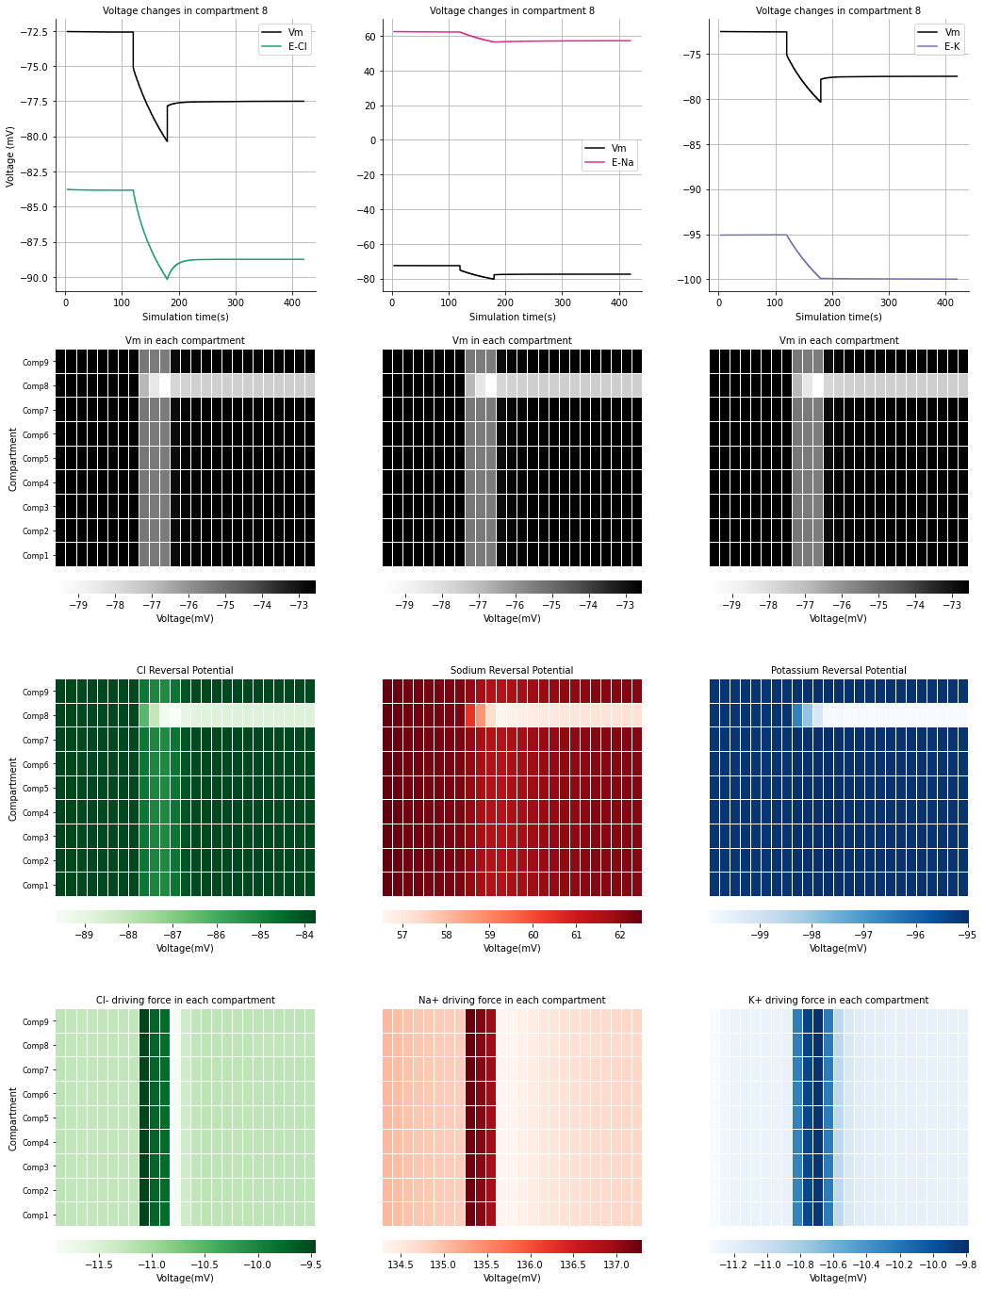

## 2.3 Local changes to impermeant anion charge (z) results in local changes to ionic concentrations

For a constant driving force to be maintained a proportional change to the ionic reversal potential is needed. Ionic reversal potential is determined by the ratio of intra-compartmental ionic concentration to extracellular concentration. Considering that the extracellular bath was held at constant concentration, the intracellular concentration of each ion had to change. In the top three panes of Figure 3D, it is shown that the concentrations of chloride, sodium, and potassium all shown permanent change respectively.

In the middle panes the transmembrane fluxes in compartment 8 and compartment 4 (manipulated versus non-manipulated compartments) were compared to identify if changes to the transmembrane were underpinning the concentrations changes seen for each ion. There appears to be a change in the amount being fluxed through individual channels in compartment 8, however the nett flux (the sum of the inward and outward flux) is balanced. The changes in ion flux across the membrane in compartment 8 were due to area scaling of the channel fluxes.

As there was no nett flux across the membrane changes to ion channels were not responsible for the concentration changes observed, instead changes between compartments (because of electrodiffusion) was likely causing the changes in ion concentration and ionic reversal potentials that allow for a constant ionic driving force. The lower panes of Figure 3D show how respective electrodiffusive changes during the manipulation of impermeant anions created concentration changes in compartment 8 which were not observed in other compartments. Once the charge of impermeant anions stabilized at -1.25, there was no further ionic flux between compartments and the system reached a steady state.

Ultimately, we have shown that electrodiffusion results in ionic microdomains where local impermeant anion charge is manipulated. This results in a non-isopotential neuron as the local membrane potential changes in a single compartment, while the ionic driving forces remain constant due to proportional changes to ionic reversal potentials that are established through the non-uniform ion flux between compartments.

**SUPPLEMENTARY FIGURE WITH AREA SCALINGON**

To discern whether the ionic sum or the area scaling were responsible for the changes to the reversal potential, the same experiment where z was changed from -0.85 to -1.25 in compartment 8 was performed however this time with area scaling not applied to the membrane potential (Fig3C). Clearly there were no differences in the membrane potentials of compartment 8 whether the area scale was present or not. This meant that changes to the ionic sum must be occurring to achieve changes in membrane potential that are proportional to the ionic reversal potentials in compartment 8.

**Figure 2C: Impermeant anion charge sets local membrane potential, ionic reversal potential and ionic concentration without changing driving force. Area scaling is applied to the membrane potential.**

Impermeant anion charge was changed from z=-0.85 to z=-1.2 between 120s and 180s.

**Top row:** Membrane potential and ionic reversal potential shift permanently only in the compartment manipulated (compartment 8).

**Middle row:** No permanent change to the ionic driving forces as membrane and ionic potentials in manipulated compartment change in proportion to other compartments.

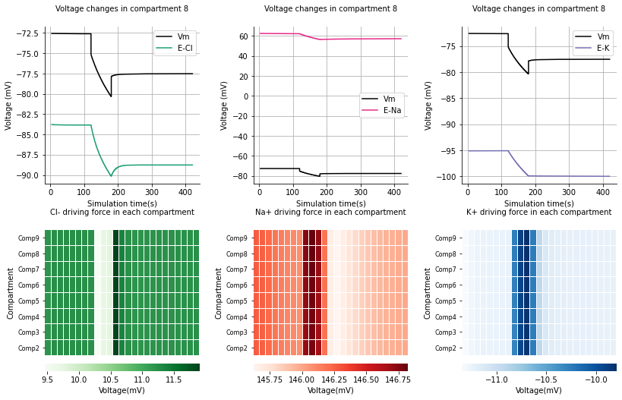

**General story for figure 3:**

* Local changes to z cause a local change in volume and impermeant anion concentration
* Resulting proportional change in membrane potential and chloride reversal potential
* Sets up a situation of chloride microdomains. All with different concentrations but similar chloride driving force.
* The stability in this system is provided by the ATP pumps
* Difficulty in explaining why the membrane potential changes with z are not linear, but rather exponential.
* Difficulty in explaining stability that occurs in z=-0.1 which contradicts the general theme

# 3) Variation in impermeant anion charge between compartments

## A screenshot of a computer Description automatically generated with low confidence3.1 – Multi z

**Figure 3a – local impermeant anion charge sets compartment volume and local impermeant anion concentration.**

*Top row:* The charge of existing impermeant anion species in compartment 8 was manipulated from z=-0.85 (default) to z = -0.1; -0.5; -1.2; -1.6 respectively between 180s to 240s. Altered charge of impermeant anions resulted in a proportional compartmental volume change (and subsequent inverse impermeant anion concentration change). These changes persisted for the remainder of the simulation.

*Bottom rows:* There was no impermeant anion manipulation in compartment 4. Temporary changes can be seen to compartment volume and impermeant anion concentration during the manipulation period in compartment 8, however they return to baseline.

**Figure 3b – local impermeant anion charge sets membrane potential and chloride reversal potential without changing chloride driving force**

*Top row:* The charge of existing impermeant anion species in compartment 8 was manipulated from z=-0.85 (default) to z = -0.1; -0.5; -1.2; -1.6 respectively between 180s to 240s. Reduction of charge of impermeants decreases the local membrane potential and chloride reversal potential proportionally such that chloride driving forces are not drastically altered.

*Middle and bottom rows:* There was no impermeant anion manipulation in either compartment 4 or the soma. No permanent changes are seen in the membrane potential, chloride reversal potential or chloride driving force.

## 3.2 – Changing z in 2 compartments

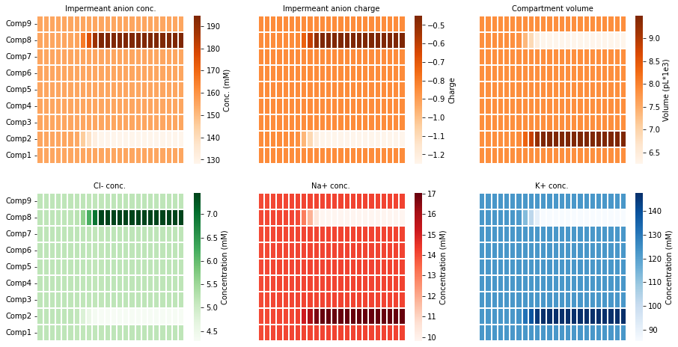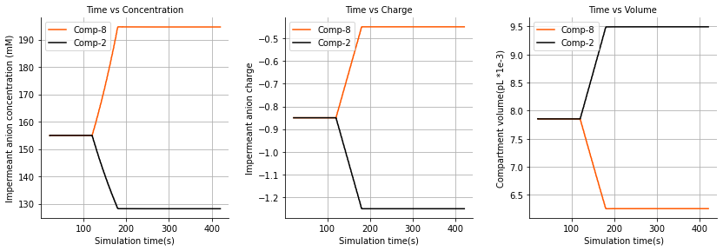

# 4) Current addition

# 5) AP firing rates