# 1 – Impermeant anion concentration changes

## 1.1 impermeant anion concentration sets local compartment volume

We simulated increases in impermeant anion quantity with our nine-compartment model. The molar quantity of impermeant anions in compartment number 8 (Comp8) was increased at a fixed rate of 3x10-16 mole/min between 20 and 40s, whilst the average charge (valence) of impermeant anions remained constant (z = - 0.85) (Schematic 1).

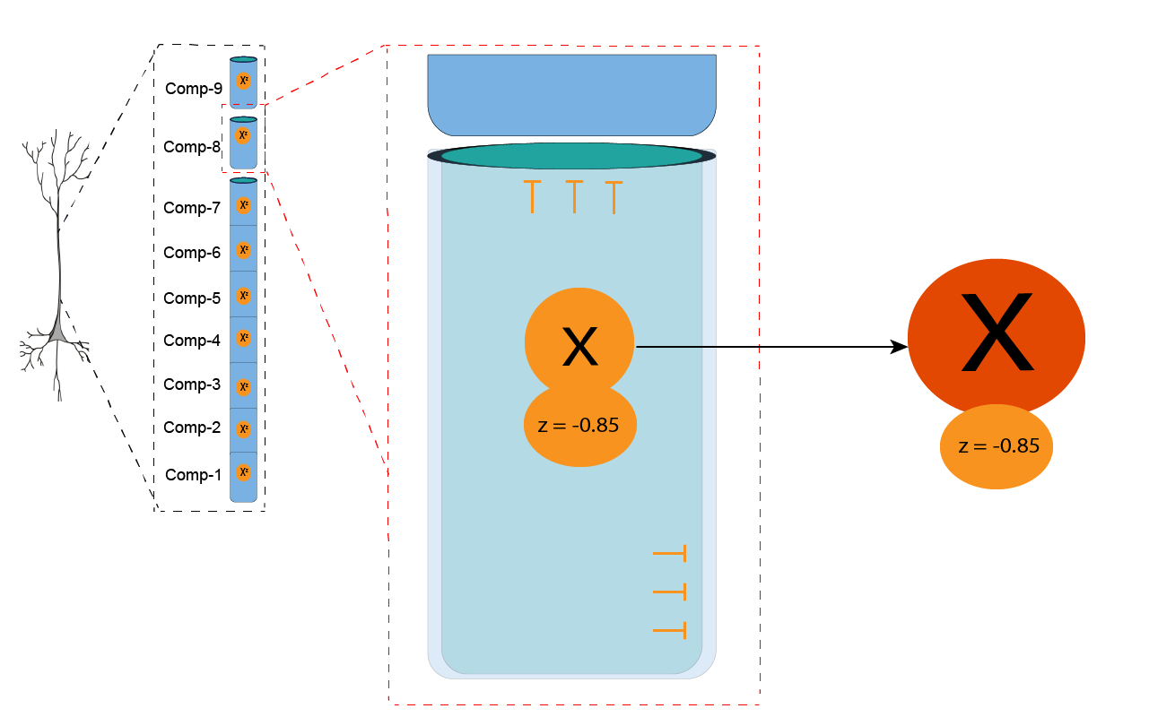

**Schematic 1:** Impermeant anion concentration increase in compartment 8, while impermeant anion charge (z) is held constant.

Approximately 1x10-16 moles of impermeant anions were added to Comp8 between 20 and 40s, resulting in a concentration increase of approximately 9mM (Figure1A). The volume of Comp8 more than tripled to accommodate the increase in impermeant anion load. Although impermeant anions were only fluxed in Comp8 there were transient changes in ionic composition and compartment volumes in all other compartments.

The ion concentrations and volumes of all other compartments returned to their original values once the flux ended in Comp8. Volume increase in Comp8 persisted beyond the flux duration.

**Figure 1A** – Increased impermeant anion (IA) concentration in compartment 8 between 120-180s results in persistent local change in compartment volume whilst permeant anion concentrations in all compartments return to steady state values following IA manipulation.

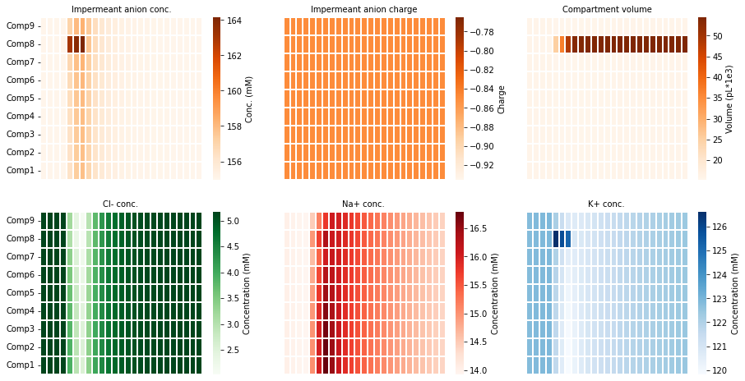

We also evaluated the electrical changes in the simulation above (Figure 1B). The membrane potential (Vm) dropped transiently in all compartments during impermeant anion flux into Comp8. This was coupled by transient decreases in sodium and potassium reversal potentials in all compartments. However, once the flux had ended and the model reached a new steady state compartment membrane potential, ionic reversal potentials and ionic driving forces returned to baseline level in all compartments.

**Figure 1B** – Increased impermeant anion concentration in compartment 8 leads to unchanged ionic driving forces and thus no change to the excitability of the dendrite.