**RESULTS #2**

We next evaluated the local and dendrite-wide impact changing impermeant anion average charge in one compartment may have. An identical 9 compartment model was used (as in Figure 1). The multicompartment model was placed within an extracellular bath containing fixed ion concentrations, while electrodiffusion was employed to model ionic movement across the cell membrane as well as between compartments. Impermeant anion charge started at a baseline of z = - 0.85 in all compartments. In compartment 8 the impermeant anion charge was decreased to z = -1.25 in a linear fashion between 120s – 180s during the simulation (Schematic 2). Note that absolute osmoles of impermeant anions were not changed in any of the compartments.

**Schematic 2:** Impermeant anion charge is manipulated in compartment 8 from -0.85 gradually to -1.25.

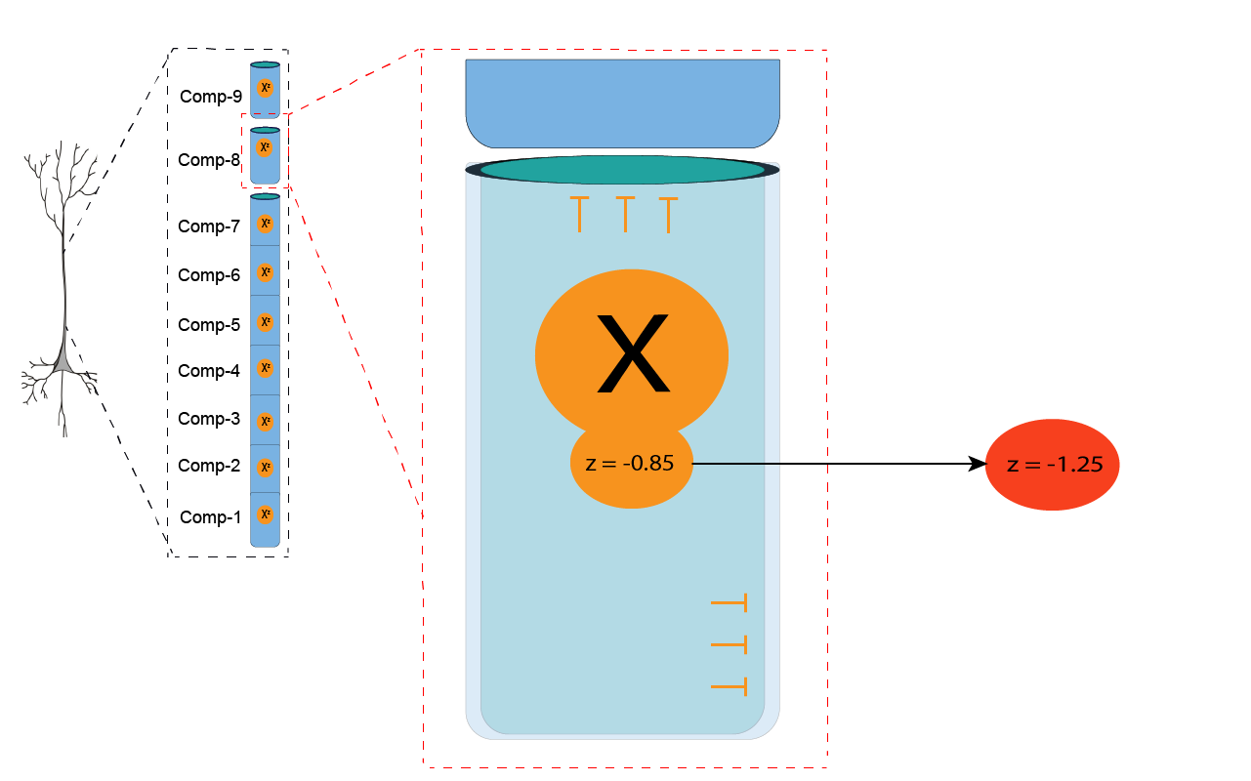

## 2.1 Local changes to impermeant anion charge (z) alters local compartment volume and permeant ion concentrations

Impermeant anion charge reduction in compartment 8 resulted in a local increase in intracellular osmotic pressure with resultant swelling of compartment (Figure 2A, top row). The compartment volume remained persistently elevated even after the IA charge manipulation ceased. Impermeant anion concentration in compartment 8 decreased proportionally to the increase in compartment volume. There were no volume changes in adjacent compartments and hence there were changes to IA concentrations in these compartments (Figure 2A, middle row).

To compensate for the increased intracellular negative charges in compartment 8 there were respective increased concentrations of sodium and potassium ions, and decreased concentrations of chloride (Figure 2A, bottom row). Once the impermeant anion charge manipulated ended at 180s, the concentrations of these permeant ions remained fixed at a new equilibrium. In the adjacent compartments there were no such changes to permeant anion concentrations. Therefore, it appears that local impermeant anion charge sets local permeant ion concentrations.

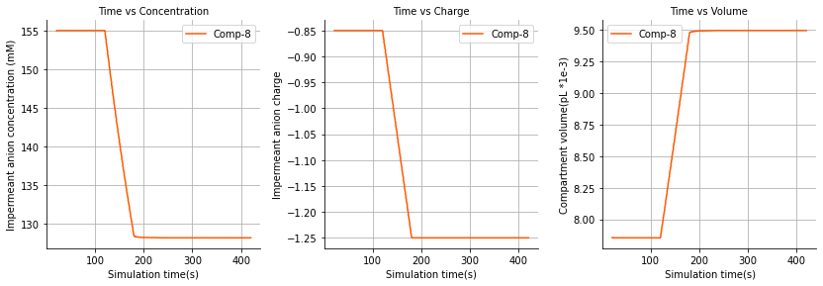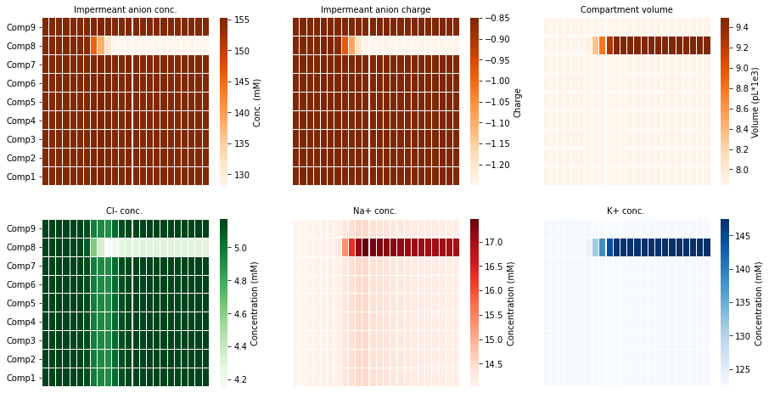

**Figure 2A: Impermeant anion charge alters local compartment volume with proportional changes to impermeant anion concentration**

**Left pane:** Impermeant anion charge was changed from z=-0.85 to z=-1.2 between 120s and 180s only in compartment 8.

**Middle and right pane:** Compartment 8 volume and impermeant anion concentration changes proportionally to the change in impermeant anion charge in compartment 8. No significant changes are seen in any other compartments.

## 2.2 Local changes to impermeant anion charge (z) create a non-isopotential neuron with no changes to ionic driving force

Reducing the IA charge from -0.85 to -1.25 led to a decrease in the membrane potential (Vm) of compartment 8 (Figure 2B, top row). The ionic reversal potentials for chloride, sodium and potassium also shifted downwards in direct proportion to Vm. The proportional shift of both Vm and the ionic reversal potential results in a maintenance of the same ionic driving force throughout the duration of the simulation. Notably, the driving forces in compartment 8 were also identical to the driving forces in the other compartments (Figure 2B, bottom row). The implication thereof is that even though there is a local compartment along the dendrite with an altered membrane potential the excitability of the dendrite should theoretically be uniform across compartments.

The change in membrane voltage could be a result of a) changes in ratios of the net ionic sum (Na + K – Cl +zX); b) changes in the area scaling constant (Ar) which scales Vm based on the compartment volume to area ratio; or c) a combination of the above factors.

**Figure 2B: Impermeant anion charge sets local membrane potential, ionic reversal potential and ionic concentration without changing driving force. Area scaling is applied to the membrane potential.**

Impermeant anion charge was changed from z=-0.85 to z=-1.2 between 120s and 180s.

**Top row:** Membrane potential and ionic reversal potential shift permanently only in the compartment manipulated (compartment 8).

**Middle row:** No permanent change to the ionic driving forces as membrane and ionic potentials in manipulated compartment change in proportion to other compartments.

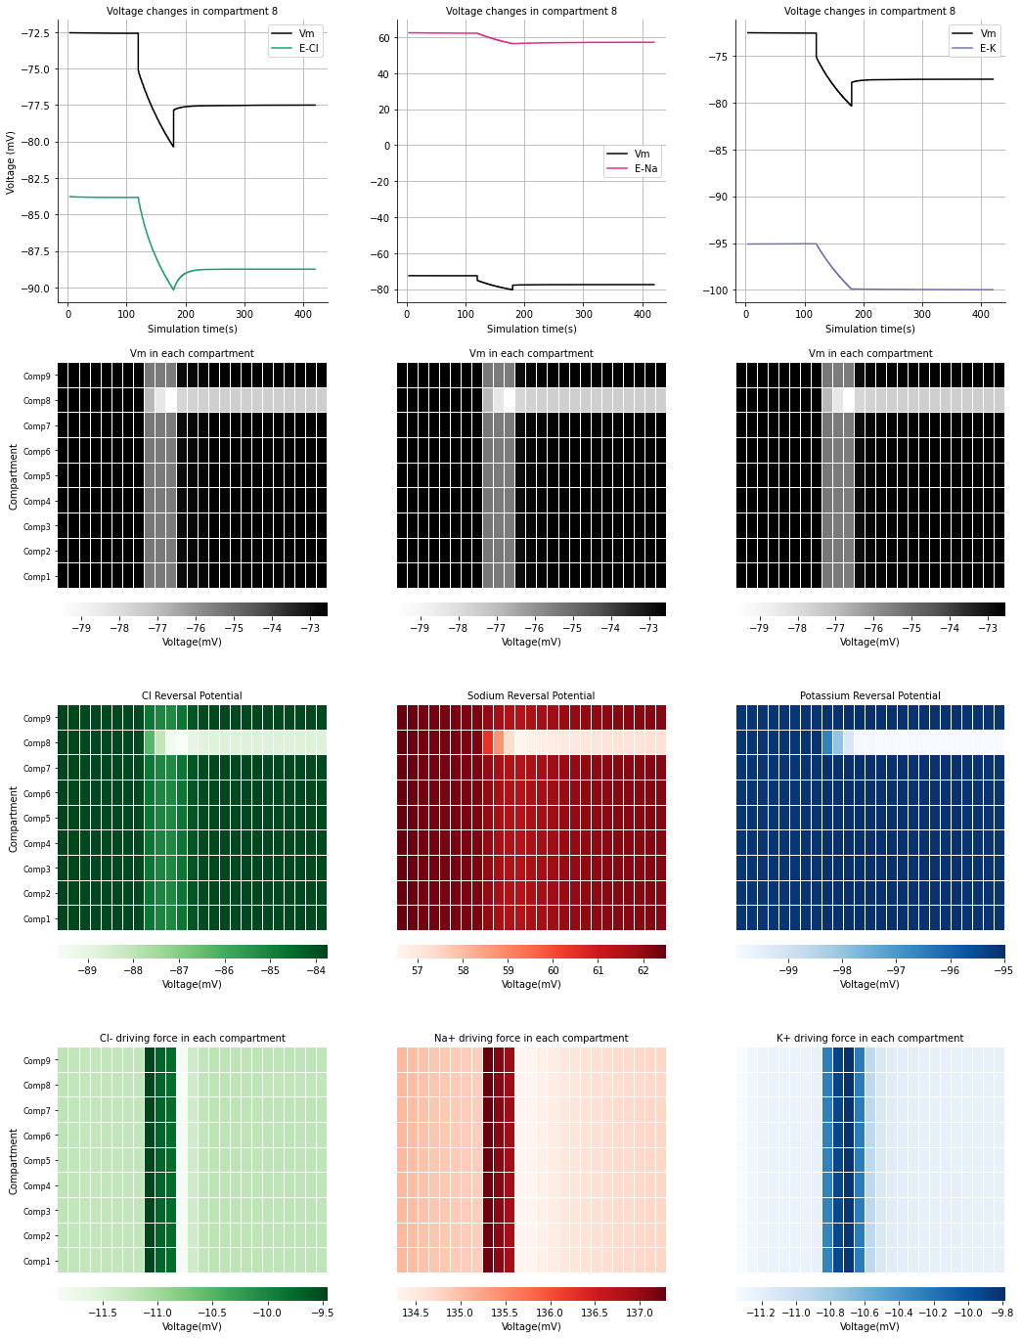

## 2.3 Local changes to impermeant anion charge (z) results in local changes to ionic concentrations

For a constant driving force to be maintained a proportional change to the ionic reversal potential is needed. Ionic reversal potential is determined by the ratio of intra-compartmental ionic concentration to extracellular concentration. Considering that the extracellular bath was held at constant concentration, the intracellular concentration of each ion had to change. In the top three panes of Figure 3D, it is shown that the concentrations of chloride, sodium, and potassium all shown permanent change respectively.

In the middle panes the transmembrane fluxes in compartment 8 and compartment 4 (manipulated versus non-manipulated compartments) were compared to identify if changes to the transmembrane were underpinning the concentrations changes seen for each ion. There appears to be a change in the amount being fluxed through individual channels in compartment 8, however the nett flux (the sum of the inward and outward flux) is balanced. The changes in ion flux across the membrane in compartment 8 were due to area scaling of the channel fluxes.

As there was no nett flux across the membrane changes to ion channels were not responsible for the concentration changes observed, instead changes between compartments (because of electrodiffusion) was likely causing the changes in ion concentration and ionic reversal potentials that allow for a constant ionic driving force. The lower panes of Figure 3D show how respective electrodiffusive changes during the manipulation of impermeant anions created concentration changes in compartment 8 which were not observed in other compartments. Once the charge of impermeant anions stabilized at -1.25, there was no further ionic flux between compartments and the system reached a steady state.

Ultimately, we have shown that electrodiffusion results in ionic microdomains where local impermeant anion charge is manipulated. This results in a non-isopotential neuron as the local membrane potential changes in a single compartment, while the ionic driving forces remain constant due to proportional changes to ionic reversal potentials that are established through the non-uniform ion flux between compartments.

**SUPPLEMENTARY FIGURE WITH AREA SCALINGOFF**

To discern whether the ionic sum or the area scaling were responsible for the changes to the reversal potential, the same experiment where z was changed from -0.85 to -1.25 in compartment 8 was performed however this time with area scaling not applied to the membrane potential (Fig3C). Clearly there were no differences in the membrane potentials of compartment 8 whether the area scale was present or not. This meant that changes to the ionic sum must be occurring to achieve changes in membrane potential that are proportional to the ionic reversal potentials in compartment 8.

**Figure 2C: Impermeant anion charge sets local membrane potential, ionic reversal potential and ionic concentration without changing driving force. Area scaling is not applied to the membrane potential.**

Impermeant anion charge was changed from z=-0.85 to z=-1.2 between 120s and 180s.

**Top row:** Membrane potential and ionic reversal potential shift permanently only in the compartment manipulated (compartment 8).

**Middle row:** No permanent change to the ionic driving forces as membrane and ionic potentials in manipulated compartment change in proportion to other compartments.

