# 4 – Current addition

## 4.1.Comparison between the electrodiffusion based model and equivalent circuit model

We next compared the passive electrical properties of our electrodiffusion based model to an equivalent circuit model constructed in NEURON1,2. We pulsed a step current of +0.1nA with a 1ms duration onto compartment 9 and calculated the time(τ) and length(λ) constants in each model (**Figure 4a**). The maximum amplitude of depolarization in Comp9 was similar for the NEURON model (-52.78mV) compared to the electrodiffusion based model (-52.63mV). There were also similar degrees attenuation of current in the NEURON model (τ = 3.12ms; λ = 48.57µm) relative to the electrodiffusion-based biophysical model (τ = 2.95ms; λ = 49.0µm).

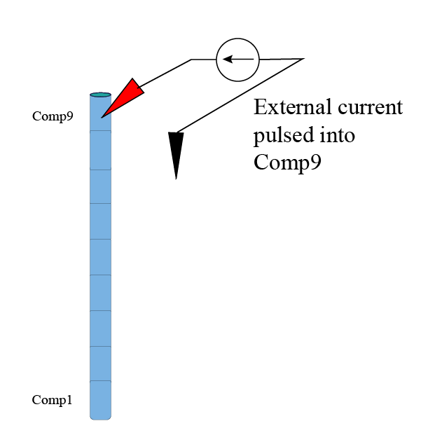

## 4.2 Cable properties when Impermeant anion valency is changed just in comp 8

In our electrodiffusion based model, we examined the influence a local change in impermeant anion valency may have on the passive cable properties of the dendrite. Valences of z=-0.65;-0.85 and -1.05 were set in Comp8 from the beginning of the simulation. Volume normalization was performed on Comp8 to ensure all that compartment volumes in all experiments were similar. A +0.1nA current for 1ms was pulsed into Comp9 in each simulation.

Figure 4b shows time and length constants were similar regardless of the valency, with minor differences between the maximum voltage deflections in compartment 9 of all experiments likely due to artefacts related to compartment volume.

Figure 4c. **Cable properties in the multicompartment biophysical model with varied impermeant anion valency in a nearby compartment.** A 1ms +0.1nA current was pulsed into compartment 9 (Comp9) of a 180µm long, 9 compartment, dendritic model. Valency (z) of impermeant anions in Comp8 were set at: -0.45; -0.85, -1.25. Remaining compartments had a default valency of z = -0.85.

*Top row:* Voltage tracing for Comp9,Comp8 and Comp1 in each simulation.

*Middle row:* Time constants (Tau/τ). z = -0.45: τ = 1.77ms. z = -0.85: τ = 2.85ms; z=-1.25: τ = 3.87ms

*Bottom row:* Length constants (Lambda/ λ). z = -0.45: λ = 43.33µm; z = -0.85: λ = 49.28µm; z=-1.25: λ = 53.4µm

