# 5 – impact of impermeant anions on synaptic transmission

We extended our electrodiffusion based biophysical model to understand the impact impermeant anions had on synaptic integration. A soma(length: 40µm; diameter 2µm) was joined onto Comp1 with Hodgkin-Huxley channels placed in this compartment. Synaptic excitatory (“Glutamatergic”) or inhibitory (“GABAergic”) inputs were directed on Comp8 and were modelled an alpha functions.

## 5.1 Excitatory and inhibitory synapse demonstration with different impermeant anion valency

We tested subthreshold excitatory and inhibitory synaptic inputs on our multicompartment model. In figure 5.1 synaptic input was directed at compartment 8. The same simulation was repeated for 3 different impermeant anion valences in compartment 8 only (z = -0.65; z = -0.85; z = -1.05) which were at steady state before the synaptic input. The resting membrane potential in compartment 8 was different in each simulation, as shown in previous experiments. The amplitude of voltage deflection due to synaptic excitation and inhibition was not affected despite the different impermeant anion valences. Moreover, there were no differences in the somatic voltage deflections in either the excitatory or inhibitory simulations.

## 5.2 Action potential generation with impermeant anion change at the synapse

5mM NT; 1 x10-9 conductance; z=-0.85 🡪 no AP (soma to -67.5mV)

5mM NT; 2 x10-9 conductance; z=-0.85 🡪 no AP (soma to -63mV)

1mM NT; 3 x10-9 conductance; z=-0.85 🡪 no AP (soma to -62.5mV)

2mM NT; 3 x10-9 conductance; z=-0.85 🡪 triggers AP

3mM NT; 3 x10-9 conductance; z=-0.85 🡪 triggers AP

5mM NT; 3 x10-9 conductance; z=-0.85 🡪 triggers AP

5mM NT; 5 x10-9 conductance; z=-0.85 🡪 triggers AP

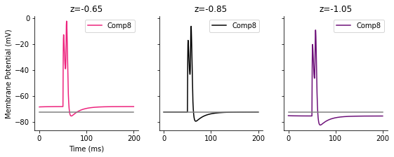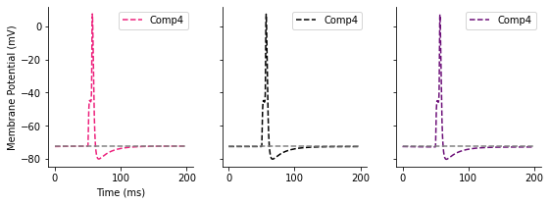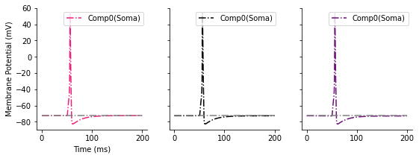

## 5.3 Action potential generation with impermeant anion change in the middle of the dendrite



T9;T10

Figure uses Exp5-4; Exp5-7;Exp5-8

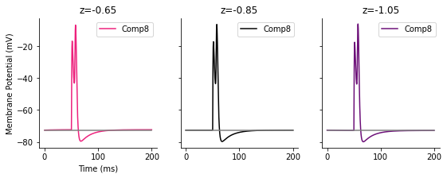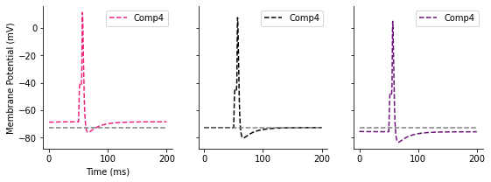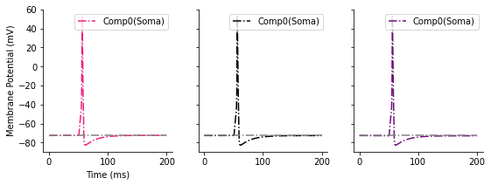

## 5.4 Action potential generation with impermeant anion change at the soma

T11;T12

Exp5-4;Exp5-9;Exp5-10

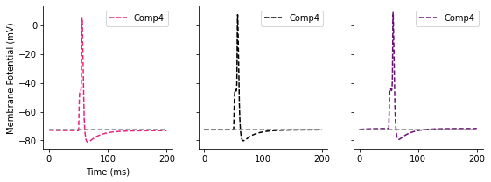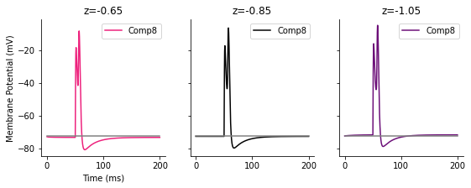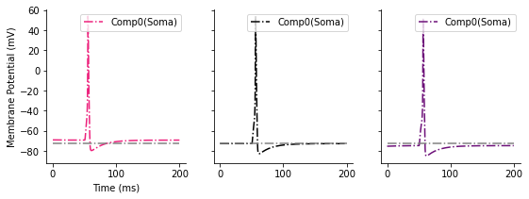

## 5.5 Inhibitory synapses and impermeant anions

