

**BizTrackME User Documentation v0.1.0***Last Updated: 2/3/2014*

Contents

Preparing the Database 2

Starting the Server 2

Accessing the System 2

User Registration 3

Logging In 3

The BizTrackMe Dashboard 3

Adding Objects 5

Searching Objects 5

Editing Objects 7

Deleting Objects 7

# Preparing the Database

BizTrackME relies on the efficient and proven data storage system, MySQL. While each client need not worry about this dependency, it is vital for the server to have, or have access to, a running instance of MySQL. As it happens, BizTrackME is designed from the ground up to be easily configurable in different environments. There is a SQL file in the application directory which can be used to build the required schema for the system. It is advised that the user begin with this file, and then simply truncates the sample data contained within it.

**./database.sql**

The Server component is built using a Servlet/JSP implementation which means it is easily compiled into a .WAR file for simple deployment. In order to properly configure the system, review the **Config.java** file and change the database location, and credentials to match your specific environment. Afterwards, compile the software once more and then the Server component is ready for deployment.

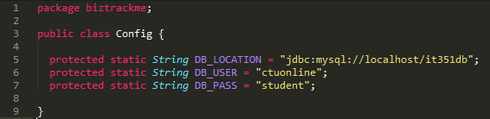

# Starting the Server

As the system is currently in the final stages of development, the screenshots and narrative will review the process involved in starting and testing the system using NetBeans to manage the associated Server component processes. What’s more, the user is recommended to perform the same steps in order to test the system’s configuration before deployment.

1. Open Project
2. Start MySQL server
3. Right click on ‘BizTrackME-web’ and click Run
4. System will launch when the required components are compiled and ready

# Accessing the System

BizTrackME is currently configured to respond to requests to *localhost*. Further, it is configured only to listen for connections on port 26951. In order to access the system from a different browser, simply access the address below from any web browser.

**http://localhost:26951/BizTrackME/**

# User Registration

If this is the first time accessing the system, a username and password will need to be registered with BizTrackME. Click the *Register* button as displayed below.

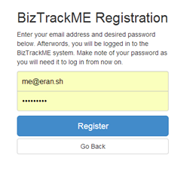

Now you may enter your desired username (in the form of an email address) and password. As it stands, there is no mechanism for retrieving or resetting lost passwords. Please make note of your password and contact your system administrator if you need to reset, or change anything else regarding your account.

# Logging In

To log in, simply enter the email address and associated password that was registered with the system in previous step. If the registered password does not work or has been forgotten/misplaced, contact the system administrator.

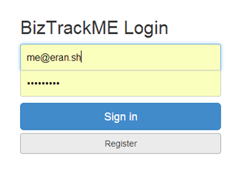

**NOTE: The system is currently in development, any email or password may be entered here.**

# The BizTrackMe Dashboard

Upon successful authentication, the user is presented with the primary display of BizTrackME, the dashboard. With a single action, the user can traverse every activity enabled by the system from this screen. There are several components of interest…

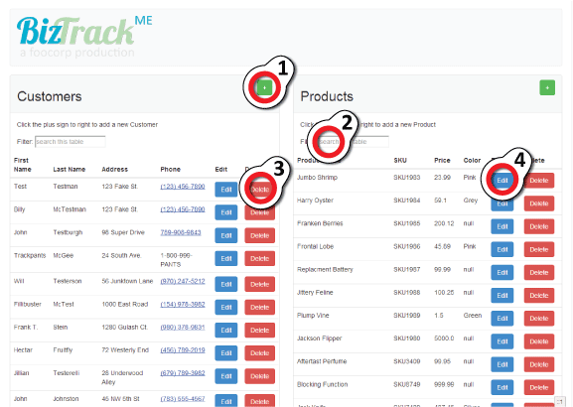

The highlighted elements are described, as referenced by their number below.

1. Add object button – Click to add an object to either the ‘Customers’ or ‘Products’ tables
2. Search Filter – Type into this box in order to filter the results of either table, the text entered is matched to any/all column
3. Delete – Removes the corresponding row from the table
4. Edit – Allows the user to change information about the corresponding object

# Adding Objects

In order to add a record, click the  button corresponding to the table you wish to make the addition. You will then be presented with a form with which to populate the desired data. 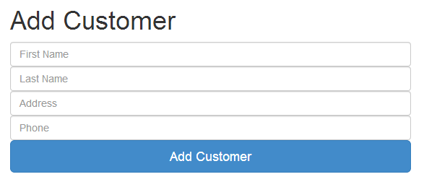

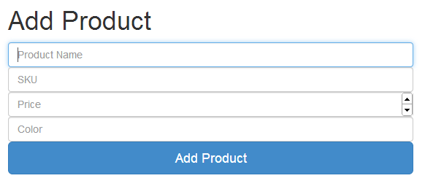

# Searching Objects

In order to search for a given object, simple type into the ‘Filter’ field above either table. The table contents will be queried in real time and you be able to watch the results narrow as you type.

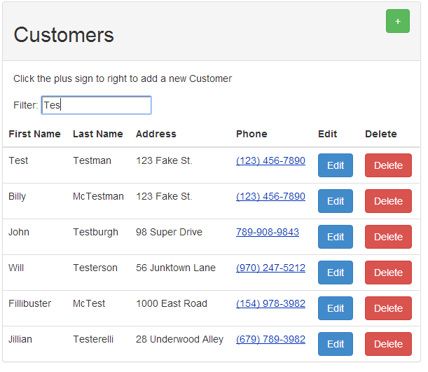

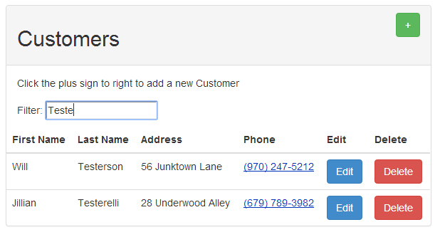

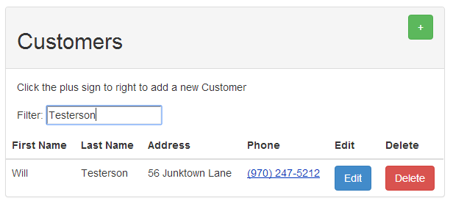

# Editing Objects

Alternatively, you may wish to update the information stored for a given object. In order to do so, simply click the object’s associated button and you will be presented with a form with which to alter any or all fields belonging to that element.

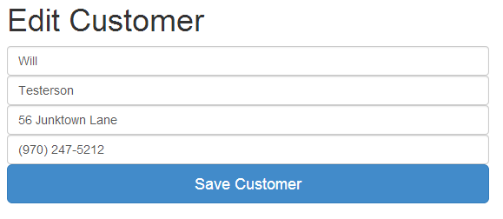

Upon clicking the ‘Save Customer’ button, the record will be instantly updated and you will be returned to the dashboard.

# Deleting Objects

The processes involved in deleting an object is extremely simple. So simple, in fact, that you should take enormous caution when deleting an object as there will be no confirmation nor any means of reversing the delete action. In order to delete an object, simply click the object’s associated  button.