TravelEye

Software Development Plan

**2nd December 2024**

Version 3

**

**Submitted By:**

Adam Wisnewski, Jacob Philips, Erand Bizati, Owen Campain

# 

# REVISION HISTORY

| **Date** | **Author** | **Distributed to** | **Version** | **Description** |
| --- | --- | --- | --- | --- |
| Spring 24 | Prof DeMarco | teams | 0 | Update for SDP 2nd |
| 3/22/2024 | Team | Nobody | 1 | Working on 1-4 |
| 4/1/2024 | Team | Nobody | 2 | Working on 5-11 |
| 12/2/2024 | Adam | Nobody | 3 | Edits before Final |

# 

**REVISION HISTORY 1**

**1. PRODUCT DESCRIPTION 3**

**2. TEAM DESCRIPTION 3**

**3. SOFTWARE PROCESS MODEL DESCRIPTION 3**

**4. PRODUCT DEFINITION 3**

Context Diagram with User Stories 3

**5. PROJECT ORGANIZATION 3**

5.1 Matrix of Responsibilities 3

5.2 PERT / Gantt Chart 3

**6. BUDGET 4**

6.1 One Page Business Plan 4

**7. VALIDATION PLAN 4**

Test Strategy 4

**8. FEASIBILITY STUDY 4**

Risk Identification 4

Risk Prioritization 4

Risk Mitigation 4

**9. CONFIGURATION AND VERSION CONTROL 4**

**10. TOOLS 4**

**11. ARCHITECTURE 5**

# 

# 

# 

# 1. PRODUCT DESCRIPTION

Surveillance devices have become cheaper, easier to use, and more accessible for most people. As a result of this, the concern of nonconsensual surveillance has grown for the general public. This concern is especially relevant for travelers who are staying in hotels, AirBnB, and other short-term housing where there is the possibility of hidden devices being present without their knowledge. Most travelers would appreciate the peace of mind knowing there are no hidden surveillance devices in the room they are staying. Unfortunately, many methods and tools for finding surveillance devices are not easy to use and are not practical for travelers without technical knowledge.

Our product is intended to give travelers the insurance of their personal privacy without requiring technical knowledge of how to find and disable these devices. Our product uses radio frequency detection to find surveillance devices and provide easy to follow instructions on how to disable the device and how to insure their privacy. Our tool should be easy to transport and use to allow travelers to focus their travel instead of their privacy.

# 2. TEAM DESCRIPTION

## Team Skills:

|  |  |  |  |  |  |
| --- | --- | --- | --- | --- | --- |
|  | **CSS/UI** | **Python** | **Raspberry pi/Sensors** | **3D printing** | **Software Defined Radio** |
| Owen | X | X | X | X |  |
| Adam | X | X |  |  |  |
| Jacob | X | X |  |  |  |
| Erand | X | o | X | X | o |

# 

# 3. SOFTWARE PROCESS MODEL DESCRIPTION

Describe the model to be used for this project (agile, game dev) Include justification for your choice. What are the pros and cons

The software process model which will be used for this product is the agile model. The agile model is being used because it will result in a working product with frequent collaboration to meet expectations. The agile methodology is a family of software development methodologies that prioritizes four things over four others. Specifically, it prioritizes individuals and interactions, working software, customer collaboration, and responding to change over processes and tools, comprehensive documentation, contract negotiation, and following a plan “dogmatically”.

For example, it does this by doing short releases and multiple iterations for responding to changes and collaborating with frequent changes. The methodology uses incremental design and development to update the product. User involvement is a large feature of the methodology as well to keep the customer collaborating with, while also prioritizing the individuals. Documentation is meant to be kept minimal, as it could slow down the process of creating the product. Communication is meant to be informal between members of the team.

There are many pros to the agile methodology. Specifically, it ensures that the product is consistently worked on and updated to the customer’s satisfaction. To ensure that the product is being made correctly and how the customer wants it, the team will communicate and work with the customer without making a large contract to follow exactly what it says. Not only this, but the agile methodology focuses on flexibility and collaboration for the team. With informal communication between the team, this promotes flexibility for how the team can work together. Flexibility in the product is also provided through the consistent changes throughout the creation of the product as it is constantly changing to fit what the customer wants. Collaboration is a large part of the methodology, as with minimal documentation the team must continue to collaborate to stay on the same page. Collaboration is not just with the team, but with the customer too, to keep the product exactly how they want it.

Although there are pros, there are cons as well. For the limited documentation, it can often confuse the members of the team who are not well informed, making it harder to fully complete a project. Not only this, but it is difficult to have a set deadline and set a specific time of how long the project may take. The traditional methodology, however, does not have these cons but does not have the same pros as agile does. Traditional is in many ways the opposite of agile but based on the preference of methodology and how the project should be done, you could pick the better one for the job. For this project, agile is the best methodology.

# 4. PRODUCT DEFINITION

Intended Users of the product will range from a wide variety of consumers from discerning travelers to home security specialists. The main application of the device will be most appealing to the general market of frequent flyers and people with little to no experience with RF or IR detection or networking technology or just generally apply to a less than tech savvy crowd. The other applications of the product will include security specialists or security conscious users who are slightly/significantly more experienced in terms of technology and require little to no assistance or instruction to accomplish their task.

User environments will vary from basic hotel rooms and studio apartments to upscale suites and larger style condominiums or houses. May include outdoor areas such as alleys, patios, or decks and will assist the user in looking in unconventional places if a signal is detected but no device has been found. User environments can be extended to include larger areas and environments, but the main functionality will be with smaller scale rooms and areas.

In the device aspect, the user environment will consist of all elements on a single or multiple included networks and any incoming or detected RF. Whether it be the user’s own home network, or a public or even hidden network used for listening devices. The user should have complete and total available information and should be shown all frequencies.

## 

## 

## 

## 

## 

## 

## Context Diagram with User Stories

Defines the scope of your system - what is inside the system and what is outside the system. High level information flow between the system and the outside users or other systems (personas)

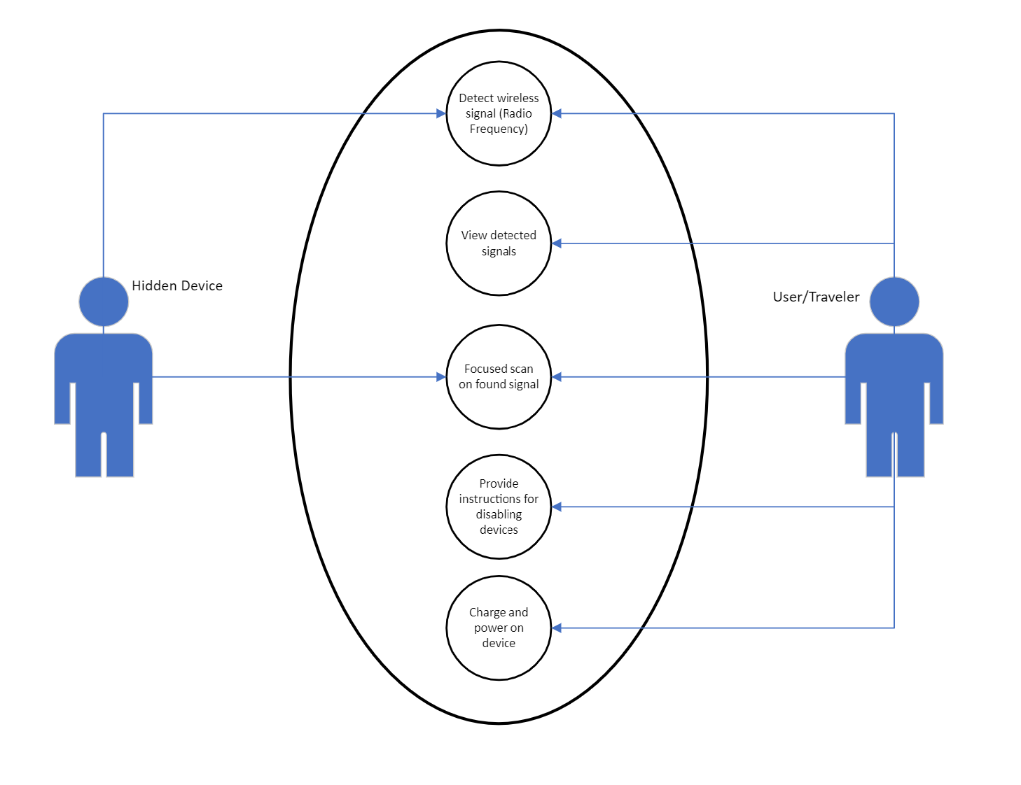

# User:

# Turn on the device

# Scan for signals using device

# Read any signals detected

# Charge device

# Learn steps to disable device

# Hidden Device Signal:

# Emit a radio frequency for the device to read

# 5. PROJECT ORGANIZATION

## 5.1 Matrix of Responsibilities

Raspberry Pi/Sensor tasks will be worked on primarily by Owen and Erand. Owen, Adam, and Jacob will be responsible for writing programs using Python. All group members will work together in collaboration with all CSS/UI elements in the project. 3D printing the case that will house all of the components will be designed/created by Owen and Erand.

## 5.2 PERT / Gantt Chart

First cut at schedule

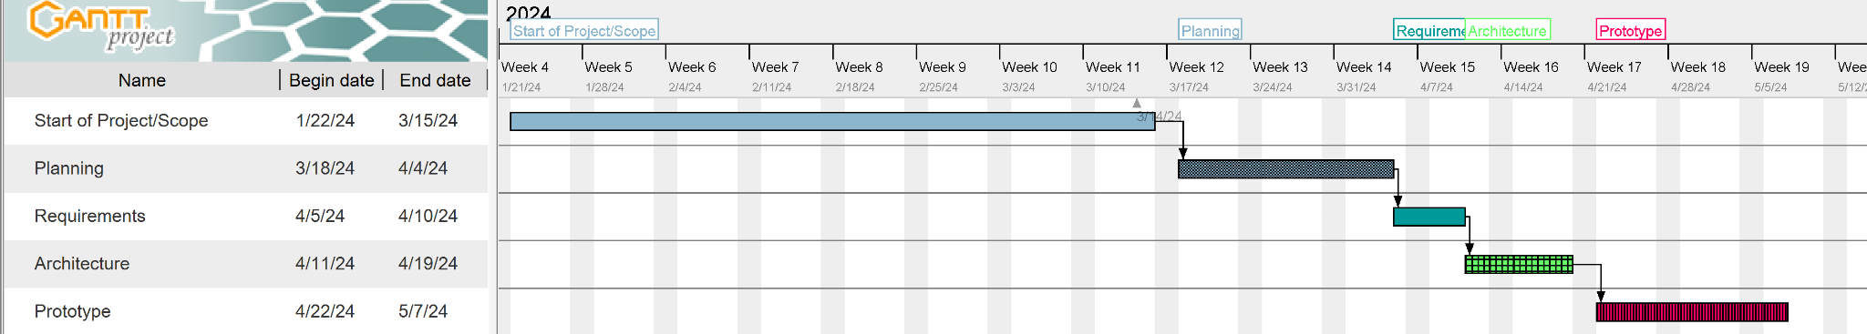

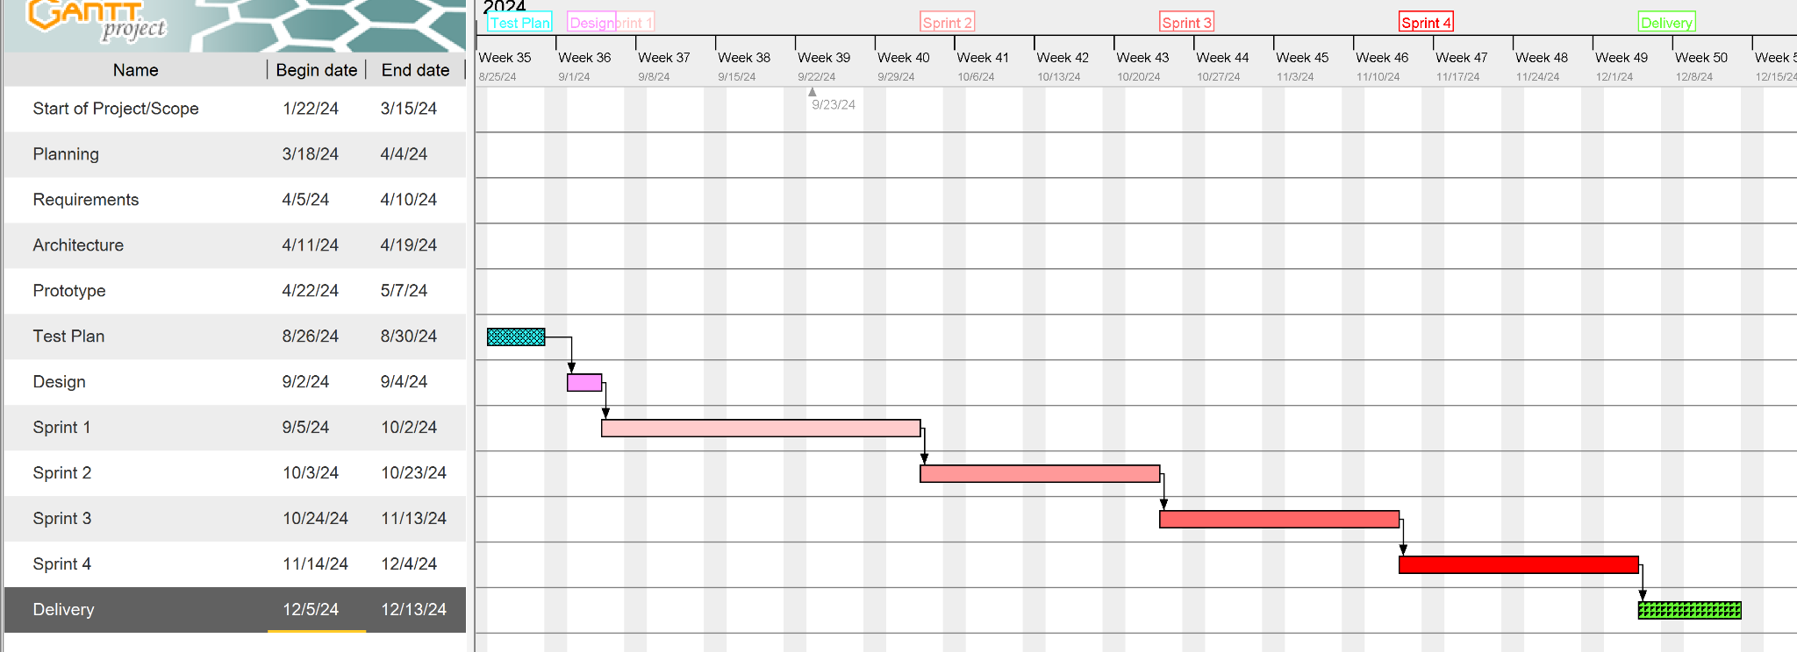

# 

# 

# 6. BUDGET

|  |  |  |  |  |  |
| --- | --- | --- | --- | --- | --- |
| **FIRST YEAR TRAVELEYE BUDGET** | | | | | **TOTAL** |
| **People** | | | | |  |
| **Team Members:** | Errand | Owen | Jacob | Adam |  |
| **Hourly Salary:** | $55.00 | $55.00 | $55.00 | $55.00 |  |
| **Multiplier:** | 2 | 2 | 2 | 2 |  |
| **Billable** | $110.00 | $110.00 | $110.00 | $110.00 |  |
| **Hours per Week** | 6 | 6 | 6 | 6 |  |
| **Two Semesters** | $23,760.00 | $23,760.00 | $23,760.00 | $23,760.00 |  |
|  |  |  |  |  |  |
|  |  |  |  |  | -$95,040.00 |
| **Software** | | | | |  |
| **Name** | **Cost** |  |  |  |  |
| Raspberry Pi OS | N/A |  |  |  |  |
| SDR++ | N/A |  |  |  |  |
| Github | N/A |  |  |  | $0.00 |
| **Hardware (prototype)** | | | | |  |
| **Name** | **Cost** |  |  |  |  |
| Raspberry Pi 3 B+ | $35.00 |  |  |  |  |
| Screen | $35.00 |  |  |  |  |
| RTL-SDR Dongle | $40.00 |  |  |  |  |
| Battery | $20.00 |  |  |  |  |
| Case | $5.00 |  |  |  | -$135.00 |
| **Revenue** | | | | |  |
| **Parts cost** | **Manufacturing** | **Unit Price** | **Units Sold** |  |  |
| $40.00 | $10.00 | $60.00 | 10000 |  |  |
|  |  |  |  |  | $100,000.00 |
|  |  |  |  | **NET PROFIT:** | **$4,825.00** |

# 7. VALIDATION PLAN

## Test Strategy

We will be done when we have a working product that can successfully detect hidden devices using radio waves and display that information effectively to the user. The device should have a reasonable success rate that would make the device practical in real world use.

Success would be a fully complete project with little to no bugs. The device would be able to detect cameras, display information to users, and provide tips and solutions to remove/block cameras within the area.

# 8. FEASIBILITY STUDY

## Risk Identification

**Incorporating SDR++ in our program**

We are using a third party application SDR++ to process the data coming from the RTL-SDR dongle. Getting the data from SDR++ might take a lot of effort and there might be more processing on our end to be done in order for the data to be useful

**Radio frequency reading accuracy**

We are relying on a third party dongle to read all the radio frequency data. The data from the dongle may not be accurate enough for our uses. It might require the device to be really close in order to be effective. Additionally, we need to determine which ranges of radio frequency will be flagged as a surveillance device

**UI functionality**

The UI of our device will require different paths and must present the data in a user friendly way. The UI may take more effort than intended and could end up having a UI that is not friendly to nontechnical people.

## Risk Prioritization

1. **Radio frequency reading accuracy**
2. **Incorporating SDR++ in our program**
3. **UI functionality**

## Risk Mitigation

These risk issues arise from a lack of knowledge our team has on certain aspects of this project. To limit this, starting on the prototype as soon as possible will allow our team time to learn these new concepts and test them well before our deadline. Ideally these problems can be figured out early on, so we can focus on other, less risky parts of the project

We will first prototype the UI and start gathering data from the dongle. We can split our team and focus on these two aspects and bring them together in our first prototype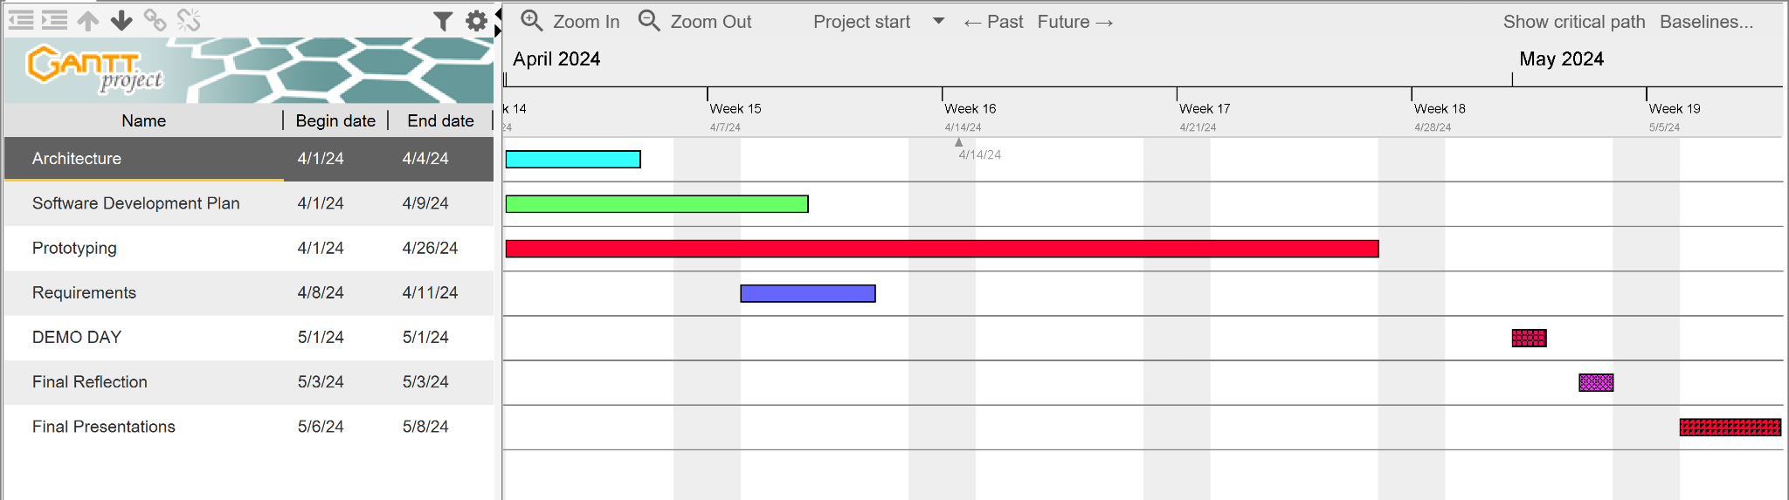

# 9. CONFIGURATION AND VERSION CONTROL

We will be primarily utilizing GitHub for version control and all project related artifacts. Versions of our software will be stored to GitHub and loaded onto the device for testing.

# 10. TOOLS

**Github** - communication and code saving/importing

**RTL-SDR** - physical device and drivers for detecting radio frequencies

**Python -** Programming language used

**Raspberry Pi OS** - the debian based operating system our device will run on

**Flipper Zero -** Used for testing frequency detection

**Autodesk Fusion -** CAD software for designing case

# 11. ARCHITECTURE

Components

* RTL-SDR (V3)
* Raspberry Pi (3B+)
* Raspberry Pi Battery (PiSugar S Plus)
* Touch Screen (Hosyond 7-inch HDMI)
* SMA Antenna (Bingfu BFN00419)
* Normal Open Button (Twidec Push Button 7mm)
* HDMI cable
* Micro USB cable
* Male to Female USB cableA diagram of a computer

  Description automatically generated