Software Requirement Specification

TravelEye

Dec 2, 2024

Version 2

**Logo**

**

**Presented To:**

CSC354

**Submitted By:**

Erand Bizati

Owen Campain

Jacob Philips

Adam Wisnewski

**Table of Contents**

**Revision History 1**

**1.0 Introduction 2**

**1.2 Scope 2**

**2.0 Related Documents 3**

**3.0 Requirements 3**

**3.0.1 Punch List 4**

**3.1 Traveler Use Cases 4**

**3.1.1 Disable Device Instructions 4**

3.1.2 View Detected Signals 5

3.1.3 Detect Wireless Signals 5

3.1.4 Charge & Power On Device 6

3.1.5 View Help Page 6

**3.1.6 User Interface Requirements 7**

**4.0 Non Functional Requirements 8**

**4.1 Other Systems 8**

**4.2 Usability 8**

**4.3 Performance 8**

**4.4 Maintainability 8**

**5.0 Architecture 9**

**Signature Page 9**

### **Revision History**

| **Date** | **Author** | **Distributed to** | **Version** | **Description** |
| --- | --- | --- | --- | --- |
| Mar 26, 2017 | DeMarco | class | 0 | template |
| Feb 6, 2024 | Team |  | 1 | Document creation |
| Dec 2, 2024 | Adam, Owen |  | 2 | Revise based on final project |

# 

# **1.0 Introduction**

This project aims to create a device that can help detect hidden surveillance items for travelers staying in temporary lodging (hotels, Airbnb, resorts, ect.). This device should be easy to use and accessible to all levels of technical knowledge. The device will use radio frequency detection to identify any possible hidden surveillance devices (cameras, audio recorders, gps trackers). If a potential device were to be found, instructions on how to find and disable the device will be given to the traveler.

This document outlines the different specifications and requirements for this device in order to reach the project's goal.

# **1.2 Scope**

The following context diagram defines the actors that are outside the system:

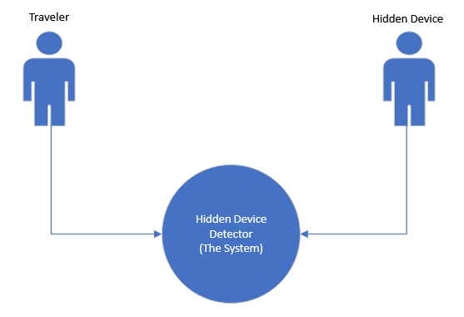

**Traveler:**

The traveler is a term used for the person using the hidden device detector.

**Hidden Device:**

The hidden device is any type of surveillance device which is hidden from the traveler and gives off a radio frequency which the hidden detector could capture.

The following use case diagram outline all of the possible interactions of outside actors with the system:

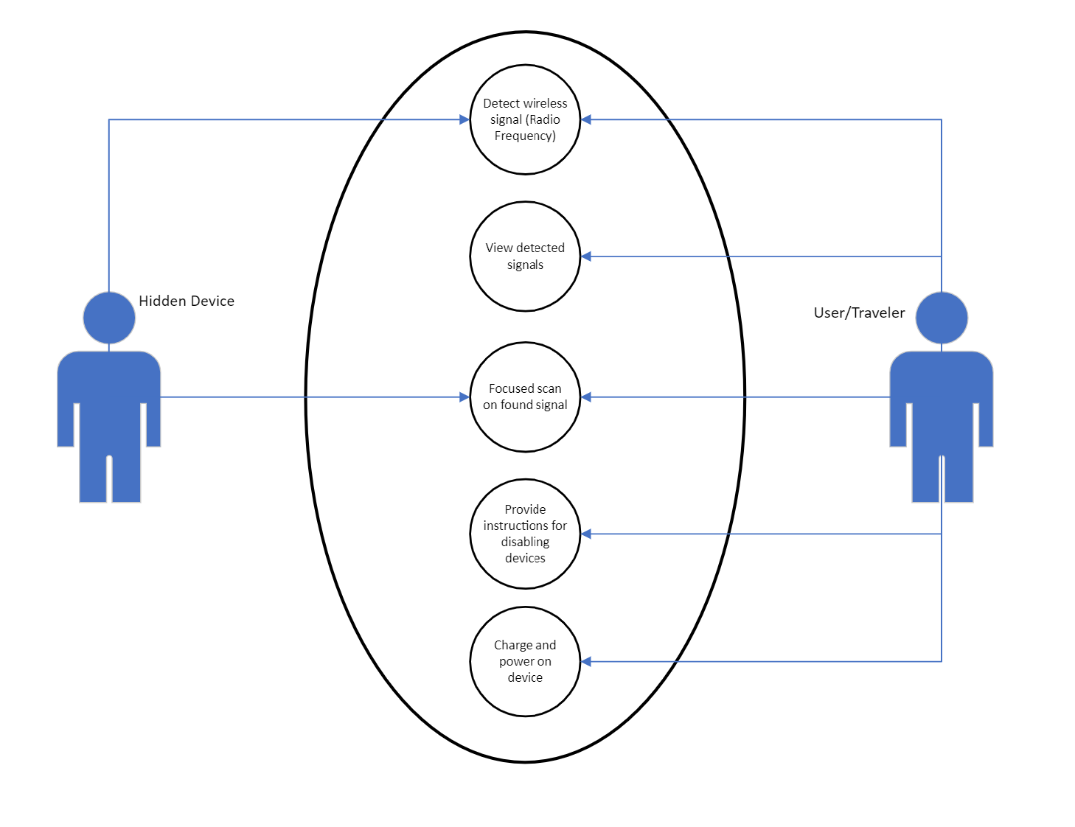

# **2.0 Related Documents**

[Context diagram link](https://livekutztown-my.sharepoint.com/:u:/g/personal/ocamp731_live_kutztown_edu/EfgFj-SR3vRDpL-uXIwYaXIBtWyubmAtK4f2kyQ_DjDRew?e=GwLN2W)

[User stories link](https://livekutztown-my.sharepoint.com/:w:/g/personal/ocamp731_live_kutztown_edu/EWKVq6K5wFBMgKUtSu_duCwBPiiVJmcgEb2n8JfCiHcrRQ?e=WRgexO)

[Use case diagram link](https://livekutztown-my.sharepoint.com/:u:/g/personal/ocamp731_live_kutztown_edu/EYCpy4jRvH9Dqu8j2hU3GG8BV4mq3jjaOgJnNMZ3DxsZhQ?e=OJp9kp)

[Use case description link](https://livekutztown-my.sharepoint.com/:w:/g/personal/ocamp731_live_kutztown_edu/Ef0b5joFGqxItQ4MdqtdzXMBfyyNTd9R-CmtZxJ7pXRLpg?e=YlDLOt)

# **3.0 Requirements**

For each Actor, list all the user stories:

As a Traveler I want to…..

* Turn on the device
* Charge device
* Scan for signals using device
* See any signals detected
* Learn steps to disable device
* Find out how to hinder device if unable to disable

As a Hidden device I want to…..

* Emit a radio frequency for the device to read

## 3.0.1 Punch List

The following list are the items still to be resolved:

1. Figure out how to get signal information from SDR++ to our own software
2. Design the hardware architecture
3. Figure out language and platform for our software
4. Design UI flow
5. Order needed hardware

# 3.1 Traveler Use Cases

## 3.1.1 Disable Device Instructions

**Description:** Be informed on how to disable a hidden device when found

1. **Participating Actor(s)**:
   1. Traveler
   2. Hidden Device
2. **Entry**: Hidden Device is found
3. **Exit**: Device is disabled
4. **Flow of events**:
   1. Device signal is detected
   2. User receives instructions on how to find the device
   3. User finds device
   4. User receives instructions on how to identify the type of device
   5. Hidden device type is determined
   6. User receives instructions on how to disable that type of device
   7. User disables device
5. **Special Requirements**:
   1. User cannot find device -> give instructions what to do next
   2. User cannot determine device type -> give instructions that could apply to all device types
   3. User cannot disable device -> give instructions on what to do next

## 3.1.2 View Detected Signals

**Description:** View any signals that have been detected

1. **Name**: View Detected Signals
2. **Participating Actor(s)**:
   1. Traveler
   2. Hidden device
3. **Entry**: The user has initiated a scan, and the system must be powered on.
4. **Exit**: User has viewed all detected systems
5. **Flow of events**:
   1. User activated scan
   2. Detected signals are compiled/analyzed by the system
   3. System categorizes based on signal type, strength, and source
   4. List of detected signals is displayed on screen
   5. User reviews list of signals
6. **Special Requirements**:
   1. If no signals are detected, inform the user
   2. Provide a refresh button/adjust sensitivity detection

## 3.1.3 Detect Wireless Signals

**Description:** Detect any wireless signals (radio frequencies) present in a room

1. **Participating Actor(s)**:
   1. Traveler
   2. Hidden Device
2. **Entry**: Device powered on, Scan initiated by user
3. **Exit**: Signal is found and the whole room is scanned
4. **Flow of events**:
   1. System starts scanning for signals
   2. User moves scanning device around the room
   3. Wireless signal is received
   4. Signal frequency and type are determined
   5. Signal information is stored locally
   6. Signal information (type, strength, and source) is displayed to user
5. **Special Requirements**:
   1. No signal found -> inform user that no signals were detected

## 3.1.4 Charge & Power On Device

**Description:** Charge the device fully and power it on with no problems

1. **Name**: Charge and Power On Device
2. **Participating Actor(s)**:
   1. Traveler
3. **Entry**: A place with adequate electricity outlets
4. **Exit**: The hidden camera device is fully charged and powered on
5. **Flow of events**:
   1. Plug charger into device
   2. Screen displays battery percentage
   3. Fully charged
   4. Unplug device
   5. Press power button
6. **Special Requirements**:
   1. If Powered on with low battery inform user that device needs to be charged

## 3.1.5 View Help Page

**Description:** view a help page on how to use device

1. **Participating Actor(s)**:
   1. Traveler
2. **Entry**: Start up device
3. **Exit**: Help page is open and read
4. **Flow of events**:
   1. Turn on device
   2. Wait for main menu to show
   3. Click on help button
   4. Read through Help section
5. **Special Requirements**:
   1. If User already knows how to use device, no need to read

## 3.1.6 User Interface Requirements

The user interface should be as simple as possible and intuitive. Since this device is a tool there should not be a long process required to get into scanning the room. Ideally the traveler should be able to turn the device on and start scanning within seconds. This can be accomplished with a clear user interface that shows each of the devices features clearly and allows for quick access to each of these features.

## 

### **4.0 Non Functional Requirements**

Below is a list of non-functional requirements gathered so far. **Must be measurable.**

## 4.1 Other Systems

The system should not need an internet connection or any other wireless connection to any other outside systems. It should be able to function on its own. The system does rely on [SDR++](https://github.com/AlexandreRouma/SDRPlusPlus), which is an open source project for interpreting incoming radio frequency signals.

## 4.2 Usability

The system is targeted towards any type of traveler so it must be convenient to bring along and easy to use and therefore should meet some usability requirements:

* Easily portable, comfortably fits in a standard backpack
* Usable with any level of technical knowledge (adult)
* Find majority of consumer grade surveillance devices

## 4.3 Performance

Each listening device is different and can cause differences in how they are detected, however there is an average performance expectation for most devices:

* Detect a device from 3ft away
* 90% detection rate
* 8 hr battery life

## 4.4 Maintainability

* No updates required for the software created by our team
* Since RTL-SDR and Raspian OS are outside of the project control there may be updates to these components, however the current build is stable and should be sufficient for the use in this project.

# **5.0 Architecture**

# 

**Hardware Use Cases/Functionality**

**Raspberry Pi:** Acts as the “core controller”. Processes input from detector(s).

**RTL - SDR :** Used to analyze RF (radio frequencies) as many hidden devices transmit data over RF.

**Battery:** Provides power to device without the need to be plugged in

**3d Printed Case:** A 3d printed case that will house all of the various components.

**Antenna** - Provide raw analog signal data to RTL-SDR

**Touch Screen** - Allows user to see scan results and interact with device