DATASTRUCTURES AND ALGORITHMS

LAB 01 EC 4070

K.M.J.G.S.C.W. Bandara

2021E073

LAB 1

SEMESTER 4

EC4070

Q1.

import java.util.Scanner;

public class Calculator {

private double nmb1;

private double nmb2;

private double sum;

public Calculator() {

nmb1 = 0;

nmb2 = 0;

sum = 0;

}

public void addition() {

sum = nmb1 + nmb2;

}

public void subtraction() {

sum = nmb1 - nmb2;

}

public void division() {

sum = nmb1 / nmb2;

}

public void multiplication() {

sum = nmb1 \* nmb2;

}

public static void main(String[] args) {

Scanner scanner = new Scanner(System.in);

Calculator calculator = new Calculator();

System.out.print("Enter your first number : ");

calculator.nmb1 = scanner.nextDouble();

System.out.print("Enter your second number : ");

calculator.nmb2 = scanner.nextDouble();

System.out.print("Enter the op (+, -, \*, /) : ");

char op = scanner.next().charAt(0);

switch (op) {

case '+':

calculator.addition();

break;

case '-':

calculator.subtraction();

break;

case '/':

calculator.division();

break;

case '\*':

calculator.multiplication();

break;

default:

System.out.println("Invalid operator,try again");

break;

}

System.out.println("sum: " + calculator.sum);

scanner.close();

}

}

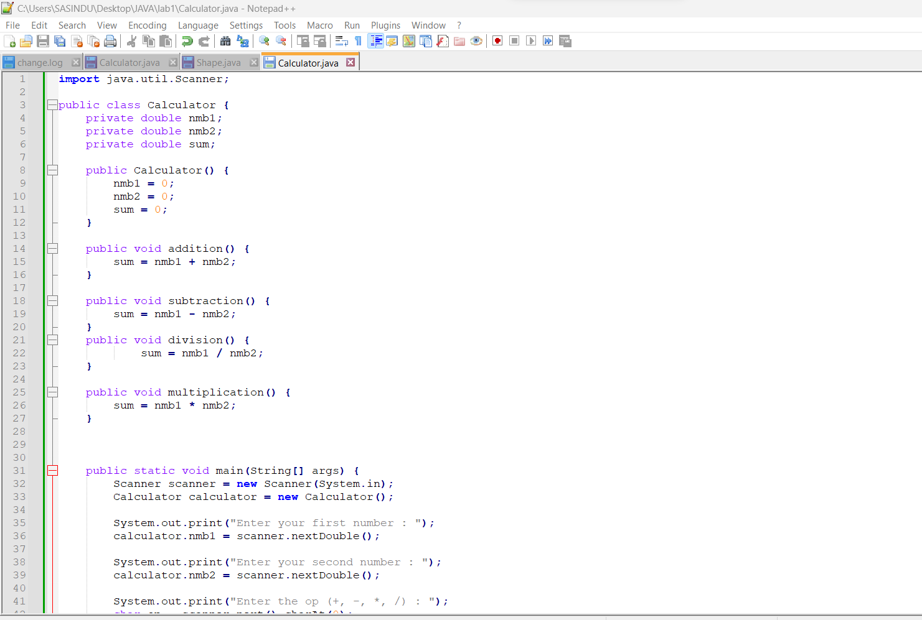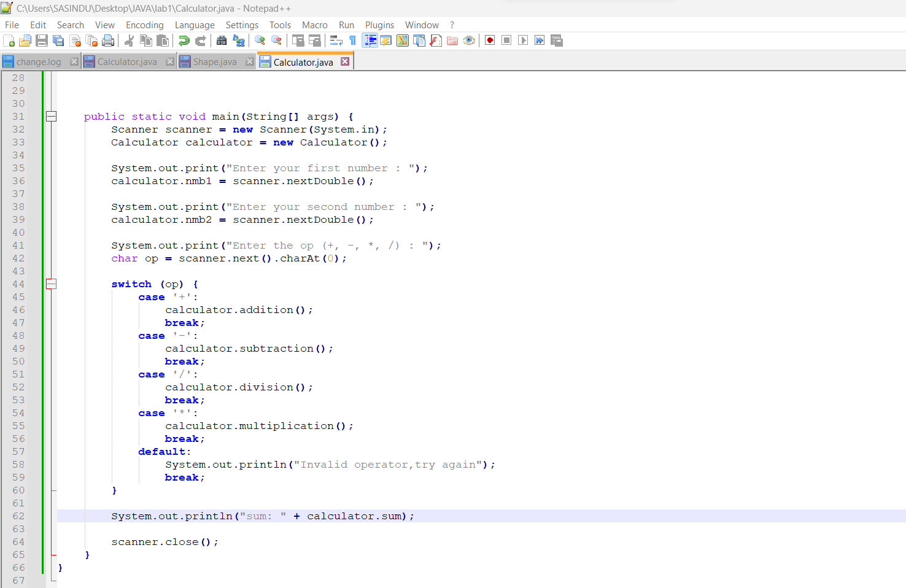

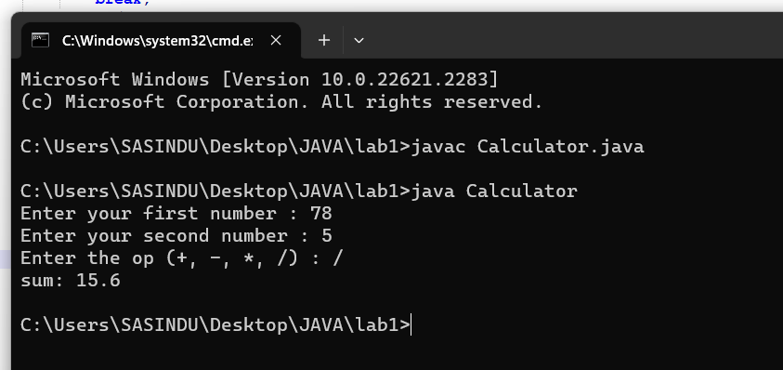

Q2.

abstract class Shape {

abstract double calculateArea();

abstract double calculatePerimeter();

}

class Circle extends Shape {

private double radius;

public Circle(double radius) {

this.radius = radius;

}

double calculateArea() {

return Math.PI\*radius\*radius;

}

double calculatePerimeter() {

return 2\*Math.PI\*radius;

}

}

class Triangle extends Shape {

private double s1, s2, s3;

public Triangle(double s1, double s2, double s3) {

this.s1 = s1;

this.s2 = s2;

this.s3 = s3;

}

double calculateArea() {

double s = (s1 + s2 + s3) / 2;

return Math.sqrt(s \* (s - s1) \* (s - s2) \* (s - s3));

}

double calculatePerimeter() {

return s1 + s2 + s3;

}

}

class Rectangle extends Shape {

private double length, width;

public Rectangle(double length, double width) {

this.length = length;

this.width = width;

}

double calculatePerimeter() {

return 2 \* (length + width);

}

double calculateArea() {

return length \* width;

}

}

public class Main {

public static void main(String[] args) {

Circle circle = new Circle(8);

System.out.println("Circle Of Area: " + circle.calculateArea());

System.out.println("Circle Of Perimeter: " + circle.calculatePerimeter());

Triangle triangle = new Triangle(7,5,9);

System.out.println("Triangle Of Area: " + triangle.calculateArea());

System.out.println("Triangle Of Perimeter: " + triangle.calculatePerimeter());

Rectangle rectangle = new Rectangle(4,7);

System.out.println("Rectangle Of Area: " + rectangle.calculateArea());

System.out.println("Rectangle Of Perimeter: " + rectangle.calculatePerimeter());

}

}

