**EC4040:** **SIGNALS AND SYSTEMS**

**LAB 01**

**“ANALYSIS OF SIGNALS AND SYSTEMS USING MATLAB”**

K.J.M.U.G.S. Eranda Jayasinghe

2021/E/075

SEMESTER 4

EC4070

06.10.2023

**REGISTRATION NUMBER**: 2021/E/075

**DATE:**

**PART 1 – ANALYSIS OF SIGNALS USING MATLAB**

**PART 1(a) – OBSERVING SIGNALS USING MATLAB**

%2021E075

%part 01 a

x = sym('x');

y=1/(1+x^2);

figure(1);

ezplot(y);

y1=1/(x^2);

figure(2);

ezplot(y1);

y2=log(x);

figure(3);

ezplot(y2);

y3=exp(x);

figure(4);

ezplot(y3);

y4=exp(-x);

figure(5);

ezplot(y4);

figure(6);

y5 = exp(x)*sin(20*x);

ezplot(y5,[0,3]);

figure(7);

y6 = exp(-x)*sin(20*x);

ezplot(y6,[0,3]);

figure(8);

t=0:0.0001:0.0625;

y7=square(2*pi*60*t);

plot(t,y7);

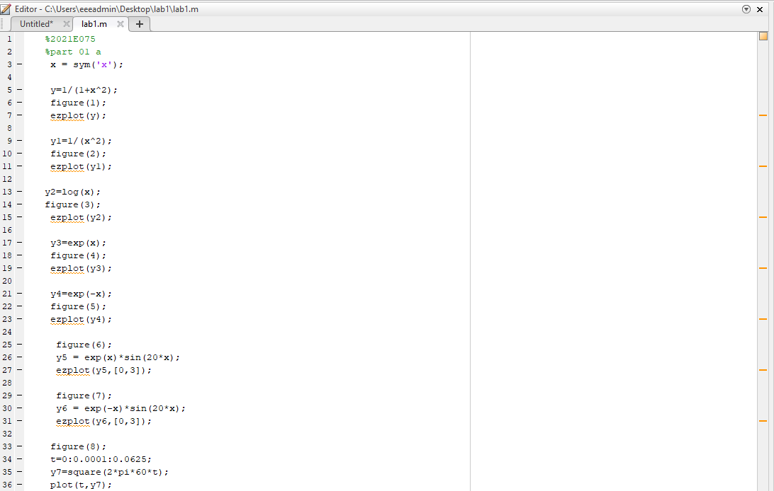

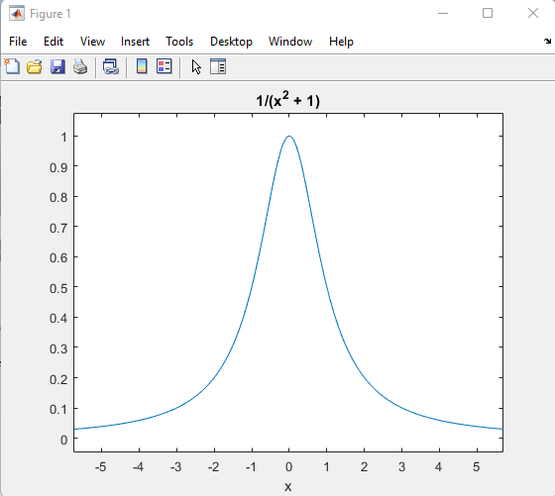

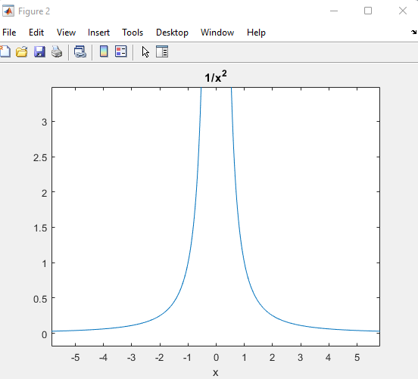

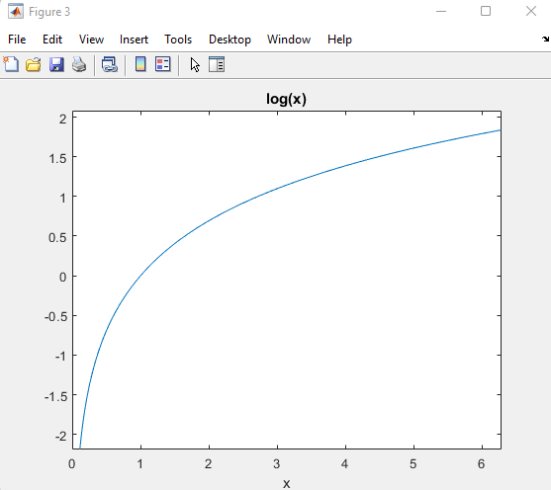

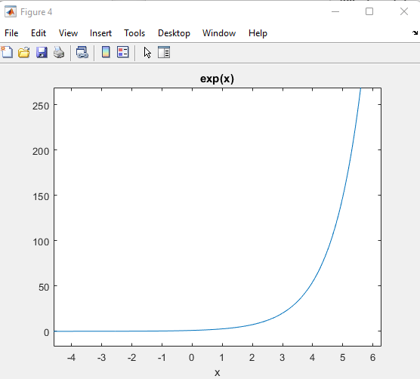

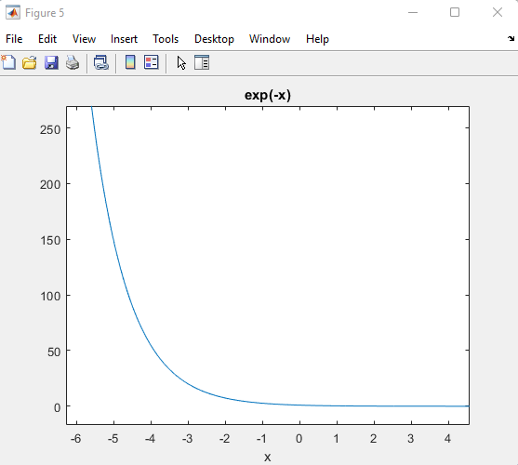

03.

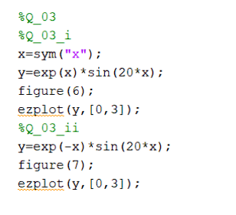

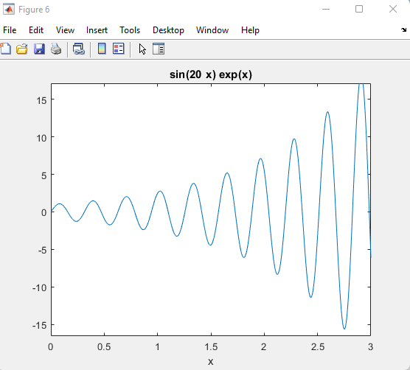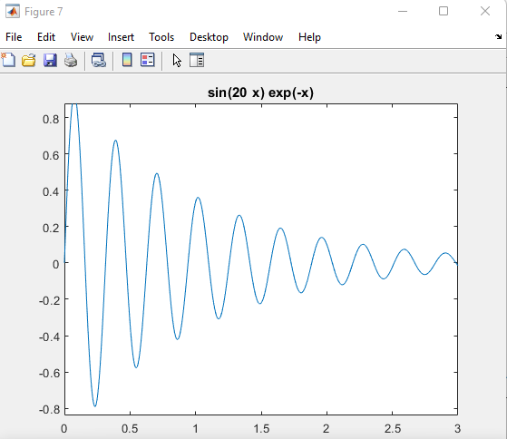

04.

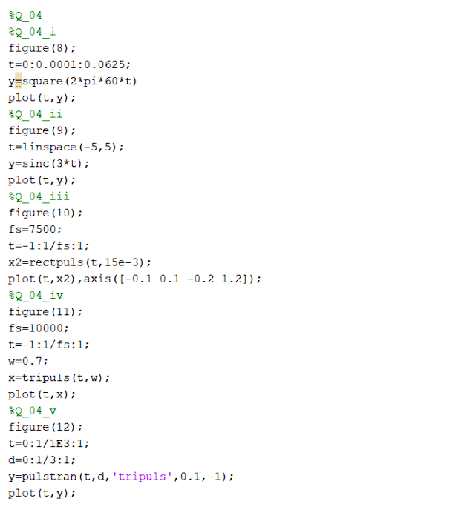

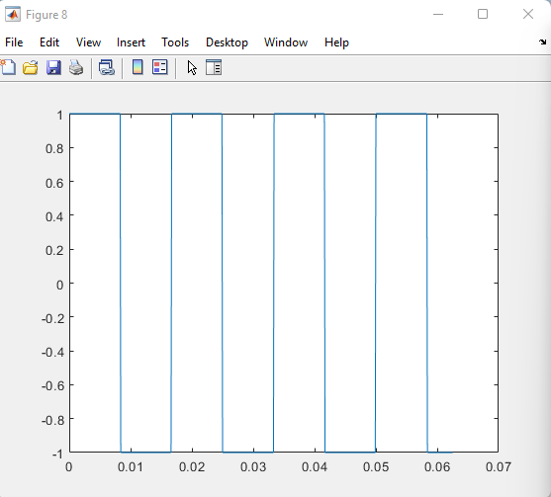

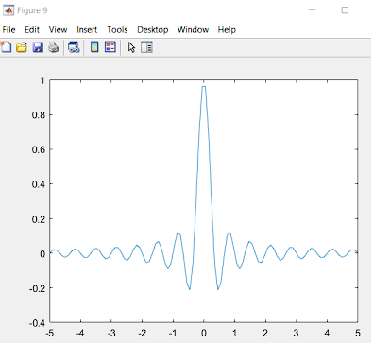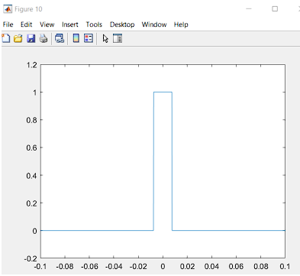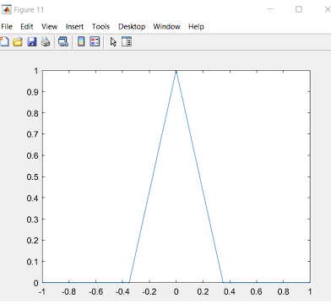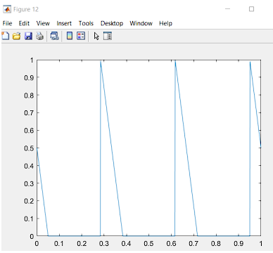

**1(b) - APPLICATION OF CONVOLUTION**

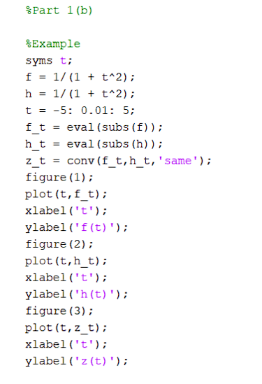

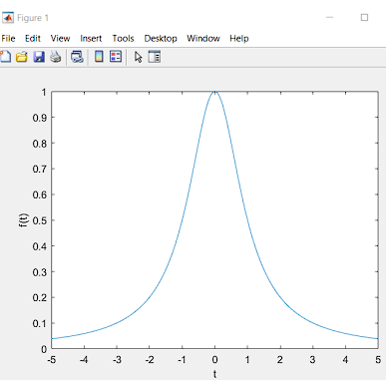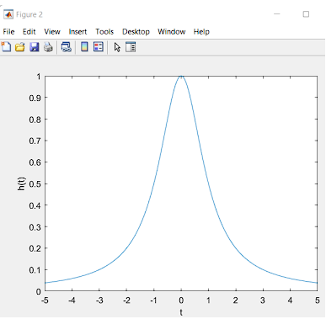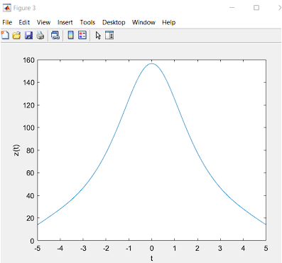

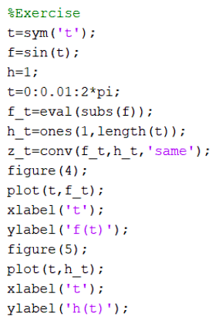

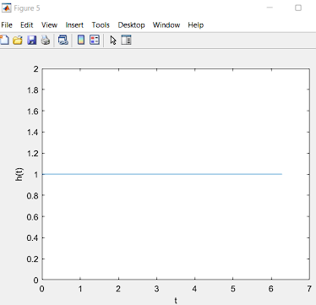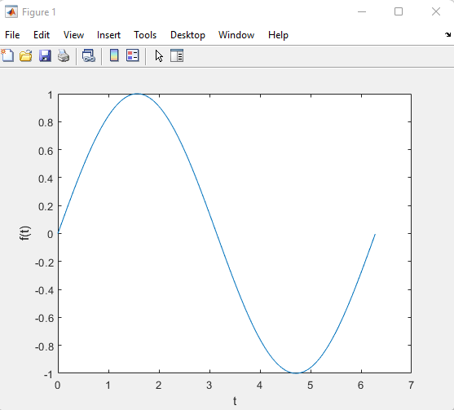

**PART 2 – ANALYSIS OF SYSTEMS USING MATLAB PART**

**2(a) – ANALYSIS OF SYSTEMS USING MATLAB CODES**

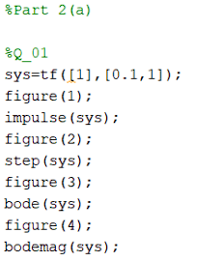

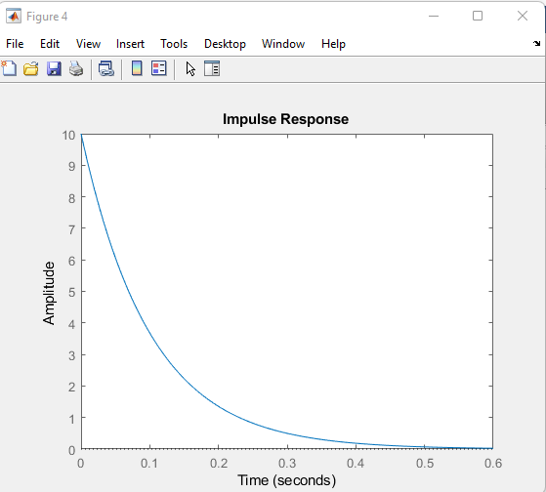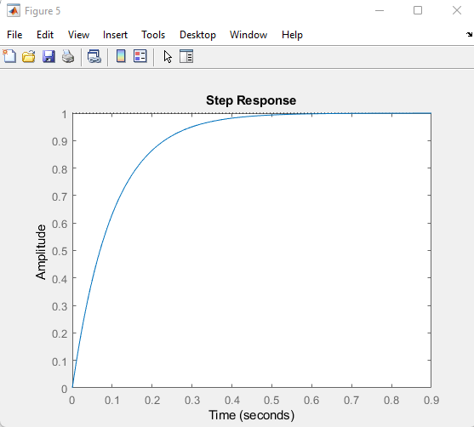

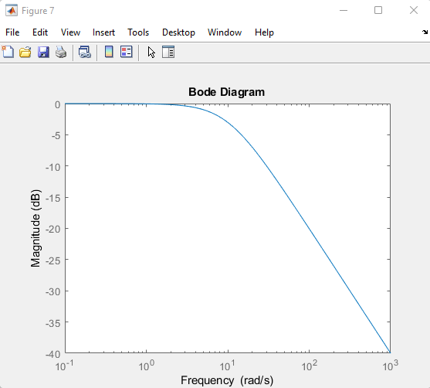

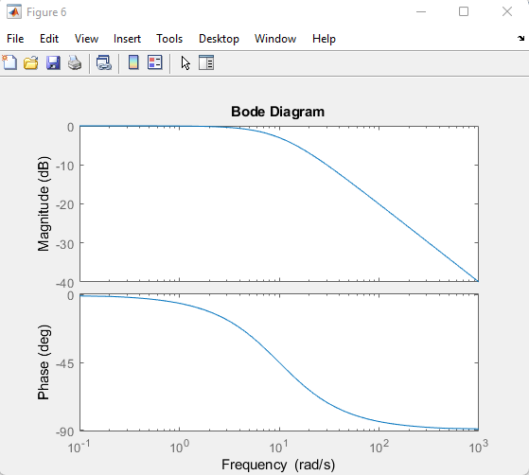

02.



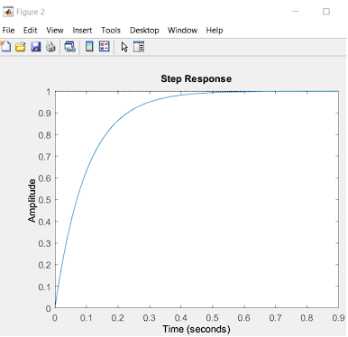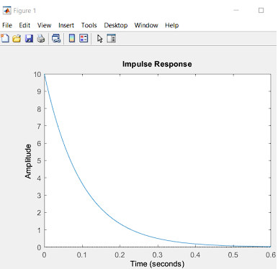

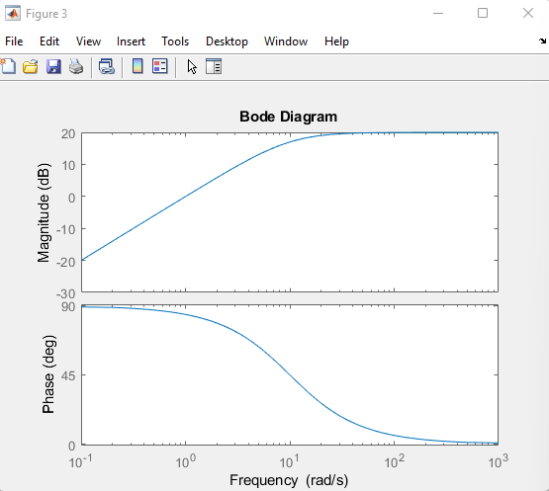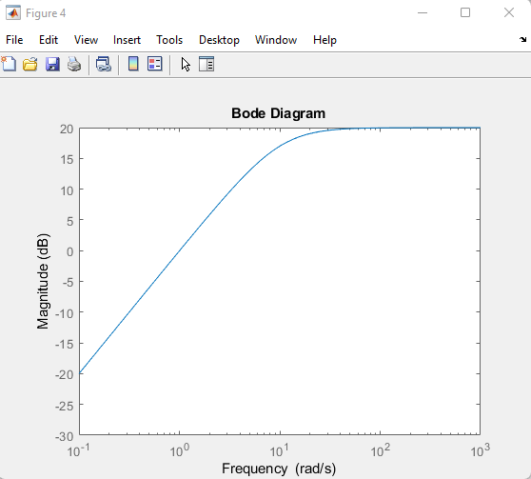

iv.   
The characteristics delineated in the provided statements appear to relate to the time-domain behavior of linear time-invariant (LTI) systems, which are represented by transfer functions G(s) and H(s).

The proposition that the impulse response of G(s) diminishes and converges towards a steady state at zero amplitude signifies the stability of G(s) when exposed to an impulse input. Conversely, the indication regarding the step response of G(s) rising and attaining a steady state at an amplitude of one implies a positive and stable response to a step input, ultimately settling at a new amplitude.

Contrarily, if the impulse response of H(s) increases and eventually reaches a steady state at zero amplitude, it signifies a stable reaction of H(s) to sudden changes. Meanwhile, the statement about the step response of H(s) decreasing and reaching a steady state at zero amplitude suggests stability and a return to the initial state following a step input.

03.

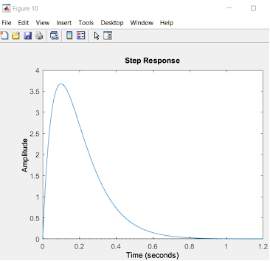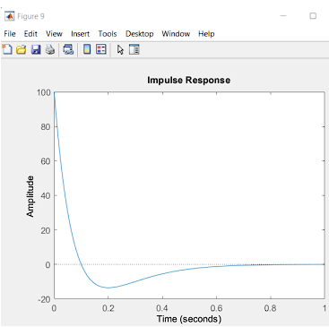

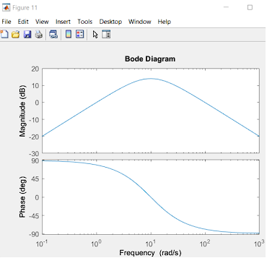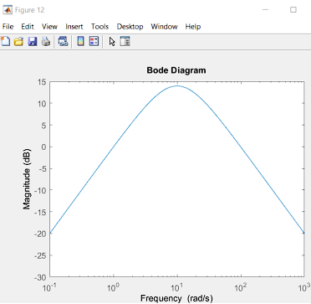

v.

The explanation hints at an examination of the combined system resulting from multiplying the transfer functions of H(s) and G(s), contrasting it with the behavior of each standalone system. When combining transfer functions to form a cascaded system, insights into the frequency response can be gleaned from the Bode Diagram. The statement suggests a transition in phase from 90 to -90 degrees in the cascaded system, indicating a reversal or alteration in the direction of phase shift compared to the individual systems. In the separate Bode Diagrams of H(s) and G(s), the phases are described as transitioning from 90 to 0 degrees for H(s) and 0 to -90 degrees for G(s). These phase shifts align with the typical response of systems to variations in frequency.

04.

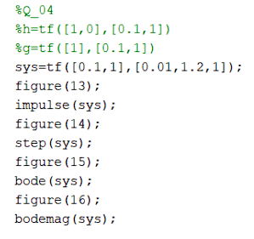

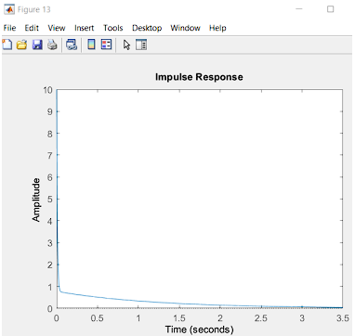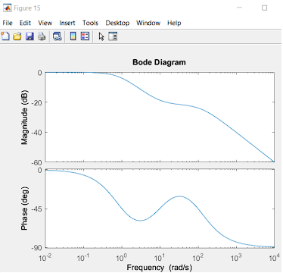

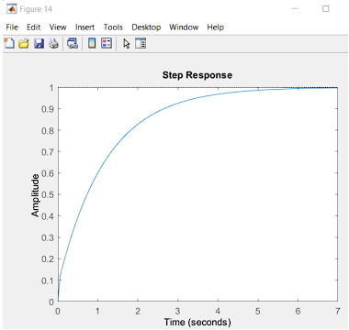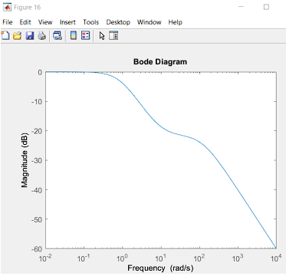

**PART 2(b) – ANALYSIS OF SYSTEMS USING MATLAB LTI VIEWER**

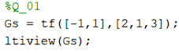

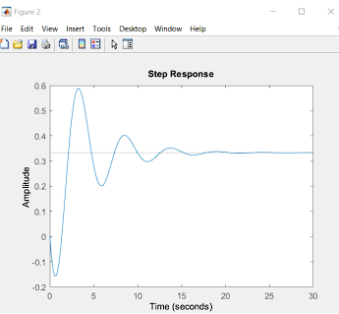

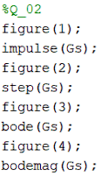

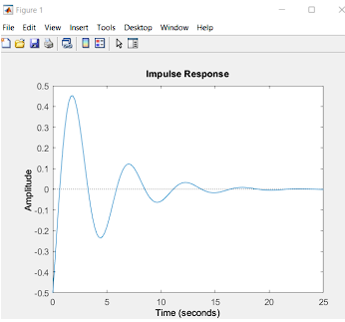

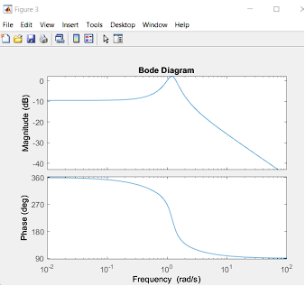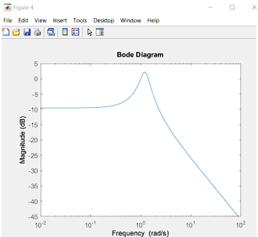

**Discussion:**

In Signals and Systems Lab 01, we delved into the world of signal and system analysis using MATLAB. The lab kicked off with a hands-on exploration of fundamental concepts, where we dived into signals, systems, and their mathematical representations. MATLAB became our go-to tool for visualizing and manipulating various types of signals.

A significant part of the lab was dedicated to understanding how signals behave under different operations like time scaling, time shifting, and amplitude scaling. MATLAB's capabilities proved crucial as we efficiently analyzed signal transformations, witnessing their effects in both time and frequency domains. This practical exercise enhanced our grasp of signal processing principles.

The lab also took us through the analysis of linear time-invariant (LTI) systems. By simulating system responses to different input signals, we gained insights into the characteristics of system outputs. This practical exploration deepened our understanding of how systems process signals, connecting theory to real-world applications.

Additionally, we tackled the concept of convolution, a key operation in the analysis of linear systems. MATLAB simulations allowed us to explore how convolution in the time domain corresponds to multiplication in the frequency domain. This exercise not only clarified the convolution process but also highlighted its importance in analyzing system behavior.

**Conclusion:**

In conclusion, Lab 01 was a rewarding journey into the analysis of signals and systems using MATLAB. The practical applications of theoretical concepts became evident through hands-on MATLAB simulations. This approach not only reinforced our theoretical foundation but also equipped us with essential skills for future coursework and practical applications.

MATLAB emerged as a powerful ally, enabling us to implement and visualize concepts covered in lectures efficiently. This lab marked a foundational step in our Signals and Systems course, laying a robust groundwork for future explorations and applications in the field of signal processing.

Top of Form