EC4070: Data Structures and Algorithms

LAB 02

K.J.M.U.G.S.E. JAYASINGHE

2021/E/075

SEMESTER 4

EC4070

29.09.2023

Q1

import java.util.Scanner;

public class Array{

public static void main (String[] args){

int[] arr;

arr = new int[20];

Scanner sc =new Scanner(System.in);

for(int a=0;a<20;a++)

{

System.out.print("enter the element: ");

arr[a] = sc.nextInt();

}

System.out.print("The array: ");

for(int b=0;b<20;b++)

{

System.out.print(arr[b]+" " );

}

System.out.print("\n");

System.out.print("Enter the number to swap: ");

int i = sc.nextInt();

System.out.print("Enter the second number to swap: ");

int j = sc.nextInt();

int temp = arr[i-1];

arr[i-1]=arr[j-1];

arr[j-1] =temp;

System.out.print("The array after swap: ");

for(int c=0;c<20;c++)

{

System.out.print(arr[c]+" ");

}

System.out.print("\n");

System.out.print("Enter k th element: ");

int k= sc.nextInt();

System.out.println("The k th element is: "+arr[k-1]);

int[] arr1 = new int[19];

for(int d=0,f=0; d<20&&f<19;d++)

{

if(d==k-1)

{

continue;

}

arr1[f++]=arr[d];

}

System.out.print("The array after deletion : ");

for(int e=0; e<19 ;e++)

{

System.out.print(arr1[e]+" ");

}

System.out.print("\n");

int[] arr2= new int[20];

System.out.print("Enter new element: ");

int n=sc.nextInt();

for (int d=0,h=0;d<19 && h<20;d++)

{

arr2[h++]=arr1[d];

}

arr2[19]=n;

System.out.print("after the insertion: ");

for (int p=0;p<20;p++)

{

System.out.print(arr2[p]+" ");

}

System.out.print("\n");

System.out.print("Enter the element: ");

int ele = sc.nextInt();

int index=20 ;

for (int x=0;x<20;x++)

{

if(arr2[x]==ele)

{

index =x;

}

}

if(index==20)

{

System.out.println("Element is not found in this array");

}

else

{

System.out.println("Element is in the array");

} }}

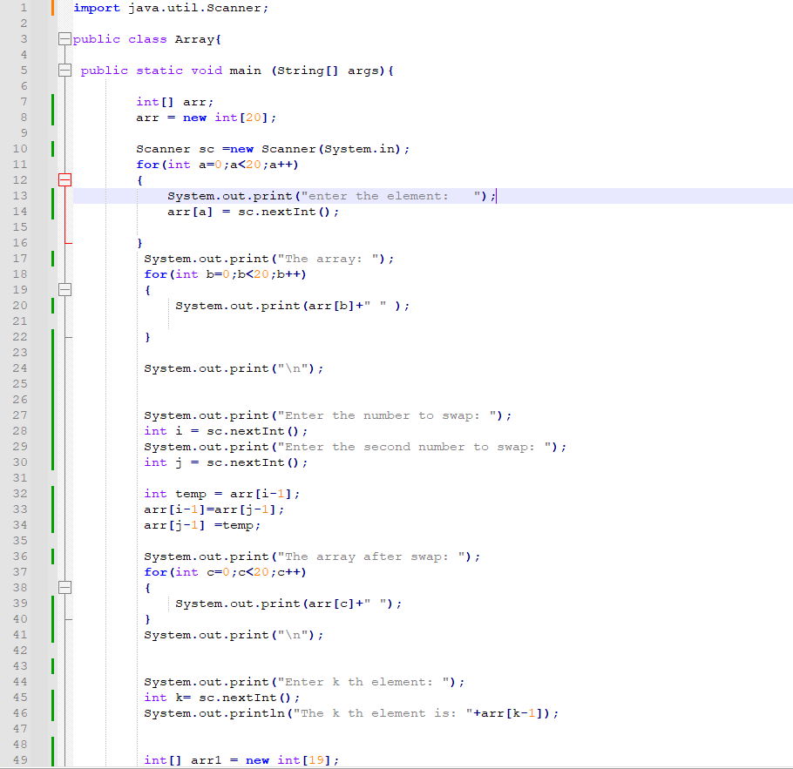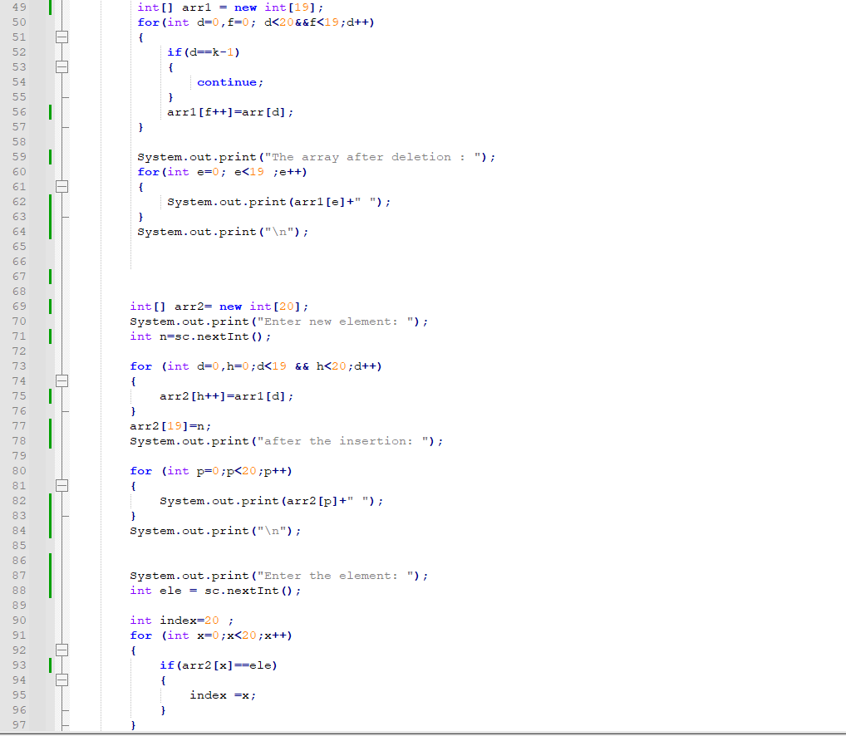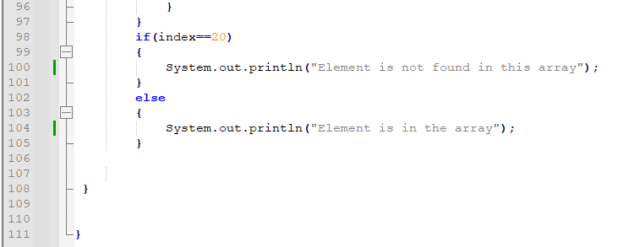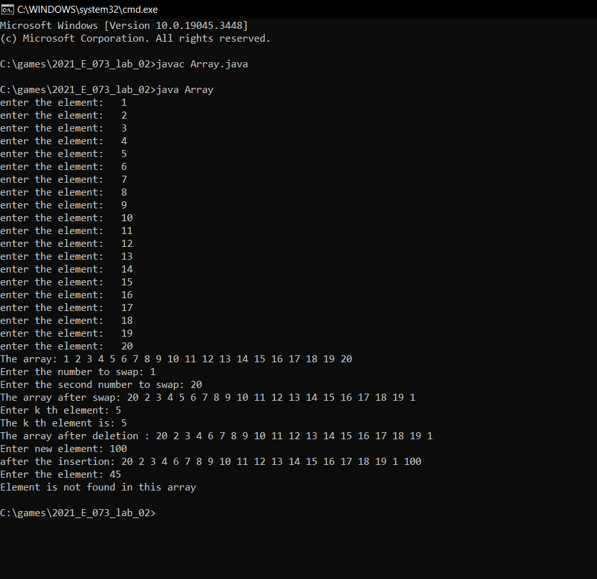

Q2

import java.util.Scanner;

public class array{

int[] arr = new int[20];

int num1,num2,temp,numDisplay,numDelete,numAdd,elementAdd,indexAdd,x,y,numSearch;

public void arrRead(){

Scanner scanner = new Scanner(System.in);

for(int i=0; i<20; i++){

System.out.print("Enter a Number : ");

arr[i] = scanner.nextInt();

}

}

public void arrPrint(){

for(int i=0; i<20; i++){

System.out.print(arr[i] + " ");

}

System.out.print("\n");

}

public void arrSwap(){

Scanner scanner = new Scanner(System.in);

System.out.print("\nEnter first number to Swap : ");

num1 = scanner.nextInt();

System.out.print("Enter second number to Swap : ");

num2 = scanner.nextInt();

temp = arr[num1-1];

arr[num1-1] = arr[num2-1];

arr[num2-1] = temp;

System.out.print("\n");

for(int i=0; i<20; i++){

System.out.print(arr[i] + " ");

}

System.out.print("\n");

}

public void printElement(){

Scanner scanner = new Scanner(System.in);

System.out.print("Enter the number if you want to Display : ");

numDisplay = scanner.nextInt();

System.out.print("The number is " + arr[numDisplay-1]);

System.out.print("\n");

}

public void deleteElement(){

Scanner scanner = new Scanner(System.in);

System.out.print("Enter the number want to Delete : ");

numDelete = scanner.nextInt();

for (int j=(numDelete-1); j<19; j++){

arr[j] = arr[j+1];

}

System.out.print("\n");

for(int i=0; i<20; i++){

System.out.print(arr[i] + " ");

}

System.out.print("\n");

}

public void addElement(){

Scanner scanner = new Scanner(System.in);

System.out.print("Enter the Number to add the arry : ");

numAdd = scanner.nextInt();

System.out.print("Enter the place in the arry : ");

elementAdd = scanner.nextInt();

indexAdd = elementAdd - 1;

for (int i=19; i>indexAdd; i--){

arr[i] = arr[i-1];

}

arr[elementAdd] = numAdd;

System.out.print("\n");

for(int i=0; i<20; i++){

System.out.print(arr[i] + " ");

}

System.out.print("\n");

}

public void elementSearch(){

Scanner scanner = new Scanner(System.in);

x = 1;

y = 0;

while (x<3){

x++;

System.out.print("\nEnter the Number search : ");

numSearch = scanner.nextInt();

for (int k=0; k<20; k++){

if (arr[k] == numSearch){

System.out.print("Number that you search is Element of the array.");

y++;

}

else if(arr[k] != numSearch && k==19 && y==0){

System.out.print("Number that you search is not in the array.");

}

}

y = 0;

}

}

public static void main(String[] args){

array obj1 = new array();

obj1.arrRead();

obj1.arrPrint();

obj1.arrSwap();

obj1.printElement();

obj1.deleteElement();

obj1.addElement();

obj1.elementSearch();

}

}

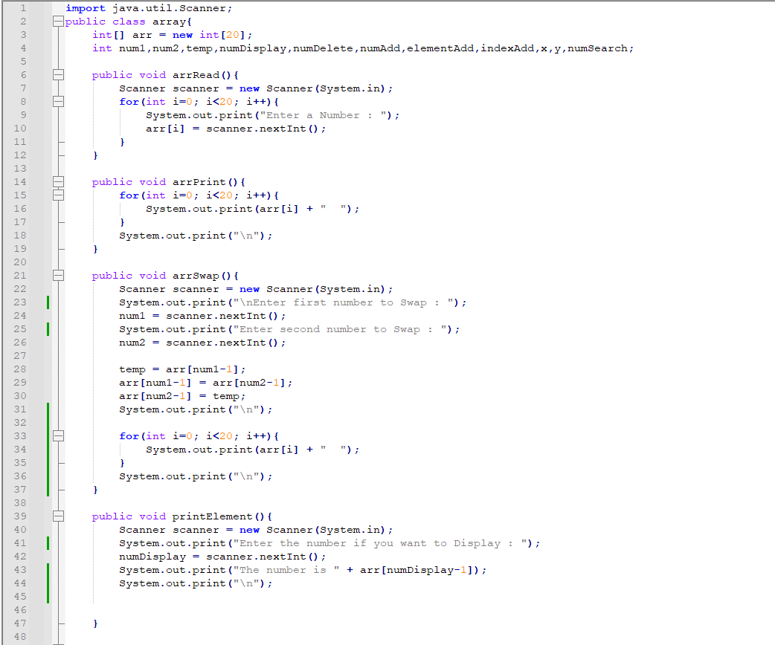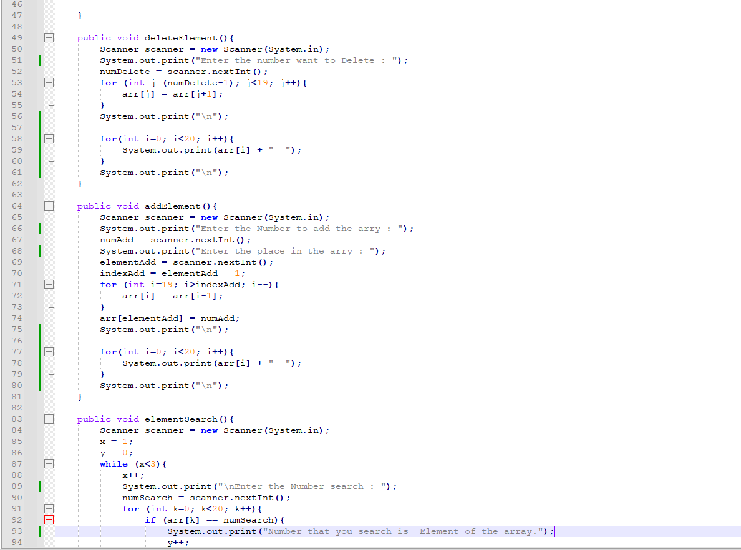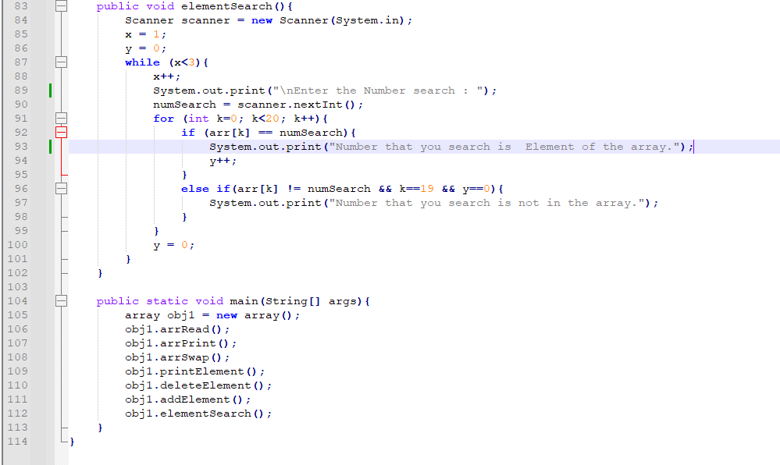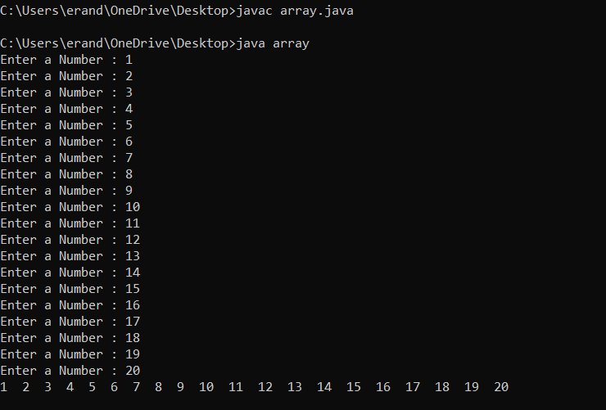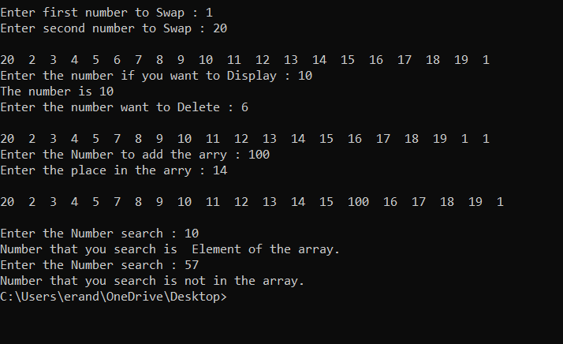

Q3

import java.util.Scanner;

public class Sorting {

private int[] arr;

public Sorting(int[] arr) {

this.arr = arr;

}

public int linearSearch(int t) {

for (int i = 0; i < arr.length; i++) {

if (arr[i] == t) {

return i;

}

}

return -1;

}

public void bubbleSort() {

int n = arr.length;

boolean swapped;

for (int i = 0; i < n - 1; i++) {

swapped = false;

for (int j = 0; j < n - i - 1; j++) {

if (arr[j] > arr[j + 1]) {

int temp = arr[j];

arr[j] = arr[j + 1];

arr[j + 1] = temp;

swapped = true;

}

}

if (!swapped) {

break;

}

}

}

public void insertionSort() {

int n = arr.length;

for (int i = 1; i < n; i++) {

int k = arr[i];

int j = i - 1;

while (j >= 0 && arr[j] > k) {

arr[j + 1] = arr[j];

j = j - 1;

}

arr[j + 1] = k;

}

}

public void selectionSort() {

int n = arr.length;

for (int i = 0; i < n - 1; i++) {

int m = i;

for (int j = i + 1; j < n; j++) {

if (arr[j] < arr[m]) {

m = j;

}

}

int temp = arr[m];

arr[m] = arr[i];

arr[i] = temp;

}

}

public void printarr() {

System.out.print("arr: ");

for (int num : arr) {

System.out.print(num + " ");

}

System.out.println();

}

public static void main(String[] args) {

Scanner scanner = new Scanner(System.in);

int[] arr = new int[20];

System.out.println("Enter 20 elements for the arr:");

for (int i = 0; i < 20; i++) {

System.out.print("Enter element : ");

arr[i] = scanner.nextInt();

}

Sorting sorting = new Sorting(arr);

System.out.println("Original arr:");

sorting.printarr();

System.out.print("Enter a number to search for: ");

int t = scanner.nextInt();

int x = sorting.linearSearch(t);

if (x != -1) {

System.out.println("Linear Search: Found at index " + x);

} else {

System.out.println("Linear Search: Not found");

}

sorting.bubbleSort();

System.out.println("Bubble Sort:");

sorting.printarr();

sorting.insertionSort();

System.out.println("Insertion Sort:");

sorting.printarr();

sorting.selectionSort();

System.out.println("Selection Sort:");

sorting.printarr();

scanner.close();

}

}

