**EC 4060 – COMPUTER AND DATA NETWORK**

**LAB 03**

K.J.M.U.G.S. Eranda Jayasinghe

2021/E/075

GROUP CG8

EC4060

13.11.2023

Q1.

OBJECTIVES: At the end of this lab you should be able to do,

• Write a simple program to simulate CRC.

• Write a simple program to simulate the Hamming code.

• Write a simple program to simulate the Go-Back-N (Sliding window) Protocol.

1. Cyclic Redundancy Check (CRC) CRC codes are often used for error detection over frames or vectors of a certain length. To get a convenient mathematical notation of the positions in the frame it can be expressed as a polynomial in 𝑥, where the exponent of 𝑥 is the place marker of the coefficient. The vector 𝑎 = 𝑎𝐿−1𝑎𝐿−2 … … … … 𝑎1𝑎0 length 𝐿 is represented by the degree 𝐿 − 1 polynomial

Write a pseudo code for a recursive algorithm to return the list of negative numbers that are in the given input list. Example: Input: [6, 3, -4, 9, -11, -2, 5] Output: [-4, -11, -2]

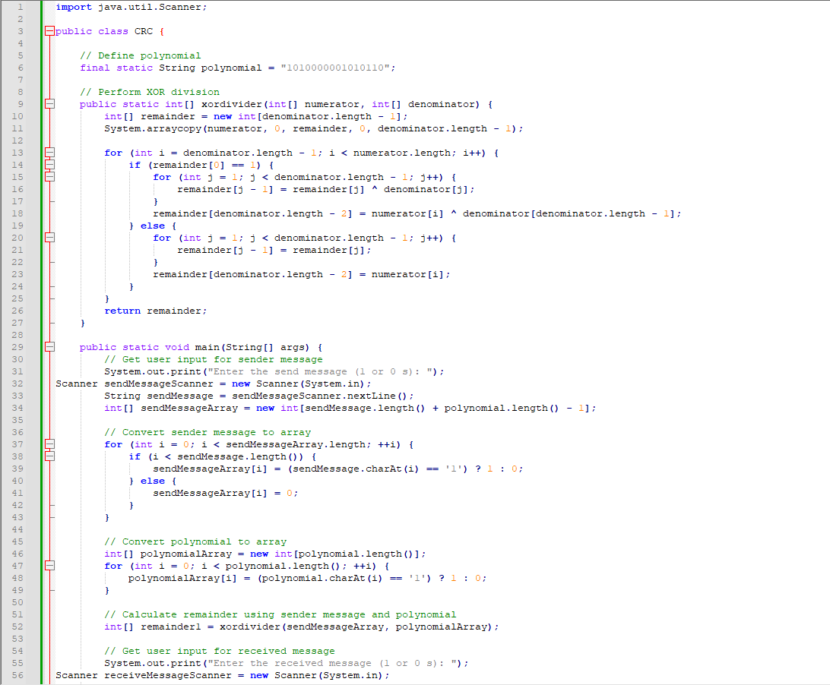

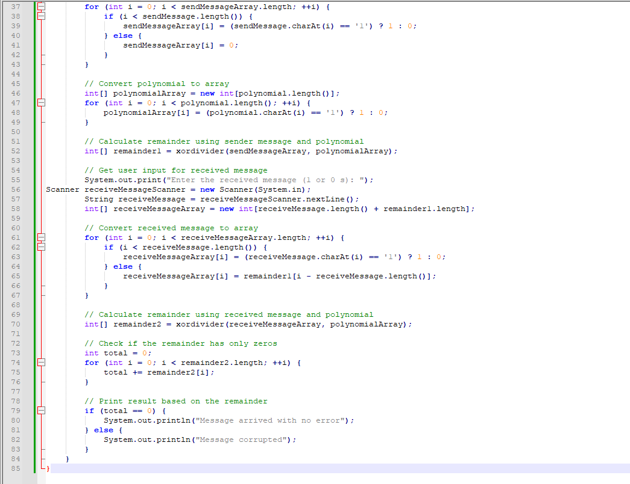

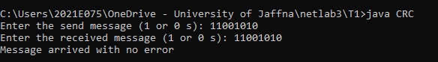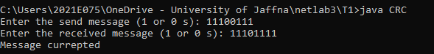

Q2.

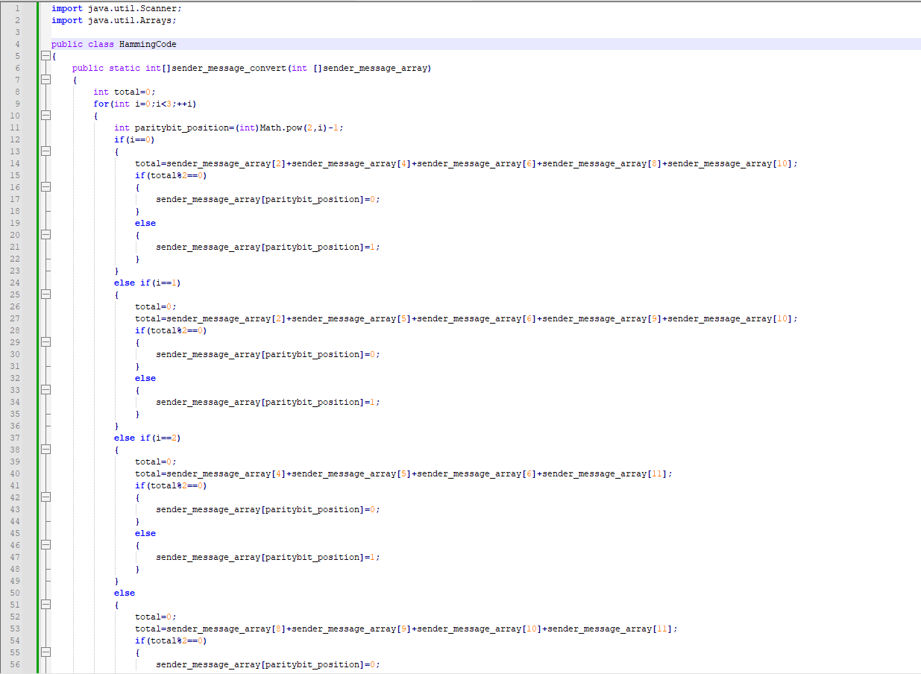

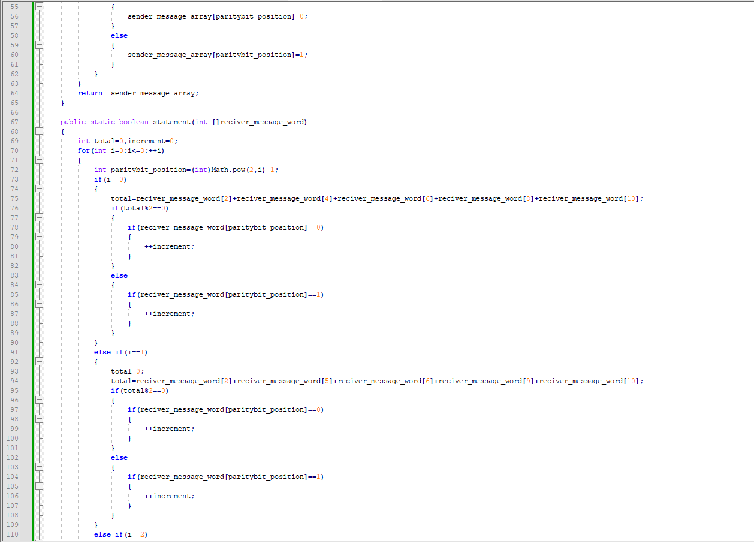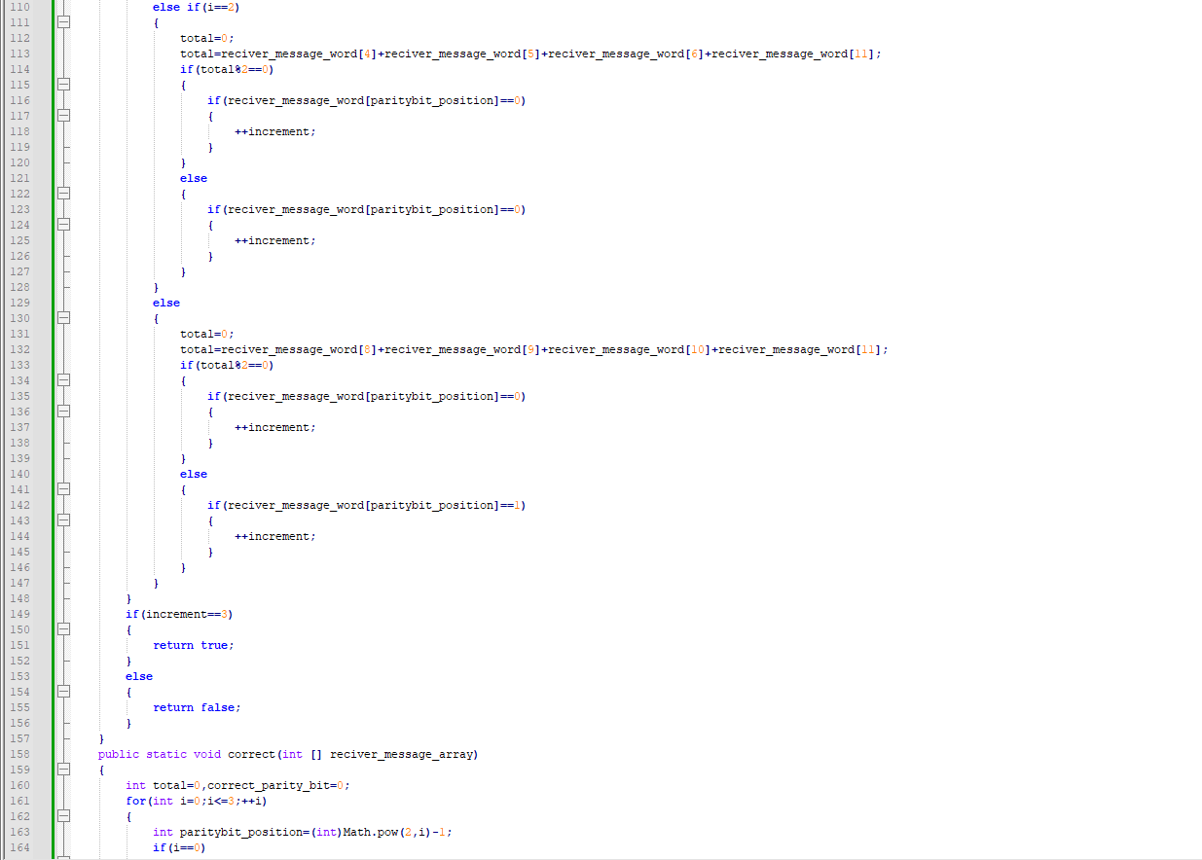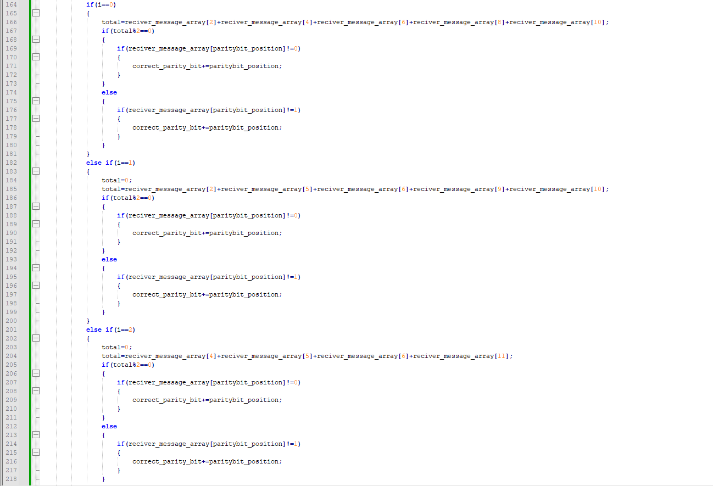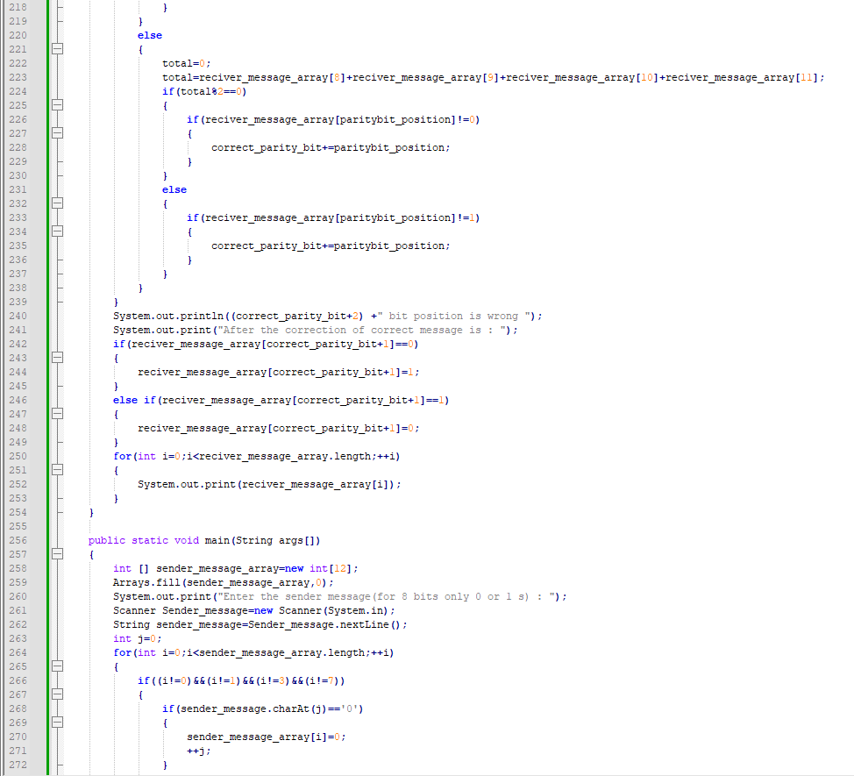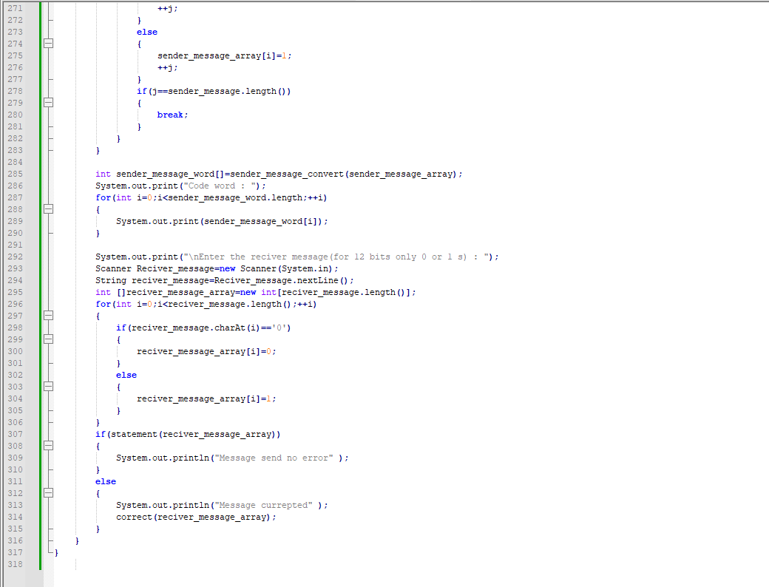

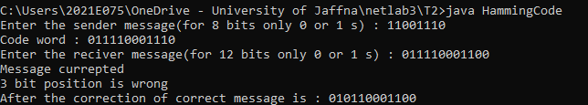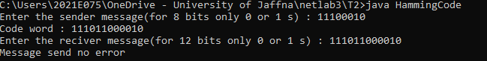

Q3

