|  |  |  |
| --- | --- | --- |
| No. | Field | Data |
| 1 | Description | Input elements should be closed with ”()”. But it seems closed by “(]” |
| Type | Error |
| Actual line | function y=matMeanDiff(A,B] |
| corrected | function y=matMeanDiff(A,B) |

EC1011: COMPUTING

LAB 07: Domain Specific Programming Languages

NAME : K.J.M.U.G.S.E. JAYASINGHE

REGISTRATION NO. : 2021/E/075

DATE ASSIGNED : 10 08 2022

|  |  |  |
| --- | --- | --- |
| No. | Field | Data |
| 1 | Description | Input elements should be closed with ”()”. But it seems closed by “(]” |
| Type | Error |
| Actual line | function y=matMeanDiff(A,B] |
| corrected | function y=matMeanDiff(A,B) |

|  |  |  |
| --- | --- | --- |
| No. | Field | Data |
| 2 | Description | Unused or wrong line |
| Type | Warning |
| Actual line | sumAllA=sum(A(:)); |
| corrected | Delete that line. It was unused |

|  |  |  |
| --- | --- | --- |
| No. | Field | Data |
| 3 | Description | Assign variable without using semicolon of the end |
| Type | Warning |
| Actual line | sumAllB=sum(B(:)) |
| corrected | sumAllB=sum(B(:)); |

|  |  |  |
| --- | --- | --- |
| No. | Field | Data |
| 4 | Description | NUMAL(x) is faster than PRODSIZE(X) |
| Type | Warning |
| Actual line | diff=meanA-sumAllB/prod(size(B)); |
| corrected | diff=meanA-sumAllB/numel(B); |

|  |  |  |
| --- | --- | --- |
| No. | Field | Data |
| 5 | Description | Ask to find mean value |
| Type | error |
| Actual line | sumAllB=sum(B(:)); |
| corrected | meanB=mean(B(:)); |

|  |  |  |
| --- | --- | --- |
| No. | Field | Data |
| 6 | Description | Ask to find mean value and also average value |
| Type | error |
| Actual line | y=mod(diff); |
| corrected | y=abs(mean(diff)); |

|  |  |  |
| --- | --- | --- |
| No. | Field | Data |
| 7 | Description | Ask to find mean value |
| Type | error |
| Actual line | diff=meanA-meanAllB/numel(B); |
| corrected | diff=meanA-meanAllB |

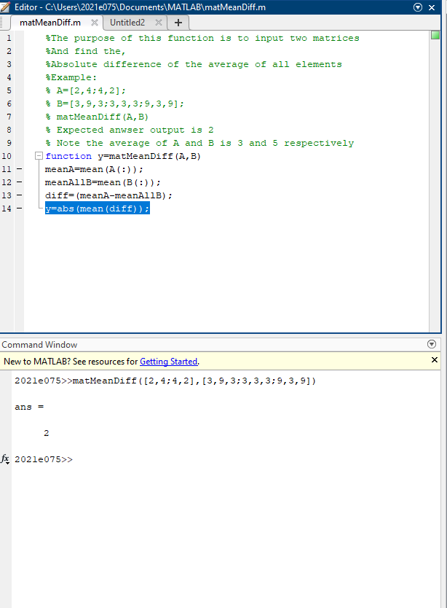

2. 