Encoding and incorporating architectural knowledge throughout the design lifecycle to enhance integrity in AEC.

Abstract.
Architectural design requires synthesising knowledge from diverse sources and ensuring consistent communication across the project lifecycle. While advances in BIM and generative design have automated specific tasks, design intent remains fragmented across files, platforms, and disciplines, limiting validation and reuse. This paper proposes an intelligent design system, "Design Grammars", based on multimodal architectural knowledge encoding that transposes information from textual requirements, parametric models, semantic rules, and natural-language interaction into a unified, object-oriented data model integrated with an Open BIM environment. The approach enables overall object-level communication, automated validation of design intent and requirements, AI-assisted reasoning in design production, and reuse of architectural knowledge datasets. The framework is evaluated through a plan-layout generation case study. The results demonstrate the integration of abstract design knowledge into the design process. By moving beyond file-based workflows, the system enhances design analysis, coordination, and sustainability while pushing forward Open BIM maturity in the AEC industry.
Keywords.
Architectural Design, Knowledge Management Systems, Design Grammars, Ontology-based Modelling, Graph Databases, Artificial Intelligence in Design Assistance, Design Copilot Systems, Open BIM
Introduction.
Shift to abstract design rules at the core of architectural design.
This paper proposes a framework for integrating Architectural Knowledge into a generative design system. Architectural design has traditionally employed an interdisciplinary approach and utilizes diverse technological stacks. In the age of Digital Design, Architectural Knowledge is especially hard to grasp when isolated to a single aspect fully, as it emerges from the integration of heterogeneous data spanning diverse dimensions - spatial, aesthetic, structural, economic, social, physical, and environmental - as widely recognised in digital design and architectural cognition research. [1–7]Subsequently, the diverse nature of architectural design requires multiple media to communicate design rules and intent, demanding high flexibility in communication while ensuring sustainability in the management of the project as a whole, containing various interconnecting parts. Eventually, the means of conveying an idea become less significant, with the communicated concept taking center stage. [1] The model should interpret and respond through any medium, effectively merging different modalities into a shared semantic schema. It distils instructions to their core information. This change reflects Schmidhuber's idea of compression. [8]: only unexpected, non-redundant input has value. Producing overly predictable information is of little value; instead, the emphasis is on sharing and understanding concise, meaningful data. This approach marks a fundamental shift from traditional computational interfaces, which often require users to follow strict input formats and commands, to abstract design rules at the core of an architectural project.
Challenges in conveying design intent and its validation
From a technological standpoint, advanced technology stacks now actively support architectural design (e.g., parametric modeling and visual programming environments such as Grasshopper, Dynamo, and Rhino.Inside.Revit, as well as AI-powered generative design platforms like PlanFinder, Spacemaker and Hypar). [9–11] However, they mainly focus on specific computational tasks with predictable results (e.g., automated clash detection, geometry optimisation, or energy performance simulations based on predefined parameters and static datasets). [12, 13] Despite these uncontested technological advances, communicating design intentions and constraints across stages and disciplines does not effectively utilise these technologies, as abstract concepts remain largely inscribed and undefined in the digital environment. Typically, strict specifications and parameters serve as inputs to computational systems, but the design intents underlying them remain undefined. Therefore, it is hard to reconstruct the intent and validate it afterwards. [10, 14, 15] Currently, architectural design still largely follows handover principles during development, meaning that with each transition of design outputs between stakeholders, the design intent and rules established before decisions are lost. The outputs reflect only final decisions, and there is no inheritance between them. Moreover, the design communication suffers because it relies on manual file exchange and cannot trace the logic behind the output solutions. Subsequently, poor management of design changes and misalignment with the original concept can lead to outdated or fragmented data and compromise design integrity during the iterative design process. [16–18] Furthermore, the validation of such solutions is limited to a specific design state and the rules applied to it, preventing dynamic evaluation of evolving design intentions. [12, 19]
Object replication
Another identified problem in existing design frameworks is the misalignment of objects across design platforms. In fact, different platforms can use the same objects with shared properties, but they must replicate the data within the common project environment because their object definitions are not connected. For example, material applied to the wall element in the BIM platform shares the same property set as the rendering platform, but must be manually redefined for visualisation without live synchronisation of its states between platforms. The Industry Foundation Classes (IFC) schema, standardised as ISO 16739, provides a well-defined data model for exchange between BIM systems [6, 20]. However, it remains largely constrained to construction-oriented information and does not natively support parametric relationships or design rules [21]. A bunch of advanced tools for cross-platform interoperability connect parametric design (PD) and generative design (GD) definitions with BIM models [22] However, there is still no versatile solution for connecting abstract objects across platforms within a project environment. Existing tools are mainly focused on specific tire applications and are limited by the vendor.
Design Grammars system
Hence, it is essential to maintain an abstraction level and focus on the symbolic representation of design objects at the core, emphasizing their common semantic relationships rather than detailed modeling of individual parts. [9] Shifting focus to well-defined abstract objects can serve as a main tier connecting versatile representations of the parts. In such a holistic approach, parts share high-level semantic properties and behavior of the core abstracts, while focusing on low-level, detailed domain description. Subsequently, the transition between domain representations and the communication of design intent and changes is expected to become much more effective and sustainable.
To address this shift in object-oriented modelling in Architecture, a Design Grammars system is proposed - a generative, evolving design copilot system that processes design rules and constraints throughout the project lifecycle. This conceptual shift directly informs the system architecture, which is designed to treat abstract design objects and grammars as the primary carriers of architectural knowledge across domains.

System framework.
The proposed system is designed to bridge the gap identified in As-Is design frameworks (Figure 1, left). Currently, Architectural Design Knowledge is shared across domains within a project through cycled datasets. This implies the need to rebuild the data to adapt to another domain and lacks change tracking.
In response, the Design Grammars system aims to eliminate manual dataset cycling by proposing the Core–Periphery Data Model to manage Design Knowledge holistically [23], with customized software connectors that share common abstract object information across domains. Consequently, the system is structured in five layers. (Figure 1, right) The core of the system is an ontology-based Data Layer with a database warehouse that stores compressed structured objects, parsed from diverse data sources, in a shared shared semantic schema. (Figure 1, right (4)) The reasoning subsystem of Analysis layer is based on the Retrieval Augmented Generation (RAG) framework (Figure 1, right (5)), which serves as the system's intelligence, processing structured data and generating meaningful outputs that respond to user queries through outer layers. Consequently, the outer layers include the Integration Layer with API & Middleware (Figure 1, right (3)), and DAG Layer with GAE and GUI for parametric inputs control (Figure 1, right (2)), which connect input models from the Communication Layer to the core. (Figure 1, right (1)) In general, this system aims to replace file-based workflows with object-level, AI-driven communication. It enables solution space generation, analysis, AI-assisted decision-making, and project orchestration.
Design Grammars domains
The architecture of the Design Grammars encompasses two main domains – the Model Domain and the Grammars Domain. (Figure 2). The system is orchestrated by built-in AI agents (LLM-assisted, ontology-constrained) operating on the n8n platform. [24] The agents interact constantly between domains, bypassing all the layers of the system and intertwining in the common Data Graph layer. (Figure 2-4) Both domains include an input zone (Figure 2-1) where an operator can enter or generate initial data via a GUI interface. (Figure 2-2) In the Grammar's Domain, the input data is presented by design rules which can include spatial program, codes, design requirements, static constraints etc. (Figure 2-1G). These rules are further interpreted and parsed into structured data nodes in the «Metagraph», based on the provided operator descriptions, and aligned with the ontological schema. This work is done by Agent A (Figure 2) The «Metagraph» serves as a reasoner database for validating model data from the Model Domain against design rules. (Figure 2-5)
In the Model Domain, the input data may include geometric context, parametric model elements, and design references. (Figure 2-1M) Model objects are associated with the Metagraph's abstract entities through the Semantic Reasoner by Agent B (Figure 2-5). Once associated, Agent B requests relative constraint values from the Data Graph. Then Agent C handles request event and retrieves the requested parametric constraints from the relative grammar collection in Data Graph using the RAG framework (Figure 2-3, Figure 2-4). Finally, this data is used by Agent B to validate the model's design state and provide system feedback to the end user.
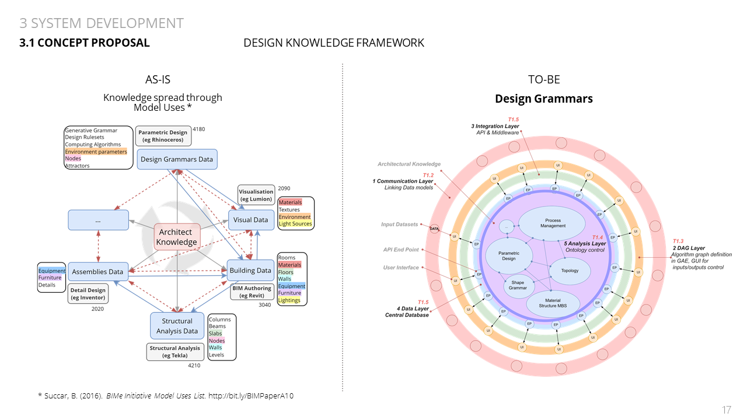
Figure 1 Design Knowledge Architecture
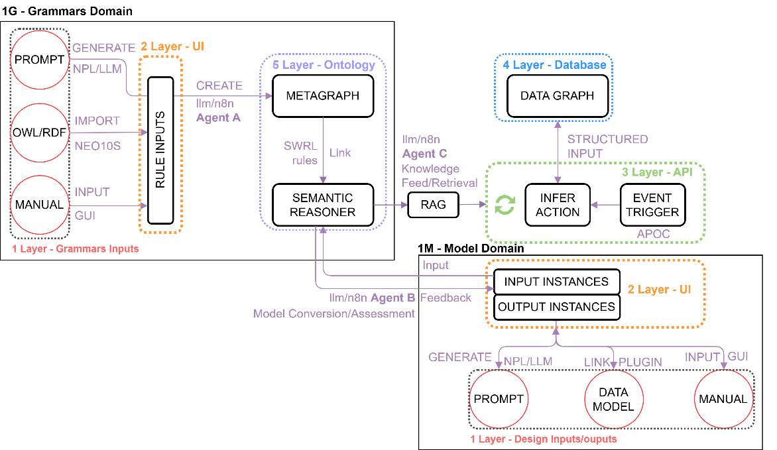
Figure 2 Design Grammar system domains
Communication layer
The communication layer of the system is designed to parse multimodal data inputs and convert them into objects defined by abstract classes and their relationships within a selected Ontology. Besides, this layer is assumed to convey system outputs back to the user in a human-readable format. Main components of the layer are plugins and interfaces that connect inputs from design platforms and applications with the Grammar system. MCP allows connecting inputs and processing them with LLM.

Parametric models in Communication Layer
Parametric models constitute a primary input to the Design Grammars system. Within this framework, a parametric model functions as a generalized design skeleton that encodes topology, dependencies, and variable relationships between design entities rather than fixed geometric outcomes. Typically authored within visual programming environments (VPL) operating on Directed Acyclic Graphs (DAGs) - such as Grasshopper or Dynamo - parametric definitions formalize design logic through explicit dependencies and rule-based transformations, enabling controlled variation and systematic exploration of the solution space [9, 10, 19]
The parametric model in this system is not treated as a final representation but as an intermediary abstraction layer capable of synchronizing multiple downstream representations. Domain-specific models - most notably Building Information Models (BIM) - are generated, enriched, and updated through live connections with the core parametric definition. This approach supports bidirectional data exchange, where semantic and parametric relationships are preserved across platforms rather than replicated as isolated datasets. In current practice, such interoperability is commonly achieved through embedded runtime environments, for example via Rhino.Inside, which enables the execution of parametric DAG definitions within BIM authoring tools such as Revit while maintaining shared object references and parameter states [15, 22]
Within the proposed Design Grammars system, the parametric model assumes an additional role beyond geometry generation: it acts as a mutable carrier of design intent subject to continuous validation against encoded grammatical rules. Design objects instantiated within the parametric model remain variable and provisional, allowing their properties, topology, and behavior to be evaluated, constrained, or reconfigured based on semantic rules retrieved from the Data Layer. This positions the parametric model as an active participant in a rule-driven reasoning process, rather than a passive generator of form. As such, validation, object population, and adaptive modification of the design definition become integral operations governed by architectural grammars, enabling coherent evolution of the design state across iterations and representations [10, 14, 17]

Design Grammars in Communication Layer
If the parametric model functions as a structural skeleton that defines dependencies and topological relationships between design entities, Design Grammars define the operational logic governing permissible transformations, constraints, and interactions within the design space. These grammars encode the “physics” of the design system, specifying how abstract objects may behave, relate, and evolve during generative and evaluative processes. Correct identification and formalisation of such constraints is critical: overly rigid grammars can severely limit the solution space, while insufficient or poorly structured rules may result in ambiguous or meaningless design outcomes.
Design Grammars in the proposed system are introduced as compressed, architecturally meaningful instructions rather than exhaustive parameter specifications, aligning with theories of information compression and design abstraction [8]. Grammars may originate from multiple sources, including regulatory requirements, spatial programs, design guidelines, BIM-derived datasets, live contextual data, or direct user input through the interface. Importantly, grammars are not restricted to a single data format; instead, they are parsed from multimodal inputs and harmonised within a shared semantic framework. This approach enables architects to articulate design intent using diverse media while relying on a common formal language for machine interpretation.
To support formal reasoning and validation, design grammars are encoded using the Semantic Web Rule Language (SWRL), which decomposes design intent into atomic rules defined over ontological entities and relationships [17]. SWRL enables grammars to remain both machine-interpretable and explicitly traceable to defined classes, properties, and constraints within the ontology. The ontology itself establishes the common abstract object classes and relationships that underpin the system, effectively functioning as a shared semantic contract across design domains. At the same time, the ontology is designed to remain extensible, allowing users to introduce project-specific classes and relationships as required.
Design grammars and ontological structure are stored and managed within a graph database management system (GDBMS) implemented in Neo4j [25], selected for its ability to efficiently represent and query complex semantic, hierarchical, and constraint-based relationships [18]. Graph-based storage supports scalable reasoning, rule validation, and interaction with Large Language Models through structured query generation, while preserving transparency and control over the underlying data. Within the Communication Layer, this configuration enables a two-level grammar control mechanism: at the upper level, architects define and refine project-specific design rules; at the lower level, the ontology governs the permissible structure, properties, and interdependencies of those rules (Figure 3). Together, these mechanisms ensure that design grammars function as a harmonised, integral component of the system, enabling validation and control of evolving parametric design states across domains.
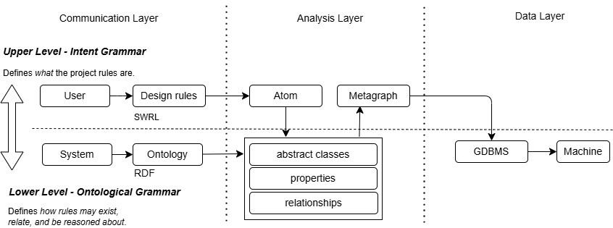
Figure 3: Grammar input architecture

Data layer.
While the Communication Layer provides interfaces and connectors to the shared project environment to translate heterogeneous inputs into abstract objects, the Data Layer constitutes the semantic and structural core of the proposed system. It is responsible for persistently storing all information parsed from heterogeneous inputs as interconnected abstract objects, ensuring consistency, traceability, and reuse across the project lifecycle. The central challenge at this level is integrating heterogeneous architectural data - geometric, semantic, temporal, and unstructured - within a unified object-oriented framework without duplicating or fragmenting information across domains.
To address this challenge, the Data Layer is implemented as a modular ETL (Extract, Transform, Load) pipeline, enabling flexible data ingestion, transformation, and live synchronisation between external design environments and the internal knowledge model [19]. Raw data is initially extracted from multiple sources via the Communication Layer, including parametric models, BIM datasets, textual requirements, and contextual inputs. During transformation, the data is parsed, validated, and aligned with a predefined ontological schema, ensuring semantic coherence and consistency of object definitions. The processed data is then loaded into a distributed data warehouse composed of specialised storage domains, each optimised for a specific data type and access pattern.
In the proposed implementation, five primary data domains are distinguished:
1. A relational database domain for BIM object data structured according to the Industry Foundation Classes (IFC) schema [6, 20];
2. A spatial domain for geometric and locational data describing shape, orientation, and spatial relationships;
3. A graph domain for semantic data, design grammars, and ontological relationships between abstract objects, implemented using a graph database due to its suitability for representing topological, hierarchical, and constraint-based relationships [18, 21];
4. A time-series domain for simulation outputs, performance metrics, and tracking of design evolution over time; and
5. A NoSQL domain for unstructured data such as sketches, textual annotations, documents, and reusable component libraries.

A core principle of the Data Layer architecture is single-source object integrity, whereby each object is stored exclusively within one domain and referenced by others as needed. This avoids redundant definitions and inconsistencies commonly found in file-based workflows. For example, material definitions are stored only once within the unstructured data domain and queried dynamically by BIM, visualisation, or analytical tools when required, rather than being duplicated across multiple platform-specific representations. Access to the Data Layer is mediated through APIs and Model Context Protocols (MCPs), enabling controlled interaction with external tools, AI agents, and reasoning pipelines as the project evolves (Figure 3).
The segregation of the Data Layer into domains reflects a deliberate architectural decision. Relational databases are optimised for structured, schema-driven datasets with well-defined entities and attributes, such as IFC-based BIM objects, where consistency, normalisation, and transactional reliability are essential [6, 20]. In contrast, architectural knowledge representation - including design grammars, ontological hierarchies, and topological or semantic relationships - exhibits high variability, evolving schemas, and complex many-to-many dependencies that are more naturally and efficiently modelled using graph structures [18, 21].
Attempting to unify these heterogeneous data characteristics within a single database paradigm typically results either in rigid schemas that inhibit semantic evolution or in denormalised structures that obscure design intent and reduce query expressiveness [6, 7, 21]. By maintaining specialised but interoperable domains, the proposed Data Layer preserves domain-specific strengths while enabling object-level integration through shared identifiers and controlled API access. This hybrid approach aligns with established practices in complex information systems and supports scalable reasoning, validation, and AI-assisted inference without constraining the expressive capacity of architectural design knowledge [17, 19].
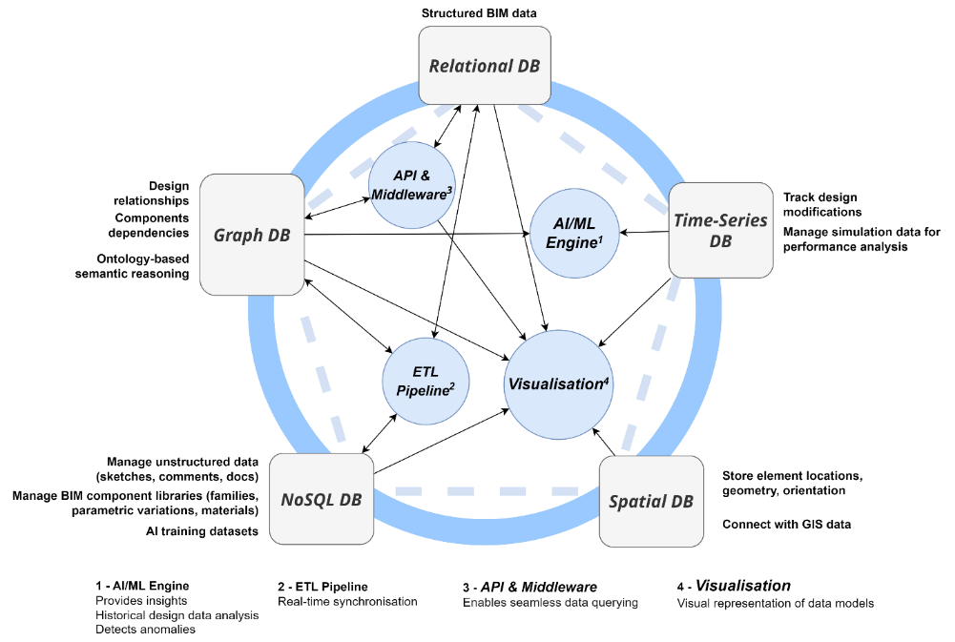
Figure 4 Data Layer architecture

Analysis layer.
The Analysis Layer operates in the system by executing reasoning, validation, and inference processes across all architectural data stored in the Data Layer. Analysis is performed through predefined yet extensible pipelines that orchestrate interactions between parametric models, design grammars, ontological structure, and external computational tools. These pipelines are activated by trigger events originating in the Communication Layer and operate on abstract objects persisted in the Data Layer. Events may include user queries, model updates, or rule modifications, enabling continuous evaluation of evolving design states rather than static, post-hoc validation.
Pipeline selection and execution are determined automatically based on the source and target data types involved in the request. Input sources may include design grammars expressed in SWRL for semantic parsing, parametric DAG definitions connected via platform-specific extensions (e.g., Grasshopper-based interfaces), BIM-derived datasets, or contextual constraints combining geometric and non-geometric information [14, 17]. Upon activation, input data is interpreted and semantically aligned with the Metagraph, ensuring that reasoning processes operate on structured, project-specific knowledge rather than generic language model priors [19].
Following semantic alignment, the system generates structured database queries - primarily in Cypher for graph-based data - to retrieve relevant objects, relationships, and constraints from the Data Layer. Raw query results are then processed within the Analysis Layer to perform rule-based validation, topological reasoning, or constraint satisfaction checks against the current parametric model state. The resulting evaluations are transformed into meaningful feedback, which is returned to the Communication Layer in a form suitable for direct user interpretation or downstream computational actions.
Central to the Analysis Layer is the ontological Metagraph, which functions as a customizable reasoning substrate connecting the Model Domain and the Grammars Domain (Figure 2-5). Below is an example of a possible Metagraph Entity-Relationship Diagram (Figure 4). The Metagraph encodes classes, relationships, and permissible interactions between abstract design entities, allowing inference processes to remain transparent, extensible, and controllable by the operator rather than being fully delegated to opaque AI models [18, 21]. Within this framework, Large Language Models are employed not as autonomous decision-makers but as mediators that assist in query formulation, rule interpretation, and pipeline orchestration under strict ontological and data constraints.
The analytical pipelines operate as AI agents implemented on the n8n automation platform, where each agent follows a deterministic workflow combining ontological reasoning, database querying, and LLM-assisted interpretation [24]. By grounding AI-assisted inference in explicit grammars, structured ontologies, and verifiable data sources, the Analysis Layer supports scalable reasoning, reproducible validation, and explainable design assistance, addressing common concerns regarding transparency and reliability in AI-driven design systems [16, 17, 19].
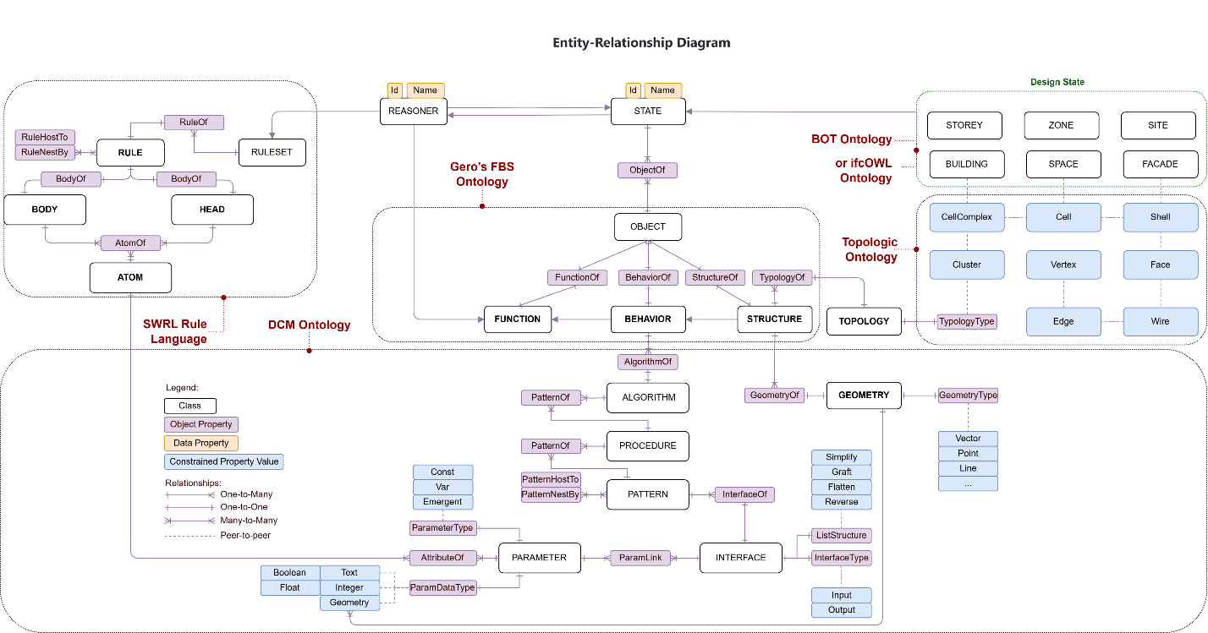
Figure 5: Ontological Metagraph example used in Analysis Layer
System Implementation.
The proposed Design Grammars system was evaluated through a case study focused on one of the most representative and demanding tasks in early-stage architectural design: plan layout generation during the conceptual phase. This task was selected because it simultaneously involves spatial reasoning, topological constraints, design intent interpretation, and iterative solution-space exploration, making it suitable for assessing both the semantic and generative capabilities of the system [26]. Meanwhile, the architect remains an active decision-maker throughout this process, using the system to explore, validate, and compare alternatives rather than to automate design decisions.
To comprehensively examine the system, the case study was structured into two complementary subtasks. The first subtask addressed the encoding of a spatial program and its topological relationships derived from an existing BIM model. This task was chosen to validate the system's ability to extract, abstract, and formalise design knowledge from conventional BIM representations. A graph-based data model was adopted for this purpose due to its lightweight structure, scalability, and suitability for representing spatial adjacency, hierarchy, and semantic relationships, as well as for supporting efficient querying and downstream reasoning [27].
The second subtask focused on generating alternative plan layouts based on the encoded spatial program, inferred design rules, and contextual constraints, with active assistance of the pipeline orchestrator and the AI agent [24]. This stage tested the system's capacity to reuse encoded knowledge for generative purposes and to expand the original solution space while preserving the underlying design intent. The generated layouts were subsequently compared with the manually designed reference solution to evaluate consistency, diversity, and compliance with the inferred rules.
The selected case study model is a dormitory building with a modular structural layout, originally designed manually by the architect as a standalone solution. The objective was not to replace this solution but to extend it by generating alternative layouts that adhere to the same spatial program and inferred design grammars. In this workflow, the architect uploads the IFC model to the system and initiates the analysis via a natural-language prompt in the Grasshopper environment, which is integrated with the system via a custom connector node. The prompt instructs the system to analyse the IFC model for topological relationships using the Topologic library [28] and to infer an abstract graph representation based on space types and their connections. For example, rather than encoding every individual space, the system abstracts recurring spatial patterns, such as corridors connecting to kitchens through intermediate spaces, and classifies connection types (e.g., direct adjacency, wall-separated, wall with door, wall with window).
Based on this prompt, the AI agent extracts the required geometric and semantic data from the BIM model via IfcOpenShell [29], executes the necessary computational routines, and populates the Neo4j graph database with the resulting spatial program [25]. In this graph representation, spaces are encoded as nodes with associated properties, while adjacency relationships are represented as edges enriched with connection-type attributes. This process transforms an explicit BIM model into an abstract, queryable semantic representation suitable for reasoning and generative reuse (Figure 6).
In the second subtask, the inferred graph-based spatial program is reused to generate new layout variants. The architect issues a subsequent prompt specifying generative constraints, such as site boundary, orientation, window exposure requirements, and maximum allowable distances to vertical circulation elements. In response, the system formulates Cypher queries to retrieve relevant spatial program data from the graph database, combines them with geometric inputs from the parametric environment, and generates multiple alternative layouts in Rhinoceros (Figure 7). The resulting solution set enables the architect to assess variations, compare them against the original design, and select configurations that best satisfy both functional requirements and inferred design rules.

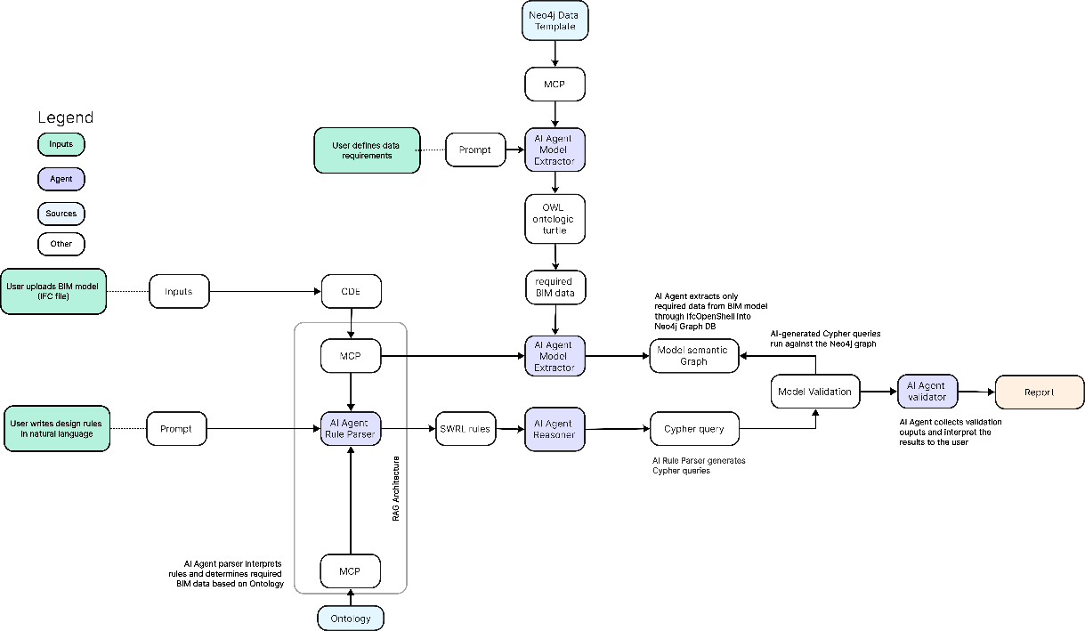
Figure 6 Case study pipeline

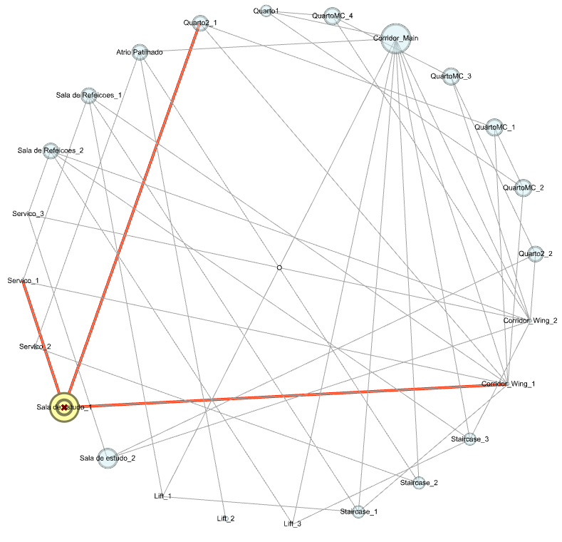
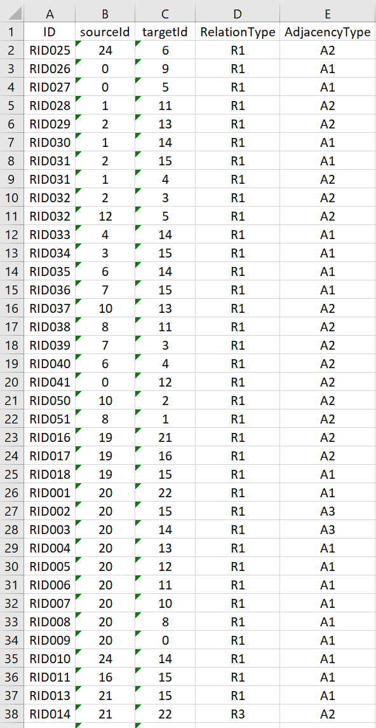
Figure 7: First Case study subtask. Spatial Program encoded in Design Grammars
R1
A2
R1
A1
R1
A2

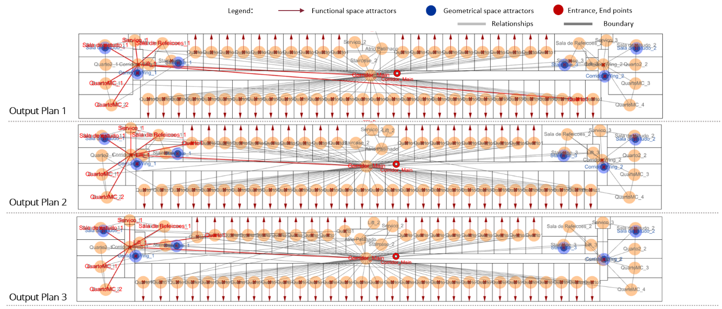
Figure 8: Second Case study subtask. Generated layouts options
Conclusion.
This research contributes an intelligent design system based on multimodal architectural knowledge encoding, capable of translating heterogeneous design information - including textual requirements, parametric models, semantic rules, and natural language interactions - into a unified, object-oriented data model integrated with Open BIM environments. By shifting the focus from file-based data exchange to object-level communication governed by explicit design grammars, the proposed system enables continuous validation of design intent, semantic consistency across domains, and reuse of encoded architectural knowledge throughout the project lifecycle.
The Design Grammars system demonstrates how abstract design rules can function as a central organising principle connecting parametric modelling, BIM representations, and AI-assisted reasoning. Through ontologies, graph-based knowledge representation, and Retrieval Augmented Generation (RAG) pipelines, the system supports both analytical and generative design tasks while maintaining transparency and traceability of the reasoning process. The case study on plan layout generation illustrates the system's ability to extract latent spatial programs from BIM data, formalise them as semantic graphs, and reuse this knowledge to expand the design solution space without sacrificing the original design intent.
In general, the proposed framework contributes to ongoing discourse on architectural knowledge management by offering a practical pathway toward sustainable design intelligence. Rather than replacing existing computational tools, the system operates as an integrative layer that enables meaningful communication between advanced technological stacks - parametric design, BIM, and AI-driven generative systems - through a shared semantic core. In this sense, the work advances Open BIM maturity and positions design grammars as a viable foundation for next-generation design copilot systems.

Limitations.
Despite its demonstrated potential, the proposed system has several limitations that reflect the current research scope rather than deficiencies in the proposed approach. First, the quality and usefulness of the inferred design grammars depend heavily on the completeness and semantic clarity of the input models and user-provided instructions. In cases where BIM data is poorly structured or design intent is weakly articulated, the inferred rules may remain coarse or ambiguous. Second, the current implementation focuses primarily on spatial and topological reasoning during early design stages and does not yet fully integrate structural, environmental, or cost-driven constraints into the generative feedback loop. Nevertheless, it certainly has the potential for scalability in future implementations. Finally, while Large Language Models are constrained by ontological and procedural boundaries, their involvement in interpretation and orchestration introduces dependencies on model performance, prompt formulation, and external AI services that may affect reproducibility across deployments.
Future work.
Future research will focus on extending the system along three main directions. First, the ontological framework will be expanded to incorporate additional performance-driven domains, including structural logic, environmental simulation feedback, and regulatory compliance, enabling multi-objective validation within the same semantic infrastructure. Second, further work will address long-term learning and adaptation by allowing the system to accumulate and generalise design grammars across multiple projects, supporting precedent-based reasoning and knowledge transfer. Finally, future development will explore tighter integration with real-time collaborative workflows and AI techniques, ensuring that AI-assisted design decisions remain interpretable, auditable, and aligned with professional architectural practice.

References.
[1] How Designers Think – The Design Process Demystified, https://www.researchgate.net/publication/30872105_How_Designers_Think_-_The_Design_Process_Demystified (2006, accessed 17 November 2025).
[2] Duvernoy S. Architecture’s New Media:Principles, Theories, and Methods of Computer-Aided Design. Nexus Netw J 2005; 7: 163–165.
[3] Oxman R. Theory and design in the first digital age. Des Stud 2006; 27: 229–265.
[4] Johnson B. Book Review: Architecture in the Digital Age. International Journal of Architectural Computing 2003; 1: 247–251.
[5] Oxman R. Oxman Rivka and Oxman Robert (2014) Theories of the Digital in Architecture, Routlideg, Talylor and Francis, https://www.academia.edu/4402003/Oxman_Rivka_and_Oxman_Robert_2014_Theories_of_the_Digital_in_Architecture_Routlideg_Talylor_and_Francis (accessed 6 December 2025).
[6] Sacks R, Barak R. BIM handbook: A guide to building information modeling for owners, managers, designers, engineers and contractors. Autom Constr 2011; 17: 439–449.
[7] Succar B. Building information modelling framework: A research and delivery foundation for industry stakeholders. Autom Constr 2009; 18: 357–375.
[8] Simple Algorithmic Theory of Subjective Beauty, Novelty, Surprise, Interestingness, Attention, Curiosity, Creativity, Art, Science, Music, Jokes, https://www.researchgate.net/publication/242540474_Simple_Algorithmic_Theory_of_Subjective_Beauty_Novelty_Surprise_Interestingness_Attention_Curiosity_Creativity_Art_Science_Music_Jokes (accessed 6 December 2025).
[9] Ko J, Ajibefun J, Yan W. Generative AI-powered parametric modeling and BIM for architectural design and visualization. Proceedings of the Design Society 2025; 5: 1943–1952.
[10] Kyratzi S, Azariadis P. Integrated Design Intent of 3D Parametric Models. CAD Computer Aided Design; 146. Epub ahead of print 1 May 2022. DOI: 10.1016/j.cad.2022.103198.
[11] Ma W, Wang X, Wang J, et al. Generative Design in Building Information Modelling (BIM): Approaches and Requirements. Sensors 2021, Vol 21, Page 5439 2021; 21: 5439.
[12] Wu S, Ramli MZ, Ngian SP, et al. Review on parametric building information modelling and forward design approaches for sustainable bridge engineering. Discover Applied Sciences; 7. Epub ahead of print 1 February 2025. DOI: 10.1007/S42452-025-06543-Y.
[13] Hamidavi T, Abrishami S, Ponterosso P, et al. OSD: A framework for the early stage parametric optimisation of the structural design in BIM-based platform. Construction Innovation 2020; 20: 149–169.
[14] An Ethnographically Informed Analysis of Design Intent Communication in BIM-Enabled Architectural Practice, https://www.researchgate.net/publication/283243131_An_Ethnographically_Informed_Analysis_of_Design_Intent_Communication_in_BIM-Enabled_Architectural_Practice (accessed 21 December 2025).
[15] Camba JD, Contero M. Assessing the impact of geometric design intent annotations on parametric model alteration activities. Comput Ind 2015; 71: 35–45.
[16] Bagasi O, Nawari NO, Alsaffar A. BIM and AI in Early Design Stage: Advancing Architect–Client Communication. Buildings; 15. Epub ahead of print 1 June 2025. DOI: 10.3390/BUILDINGS15121977.
[17] Abrishami S, Goulding J, Pour Rahimian F, et al. Virtual generative BIM workspace for maximising AEC conceptual design innovation: A paradigm of future opportunities. Construction Innovation 2015; 15: 24–41.
[18] Alassaf N. Computational Precedent-Based Instruction (CPBI): Integrating Precedents and BIM-Based Parametric Modeling in Architectural Design Studio. Buildings; 15. Epub ahead of print 1 April 2025. DOI: 10.3390/BUILDINGS15081287.
[19] Coenders JL. Next generation parametric design. Journal of the International Association for Shell and Spatial Structures 2021; 62: 153–166.
[20] Industry Foundation Classes (IFC) - buildingSMART Technical, https://technical.buildingsmart.org/standards/ifc/ (accessed 6 December 2025).
[21] Wu J, Esser S, Nousias S, et al. Enriching IFC Models with Spatial Design Logic and Parametrics to Improve Design Adaptability – The Case of Alignment Grids. Lecture Notes in Civil Engineering 2025; 628 LNCE: 91–105.
[22] Semjén Á, Szép J. Integrating generative and parametric design with BIM: A literature review of challenges and research gaps in construction design. Applications in Engineering Science 2025; 23: 100253.
[23] Papachristou M, Kleinberg J. Core-periphery Models for Hypergraphs. Proceedings of the ACM SIGKDD International Conference on Knowledge Discovery and Data Mining 2022; 1337–1347.
[24] AI Workflow Automation Platform & Tools - n8n, https://n8n.io/?ps_partner_key=NGQzYWVkOTM2YzZl&ps_xid=tWiKXjkU7vbC04&gsxid=tWiKXjkU7vbC04&gspk=NGQzYWVkOTM2YzZl&gad_source=1 (accessed 6 December 2025).
[25] (42) Going Meta - Ep 17: RDF-ing between OpenAI and Neo4j - YouTube, https://www.youtube.com/watch?v=w-PwMyzokSw&t=28s (accessed 2 March 2025).
[26] Automating modular open-plan office layouts with performance-based generative design. Autom Constr 2024; 167: 105692.
[27] Zhu J, Wu P, Lei X. IFC-graph for facilitating building information access and query. Autom Constr; 148. Epub ahead of print 1 April 2023. DOI: 10.1016/j.autcon.2023.104778.
[28] Aish R, Jabi W, Lannon S, et al. Topologic: tools to explore architectural topology. 2018.
[29] IfcOpenShell - The open source IFC toolkit and geometry engine, https://ifcopenshell.org/ (accessed 18 January 2026).

