THE DESIGN GRAMMAR ONTOLOGY: A SEMANTIC CORE FOR CROSS-PLATFORM ARCHITECTURAL DESIGN-INTENT MANAGEMENT AND DATA-DRIVEN DESIGN VALIDATION
SUBMITTED:
REVISED:
PUBLISHED:
EDITOR:
DOI:
Evgenii Ermolenko, PhD Candidate,
University of Minho; EAAD; Lab2PT; ISISE, Guimaraes, Portugal
ORCID: 0009-0003-1228-9550
email: erarchitech@gmail.com
Bruno Figueiredo, Pr,
University of Minho; EAAD; Lab2PT; IN2PAST, Guimaraes, Portugal
ORCID: 0000-0001-8439-7065
email: bfigueiredo@eaad.uminho.pt
Miguel Azenha, Pr,
University of Minho; ISISE; ARISE; Department of Civil Engineering, Guimaraes, Portugal
ORCID: 0000-0003-1374-9427
email: miguel.azenha@civil.uminho.pt

SUMMARY: In architectural design, the rules that govern a scheme and the intent behind them fragment across files, tools, and disciplines: each handover exchanges only the final state, and the rules that produced it are lost. Large language models now interpret regulations reliably, but the resulting interpretation has no durable representation: within a prompt-response cycle, it cannot be audited, versioned, or re-executed deterministically. This paper presents the Design Grammar (DG) ontology, developed through explicit ontology-engineering activities with defined competency questions and systematic reuse of established design and topology ontologies. The schema organises an object-centred Function–Behaviour–Structure (FBS) core across five modular graph layers that share a compact core, so further layers can be added without disturbing it. The central definition of the schema is an object that acts as an identity carrier, so separate representations across parametric design systems and BIM platforms resolve to a single identity, enriching semantics and enhancing the consistency of design solutions. Function, the design intent an object must fulfil, is externalised into the graph, defined by generative shared vocabulary, and enforced as decomposed SWRL rules under an auditable violation-pattern encoding — a rule fires only when its constraint is broken — complemented by OWL 2 DL and SHACL reasoning over an explicit RDF projection of the property graph. Parametric configurations of the models persist as time-stamped Design States, and a provider-agnostic, human-in-the-loop LLM workflow operationalises rule authoring. Four competency questions are answered against the running graph of a mixed-use masterplan, as a proof of concept.
KEYWORDS: Design Grammars; Ontology; Knowledge Graph; SWRL; Design Intent; openBIM; Compliance Checking; Design State
REFERENCE: Evgenii Ermolenko, Bruno Figueiredo & Miguel Azenha (2026). The Design Grammar ontology: a semantic core for cross-platform architectural design-intent management and data-driven design validation. Journal of Information Technology in Construction (ITcon), Vol. 31, pg. 1-xx, DOI: 10.36680/j.itcon.2026.xxx
COPYRIGHT: © 2026 Evgenii Ermolenko, Bruno Figueiredo, Miguel Azenha. This is an open access article distributed under the terms of the Creative Commons Attribution 4.0 International (https://creativecommons.org/licenses/by/4.0/), which permits unrestricted use, distribution, and reproduction in any medium, provided the original work is properly cited.

1. INTRODUCTION
The built environment is governed by an increasingly dense body of regulatory codes, planning guidelines, and project-specific design rules that architects and engineers must navigate throughout the design process. Manual compliance validation is time-consuming, error-prone, and difficult to scale across large project portfolios and design stages. The emergence of Building Information Modelling (BIM) as the dominant digital medium for architectural design has created an opportunity to automate compliance checking by querying structured geometric and semantic data against machine-readable rule sets (Eastman et al., 2009).
Design grammars, introduced by Stiny and Gips (1972) as shape grammars, provide a generative, rule-based formalism for describing spatial configurations, and subsequent extensions have brought the formalism closer to practical compliance-checking workflows (Duarte, 2005; Beirão et al., 2011). However, translating design-grammar rules into executable ontology representations that operate directly on BIM data remains largely unsolved. A central obstacle is the absence of a shared, well-structured ontology capable of hosting such rules: existing ontologies are typically developed for individual studies, with limited documented reuse or alignment. This paper addresses that gap by focusing on the ontology itself.
An ontology is the shared code space of a knowledge graph: the agreed vocabulary and axioms that any interpreting agent, human or machine, must follow when entities are classified, relationships are inferred, and queries are answered. Establishing such a shared conceptual foundation across the diverse domains of architectural knowledge is the precondition for design-grammar reasoning. Ontology-based compliance checking has been studied in the AEC sector for two decades, from early rule systems operating on enriched Industry Foundation Classes (IFC) files (Eastman et al., 2009) to approaches based on the Web Ontology Language (OWL) using IfcOWL, the Simple Protocol and RDF Query Language (SPARQL), and the Semantic Web Rule Language (SWRL) (Pauwels & Terkaj, 2016; Pauwels et al., 2017), knowledge-graph backends for rule storage and evaluation (Zhou et al., 2022), and property-graph stores for heterogeneous building knowledge (Sacks et al., 2020). The present work builds on this lineage with a different emphasis: it develops the common ontology that such systems presuppose. This schema underlies the cross-platform knowledge-management framework introduced in a precedent work (Ermolenko et al., 2026). In precedent work, we presented the platform focusing on its conceptual architecture, the authoring addin for Grasshopper, and the cross-platform workflow support. The present work takes the underlying schema as its object: the ontology-development methodology and the competency questions that bound it; the object-centred core, the five-layer partition, the violation-pattern rule encoding, and the property-graph-to-OWL projection; and the machine-checked evaluation of the vocabulary against those competency questions.
The relevant work divides into four strands, each addressing a different artefact of the schema. The rule-translation strand converts grammars from flat text into executable graph form and leaves the output inside the checking engine; Eastman et al. (2009) established the decomposition it still follows — rule interpretation, model preparation, rule execution, reporting — and the semantic-web strand expressed both the building model and the rules in World Wide Web Consortium (W3C) standards, lifting IFC into OWL (Pauwels & Terkaj, 2016) and writing the rules as SPARQL queries and as SWRL clauses that any conforming reasoner can evaluate (Pauwels et al., 2017). The rule thereby becomes a document in a standard language rather than a vendor-specific checker configuration. The cost of that route is the transformation burden it imposes: a full IfcOWL serialisation must exist before a single rule can run. The graph-persistence strand lowers that cost by holding building knowledge in a property graph rather than a triple store (Sacks et al., 2020; Zhou et al., 2022), so that a rule can run against the model as authored instead of waiting on a complete standards-conformant serialisation, and the shape-validation strand shows that structural conformance is better served by the closed-world semantics of SHACL than by open-world OWL (Hagedorn et al., 2023). None of these strands addresses the status of the rule itself. In each, a rule is a shape to conform to, a query to run, or a parameter set handed to a checking engine , and its internal structure — the conditions it tests, the vocabulary those conditions are grounded in, the revision history of each condition — is not separately addressable. Design-grammar research (Stiny & Gips, 1972; Duarte, 2005; Beirão et al., 2011) treats a rule as a composed and inspectable object, but has not been given an encoding that operates on BIM data. This paper joins the two commitments in one schema.
The most recent generation of automated compliance checking delegates the entire pipeline to large language models (LLM): LLM-centric frameworks interpret regulations, extract BIM data, execute checks, and generate reports with high rule-interpretation accuracy (Iversen & Huang, 2026; Madireddy et al., 2025; Chen et al., 2024). These systems indicate that natural-language rule interpretation is no longer the principal bottleneck; the persistence of the interpreted rule remains open. A rule that exists only inside a prompt-response cycle cannot be audited atom-by-atom, versioned, shared across projects, or re-executed deterministically. The industry context indicates the same requirement: reviews of semantic-web adoption identify the transition from file-based BIM maturity stage 2 to the object-level collaboration of stage 3 as the sector's central interoperability challenge and name ontologies as the key enabling technology (Palihakkara et al., 2025), while openBIM deliverables are increasingly mandated and are moving from pilot to production (buildingSMART, 2025, 2026) in a BIM software market converging on AI-assisted, model-centric workflows (Fortune Business Insights, 2026). The schema supplies the persistent, queryable substrate in which machine-interpreted rules become durable, inspectable artifacts, while LLMs are used for encoding, recognition, consultation, and generation.
Against this background, the research makes three contributions to data-driven design development.
• A systematic ontology-development methodology applied to design grammars — explicit specification, knowledge sources, competency questions, and implementation-grounded milestones — in a domain where documented ontology-development methodology has been limited (Farghaly et al., 2023).
• A schema for consolidated management of design grammars: an object-centred reading of the Function–Behaviour–Structure (FBS) decomposition, spanning five modular knowledge-graph layers, with a violation-pattern SWRL encoding and typed cross-layer bridges. Since each layer corresponds to the same compact core, additional layers can be integrated without modifying existing ones, and the core is vendor-neutral, with optional modular extensions to align with external vocabularies.
• Design lifecycle operability: parametric configurations of design objects are captured as time-stamped Design States for longitudinal validation; design objects act as identity carriers, so separated representations of same conceptual object in different authoring platforms resolve to a single identity and share unique semantic properties; and an AI-facilitation layer — a provider-agnostic LLM gateway whose context assembler compiles the vocabulary, rule conventions, and query templates relevant to the specific definition into each model call — is intended to let practitioners author rules and serialise parametric models with human-in-the-loop confirmation, without formal ontology expertise (section 4).
Table 1 positions the proposed ontology in relation to the rule-persistence gap identified in the introduction. The focus is on the five dimensions that the gap turns on: rule persistence — whether rules persist as first-class artefacts; auditability — whether they are independently auditable; the data-transformation burden imposed on the authoring-tool side; alignment with open standards; and deterministic re-execution of verdicts.Table 7 in Section 6.2 presents the same dimensions corresponding to the alternatives and provides the evidence for each respective approach.

Approach | Rules persist as artifacts | Independently auditable | Transformation burden | Standards alignment | Deterministic re-execution
DG ontology (this paper) | Yes — decomposed SWRL atoms in the Metagraph | Yes — atom-by-atom, versioned | Low — no full IfcOWL serialisation required | OWL 2 DL / SWRL / SHACL / GQL path | Yes
Table 1: Design Grammar ontology closing the research gap identified across five dimensions.
The schema has a single cross-cutting core band containing classes such as Object, Function, Behaviour, Structure, Geometry, Topology, Design State, and Session — and five coplanar knowledge-graph layers that all reference that band: the Ontograph holds the generative domain vocabulary; the Metagraph holds design rules decomposed into individually addressable SWRL atoms; the ComputGraph holds the parametric definition that produces the geometry; the ValidGraph retains validation runs and their respective verdicts for individual objects; and the SpecGraph accumulates project documentation memory connected to objects. Three deterministic reasoning services share that graph: a SWRL validator for quantitative threshold constraints, an OWL 2 DL reasoner for terminological consistency, and Shapes Constraint Language (SHACL) shapes for structural integrity.
Subsequently, the following sections describe the proposed schema development in detail. Section 2 presents the ontology-development methodology. Section 3 describes the ontology structure: its core, graph layers, Design State, rule encoding, and property-graph/OWL projection. Section 4 presents lifecycle integration and the AI-facilitated workflow. Section 5 evaluates the ontology by answering its competency questions directly against the running graph. Section 6 discusses expressiveness, positioning, and scalability. Section 7 concludes.

2. ONTOLOGY DEVELOPMENT METHODOLOGY
There is no single correct way to model a domain; viable alternatives always exist (Noy & McGuinness, 2001). The design-grammar ontology was therefore developed through a structured set of ontology-engineering activities organised as an iterative process across increasing levels of formality (Figure 1), combining the scenario-based development process of the NeOn methodology (Suárez-Figueroa et al., 2015) with the lighter-weight, industrial-oriented practices of the LOT framework (Poveda-Villalón et al., 2022), following the general activity model taught in Sack (2019). Four principal activities are carried out in sequence and revisited iteratively: (1) Specification establishes the definition and boundaries of the ontology — its purpose, domain, users, and the competency questions it must answer; (2) Conceptualisation structures domain knowledge into a conceptual model and settles what is reused from existing ontologies; (3) Formalisation expresses that model in OWL 2 constructs and SWRL clauses, and (4) Implementation realises it as a property graph in Neo4j, authored in a dedicated ontology editor (Protégé) and checked by the three deterministic reasoning services introduced in section 1 — the SWRL validator, the OWL 2 DL reasoner, and the SHACL shape set. These principal activities are accompanied by continuous supporting activities: knowledge acquisition, evaluation, reuse, documentation, and configuration management. Evaluation is continuous rather than conclusive: an activity closes only once the competency questions it affects are answered against the running graph, a structural self-audit against the ontology pitfall catalogue of Poveda-Villalón et al. (2014) is clean, and machine-checked OWL 2 DL consistency holds. The evidence for all three is reported in section 5. The subsections below follow the four activities in that order.
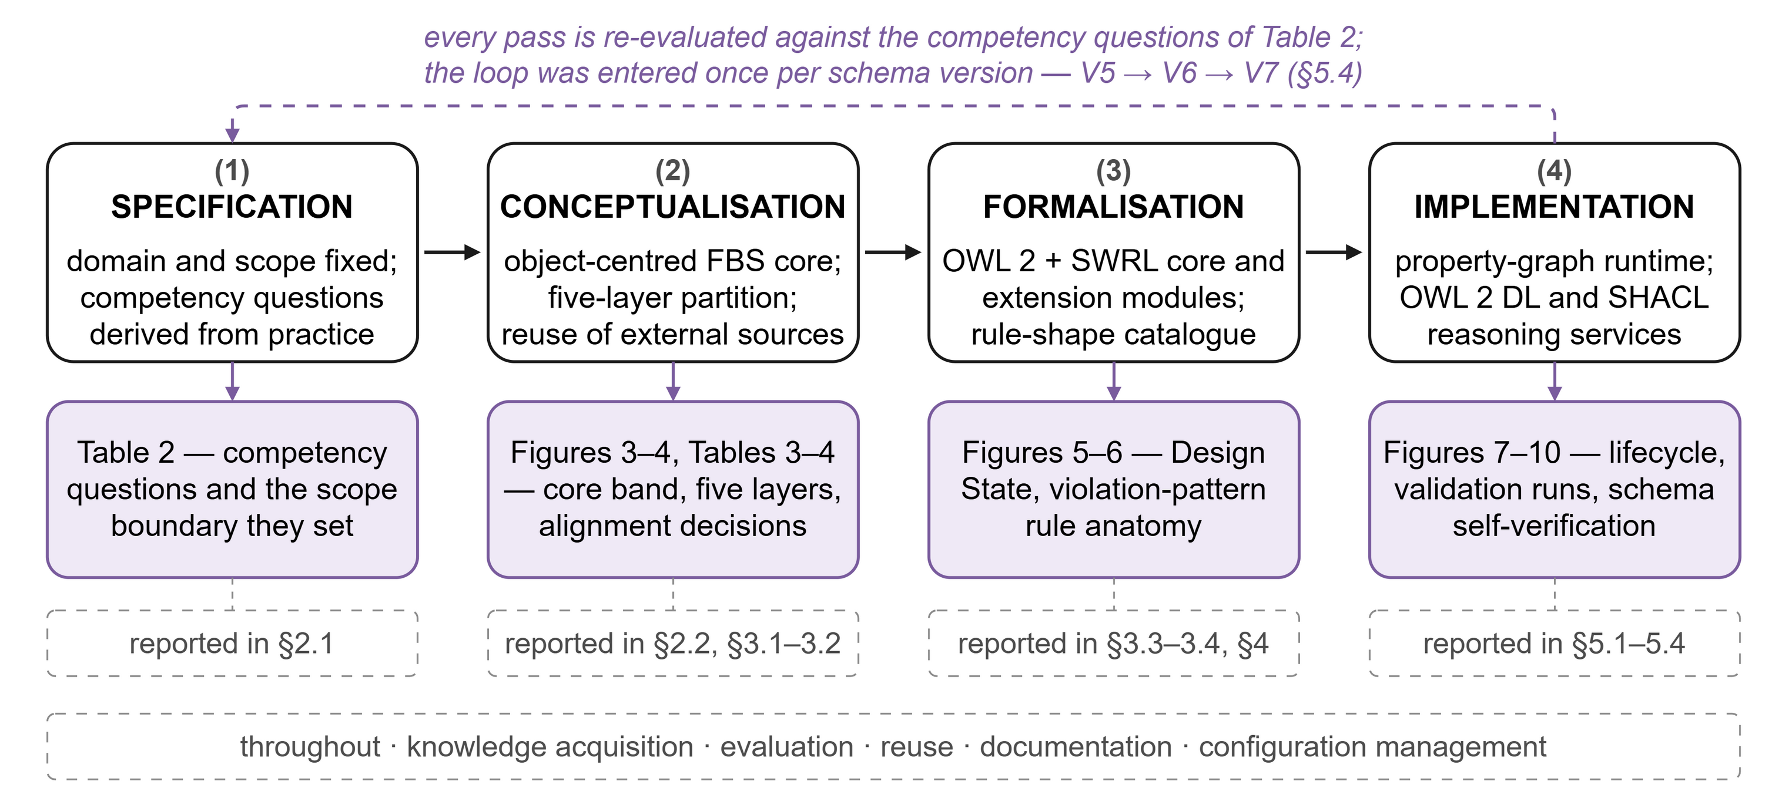

Figure 1: The ontology-development process — the four principal activities (1)–(4), the iterative-refinement loop that connects them, and the continuous supporting activities that accompany all four

2.1 Specification: purpose, domain, scope, and competency questions
The specification establishes the purpose, domain, and users of the ontology. Its purpose is to represent design grammars as durable, auditable knowledge that can be authored in natural language, evaluated against evolving states of the design, and reused across disciplines and projects. Its domain is data-driven parametric design in early design development, from preparation and briefing through concept design to spatial coordination. These activities correspond broadly to Stages 1 through 3 of the RIBA Plan of Work (RIBA, 2020) as an indicative reference for locating that scope, although comparable phases are defined differently in national European project-delivery frameworks. The stage-bound applies to where rules are authored, not to where they are used: rules authored in these stages are consumed later, in detailing and validation, without the domain of the ontology necessarily extending into those stages. The intended end-users are architects, engineers, computational designers, and clients, while maintainers are BIM departments. The anticipated benefits are consistent communication of design grammars, simplified management of multiple interconnected constraints, automatic design-intent validation, and durable design knowledge that survives reformulation and reuse.
The scope is informed by how architects reason: through problem–solution co-evolution (Schön, 1992; Poon & Maher, 1997; Dorst & Cross, 2001), framing and abductive reasoning (Dorst, 2011), analogical and case-based reasoning (Gero, 1992; Mubarak, 2004; Fu et al., 2015), and function–behaviour–structure mapping and decomposition (Gero, 1990). From these, the ontology is required to support the decomposition of a design problem into computable parts, the modular structuring of design knowledge, interoperability and shared perception across stakeholders, the translation of design knowledge among authoring systems, and semantic reasoning with automatic design-intent validation based on defined rules.
Feasibility is determined by the competency questions the ontology must address, which also serve as acceptance criteria for its evaluation (Table 2). Each question is derived from one of the design-reasoning requirements listed above: CQ1 from the decomposition of a design problem into computable parts and from shared perception across stakeholders; CQ2 from automatic design-intent validation; and CQ3 from function–behaviour–structure mapping and the translation of design knowledge among authoring systems. CQ4 is of a different kind — a validation question about the schema itself rather than about a design — and is marked as such in Table 2, because a rule library is only interoperable between offices if the vocabulary its rules are grounded in is itself consistent and structurally complete. For each question, Table 2 records the domain need it answers, the schema elements needed to answer it, and what it leaves outside the ontology. Section 5 answers CQ1 through CQ4 directly against the running graph.
Table 2 sets out the four competency questions. For each, it records the domain need behind the question, the graph layer that must contain the answer, and what the question leaves outside the scope of the ontology. The layers named there are introduced in full in section 3: the Ontograph holds a project's domain vocabulary, the Metagraph its design rules, the ComputGraph its parametric definitions, the ValidGraph its validation runs and the states they were computed against, and the SpecGraph its accumulated project memory, with a core band of shared concepts cutting across all five.

Competency question | Type | Domain need it answers | Ontology elements implied | Scope boundary — deliberately excluded
CQ1 (§5.1) — Can a design rule authored in natural language be decomposed into individually addressable, auditable parts and grounded in shared vocabulary? | Domain | Rule libraries shared between offices must be inspectable condition by condition, so that a reviewer can see what a rule tests and audit each revision. | Metagraph, grounded in the Ontograph. | Natural-language interpretation itself: the ontology stores the interpreted rule, it does not model the act of interpreting.
CQ2 (§5.2) — Does the current design state of a scheme satisfy the constraints defined for it, with an individually addressable verdict per object? | Domain | A design review requires a definitive outcome attributable to a single object at a specific moment, rather than an overall pass or fail for the entire model. | ValidGraph, with the core band’s Design State. | Remediation: the schema records verdicts and the state they were computed against, not how a violation should be repaired.
CQ3 (§5.3) — Can a planning-constraint rule be traced to the specific parametric quantity it constrains? | Domain | Design-space exploration must know which slider or computed quantity a rule bounds, and which rules govern a given parameter. | ComputGraph, reached from the Metagraph. | Evaluation semantics of the visual-programming components: the ComputGraph records the structure of a definition, not a re-implementation of its solver.
CQ4 (§5.4) — Is the design-grammar vocabulary that rules are grounded in terminologically consistent and structurally complete, so that rules authored independently in different projects and offices remain interoperable? | Validation | Two offices grounding rules in the same vocabulary must be able to rely on it: an inconsistent or incompletely declared term makes every verdict built on it untrustworthy. | The core declarations, the disjointness overlay and the SHACL shape set. | General ontology-quality metrics unrelated to rule grounding — modularity, richness, reasoner benchmarks — which say nothing about whether a shared rule library is safe to use.
Table 2: Competency questions — derivation, implied schema elements, scope boundary, and the section answering each.

2.2 Conceptualisation: knowledge sources, reuse and alignment
One of the core principles of the methodology is the systematic reuse of existing ontologies, aggregating available domain knowledge and extending it. Four sources were analysed for versatility of implementation, accessibility for external use, and maintainability, and were aligned to the design-grammar domain under a common SWRL convention (Figure 2). They are absorbed in two different ways. Function–Behaviour–Structure (FBS) and Design Criteria Modelling (DCM) are integrated into the core module itself, as they provide its fundamental conceptual framework — specifically, the three-way FBS decomposition and the Body–Head criterion form — and do not introduce any external vocabulary. The Building Topology Ontology (BOT) and Topologic, by contrast, are bridged through dedicated extension modules rather than embedded in the schema, so that reuse does not couple the core to a particular external vocabulary, following the core-plus-extension modularisation established for W3C vocabularies such as SOSA/SSN (Janowicz et al., 2019), and the same mechanism accommodates further alignments as the ecosystem around the ontology grows.
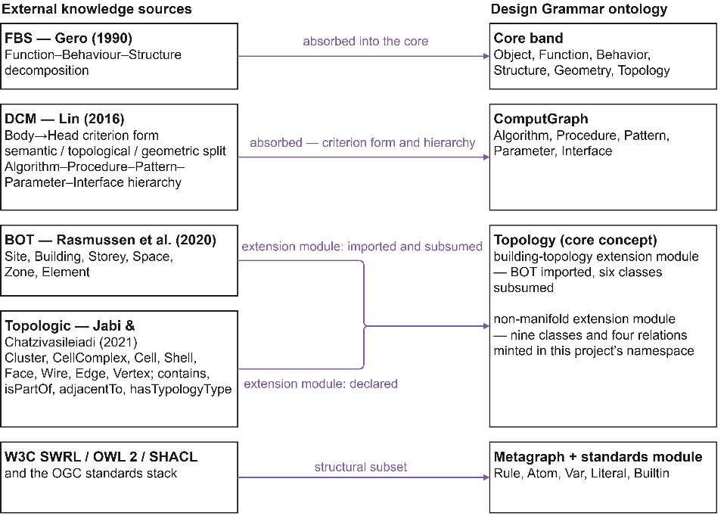
Figure 2: Reuse and alignment of the four knowledge sources onto the Design Grammar ontology.
Figure 2 maps external knowledge sources onto the schema. The two bridged sources reach the core's Topology concept by different routes. The building-topology module imports BOT and subsumes bot:Site, bot:Building, bot:Storey, bot:Space, bot:Zone and bot:Element under that concept; the topology relations the schema evaluates come from the non-manifold module. That module declares Topologic's Cluster, CellComplex, Cell, Shell, Face, Wire, Edge, and Vertex, together with containment, parthood, adjacency, and typology relations, in this project's own namespace, thereby adapting Topologic to formal OWL. Its adjacency and enclosure relations intersect with the corresponding DCM predicates, which is the reason why DCM's topology-predicate library is not considered separately. The Topologic set encompasses parthood and typology as well, thereby aligning more comprehensively with the non-manifold spatial scope required by this schema. A third module carries the alignment axioms to the W3C and Open Geospatial Consortium (OGC) standards stack. The alignments that were deliberately not made are recorded here as well. BOT leaves element classification to other vocabularies — it constrains an instance of bot:Element no further — so there is no element taxonomy to import. Rather than importing a hierarchy, the schema relates its own generated terms to the imported spatial classes by annotation: a domain class minted per project carries a graded SKOS match to the BOT class it corresponds to, where one exists, so the term keeps its project identity while remaining resolvable to the shared vocabulary. An IfcOWL alignment is kept out of the core on the same principle, where importing it would bind the schema to one exchange format. Regarding the integrated aspect, FBS offers a tripartite decomposition of the design process. Furthermore, drawing from the situated extension (Gero & Kannengiesser, 2004), which conceptualises designing as a transition between state spaces, the schema considers the state as its fundamental unit of design process documentation: each Design State is represented as a triple captured at a specific moment. Typing the movement between states is treated in section 6.1. Meanwhile, DCM provides the Body→Head criterion form along with the division into semantic, topological, and geometric aspects. Three of these boundaries — generated vocabulary, IFC alignment, and movement between Design States — are developed in section 6.1, each with the shape its extension would take. The core module, the three extension modules, and the catalogue that binds them are itemised under Availability.

2.3 Formalisation: OWL 2 DL and the SWRL rule form
Formalisation expresses the conceptual model in OWL 2 DL and SWRL. Three commitments establish how a design rule is represented, and each is carried through the schema described in section 3. First, a rule is a single SWRL clause whose conditions and conclusion are represented as atoms that can be individually targeted rather than held as an opaque string, so that a rule can be inspected, versioned and traced condition by condition. Second, those atoms are typed — ClassAtom, DataPropertyAtom, ObjectPropertyAtom and BuiltinAtom — and each reaches its arguments through a relationship carrying the argument's position, so that the order of a clause survives storage and can be reconstructed exactly. Third, rules are written in violation form: the body states the condition under which the design fails and the head asserts that failure, so that a satisfied rule returns nothing and every returned result is a finding. The OWL semantics that accompany this choice, and the mapping between the formalisation and the property-graph runtime, are set out in section 3.6.

2.4 Implementation: grounded passes against a running system
Since the ontology is developed alongside an active system, implementation occurs through iterative grounded passes instead of a single final step. Each pass completes a full cycle through the four activities, ensuring that the specification, the conceptual model, the formalisation, and the runtime progress together. Each step is verified against the competency questions and regression-tested before starting the next iteration. The ontology is designed to operate within mainstream BIM and parametric-design environments — BIM authoring tools (e.g., Revit), geometry modellers (e.g., Rhinoceros), and visual-programming editors (e.g., Grasshopper, Dynamo). The surrounding software services are described solely to establish the schema's runtime context.

3. THE DESIGN GRAMMAR ONTOLOGY
This section outlines the main features of the resulting ontology: the object-centred FBS core, the five graph layers, their modular packaging, the schema's element inventory, the Design State, the SWRL encoding and reasoning services, the mapping of parametric definitions, and the property-graph/OWL projection that operationalises the schema's OWL semantics. Table 3 gives the normative vocabulary — every layer name, its role, and its element counts; The entire schema, including node labels, relationship types, and the complete class and property inventory, is maintained as a version-controlled, open ontology project (Ermolenko, 2026).

3.1 The object-centred FBS core
The core concept of the ontology is an object-oriented interpretation of Gero's Function–Behaviour–Structure (FBS) triad (Gero, 1990; Gero & Kannengiesser, 2004): a cross-cutting band that sits above the graph layers and is referenced by all of them (Figure 3). The Object — the designed artefact — stands at the centre of the model, and the familiar FBS roles are arranged around it, with one deliberate repositioning. An Object carries Behavior, the generative, parametric process that produces it, and Structure, the realised geometric and topological form. Function, the design intent the artefact must fulfil, is externalised into the knowledge graph, where the vocabulary layer defines it and the rule layer enforces it. The schema carries the relation explicitly. A DEFINES_FUNCTION property runs from an Ontograph entity — a class, an object property, or a data property — to the Function it realises for an Object. One Object may hold many Functions, and a set of Objects may share some while differing in others; an attribute on the object expresses neither.
This repositioning involves a cost. Gero's original triad keeps Function internal to the artefact, much as it keeps Structure internal: the object simply has a function. That is natural for describing one artefact in isolation, but intent is then not accessible outside that artefact: a second tool reading the object's geometry has no access to the purpose it was meant to serve, and a rule governing the object has no shared location. Function is therefore represented at project level, so that rules can be shared across multiple object sets. Externalisation removes the artefact's self-contained description: an Object node no longer carries the complete FBS description, but references an instantiated interpretation of the Function in the shared grammar graph. In return, Function becomes addressable by any agent with graph access, expressible in the vocabulary the rules already use, and revisable independently of the geometry it constrains. Because SWRL rules bind variables to typed properties declared in the Ontograph rather than to attributes buried inside an object's internal state, this externalisation is also the precondition for the violation-pattern encoding of section 3.4: a rule can reference only the properties the object exposes.
Design intent is thereby represented as a queryable and verifiable artefact rather than an implicit property of geometry. This supports communication of intent across disciplines and platforms, and persistent intent management, which file-based exchange does not provide (Wyke & Lindhard, 2025). Geometry and Topology complete the structural side of the core, ensuring that the validated model and the parametric definition share a common spatial vocabulary. Two further constructs close the band: the Design State, a time-stamped snapshot of an Object and its bindings (section 3.3), and the Session, a provenance record of every authoring, query, or validation interaction. Keeping these cross-cutting concepts in one band allows the graph layers to remain decoupled yet interoperable.
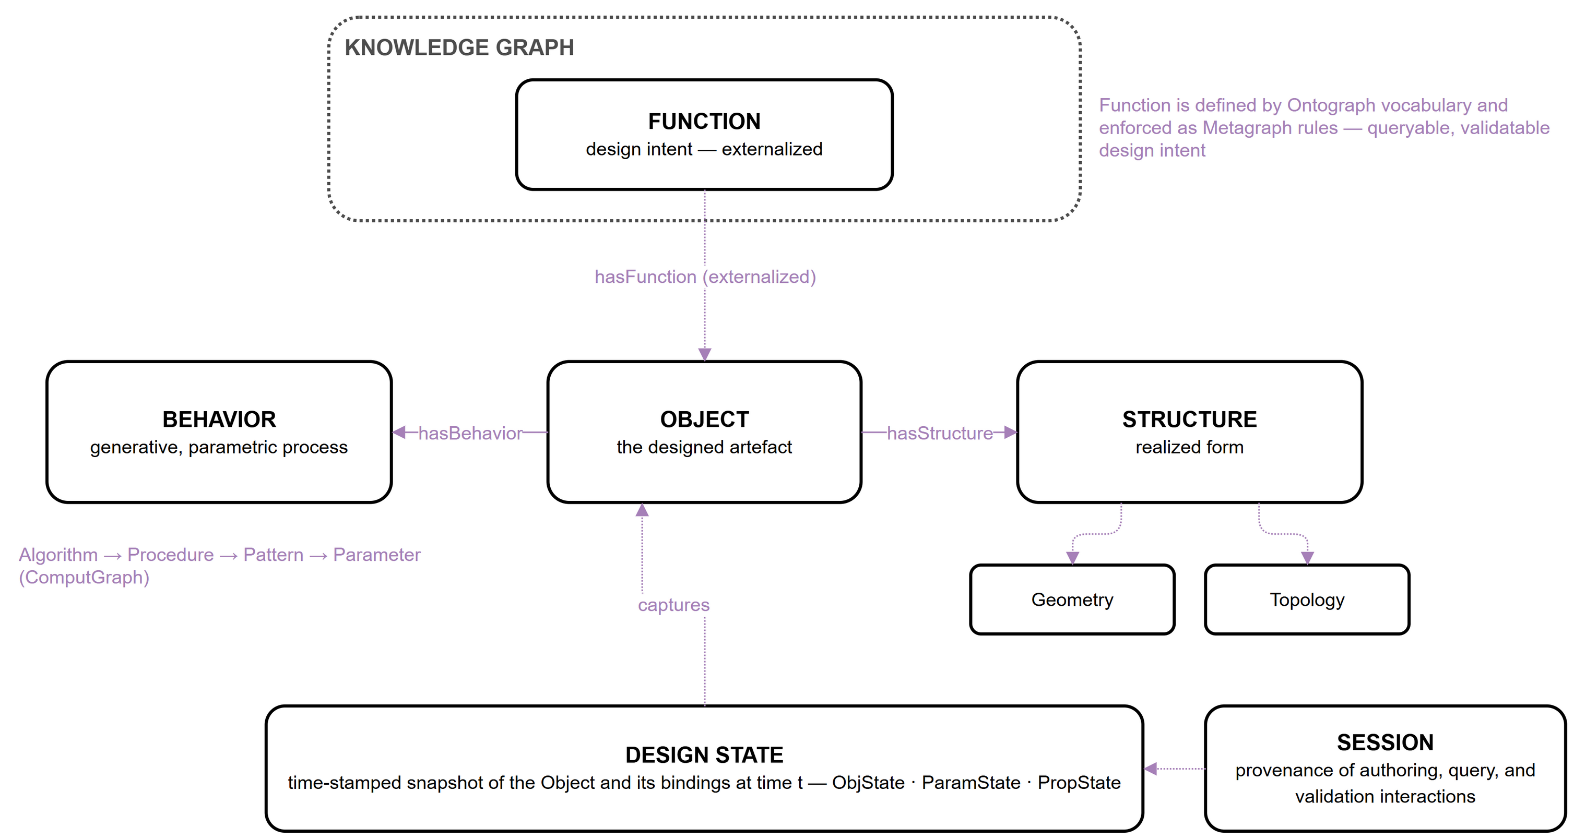
Figure 3: The object-centred FBS core. Function is externalised: defined in the Ontograph, enforced as Metagraph rules; the Design State captures the Object and its bindings at time t.

3.2 Five graph layers, modular packaging, and project isolation
Apart from the Core band, the primary constructs of the proposed schema include a knowledge graph model built on a Labeled-Property-Graph (LPG). This data model depicts information as nodes (entities) and directed edges (relationships), with both nodes and edges capable of holding labels and key-value properties. The knowledge graph comprises five coplanar layers residing in a single property-graph instance, logically partitioned by a graph property and isolated per project via a project label (Figure 4, Table 3). The layers include OntoGraph, MetaGraph, ComputGraph, ValidGraph, and SpecGraph. The partition is the organisational commitment of this work; no equivalent was identified in the reused ontologies (section 2.2). Though the vocabularies inside them are deliberately standardised and inherit partially entities from existing ontologies: the Metagraph's rule vocabulary is a structural subset of the W3C SWRL model projected into property-graph form (Pauwels & Terkaj, 2016; Pauwels et al., 2017), and the ComputGraph's Algorithm–Procedure–Pattern–Parameter–Interface hierarchy follows Design Criteria Modelling (Lin, 2016). The layers are coplanar rather than stacked: none subsumes another, and the order in which Table 3 lists them is presentational, carrying no hierarchy or precedence. Six typed cross-layer bridges make the layers mutually addressable: REFERS_TO grounds every Metagraph atom in Ontograph vocabulary; ATTRIBUTE_OF links a rule atom to the ComputGraph parameter it constrains; VALIDATES connects a validation run to the Design State it was computed against, with the per-object verdicts it produced reaching the object instances themselves; ENCODED_AS runs from a SpecGraph note to the Metagraph rule that formalises it, so that a rule carries the specification it came from and a specification that has been formalised is distinguishable from one that has not; GROUNDED_IN runs from a SpecGraph note to the Ontograph terms it commits the project to, keeping a note and the vocabulary it introduced linked as the vocabulary grows; and DERIVED_FROM runs from a ValidGraph result to the ComputGraph parameter whose value produced it, closing the path between a verdict and the parametric quantity behind it. Each of the five layers is thereby connected by at least one typed bridge. Since each layer references the shared core band rather than the internal components of other layers, the layer set remains open-ended: an additional layer — such as one for cost or environmental analysis — can be integrated into the same core without disrupting the current schema.
The partition has three consequences. It bounds what a change can reach: a project's vocabulary can be enriched without disturbing a rule's decomposition, and a parametric definition can be re-serialised without invalidating a verdict already recorded against it. It gives each layer a single owner among the reasoning services, which allows the rule-partition policy of section 3.4 to be expressed. And it keeps the set open: because a layer refers to the shared core rather than to another layer's internals, a further layer — cost, or environmental performance — can be added against the same core without renegotiating the existing five.
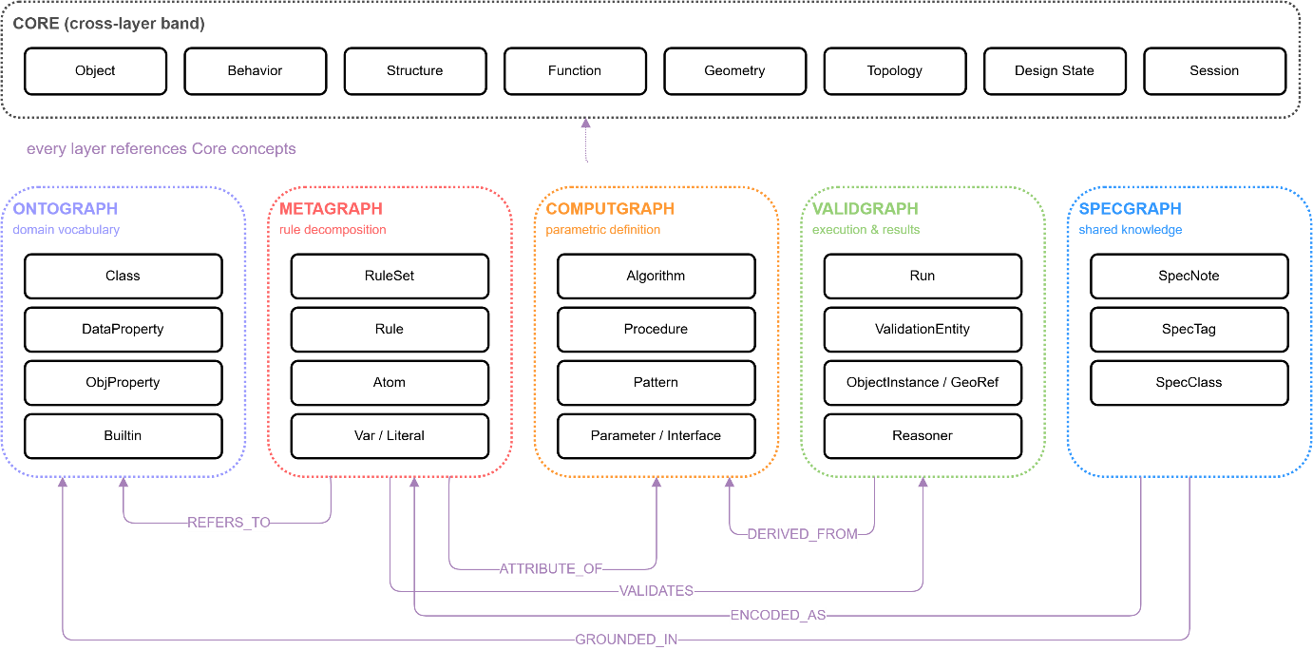
Figure 4:The core band over the five coplanar graph layers, with the typed cross-layer bridges
Layer | Role | Principal node types | Cls | ObjP | DataP
Core + Ontograph | Cross-cutting FBS concepts (Core) plus the domain vocabulary every rule and function is expressed in (Ontograph) | Object, Function, Behavior, Structure, Geometry, Topology, DesignState, Session; Class, DataProperty, ObjProperty | 18 | 10 | 9
Metagraph | Rule decomposition: every SWRL clause as individually addressable nodes | Rule, Atom, Var, Literal, Builtin | 15 | 8 | 18
ComputGraph | Parametric process: the visual-programming definition | Algorithm, Procedure, Pattern, Parameter, Interface | 13 | 10 | 7
ValidGraph | Validation evidence: runs, per-object results, integration config, reasoner | Run, ValidationEntity, ObjectInstance, Reasoner | 12 | 13 | 26
SpecGraph | Accumulated project memory connected with objects: specifications, notes, tags, conventions | SpecNote, SpecTag, SpecClass | 4 | 2 | 8
Total (core module) |  |  | 62 | 43 | 68
Table 3: The five graph layers plus the cross-cutting core band — role, principal node types, and element counts. (The counts are generated from the versioned core module file itemised under Availability.)
The schema is delivered as a compact, vendor-neutral core module accompanied by extension modules, following the core-plus-extension pattern (Janowicz et al., 2019). The core contains only design-grammar-native content and declares no external imports, so it loads without external dependencies and names no product or format. Extension modules carry the alignment axioms to external vocabularies — currently the W3C/OGC standards stack, building topology, and a non-manifold spatial hierarchy — and further extensions can be added in the same manner. Extensions engage automatically: when new entities are ingested into a given graph layer, the extension aligned with that layer assigns them to the appropriate external classes, so a consumer loads the lean core for schema editing and rule authoring and gains cross-vocabulary reasoning only where needed. The modular structure allows external contributors to add extensions without modifying the core. The schema also supports accumulation and sharing of design grammars across offices and projects. All nodes carry a project label that scopes them to a named design project, allowing a graph database to host multiple concurrent projects with logical isolation while still permitting cross-project queries, so accumulated rules remain queryable across projects. This isolation strategy is adequate for a single organisation operating a handful of concurrent projects in a shared data environment.

3.3 Design State: the unit of lifecycle traceability
The Design State is the second entity introduced by the schema itself, alongside the externalised Function, and it is the most frequently used in the knowledge graph: every validation run in the ValidGraph is computed against one. It is the unit of lifecycle traceability — a time-stamped, immutable snapshot of a design object and everything that determines it at a given moment (Figure 5). It comprises three types of states, which together fulfil the three roles of the core band. The ObjState binds the object and a reference to its geometry, holding the Structure as realised at that moment; the ParamState captures the parameter bindings of the parametric definition — the sliders, toggles, and value inputs of the Behaviour; and the PropState records, per object, the rule, the data property it constrains, and the observed value, and so holds the Function the object is required to fulfil. A Design State constitutes, in this context, a triple of Function, Behaviour, and Structure that is resolved at a single point in time. Consequently, a compilation of these states documents the various configurations that a scheme has adopted, whether these configurations occur sequentially over time or coexist as alternative options. A validation Run consumes such a snapshot and returns one Boolean verdict per object state — so per-object outcomes remain addressable — together with a flag confirming publication of colour-coded results to an external 3D viewer. Concretely, a Design State is a single node whose identifier is derived deterministically from the identifiers of its members, so the same configuration captured twice resolves to the same state rather than a duplicate; it is written when a validation is published, and it persists in the ValidGraph beside the runs that consume it. Its three parts are themselves nodes and not properties: one ObjState per design object, one ParamState per parameter binding, one PropState per rule, property and observed-value triple. A run's verdict is a Boolean sequence index-matched to those ObjStates and persisted with the run, so every per-object outcome is stored while the aggregate pass or fail is derived on read rather than stored separately, which keeps each object's outcome addressable. One Design State may be consumed by many runs and every run persists, so the graph retains the execution history rather than only the latest result: re-running a revised rule set against an unchanged state leaves both verdicts in place, and the two can be compared by query. Since snapshots are persisted rather than overwritten, the graph consolidates a collection DS_{t_0} ... DS_{t_n} whose members can be compared, replayed, and selectively reinstated. Validation thereby turns from a point-in-time gate into a longitudinal record of how a scheme evolves across concept, parametric development, BIM detailing, and operation.
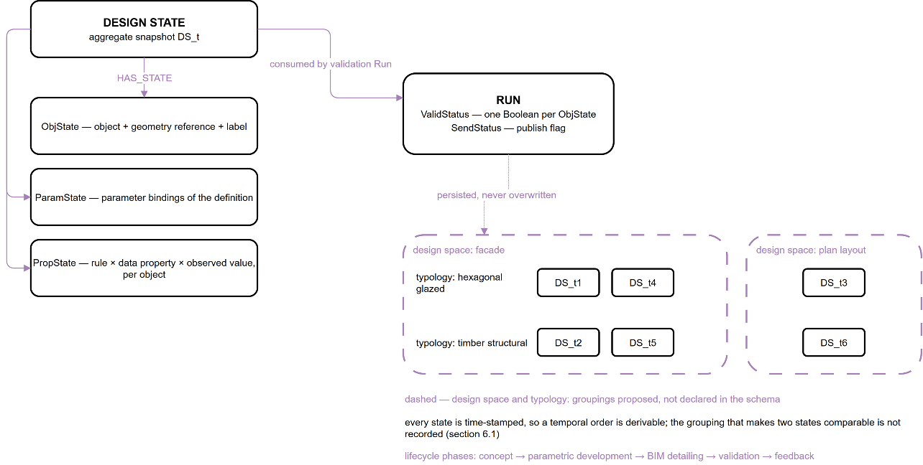
Figure 5: Design State composition (ObjState, ParamState, PropState), its consumption by validation Runs. Design states accumulate in groupings (shown dashed) — alternatives within a facade typology, typologies within one design space, separate design spaces for one building. Partitioning determines which states are comparable for typing movement (section 6.1).

3.4 SWRL rule encoding and deterministic reasoning services
Design rules are encoded as SWRL clauses of the form Body - Head, where the body atoms express the condition that violates the constraint and the head atom asserts a boolean violation flag. This inverted, violation-first semantics simplifies rule evaluation: a rule fires only if the constraint is broken, avoiding the need to reason over the complement of a positive condition. The upper-bound pattern is exemplified by the regulation that the maximum building height is 75 metres:
Building(?b) ∧ hasHeightM(?b, ?h) ∧ swrlb:greaterThan(?h, 75.0) → violatesMaxHeight(?b, true)
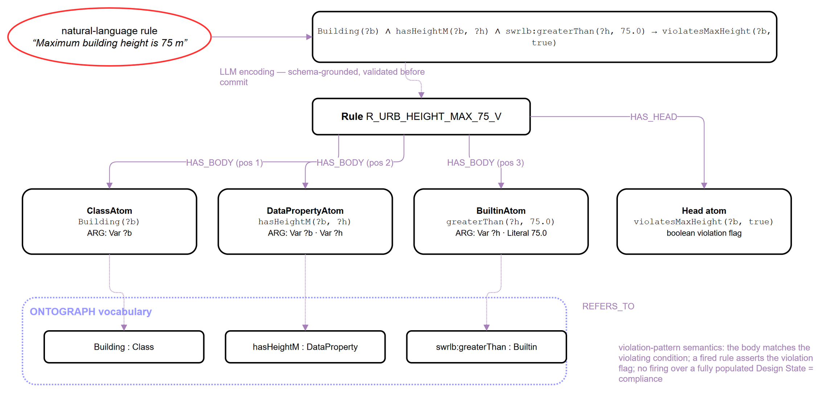
Figure 6: Anatomy of a violation-pattern SWRL rule: LLM encoding of a natural-language constraint, Metagraph decomposition into typed atoms with ordered arguments, and grounding of every atom in Ontograph vocabulary.
The complementary lower-bound pattern is exemplified by the constraint that a street maintains a minimum width of 18 metres:
Street(?s) ∧ hasWidthM(?s, ?w) ∧ swrlb:lessThan(?w, 18.0) → violatesMinWidth(?s, true)
The two rules share one atom structure and differ only in the comparison built-in and the head predicate; where a single property is bounded both above and below, a true range constraint decomposes into exactly this pair, preserving the principle that each rule node encodes one atomic constraint. Minimum constraints are implemented using swrlb:lessThan, maximum constraints with swrlb:greaterThan, and equality constraints with swrlb:notEqual. Range constraints are broken down into separate lower and upper constraints instead of a single compound rule, because compound rules are harder to trace during debugging and auditing. Each rule carries a structured identifier (e.g., R_BUILDING_MAX_HEIGHT_75_V), is decomposed in the Metagraph into body and head atoms with ordered argument links to variables and literals, and is grounded in the Ontograph through REFERS_TO (Figure 6); Figure 9 shows the maximum-height rule's full decomposition, with every atom, argument and grounding populated from the running graph.
The encoding also covers rules that do not bound a dimension. A facade grammar for a hexagonal curtain-wall system shows the range of forms the same violation pattern absorbs. The four clauses below are encoding illustrations: they show how a grammar stated in a designer’s own terms decomposes under the schema, and the vocabulary they use is the per-project vocabulary a rule author would generate rather than core terminology. A grid whose pattern departs from the intended typology is the qualitative case:
FacadeGrid(?g) ∧ hasGridPattern(?g, ?p) ∧ swrlb:notEqual(?p, "hexagonal") → violatesHexagonalPattern(?g, true)
Alignment of a unit’s vertices to the building’s level planes traverses a relation rather than reads a value, and the violation form tests the alignment flag the geometry engine computes:
HexagonalUnit(?u) ∧ hasVertex(?u, ?v) ∧ isLevelAligned(?v, ?a) ∧ swrlb:notEqual(?a, true) → violatesLevelAlignment(?v, true)
Symmetry of the repeating unit is a property of the unit as a whole, and reduces to the same boolean test:
HexagonalUnit(?u) ∧ hasMirrorSymmetry(?u, ?s) ∧ swrlb:notEqual(?s, true) → violatesUnitSymmetry(?u, true)
A panel proportion is a calculated value, and its bounds take the same form as those of building height:
GlassPanel(?p) ∧ hasAspectRatio(?p, ?r) ∧ swrlb:greaterThan(?r, 4.0) → violatesPanelSlenderness(?p, true)
The four clauses vary in their focus—namely, a typology, a traversed relation, a property of a whole, and a computed ratio. — while sharing one structure: a class atom that scopes the rule, atoms that reach the values it depends on, a built-in that decides, and a head that records the finding. Only the second reaches beyond what the validator evaluates today. Its second atom is an object-property atom, a type the Metagraph declares and decomposes, but the SWRL validator does not yet execute, so the clause is representable and auditable in the schema while its evaluation waits on the validator. The other three use only the class, data-property and built-in atom types the validator handles.
The SWRL validator is one of three deterministic reasoning services that share the graph under an explicit rule-partition policy assigning each rule category to exactly one owner. Quantitative threshold constraints on design states are evaluated by the SWRL validator. Terminological consistency of the ontology itself — class disjointness, property domains and ranges — is checked by an OWL 2 DL reasoner (HermiT). Structural and data-integrity constraints — required properties, cardinalities, enumerated kinds — are validated by SHACL shapes over a Resource Description Framework (RDF) projection of the graph (section 3.6), following the closed-world validation semantics for which SHACL is designed and which have proven effective for cross-domain building data (Hagedorn et al., 2023). The two terminological services run in an isolated reasoner sidecar — a separate process that assembles the RDF projection and runs the OWL and SHACL engines without holding a lock on the graph database — while SWRL evaluation is performed where the design state is authored, so that a rule check does not depend on a projection being current. Their verdicts are persisted to the ValidGraph beside the design states they judge, so the evidence trail of every compliance claim (rule, state, service, verdict) is reconstructible from the graph alone.

3.5 Mapping parametric definitions onto the ComputGraph
The ComputGraph is designed so that the parametric definitions architects already build in visual-programming environment can be expressed in the ontology through a one-to-one correspondence. A definition maps one-to-one onto the ComputGraph hierarchy: the definition is an Algorithm, each named cluster of components is an ordered Procedure, each component set inside the Procedure is a Pattern, and the sliders, panels, and computed values that drive the definition become Parameters — typed as constant, variable, or emergent (derived values) — exposed through input and output Interfaces. The mapping makes a design rule and its parametric definition mutually addressable. The ATTRIBUTE_OF bridge connects a rule atom — for instance, the variable bound by a maximum-height comparison — to the specific parameter that produces the value being checked. A rule can therefore be traced back to the exact slider or computed quantity it constrains, and, conversely, a parameter can report which rules govern it. This correspondence supports the bidirectional translation between design grammars and parametric definitions described in section 4: rules authored in natural language are projected onto the parameters of a live parametric definition, and changes to a definition are checked against the rules attached to its parameters. Section 5.3, which answers competency question CQ3, exercises this bridge against the running graph, tracing the minimum-separation rule to the parameter it governs and back.

3.6 Property-graph implementation and OWL semantics
The ontology is specified in OWL 2 DL and its rules in SWRL, but the runtime graph is a Neo4j labelled-property graph, not a triple store — the two are different data models, and the mapping between them is stated explicitly. A normative, versioned mapping fixes the projection in both directions: every property-graph node label, relationship type, and edge property maps onto a standard term from the W3C OWL and SWRL RDF vocabularies, and the mapping is exercised at reasoning time.
Projected mapping: Ontograph classes and properties map onto owl:Class, owl:DatatypeProperty, and owl:ObjectProperty; Metagraph Rule, Atom, Var, Literal, and Builtin nodes map onto swrl:Imp and its constituent atom types, with the graph's ordered ARG and HAS_BODY/HAS_HEAD edge properties reified as RDF lists so that atom and argument order — which the property graph stores as edge properties, a construct RDF has no direct equivalent for — survives the round trip.
The per-project domain vocabulary is integrated into the reasoning graph only during reasoning, remaining separate from the static core terminological box (TBox). The separation prevents classes from one project from affecting the terminological reasoning of another, and rules whose bodies contain SWRL built-in atoms outside the OWL 2 DL profile are withheld from the terminological run, with the withheld count reported alongside the verdict. The consistency verdict therefore applies to the terminology, not to the rule corpus, and the reported count indicates how much of the corpus the verdict does not cover.
Concretely, when a rule is evaluated: the SWRL validator operates natively on the property graph for the quantitative threshold checks that dominate this ontology's rule population (section 3.4); The OWL 2 DL reasoner and the SHACL validator operate on an RDF projection, assembled on demand by the isolated reasoner sidecar, which unions the static core TBox, a curated disjointness-axiom overlay, and the live per-project export. This ensures that terminological reasoning never blocks the validation path and that a reasoner failure cannot corrupt the graph it reasons about. All three verdicts are written back to the same ValidGraph, but each is recorded under its own property and tagged with the service that produced it, so a structural verdict is distinguishable from a rule verdict. A single destination with source tagging allows one evidence trail to carry findings from services that do not share a data model.
The property-graph commitment was made for three operational reasons. The authoring workflow is write-heavy — rules, states and runs accumulate continuously as a scheme develops — and a property graph absorbs that pattern natively, where a triple store would place a serialisation step before every write. The query surface is already familiar to the BIM-adjacent tooling ecosystem, which lowers the cost of the connectors the schema depends on. The commitment also admits migration: the Graph Query Language (GQL) standard (ISO/IEC, 2024) defines graph types as a schema layer for property graphs, providing a vendor-neutral path beyond any single database product. The projection makes the OWL semantics asserted here derivable from the queried graph, and the runtime requires no deviation from standard OWL 2 DL semantics.

4. LIFECYCLE INTEGRATION AND AI-FACILITATED WORKFLOW
The proposed schema is designed to serve as vendor-neutral ground for an open-standard ecosystem, enabling cross-platform exchange of design data, validation, and management of multiple design representations. This lifecycle integration is realised through an object-centric identification mechanism. The DG (Design Grammars) ID establishes a primary identity type within the Core band, and the cross-platform design data exchange, as illustrated below, directly results from that modelling decision (Figure 7). Design Grammars' interoperability rests on treating the design object itself as the carrier of identity. Every object serialised into the graph is minted a durable, platform-neutral identity — the DG ID — to which native platform identifiers (e.g. a Grasshopper instance GUID, a Revit UniqueId, an IFC GlobalId, a viewer applicationId) are bound as representations. Separated representations of a single conceptual object thus resolve to a single identity within a Design State, and properties computed on one representation become readable, with provenance, from every other representation: for example, an insulation value computed in the parametric model is exposed on the corresponding BIM element. This supports object-level rather than file-level exchange, and it is the mechanism by which externalised design intent is carried with the object across the lifecycle.
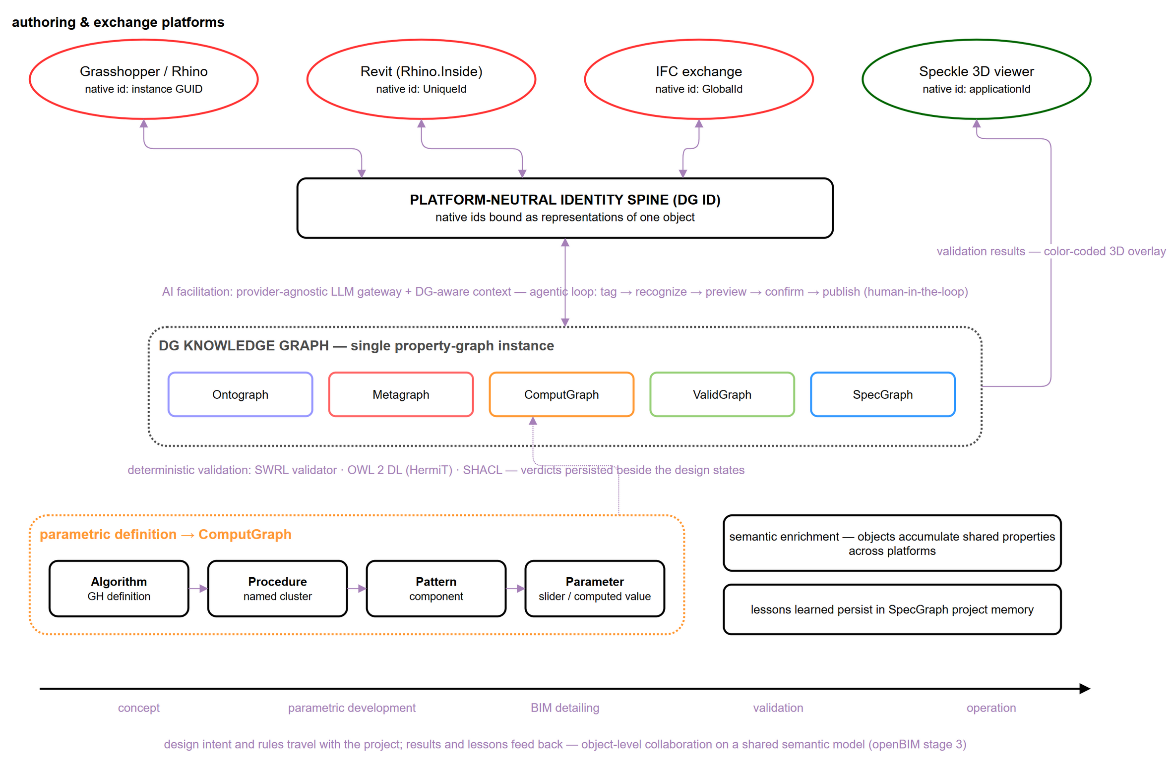
Figure 7: The knowledge graph as the hub of a cross-platform lifecycle: platform representations bound to a platform-neutral identity; AI facilitation above, deterministic validation below; the parametric definition mapped onto the ComputGraph.
The ComputGraph acquires its content by serialising the live parametric definitions. It follows the object-behaviour schema convention applied to parametric definition as a tool within DG (Design Grammars) addin directly analyzing and mapping components on canvas in visual-programming environment. Recognition of object-behaviour constructs on canvas is delegated to a large language model (LLM) behind a provider-agnostic gateway, reflecting the emerging pattern of protocol-mediated agentic BIM interaction (Heimig-Elschner et al., 2026). Every call is prepared by a context assembler — a service that compiles the current ontology catalogue, the SWRL conventions, and a versioned library of parameterised query templates into the model's context, scoped to the definition under consideration and bounded by a declared entity budget whose truncation is reported in the response — and every generated statement is schema-validated before it reaches the graph, the graph-grounded discipline that distinguishes reliable text-to-Cypher systems (Gusarov et al., 2025). Rule encoding runs through the same assembler. Encoding proceeds in stages. A natural-language constraint is first resolved against the Ontograph entities the project already declares; where a term the constraint needs has no counterpart there, that entity is declared and the Ontograph grows to hold it before any rule is written. The Ontograph is in this sense a generative part of the schema rather than a fixed vocabulary — it is enriched in step with the constraints a project accumulates — and it is the layer that governs which entities a SWRL expression may name. Against that resolved vocabulary the constraint is matched to a versioned catalogue of rule shapes, each pairing a constraint form — upper bound, lower bound, range, ratio, count, boolean requirement — with the atom sequence it decomposes into, the graph write that creates those atoms, and a worked example. The model's task is therefore classification and slot-filling against known components rather than free-form formalisation: it selects the shape, then identifies the class, the data property, the comparison and the bound, and the atoms are constructed by template. Every write is checked against the permitted labels, relationship types and key-name conventions of the schema before it reaches the graph, so a malformed construction is refused structurally even where the vocabulary it names is new. The model is thereby confined to encoding, and the resulting rule is auditable atom by atom (section 5.1): its structure comes from the catalogue and its vocabulary from the Ontograph. The interaction contract is conservative: tag → recognise → preview → confirm → publish. The model proposes on-canvas changes as temporary highlights; the architect accepts or rejects them; nothing is written without confirmation, matching the emerging consensus for conversational design agents in architecture (Cheung et al., 2025). On the same substrate, the definition's node-and-wire topology is persisted so that any two snapshots are diffable — the evolution of the generative process itself, not only of its outputs, becomes queryable — and a rule-aware consulting agent answers design questions against the graph, proposing but never executing canvas actions. In parallel, the SpecGraph accumulates decisions, debugging notes, and conventions beside the formal rules they explain, addressing the knowledge-loss problem long documented for design rationale in the AEC industry (Wyke & Lindhard, 2025).

5. ONTOLOGY EVALUATION THROUGH COMPETENCY QUESTIONS
Since this paper pertains to the ontology rather than an operational system, the evaluation is conducted through competency questions (CQs) on a per-question basis (Table 2): each of the following subsections states the question, gives the Cypher query executed directly against the running graph. Section 5.4 complements this with machine-checked terminological evaluation (CQ4) and states what the regression test suite verifies.

5.1 CQ1 — Rule decomposition and grounding
CQ1 asks whether a design rule expressed in natural language can be communicated unambiguously to all stakeholders and to the machine, later inspected and grounded in shared vocabulary. The Metagraph decomposition answers this need: every SWRL atom is individually addressable; the rule carries its natural-language description, its structured identifier, and its SWRL expression side by side; and each atom is grounded in shared Ontograph vocabulary rather than in duplicates created per rule. Sessions record who ingested or edited the rule, from which prompt, and with what result. The intended application is shared, versioned rule libraries communicated across offices and disciplines, with atom-level audit of every revision. Figure 6 sets out the encoding path that this query reads back — natural-language constraint, LLM encoding, decomposition into typed atoms, and grounding in shared vocabulary. Below, the minimum-building-separation rule (section 3.4) is queried by its full body/head decomposition:
MATCH (r:Rule {Rule_Id:'R_BUILDING_MAX_HEIGHT_75'})-[m:HAS_BODY|HAS_HEAD]->(a:Atom)
OPTIONAL MATCH (a)-[g:ARG]->(x) OPTIONAL MATCH (a)-[:REFERS_TO]->(t)
RETURN type(m), m.order, a.type, t.iri, g.pos, coalesce(x.name, x.lex)
ORDER BY type(m) DESC, m.order, g.pos

Part | Order | Atom type | Grounds (REFERS_TO) | Arg pos | Argument
HAS_BODY | 1 | ClassAtom | ex:Building | 1 | ?b
HAS_BODY | 2 | DataPropertyAtom | ex:hasHeightM | 1 | ?b
HAS_BODY | 2 | DataPropertyAtom | ex:hasHeightM | 2 | ?h
HAS_BODY | 3 | BuiltinAtom | swrlb:greaterThan | 1 | ?h
HAS_BODY | 3 | BuiltinAtom | swrlb:greaterThan | 2 | 75
HAS_HEAD | 1 | DataPropertyAtom | ex:violatesMaxHeight | 1 | ?b
HAS_HEAD | 1 | DataPropertyAtom | ex:violatesMaxHeight | 2 | true
Table 5:CQ1 result — the seven rows returned by the query above.
The seven returned rows are exactly the rule's three body atoms (a ClassAtom grounded in ex:Building, a DataPropertyAtom grounded in ex:hasHeightM, and a BuiltinAtom grounded in swrlb:greaterThan) and one head atom (grounded in ex:violatesMaxHeight), each with its ordered arguments. Figure 9a renders the same rows as a populated subgraph. Every atom is individually addressable and re-queryable, the rule carries its natural-language description alongside its structured identifier and SWRL string side by side, and every REFERS_TO edge grounds an atom in a class or property that the Ontograph, not the rule, owns — so each vocabulary term is defined once. The result answers CQ1: the query returns the decomposition and the grounding.

5.2 CQ2 — Per-object validation verdicts
CQ2 asks whether the current design state satisfies the constraints defined for it, with an individually addressable verdict per object. The design state of a mixed-use master plan used as use case for validation runs with the planning constraints defined for each zone — maximum building height per zone, minimum street-wall height, and maximum floor-plate area. A persisted validation run (UrbanBlock-run-001) checks the zone constraints against the Building objects of the scheme; the entities and verdicts it recorded are read back with the Cypher expression:
MATCH (run:ValidationRun {runId:'UrbanBlock-run-001'})-[:HAS_ENTITY]->(e:ValidationEntity)
RETURN e.dgEntityId, e.ruleId, e.status ORDER BY e.dgEntityId
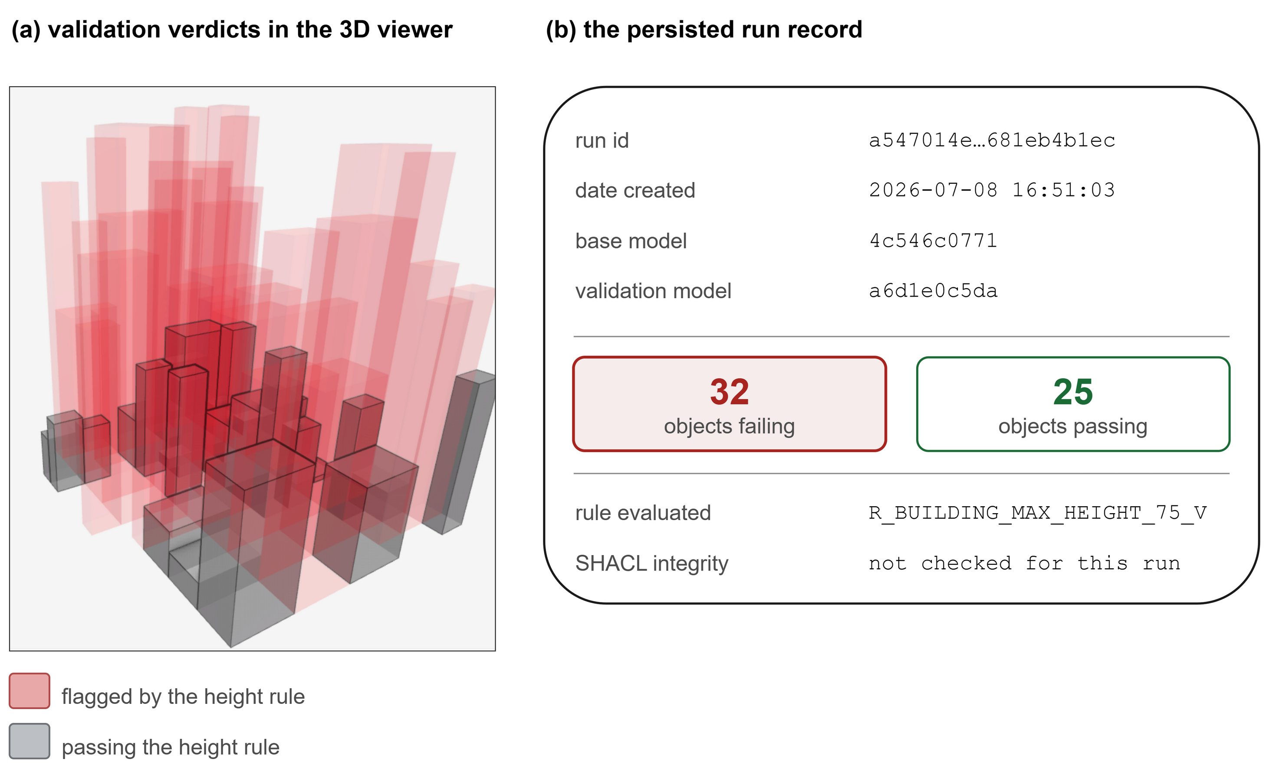
Figure 8: Validation-run results per object as shown in the Design Grammars platform interface: the Design State panel with its per-object verdicts, beside the 3D viewport the run was computed against.
The 57 returned rows from the validation run record 32 violations, each individually addressable and traceable back through HAS_ENTITY to the Run node and to the ObjState/ParamState/PropState snapshot against which it was evaluated (Figure 8b). Because the violation-pattern semantics makes the absence of a recorded violation a positive statement of compliance only once the graph is known to be fully populated (section 6.1), the run additionally records SendStatus, confirming that the complete result set (57 entities) was published to the platform. The same mechanism composes across constraint categories without change: the masterplan's rule catalogue already includes minimum-separation (R_BUILDING_MIN_DISTANCE_12_V, section 3.4), minimum floor-plate area, and minimum street width rules following the identical decomposition pattern; a single rule can attach any number of validation runs matched with Design States, which then can be evaluated in comparison across iterative development cycles.
. 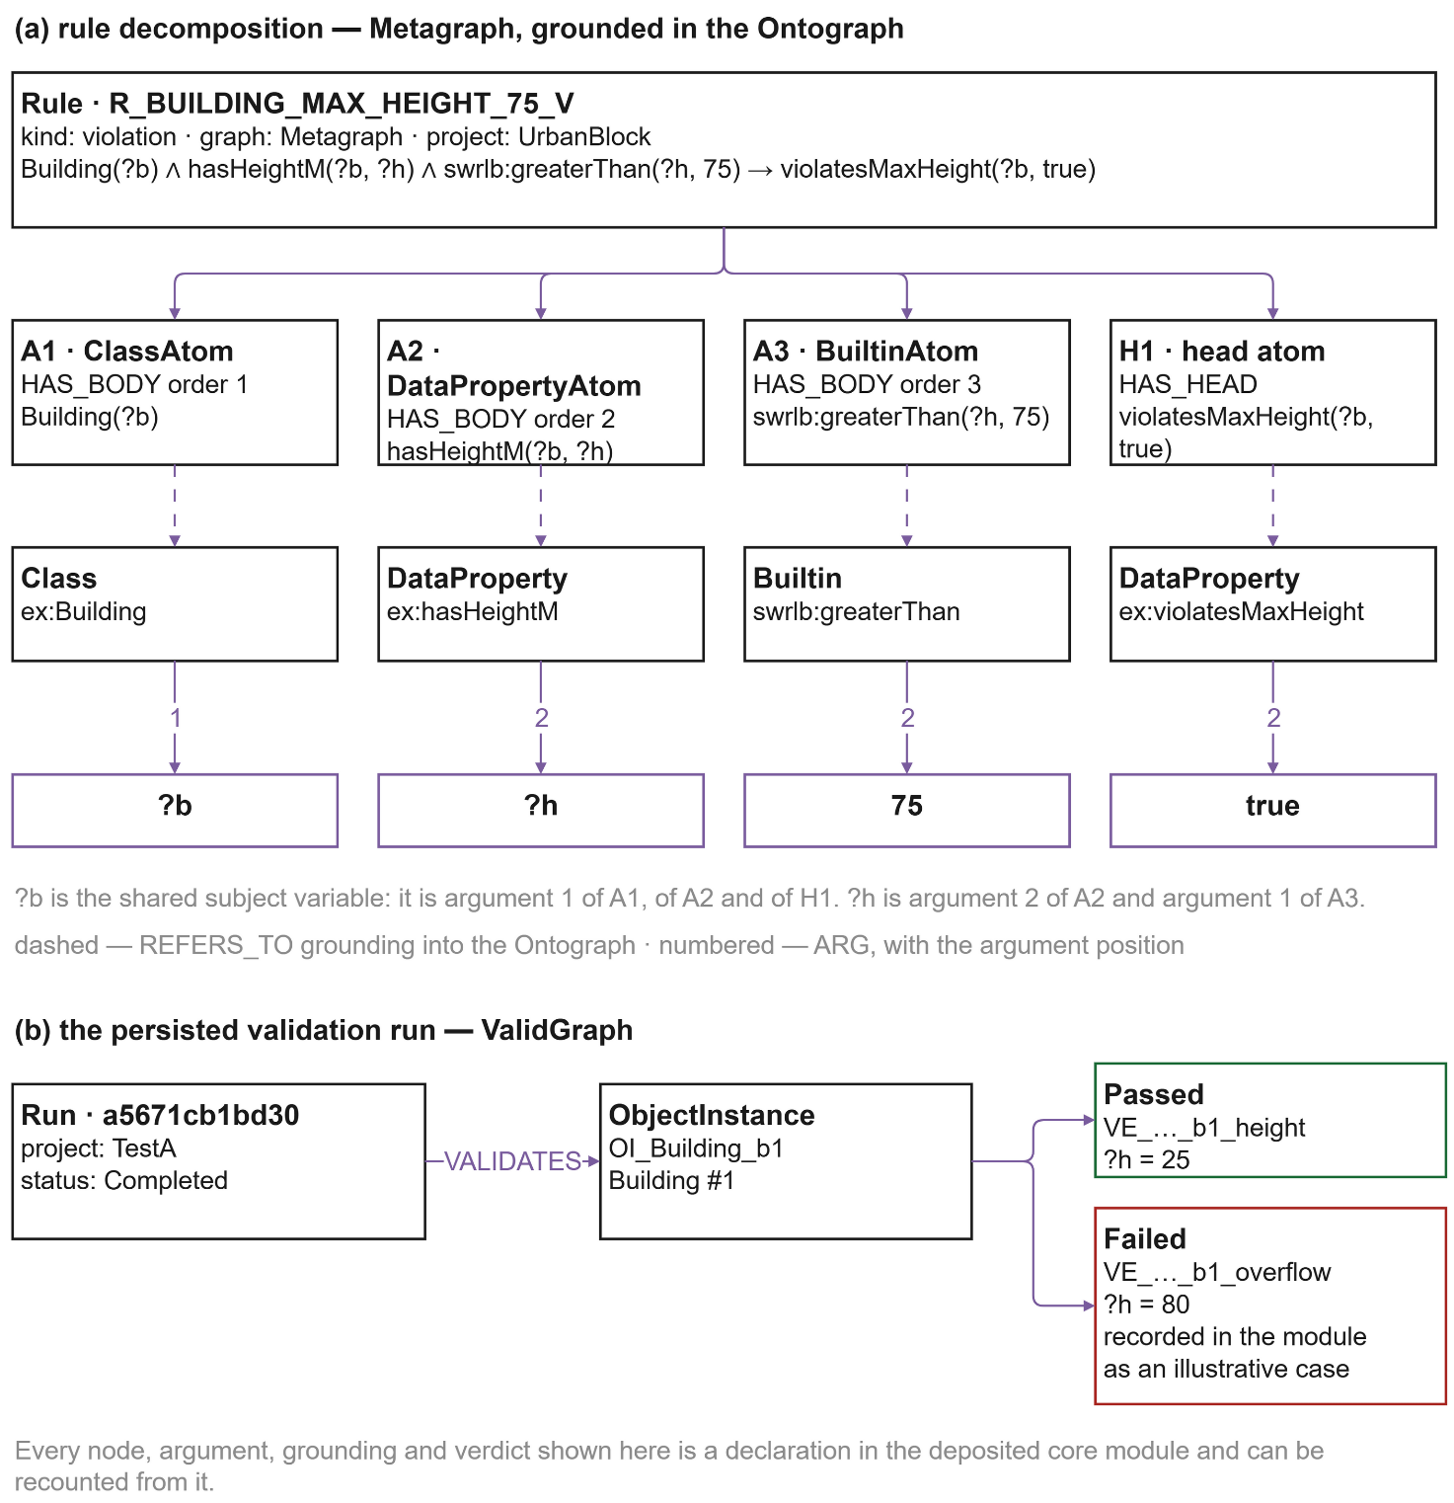
Figure 9: A populated subgraph read back from the running system — (a) the maximum-height rule's full atom decomposition and grounding (CQ1, §5.1); (b) the persisted validation run and its per-object verdicts (CQ2, §5.2), with the property values as stored in the deposited module.

5.3 CQ3 — Tracing a rule to its governing parameter
CQ3 asks whether a planning-constraint rule can be traced to the specific parametric quantity it constrains and, conversely, whether a parameter can report which rules govern it — the mechanism a design-space-exploration workflow uses to filter candidate configurations. The schema realises this as the ATTRIBUTE_OF bridge, a domain-Atom, range-Parameter relationship (section 3.2) that connects the atom carrying the constrained quantity to the ComputGraph parameter that produces its value (section 3.5). For the minimum-separation rule of section 3.4, the constrained quantity is the distance ?d bound by the DataPropertyAtom grounded in ex:hasDistanceM — the rule's second body atom (Table 5); in the site-layout definition that positions the scheme's buildings, that distance is produced by a variable parameter, SeparationDistance, which a design-space workflow sweeps. The forward trace, from a rule to the parameter it governs, is:
MATCH (r:Rule {Rule_Id:'R_BUILDING_MIN_DISTANCE_12_V'})-[:HAS_BODY]->(a:Atom)-[:ATTRIBUTE_OF]->(p:Parameter)
RETURN r.Rule_Id, a.Atom_Id, a.SWRL_label, p.parameterName, p.parameterType

Rule | Body Atom | SWRL_label | Param | Param_type
R_BUILDING_MIN_DISTANCE_12_V | A2 | hasDistanceM | SepDist | Variable
Table 6:CQ3 result — the single row returned by the forward trace above.
The row identifies which atom of the rule constrains which parameter of the definition: the rule's second body atom is bound through ATTRIBUTE_OF to the SeparationDistance parameter, so the trace resolves to the individual quantity being checked rather than to the rule as a whole. Because that parameter carries a DG ID (section 4), the same quantity stays addressable across every platform representation of the definition — the Grasshopper slider that sets it and any BIM element later derived from it — so the trace remains valid across platform representations.
The correspondence is bidirectional, which is what a design-space workflow queries: given a candidate parameter, which rules govern it? Reversing the same bridge answers exactly that, returning SeparationDistance governed by [R_BUILDING_MIN_DISTANCE_12_V]. The two queries answer CQ3 directly and in both directions: a rule resolves to the exact parametric quantity it bounds, and a parameter resolves to the set of rules that govern it — the two-way rule–parameter correspondence of section 3.5, exercised against the running graph.

5.4 CQ4 — Terminological consistency, structural conformance, catalogue self-audit, and implementation evidence
As Section 2.1 articulates, CQ4 functions as a validation question rather than a domain-specific inquiry: it asks whether the design-grammar vocabulary in which the rules are grounded is itself terminologically consistent and structurally complete, so that rules authored independently across different projects and offices remain interoperable. The three domain competency questions above presuppose an affirmative answer to it. Two machine-checked reasoning services answer it directly. The OWL 2 DL reasoner (HermiT), run over the hybrid TBox described in section 3.6, reports the schema as consistent with zero unsatisfiable classes; the same run resolves 65 subclass axioms, 111 property domains, 142 property ranges, and 2 disjointness axioms from a curated overlay, after stripping 5 BuiltinAtom rules the reasoner cannot parse natively (section 3.6). The SHACL validator, run over the same project's structural shapes, reports full conformance: zero violations, warnings, or informational findings. Both checks are reproducible against the live system via POST /reason/consistency and POST /shacl/validate on the reasoner sidecar (Figure 10).
The schema was additionally self-audited against the pitfall catalogue used by the OOPS! ontology-evaluation tool (Poveda-Villalón et al., 2014), a widely used evaluation instrument for this class of check. The audit reports no findings on the annotation and declaration pitfalls the catalogue targets: every one of the 62 core classes carries both an rdfs:label and an rdfs:comment, and every one of the 111 object and datatype properties carries an explicit rdfs:domain and rdfs:range — no missing-annotation pitfall and no missing-domain-or-range pitfall. Class disjointness is deliberately not embedded in the core TBox but supplied through a separate, curated overlay so the core remains minimal for reasoning; the overlay currently declares two disjointness axioms, and their effect is visible directly in the consistency-check axiom counts above.
Implementability is further evidenced by the co-developed runtime. The ontology has passed through three formalisation versions, with the core band and layer partition unchanged since the previous version — an indication that the conceptual structure has converged while the property vocabulary continues to grow additively. A regression test suite spans four service boundaries: OntoGraph/Metagraph/ValidGraph/SpecGraph model round-trips and SWRL rule parsing in the authoring-tool plugin; Design State (ObjState/ParamState/PropState) serialisation, parameter binding, and reinstatement in the same plugin; canvas-to-ComputGraph annotation parsing and connector-heartbeat contracts; and OWL/SHACL export, consistency reasoning, and validation-publish integrity in the graph data service and reasoner sidecar — the last two exercised by the same /reason/consistency and /shacl/validate endpoints reported above, so the terminological evidence for CQ4 is regenerated by the suite rather than recorded once. Every schema change is required to propagate across the ontology file, the Cypher templates, the labelled-property-graph (LPG)-to-OWL mapping, and the SHACL shapes before it is considered complete — a checklist enforced in the project's contribution documentation; the regression suite detects incomplete propagation.
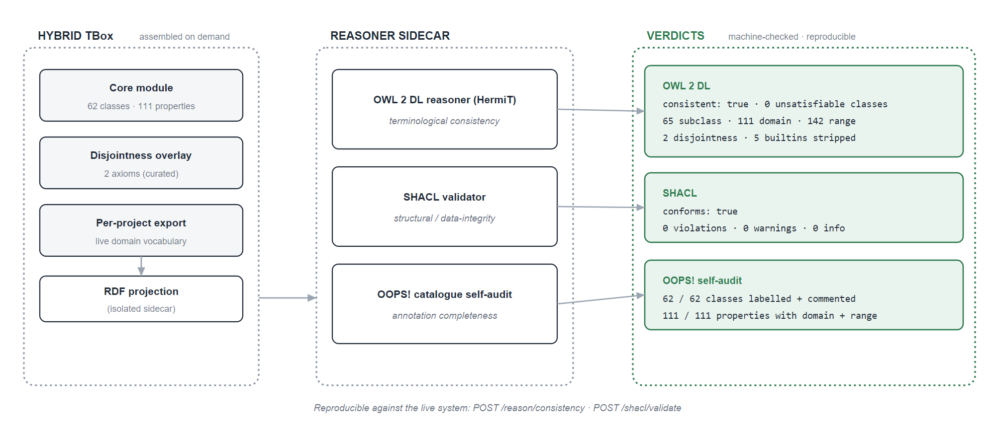
Figure 10:Schema self-verification. The hybrid TBox (core module, disjointness overlay, and per-project export) is projected to RDF on demand by the isolated sidecar; two machine-checked reasoning services and a catalogue self-audit return the verdicts shown. All three are regenerated by the regression suite and reproducible through the sidecar endpoints.

6. DISCUSSION

6.1 Expressiveness and limitations
The current schema encodes a subset of OWL 2 + SWRL expressiveness sufficient for quantitative threshold constraints — minimum, maximum, range, equality, cardinality — through the ClassAtom, DataPropertyAtom, ObjectPropertyAtom, and BuiltinAtom types. It does not yet support disjunctive rules, complex class expressions, or temporal constraints, which are common in building energy codes and fire-safety regulations; extending the schema toward these patterns, most likely through a connector node type representing logical operators between atoms, is a priority for future work. The violation-pattern semantics also operates under an open-world assumption: if no building object is present in the graph, a height rule will not fire, irrespective of whether the constraint is satisfied — counterintuitive for practitioners expecting closed-world compliance semantics. The mitigation is twofold: the graph is pre-populated with all model objects before rule evaluation, so that the absence of a violation indicates compliance rather than an unpopulated graph, and the SHACL layer closes the world for structural completeness — a shape violation reports the missing population that would otherwise prevent a rule from firing.
Three of the boundaries recorded in section 2.2 are open questions rather than settled limits. The first concerns generated vocabulary. Ontograph classes are minted per project from the terms a rule author uses, which keeps the schema free of a fixed spatial hierarchy but also allows two projects to name one concept twice. A default-class discipline would resolve a generated term against the aligned vocabularies first and mint a new class only where no candidate matches it semantically, so that reuse accumulates across projects rather than being re-declared in each. The second follows from the first. IFC is the agreed open format for cross-platform exchange, and an IfcOWL alignment would let generated classes resolve against IFC entities under the same resolve-then-mint discipline that the topology alignment already expresses, giving the schema a route to exchange without binding its core to one format. The third concerns movement. The situated extension of FBS (Gero & Kannengiesser, 2004) treats designing as movement between state spaces, and section 3.3 has established what the schema holds at each moment: a Design State resolves Function, Behaviour and Structure. Typing the movement between two such states asks one further thing of the schema — the design space each state belongs to. States accumulate in partitions as much as in succession: one set may hold facade alternatives while another holds plan layouts of the same building, and a facade set may divide again by typology, a hexagonal glazed pattern in one partition and a timber structural system in another. A comparison between two states within one partition therefore carries a different meaning from a comparison across partitions. Reformulation in the framework's sense redefines a state space, and so appears as a change of partition; refinement is movement within a partition, leaving its Function intact. Recording partition membership on the state is the addition this direction asks for, and it is what would let the graph carry the distinction between reframing and refinement that the co-evolution literature treats as central (Schön, 1992; Poon & Maher, 1997; Dorst & Cross, 2001; Dorst, 2011). Two boundaries give such a relation its shape: it describes movement between the moments an architect chose to validate, at the granularity of those checkpoints, and it reaches the framework's external world in the authoring model and its expected world in the rules, while the designer's interpretation of either belongs to protocol study.

6.2 Positioning and scalability
Table 7 positions the proposed ontology in relation to the rule-persistence gap identified in the introduction. The comparison focuses on the five dimensions that gap turns on: rule persistence — whether rules persist as first-class artifacts; auditability — whether they are independently auditable; the data-transformation burden imposed on the authoring-tool side; alignment with open standards; and deterministic re-execution of verdicts.

Approach | Rules persist as artifacts | Independently auditable | Transformation burden | Standards alignment | Deterministic re-execution
IfcOWL + SPARQL (Pauwels et al., 2017) | Yes, as RDF triples | Yes | High — full IfcOWL serialisation | OWL/SPARQL | Yes
Proprietary rule engines | Yes, in a closed format | No — opaque to inspection | Low–moderate | None | Vendor-dependent
SHACL-only validation (Hagedorn et al., 2023) | Shapes persist, express structure not intent | Yes, for structural checks | Moderate | SHACL/RDF | Yes
LLM-first compliance checking (Iversen & Huang, 2026; Madireddy et al., 2025) | No — lives in a prompt-response cycle | No — implicit in the context window | Low | None claimed | No — reinterpretation may vary
DG ontology (this paper) | Yes — decomposed SWRL atoms in the Metagraph | Yes — atom-by-atom, versioned | Low — no full IfcOWL serialisation required | OWL 2 DL / SWRL / SHACL / GQL path | Yes
Table 7:Positioning against comparison approaches.
The LLM-first and graph-persistent approaches converge rather than compete: recent agentic architectures ground LLM interaction in property graphs and protocol-mediated tool access (Gusarov et al., 2025; Heimig-Elschner et al., 2026), and the DG system combines both: LLM assistance for encoding and recognition, deterministic services for verdicts. These mechanisms correspond to the requirements identified for openBIM maturity stage 3: a single shared semantic model, object-level rather than file-level collaboration, lifecycle-wide information management, and open-standards alignment (Palihakkara et al., 2025; buildingSMART, 2025, 2026).
Regarding scalability, project isolation via a property filter within a single graph suits the pilot scale defined in section 3.2 but should be revisited for multi-tenant settings, where sharding or per-project databases may be preferable; city-scale models and national regulatory libraries will additionally require query-indexing strategies.

7. CONCLUSION
LLM-centric compliance checking leaves one question open: after a rule has been interpreted from natural language, where is it stored, and by what means is it audited, versioned, or re-executed? The Design Grammar ontology provides the interpreted rule with a durable, queryable representation — decomposed into individually addressable SWRL atoms, grounded in a generated shared vocabulary that is itself machine-checked for consistency, and evaluated under a violation-pattern encoding whose absence-of-violation verdict depends on explicit population discipline. All four of the paper's competency questions are answered directly against the running graph (section 5).
The schema inherits the three-way Function–Behaviour–Structure decomposition (Gero, 1990), retaining Behaviour and Structure on the Object and externalising Function into the knowledge graph, where it is addressable independently of the artefact it governs. The object-centred core holds that decomposition, the property-graph-to-OWL projection keeps it machine-checked for consistency, and the identity-carrier mechanism carries an object's semantic properties across a platform change.
Future work follows directly from where the evidence in section 5 runs out: (1) scale the ATTRIBUTE_OF trace demonstrated in section 5.3 into a full design-space-exploration case study, in which many parameters are filtered against the rules that govern them across a swept configuration space; (2) extend the rule schema to disjunctive and temporal constraints, which the current three-atom-type encoding does not support (section 6.1); (3) deepen the standards bridges toward full topological reasoning and requirement-driven exchange workflows (IfcOWL/IDS). The ontology, its extension modules, and the supporting artifacts will be released as open source under the terms stated below, to support community adoption and comparative evaluation.

AVAILABILITY
The core ontology module, its three extension modules (standards, BOT, Topologic), the SHACL shape set, and the normative property-graph-to-OWL mapping documentation described in this paper are maintained as a versioned project and will be deposited at an open, citable archive with an assigned DOI and an explicit open licence upon acceptance; the namespace currently in use (http://example.org/design-grammar#) is a development placeholder and will be replaced by a resolving, permanent namespace at the same time, consistent with linked-data best practice. The deposit comprises the core ontology module and its catalogue; the three extension modules for the standards stack, building topology, and non-manifold topology; the SHACL shape set and the curated disjointness overlay; the normative property-graph-to-OWL mapping specification; the graph schema specification and the rule-partition policy; the catalogue of rule shapes that drives LLM rule encoding (section 4); the cross-platform identity specification (section 4); and the schema migration scripts. The element counts of Table 3 are generated from the deposited core module, so a reader can recount them against that file. The runtime services that exercise the schema — the graph data service, the reasoner sidecar, and the Grasshopper authoring plugin — are versioned in the same deposit (Ermolenko, 2026). The ontology modules, the shape set and the specifications are released under the Creative Commons Attribution 4.0 International licence, and the runtime services, the rule-shape catalogue and the migration scripts under the Apache License 2.0.

ACKNOWLEDGEMENTS
This work is supported by national funds through FCT — Foundation for Science and Technology under grant agreement 2024.03763.BD attributed to the first author, and by the R2U Technologies | modular systems project (ref.: C644876810-00000019) funded by PRR — Plano de Recuperação e Resiliência — and by European Funds Next Generation EU. Additional support was provided through the Multiannual Funding of Lab2PT (UID/04509), FCT R&D Unit ISISE (UID/4029/2025; UID/PRR/04029/2025), and Associate Laboratory ARISE (LA/P/0112/2020).

REFERENCES
Beirão, J. N., Duarte, J. P., & Stouffs, R. (2011). Creating Lisbon: Urban design with a city grammar. In Proceedings of the 2011 Symposium on Simulation for Architecture and Urban Design (SimAUD).
buildingSMART International. (2025). Global openBIM mandates: 2025 edition. https://www.buildingsmart.org/wp-content/uploads/2025/03/IFC-Mandate_2025.pdf
buildingSMART International. (2026). Embracing challenges and opportunities of using openBIM for construction: Industry insight report. https://www.buildingsmart.org/wp-content/uploads/2026/03/Construction-openBIM_Industry_Insight_bSI_final.pdf
Chen, N., Lin, X., Jiang, H., & An, Y. (2024). Automated building information modeling compliance check through a large language model combined with deep learning and ontology. Buildings, 14(7), 1983. https://doi.org/10.3390/buildings14071983
Cheung, L. H., Lombardi, D., & Di Marco, G. (2025). Agentic, multimodal large language model (LLM) with behavioural parameters and self-iterative capabilities for conversational architectural design processes. Architectural Science Review, 1–21. https://doi.org/10.1080/00038628.2025.2586655
Dorst, K. (2011). The core of 'design thinking' and its application. Design Studies, 32(6), 521–532. https://doi.org/10.1016/j.destud.2011.07.006
Dorst, K., & Cross, N. (2001). Creativity in the design process: Co-evolution of problem–solution. Design Studies, 22(5), 425–437. https://doi.org/10.1016/S0142-694X(01)00009-6
Duarte, J. P. (2005). Towards the mass customization of housing: The grammar of Siza's Malagueira houses. Environment and Planning B: Planning and Design, 32(3), 347–380. https://doi.org/10.1068/b3144
Eastman, C., Lee, J.-m., Jeong, Y.-s., & Lee, J.-k. (2009). Automatic rule-based checking of building designs. Automation in Construction, 18(8), 1011–1033. https://doi.org/10.1016/j.autcon.2009.07.002
Ermolenko, E. (2026). Design Grammar ontology (Version 1.0.1) [Computer software]. GitHub. https://github.com/Erarchitech/design-grammar-ontology
Ermolenko, E., Figueiredo, B., & Azenha, M. (2026). Management of the design knowledge core in a cross-platform environment of the BIM project. In Proceedings of the ptBIM 2026 Conference. University of Porto.
Farghaly, K., Soman, R. K., & Zhou, S. A. (2023). The evolution of ontology in AEC: A two-decade synthesis, application domains, and future directions. Journal of Industrial Information Integration, 36, 100519. https://doi.org/10.1016/j.jii.2023.100519
Fortune Business Insights. (2026). Building information modeling (BIM) market size, share & industry analysis, with forecast to 2034 (Report No. 102986). https://www.fortunebusinessinsights.com/building-information-modelling-software-market-102986
Fu, K., Murphy, J., Yang, M., Otto, K., Jensen, D., & Wood, K. (2015). Design-by-analogy: Experimental evaluation of a functional analogy search methodology for concept generation improvement. Research in Engineering Design, 26(1), 77–95. https://doi.org/10.1007/s00163-014-0186-4
Gero, J. S. (1990). Design prototypes: A knowledge representation schema for design. AI Magazine, 11(4), 26–36.
Gero, J. S., & Kannengiesser, U. (2004). The situated function–behaviour–structure framework. Design Studies, 25(4), 373–391. https://doi.org/10.1016/j.destud.2003.10.010
Gusarov, A., Volkova, A., Khrulkov, V., Kuznetsov, A., Maslov, E., & Oseledets, I. (2025). Multi-agent GraphRAG: A text-to-Cypher framework for labeled property graphs. arXiv. https://doi.org/10.48550/arXiv.2511.08274
Hagedorn, P., Pauwels, P., & König, M. (2023). Semantic rule checking of cross-domain building data in information containers for linked document delivery using the shapes constraint language. Automation in Construction, 156, 105106. https://doi.org/10.1016/j.autcon.2023.105106
Heimig-Elschner, T., Du, C., Scheuvens, A., Borrmann, A., & Beetz, J. (2026). A modular reference architecture for MCP-servers enabling agentic BIM interaction. arXiv. https://arxiv.org/abs/2601.00809
ISO/IEC. (2024). ISO/IEC 39075:2024 — Information technology — Database languages — GQL. International Organization for Standardization.
Iversen, O., & Huang, L. (2026). Leveraging large language models for BIM-based automated compliance checking. Automation in Construction, 182, 106707. https://doi.org/10.1016/j.autcon.2025.106707
Jabi, W., & Chatzivasileiadi, A. (2021). Topologic: Exploring spatial reasoning through geometry, topology, and semantics. In Formal Methods in Architecture (pp. 277–285). Springer. https://doi.org/10.1007/978-3-030-57509-0_25
Janowicz, K., Haller, A., Cox, S. J. D., Le Phuoc, D., & Lefrançois, M. (2019). SOSA: A lightweight ontology for sensors, observations, samples, and actuators. Journal of Web Semantics, 56, 1–10. https://doi.org/10.1016/j.websem.2018.06.003
Lin, C.-J. (2016). Design criteria modeling — Use of ontology-based algorithmic modeling to represent architectural design criteria at the conceptual design stage. Computer-Aided Design and Applications, 13(4), 549–557. https://doi.org/10.1080/16864360.2015.1131551
Madireddy, S., Gao, L., Din, Z. U., Kim, K., Senouci, A., Han, Z., & Zhang, Y. (2025). Large language model-driven code compliance checking in building information modeling. Electronics, 14(11), 2146. https://doi.org/10.3390/electronics14112146
Mubarak, K. (2004). Case-based reasoning for design composition in architecture [Doctoral dissertation, Carnegie Mellon University].
Noy, N. F., & McGuinness, D. L. (2001). Ontology development 101: A guide to creating your first ontology. Stanford Knowledge Systems Laboratory Technical Report KSL-01-05.
Palihakkara, A. D., Osorio-Sandoval, C. A., & Tizani, W. (2025). A review of the application of ontologies and semantic web for building information modelling and digital twins based construction management. Journal of Information Technology in Construction (ITcon), 30, 1208–1243. https://doi.org/10.36680/j.itcon.2025.049
Pauwels, P., & Terkaj, W. (2016). EXPRESS to OWL for construction industry: Towards a recommendable and usable ifcOWL ontology. Automation in Construction, 63, 100–133. https://doi.org/10.1016/j.autcon.2015.12.003
Pauwels, P., Zhang, S., & Lee, Y. C. (2017). Semantic web technologies in AEC industry: A literature overview. Automation in Construction, 83, 145–165. https://doi.org/10.1016/j.autcon.2017.03.009
Poon, J., & Maher, M. L. (1997). Co-evolution and emergence in design. Artificial Intelligence in Engineering, 11(3), 319–327. https://doi.org/10.1016/S0954-1810(96)00047-7
Poveda-Villalón, M., Fernández-Izquierdo, A., Fernández-López, M., & García-Castro, R. (2022). LOT: An industrial oriented ontology engineering framework. Engineering Applications of Artificial Intelligence, 111, 104755. https://doi.org/10.1016/j.engappai.2022.104755
Poveda-Villalón, M., Gómez-Pérez, A., & Suárez-Figueroa, M. C. (2014). OOPS! (OntOlogy Pitfall Scanner!): An on-line tool for ontology evaluation. International Journal on Semantic Web and Information Systems, 10(2), 7–34. https://doi.org/10.4018/ijswis.2014040102
Rasmussen, M. H., Lefrançois, M., Schneider, G. F., & Pauwels, P. (2020). BOT: The building topology ontology of the W3C linked building data community group. Semantic Web, 12(1), 143–161. https://doi.org/10.3233/SW-200385
RIBA. (2020). RIBA Plan of Work 2020 overview. Royal Institute of British Architects.
Sack, H. (2019). Knowledge engineering with semantic web technologies: Ontological engineering [MOOC]. openHPI.
Sacks, R., Brilakis, I., Pikas, E., Xie, H. S., & Girolami, M. (2020). Construction with digital twin information systems. Data-Centric Engineering, 1, e14. https://doi.org/10.1017/dce.2020.16
Schön, D. A. (1992). Designing as reflective conversation with the materials of a design situation. Research in Engineering Design, 3(3), 131–147. https://doi.org/10.1007/BF01580516
Stiny, G., & Gips, J. (1972). Shape grammars and the generative specification of painting and sculpture. In C. V. Freiman (Ed.), Information Processing 71 (pp. 1460–1465). North-Holland.
Suárez-Figueroa, M. C., Gómez-Pérez, A., & Fernández-López, M. (2015). The NeOn methodology for ontology engineering. In M. C. Suárez-Figueroa, A. Gómez-Pérez, E. Motta, & A. Gangemi (Eds.), Ontology engineering in a networked world (pp. 9–34). Springer. https://doi.org/10.1007/978-3-642-24794-1_2
Wyke, S., & Lindhard, S. M. (2025). Understanding design rationale and intent through natural language processing analysis: A search for consensus. Journal of Information Technology in Construction (ITcon), 30, 631–649. https://doi.org/10.36680/j.itcon.2025.026
Zhou, Y., Braun, A., & Borrmann, A. (2022). Knowledge graph-based automated code compliance checking for building design. In Proceedings of the European Conference on Computing in Construction (EC3). https://doi.org/10.35490/EC3.2022.188

ANNEX A — WORKED RULE DECOMPOSITION
The rule below is stored in the core module and is evaluated in section 5.1. It is reproduced here atom by atom so that the decomposition described in section 3.4 can be checked against the artefact. Rule identifier R_BUILDING_MAX_HEIGHT_75_V; rule kind, violation; graph, Metagraph; project, UrbanBlock. Its stored SWRL form is Building(?b) ∧ hasHeightM(?b,?h) ∧ swrlb:greaterThan(?h,75) → violatesMaxHeight(?b,true).
Body atom A1 is a ClassAtom on ex:Building, carrying the single argument ?b. Body atom A2 is a DataPropertyAtom on ex:hasHeightM, carrying ?b and ?h in that order. Body atom A3 is a BuiltinAtom on swrlb:greaterThan, referring to the greaterThan builtin individual and carrying ?h and the literal 75. Head atom H1 is a DataPropertyAtom on ex:violatesMaxHeight, carrying ?b and the literal true. Every atom, argument and argument position in this listing corresponds to a node or an edge in the deposited module.

ANNEX B — WORKED VALIDATION ENTITIES
Validation run a5671cb1bd30 is recorded in the ValidGraph of project TestA with status Completed. It carries two per-rule, per-instance result cells, both bound to the ObjectInstance OI_Building_b1 and both citing R_BUILDING_MAX_HEIGHT_75_V. The first, VE_a5671cb1bd30_b1_height, records a passing result with the observed value of ?h at 25. The second, VE_a5671cb1bd30_b1_overflow, records a failing result with the observed value of ?h at 80, and is labelled in the module as an illustrative failing case rather than a second measured run: it exists to show the shape a violation cell takes for the same object under a different parametric configuration. The pair demonstrates the property that section 5.2 relies on — that a verdict is addressable per object and per rule, and that the value which produced it is stored beside it rather than recomputed.

ANNEX C — STANDARDS ALIGNMENT AXIOMS
The standards extension module is the largest single body of reuse in the schema, and its contents are itemised below. It carries nine equivalent-class axioms, nine subclass axioms and sixteen subproperty axioms aligning core terms to the W3C and OGC standards stack. Alongside it, the curated disjointness overlay carries two disjointness axioms, and the shape set carries seventeen SHACL node shapes, each with a target class, a validation message and a remediation hint. These are the files itemised under Availability, and each figure in this annex is obtained by counting declarations in them.

