THE DESIGN GRAMMAR ONTOLOGY: A SEMANTIC CORE FOR CROSS-PLATFORM DESIGN-INTENT MANAGEMENT AND DATA-DRIVEN DESIGN VALIDATION
SUBMITTED: August 2026
REVISED:
PUBLISHED:
EDITOR:
DOI:
Evgenii Ermolenko, Mr,
University of Minho; EAAD; Lab2PT; ISISE, Guimaraes, Portugal
ORCID: 0009-0003-1228-9550
email: erarchitech@gmail.com
Bruno Figueiredo, Pr,
University of Minho; EAAD; Lab2PT; IN2PAST, Guimaraes, Portugal
ORCID: 0000-0001-8439-7065
email: bfigueiredo@eaad.uminho.pt
Miguel Azenha, Pr,
University of Minho; ISISE; ARISE; Department of Civil Engineering, Guimaraes, Portugal
ORCID: 0000-0003-1374-9427
email: miguel.azenha@civil.uminho.pt

SUMMARY: Design rules and the intent behind them remain fragmented across files, tools, and disciplines: each design handover exchanges only the final geometry, while the rules that produced it are lost. This paper responds to that challenge with the Design Grammar (DG) ontology — a shared semantic substrate through which design intent is managed as durable, machine-readable knowledge throughout the project lifecycle. The ontology was developed through established ontology-engineering activities — specification, conceptualisation, formalisation, and implementation — with explicit competency questions and systematic reuse of existing sources: the Function–Behaviour–Structure framework, Design Criteria Modelling, and open topology ontologies. Conceptually, it organises an object-centred FBS core over five modular layers of a shared knowledge graph covering vocabulary, rules, parametric process, validation evidence, and accumulated project knowledge; because every layer maps onto the same compact core, further layers can be added without disturbing the schema. Design intent, modelled as Function, is externalised from the object into the graph, where it is defined by shared vocabulary and enforced as decomposed SWRL rules under auditable violation-pattern semantics, complemented by OWL 2 DL and SHACL reasoning. Design objects act as identity carriers: separate representations of a single conceptual object across authoring platforms resolve into a single identity and share semantic properties, improving the consistency and sustainability of design decisions. Parametric configurations of design objects are captured as time-stamped Design States, making the evolving design longitudinally traceable and validatable, and a provider-agnostic, human-in-the-loop LLM workflow operationalises rule authoring for practitioners. Three formalised use cases illustrate applicability across rule communication, state validation, and layout generation, positioning the ontology as a semantic foundation for data-driven, AI-facilitated design aligned with openBIM maturity stage 3.

KEYWORDS: Design Grammars; Ontology; Knowledge Graph; SWRL; Design Intent; openBIM; Agentic AI

REFERENCE: Evgenii Ermolenko, Bruno Figueiredo & Miguel Azenha (2026). The Design Grammar ontology: a semantic core for cross-platform design-intent management and data-driven design validation. Journal of Information Technology in Construction (ITcon), Vol. 31, pg. 1-xx, DOI: 10.36680/j.itcon.2026.xxx

COPYRIGHT: © 2026 Evgenii Ermolenko, Bruno Figueiredo, Miguel Azenha. This is an open access article distributed under the terms of the Creative Commons Attribution 4.0 International (https://creativecommons.org/licenses/by/4.0/), which permits unrestricted use, distribution, and reproduction in any medium, provided the original work is properly cited.

1. INTRODUCTION
The built environment is governed by an increasingly dense body of regulatory codes, planning guidelines, and project-specific design rules that architects and engineers must navigate throughout the design process. Manual compliance validation is time-consuming, error-prone, and difficult to scale across large project portfolios and design stages. The emergence of Building Information Modelling (BIM) as the dominant digital medium for architectural design has created an opportunity to automate compliance checking by querying structured geometric and semantic data against machine-readable rule sets (Eastman et al., 2009).
Design grammars, first introduced by Stiny and Gips (1972) as shape grammars, provide a generative, rule-based formalism for describing spatial configurations, and subsequent extensions have brought the formalism closer to practical compliance-checking workflows (Duarte, 2005; Beirão et al., 2011). However, translating design-grammar rules into executable ontology representations that operate directly on BIM data remains largely unsolved. A central obstacle is the absence of a shared, well-structured ontology that can host such rules: existing efforts tend to author ontologies ad hoc for individual studies, with little attention to reuse, alignment, or systematic development. This paper addresses that gap by focusing on the ontology itself rather than on any particular software system built around it.
An ontology is not an active interpreter. It is the shared code space of a knowledge graph — the agreed vocabulary and axioms that any interpreting agent, human or machine, must follow when entities are classified, relationships are inferred, and queries are answered. Establishing such a shared conceptual foundation across the diverse domains of architectural knowledge is the precondition for genuine design-grammar reasoning. Ontology-based compliance checking has been studied in the AEC sector for two decades, from early rule systems operating on enriched IFC files (Eastman et al., 2009) to OWL-based approaches using IfcOWL, SPARQL, and SWRL (Pauwels & Terkaj, 2016; Pauwels et al., 2017), knowledge-graph backends for rule storage and evaluation (Zhou et al., 2022), and property-graph stores for heterogeneous building knowledge (Sacks et al., 2020). The present work builds on this lineage but inverts its emphasis: rather than building another validation system, it develops the common ontology that such systems presuppose. Within the research scope, this schema underlies the cross-platform knowledge-management framework introduced in Ermolenko et al. (2026): that companion paper presented the surrounding system architecture — its communication, data, and analysis layers — and the case studies, whereas the present paper formalizes the knowledge schema those services share.
The most recent wave of automated compliance checking delegates the entire pipeline to large language models: LLM-centric frameworks interpret regulations, extract BIM data, execute checks, and generate reports with high rule-interpretation accuracy (Iversen & Huang, 2026; Madireddy et al., 2025; Chen et al., 2024). These systems demonstrate that natural-language rule interpretation is no longer the bottleneck; what remains unsolved is where the interpreted rule lives. A rule that exists only inside a prompt–response cycle cannot be audited atom-by-atom, versioned, shared across projects, or re-executed deterministically. The industry context sharpens the same requirement: reviews of semantic-web adoption identify the transition from file-based BIM maturity stage 2 to the object-level collaboration of stage 3 as the sector's central interoperability challenge and name ontologies as the key enabling technology (Palihakkara et al., 2025), while openBIM deliverables are increasingly mandated and are moving from pilot to production (buildingSMART, 2025, 2026) in a BIM software market converging on AI-assisted, model-centric workflows (Fortune Business Insights, 2026). The present work is complementary to the LLM wave: it supplies the persistent, queryable substrate in which machine-interpreted rules become durable, inspectable artifacts, while LLMs are confined to the roles they perform reliably — encoding, recognition, and consultation.
Against this background, the paper makes three contributions to data-driven design development. First, it applies a systematic ontology-development methodology to design grammars — explicit specification, knowledge sources, competency questions, and implementation-grounded milestones — where previous design-grammar ontologies were authored ad hoc. Second, it delivers the resulting schema: an object-centred core derived from the Function–Behaviour–Structure framework, spanning five modular knowledge-graph layers, with a violation-pattern SWRL encoding and typed cross-layer bridges; because every layer maps onto the same compact core, the schema is scalable — further layers can be added without disturbing existing ones — and it is packaged as a vendor-neutral core with modular alignment extensions to external vocabularies. Third, it makes the ontology operable across the design lifecycle: parametric configurations of design objects are captured as time-stamped Design States for longitudinal validation; design objects act as identity carriers, so that separated representations of one conceptual object in different authoring platforms resolve to a single identity and share unique semantic properties — substantially improving the consistency and sustainability of design decisions; and an AI-facilitation layer — a provider-agnostic LLM gateway whose context assembler compiles the graph's vocabulary, rule conventions, and query templates into each model call — lets practitioners author rules and serialize parametric models under human confirmation, without formal ontology expertise. The remainder of the paper is organized as follows. Section 2 presents the ontology-development methodology. Section 3 describes the ontology: its core, graph layers, Design State, and rule encoding. Section 4 presents lifecycle integration and the AI-facilitated workflow. Section 5 evaluates the ontology through three formalized use cases and implementation evidence. Section 6 discusses expressiveness, positioning, and scalability. Section 7 concludes.

2. ONTOLOGY DEVELOPMENT METHODOLOGY

2.1 Development process and grounding
There is no single correct way to model a domain; viable alternatives always exist (Noy & McGuinness, 2001). The design-grammar ontology was therefore developed through a structured set of ontology-engineering activities (Sack, 2019) organised as an iterative process across increasing levels of formality (Figure 1). The specification establishes the definition and boundaries of the ontology. Conceptualisation structures domain knowledge into a conceptual model. Formalisation expresses that model in OWL 2 constructs and SWRL Horn clauses. Implementation realises it as a property graph in Neo4j, authored in a dedicated ontology editor (Protégé) and checked by the deterministic reasoning services of section 3.4. These principal activities are accompanied by continuous supporting activities: knowledge acquisition, evaluation, reuse, documentation, and configuration management.

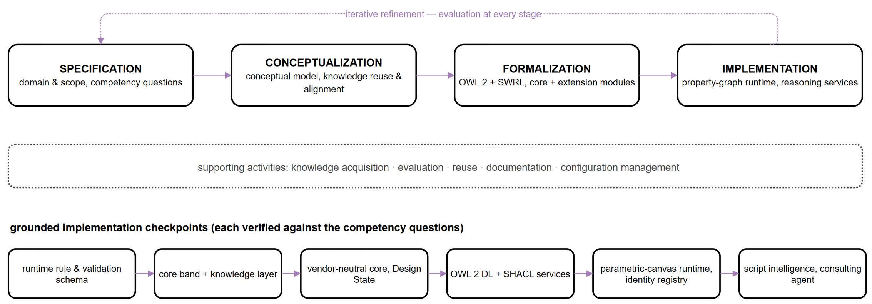
Figure 1: Ontology-development activities (top), continuous supporting activities (middle), and the grounded implementation checkpoints of the DG ontology (bottom).
Because the ontology is co-developed with a running system, each formalisation step is grounded in an implementation checkpoint (Figure 1): the runtime graph encoding of rules and validation runs came first, followed by the cross-cutting core band and the knowledge layer, the vendor-neutral core with the three-part Design State, the OWL 2 DL and SHACL reasoning services, the serialisation of live parametric canvases with the cross-platform identity registry, and finally script-level intelligence. Each checkpoint was verified against the competency questions and regression-tested before the next was undertaken, implementing the continuous-evaluation principle of the methodology. The ontology is designed to operate within mainstream BIM and parametric-design environments — BIM authoring tools (e.g., Revit), geometry modellers (e.g., Rhinoceros), and visual-programming editors (e.g., Grasshopper, Dynamo); the surrounding software services are described only insofar as they ground the schema's runtime (section 4).

2.2 Specification: purpose, domain, scope, and competency questions
The specification fixes the purpose, domain, and users of the ontology. Its purpose is to represent design grammars as durable, auditable knowledge that can be authored in natural language, evaluated against evolving states of the design, and reused across disciplines and projects. Its domain is data-driven parametric design, spanning RIBA Plan of Work Stages 1 through 3 — from preparation and briefing through concept design to spatial coordination (RIBA, 2020) — and extending into the detailing and validation activities that consume the rules authored earlier. The intended end-users are architects, engineers, computational designers, and clients, while maintainers are BIM departments. The anticipated benefits are rigorous communication of design grammars, simplified management of multiple constraints, automatic design-intent validation, and durable design knowledge that survives reformulation and reuse.
The scope is informed by how architects reason: through problem–solution co-evolution (Schön, 1992; Poon & Maher, 1997; Dorst & Cross, 2001), framing and abductive reasoning (Dorst, 2011), analogical and case-based reasoning (Gero, 1992; Mubarak, 2004; Fu et al., 2015), and function–structure mapping and decomposition (Gero, 1990). From these, the ontology is required to support the decomposition of a design problem into computable parts, the modular structuring of design knowledge, interoperability and shared perception across stakeholders, the translation of design knowledge among authoring systems, and semantic reasoning with automatic design-intent validation based on defined rules.
Feasibility is bounded by the competency questions the ontology must answer, which double as acceptance criteria for evaluation. Representative questions include: Does a staircase comply with defined dimension constraints and spatial adjacencies? Does the current model state meet the lighting constraints? Can a design space of plan configurations be generated according to the spatial program and its constraints? Does the detailed-design BIM model comply with the parametric schema defined at the conceptual stage? The three use cases of section 5 are derived directly from these questions.

2.3 Knowledge sources, reuse and alignment
A core principle of the methodology is reuse of existing ontologies rather than de novo authoring. Three source families were analyzed for versatility of implementation, accessibility for external use, and maintainability, and were aligned to the design-grammar domain under a common SWRL convention. The Function–Behaviour–Structure (FBS) framework (Gero, 1990; Gero & Kannengiesser, 2004) supplies the conceptual scaffolding of the core band: a design decomposes into functions mapped to structures, with behaviour mediating the relationship and driving reformulation. Design Criteria Modelling (Lin, 2016) distinguishes semantic, topological, and geometric design information and expresses criteria as SWRL clauses of the form Body → Head over algorithmically computed topological predicates; it directly informs both the rule encoding adopted here (section 3.4) and the treatment of computed quantities as parameters of a parametric definition (section 3.5). Finally, the topology ontologies BOT (Rasmussen et al., 2020) and Topologic (Jabi & Chatzivasileiadi, 2021) provide navigable representations of building topology for spatial relationships; rather than being embedded in the schema, they are bridged through dedicated extension modules, following the core-plus-extension modularization established for W3C vocabularies such as SOSA/SSN (Janowicz et al., 2019). Reuse therefore never couples the vendor-neutral core to a particular external vocabulary, and the same mechanism accommodates further alignments as the ecosystem around the ontology grows.

3. THE DESIGN GRAMMAR ONTOLOGY
This section presents the resulting ontology: the object-centered FBS core (section 3.1), the five graph layers and their modular packaging (section 3.2), the Design State (section 3.3), the SWRL encoding and reasoning services (section 3.4), and the mapping of parametric definitions (section 3.5). The complete normative schema — node labels, relationship types, and module inventory — is maintained as a versioned, open ontology project in the accompanying repository [reference to be added upon publication].

3.1 The object-centred FBS core
The conceptual heart of the ontology is an object-centred rendering of Gero's Function–Behaviour–Structure triad (Gero, 1990; Gero & Kannengiesser, 2004): a cross-cutting band that sits above the graph layers and is referenced by all of them (Figure 2). The Object — the designed artefact — stands at the centre of the model, and the familiar FBS roles are arranged around it, with one deliberate repositioning. An Object carries Behavior — the generative, parametric process that produces it — and Structure — the realized geometric and topological form. Function, the design intent the artefact must fulfil, is not modelled as an internal attribute of the object: it is externalized into the knowledge graph, where it is defined by the vocabulary layer and enforced as decomposed rules. Design intent thereby becomes a first-class, queryable, and validatable artifact rather than an implicit property of geometry — the precondition for communicating intent across disciplines and platforms, and for the persistent intent management that file-based exchange cannot provide (Wyke & Lindhard, 2025). Geometry and Topology complete the structural side of the core, so that the validated model and the parametric definition share one spatial vocabulary. Two further constructs close the band: the Design State, a time-stamped snapshot of an Object and its bindings (section 3.3), and the Session, a provenance record of every authoring, query, or validation interaction. Keeping these over-layer concepts in one band is what lets the graph layers remain decoupled yet interoperable.
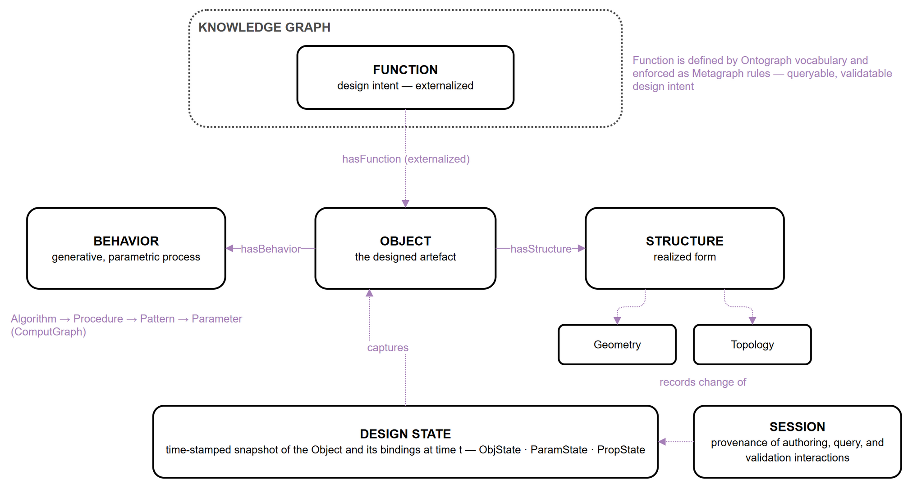
Figure 2: The object-centred FBS core. Function is externalized: defined in the Ontograph, enforced as Metagraph rules; the Design State captures the Object and its bindings at time t.

3.2 Five graph layers, modular packaging, and project isolation
The knowledge graph comprises five coplanar layers resident in a single property-graph instance, partitioned logically by a graph property and isolated per project by a project property (Figure 3). The Ontograph is the vocabulary layer: a lightweight OWL 2 rendering of domain classes, typed datatype properties, object properties, and SWRL built-ins — the terms in which every rule and every function is expressed. The Metagraph is the rule layer: each design rule is decomposed into rule, atom, variable, and literal nodes, making every component of a SWRL clause individually addressable, auditable, and updatable (section 3.4). The ComputGraph is the process layer: it models the parametric definition — the Behavior of the core — as an algorithm decomposed into procedures, patterns, parameters, and typed interfaces, mirroring the visual-programming environments architects already use (section 3.5). The ValidGraph is the evidence layer: it records validation runs, per-object result entities, object instances with neutral geometry handles, and the evaluating reasoner. The SpecGraph is the memory layer: titled, tagged knowledge notes that accumulate decisions, conventions, and lessons learned beside the formal rules they explain. Three typed cross-layer bridges make the layers mutually addressable: REFERS_TO grounds every Metagraph atom in Ontograph vocabulary; ATTRIBUTE_OF links a rule atom to the ComputGraph parameter it constrains; and VALIDATES connects an evaluated rule set to the object instances it checks. Because every layer references the shared core band rather than the internals of other layers, the layer set is open-ended: an additional layer — for cost or environmental-analysis knowledge, for example — can be mapped onto the same core without disturbing the existing schema.
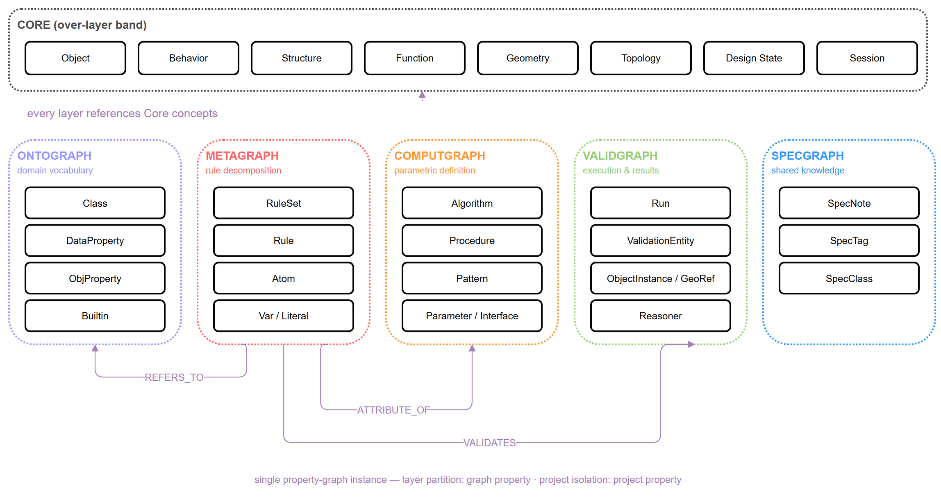
Figure 3: The core band over the five coplanar graph layers, with the typed cross-layer bridges REFERS_TO, ATTRIBUTE_OF, and VALIDATES.

The schema is delivered as a compact, vendor-neutral core module accompanied by optional extension modules, following the core-plus-extension pattern (Janowicz et al., 2019). The core contains only design-grammar-native content and declares no external imports, so it loads cleanly, reasons quickly, and names no product or format. Extension modules carry the alignment axioms to external vocabularies — currently the W3C/OGC standards stack, building topology, and a non-manifold spatial hierarchy — and further extensions can be added in the same manner. Extensions engage automatically: when new entities are ingested into a given graph layer, the extension aligned with that layer allocates them to the proper external classes, so a consumer loads the lean core for schema editing and rule authoring and gains cross-vocabulary reasoning only where it is needed. All nodes carry a project property that scopes them to a named design project, allowing a single graph to host multiple concurrent projects with logical isolation while still permitting cross-project queries — lessons learned accumulate in a shared stakeholder memory rather than fragmenting across isolated databases. This isolation strategy is adequate for pilot-scale use — a single organization operating a handful of concurrent projects on one graph instance; multi-tenant production scenarios may require sharding or per-project databases (section 6.2).

3.3 Design State: the unit of lifecycle traceability
A Design State is the ontology's unit of lifecycle traceability: a time-stamped, immutable snapshot of a design object and everything that determines it at a given moment (Figure 4). It composes three state kinds. The ObjState binds the object and a neutral reference to its geometry; the ParamState captures the parameter bindings of the parametric definition — the sliders, toggles, and value inputs of the Behavior; and the PropState records, per object, the rule, the data property it constrains, and the observed value. A validation Run consumes such a snapshot and returns one Boolean verdict per object state — so per-object outcomes remain addressable — together with a flag confirming publication of color-coded results to an external 3D viewer. Because snapshots are persisted rather than overwritten, the graph accumulates an ordered series DS_t0 … DS_tn that can be compared, replayed, and selectively reinstated. Validation thereby turns from a point-in-time gate into a longitudinal record of how a scheme evolves across concept, parametric development, BIM detailing, and operation.
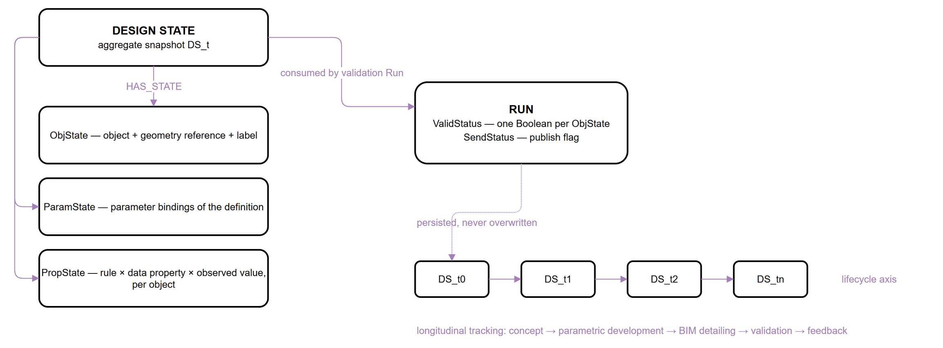
Figure 4:Design State composition (ObjState, ParamState, PropState), its consumption by a validation Run, and longitudinal tracking along the lifecycle axis.

3.4 SWRL rule encoding and deterministic reasoning services
Design rules are encoded as SWRL Horn clauses of the form Body → Head, where the body atoms express the condition that violates the constraint and the head atom asserts a boolean violation flag. This inverted, violation-first semantics simplifies rule evaluation: a rule fires if and only if the constraint is broken, avoiding the need to reason over the complement of a positive condition. For example, the regulation that maximum building height is 75 meters is encoded as:
Building(?b) ∧ hasHeightM(?b, ?h) ∧ swrlb:greaterThan(?h, 75.0) → violatesMaxHeight(?b, true)

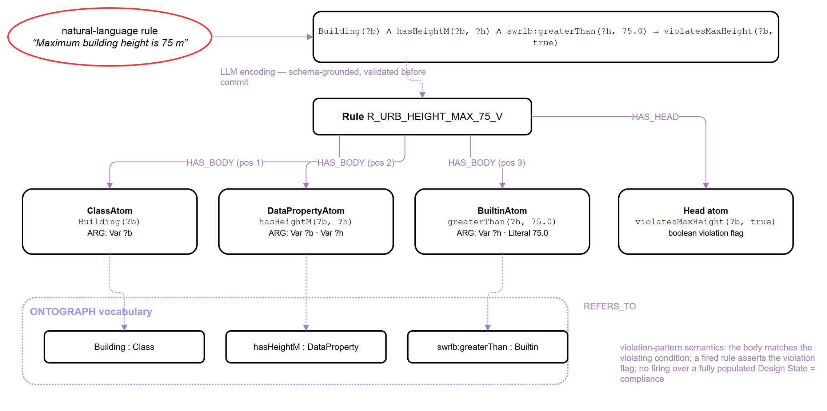
Figure 5:Anatomy of a violation-pattern SWRL rule: LLM encoding of a natural-language constraint, Metagraph decomposition into typed atoms with ordered arguments, and grounding of every atom in Ontograph vocabulary.
Minimum constraints use swrlb:lessThan, equality constraints swrlb:notEqual, and range constraints decompose into separate lower- and upper-bound rules, preserving the principle that each rule node encodes a single, atomic constraint — compound rules are difficult to trace during debugging and audit. Each rule carries a structured identifier (e.g., R_URB_HEIGHT_MAX_75_V), is decomposed in the Metagraph into body and head atoms with ordered argument links to variables and literals, and is grounded in the Ontograph through REFERS_TO (Figure 5).
The SWRL validator is one of three deterministic reasoning services that share the graph under an explicit rule-partition policy assigning each rule category to exactly one owner. Quantitative threshold constraints on design states are evaluated by the SWRL validator. Terminological consistency of the ontology itself — class disjointness, property domains and ranges — is checked by an OWL 2 DL reasoner (HermiT). Structural and data-integrity constraints — required properties, cardinalities, enumerated kinds — are validated by SHACL shapes over an RDF projection of the graph, following the closed-world validation semantics for which SHACL is designed and which has proven effective for cross-domain building data (Hagedorn et al., 2023). All three services run in an isolated reasoner sidecar, and their verdicts are persisted to the ValidGraph beside the design states they judge, so that the evidence trail of every compliance claim — rule, state, reasoner, verdict — is reconstructible from the graph alone.

3.5 Mapping parametric definitions onto the ComputGraph
The ComputGraph is designed so that the parametric definitions architects already build in visual-programming environments can be expressed in the ontology without translation loss. A definition maps one-to-one onto the ComputGraph hierarchy: the definition is an Algorithm, each named cluster of components is an ordered Procedure, each component is a Pattern, and the sliders, panels, and computed values that drive the definition become Parameters — typed as constant, variable, or emergent — exposed through input and output Interfaces (Figure 6). The value of this mapping is that it makes a design rule and the parametric definition that must satisfy it mutually addressable. The ATTRIBUTE_OF bridge connects a rule atom — for instance, the variable bound by a maximum-height comparison — to the specific parameter that produces the value being checked. A rule can therefore be traced back to the exact slider or computed quantity it constrains, and, conversely, a parameter can report which rules govern it. This two-way correspondence underpins the bidirectional translation between design grammars and parametric definitions on which the lifecycle workflow of section 4 rests: rules authored in natural language are projected onto the parameters of a live definition, and changes to a definition are checked against the rules attached to its parameters.

4. LIFECYCLE INTEGRATION AND AI-FACILITATED WORKFLOW
Cross-platform continuity rests on treating the design object itself as the carrier of identity (Figure 6). Every object serialized into the graph is minted a durable, platform-neutral identity — the DG ID — to which native platform identifiers (a Grasshopper instance GUID, a Revit UniqueId, an IFC GlobalId, a viewer applicationId) are bound as representations. Separated representations of one conceptual object thus resolve to a single identity within a Design State, and properties computed on one representation become readable, with provenance, from every other: an insulation value computed in the parametric model is exposed on the corresponding BIM element. This realizes object-level semantic enrichment — the object accumulates meaning as it moves through tools — rather than the file-level exchange of conventional interoperability, and it is the mechanism by which externalized design intent travels with the object across the lifecycle, improving the consistency and sustainability of design decisions.
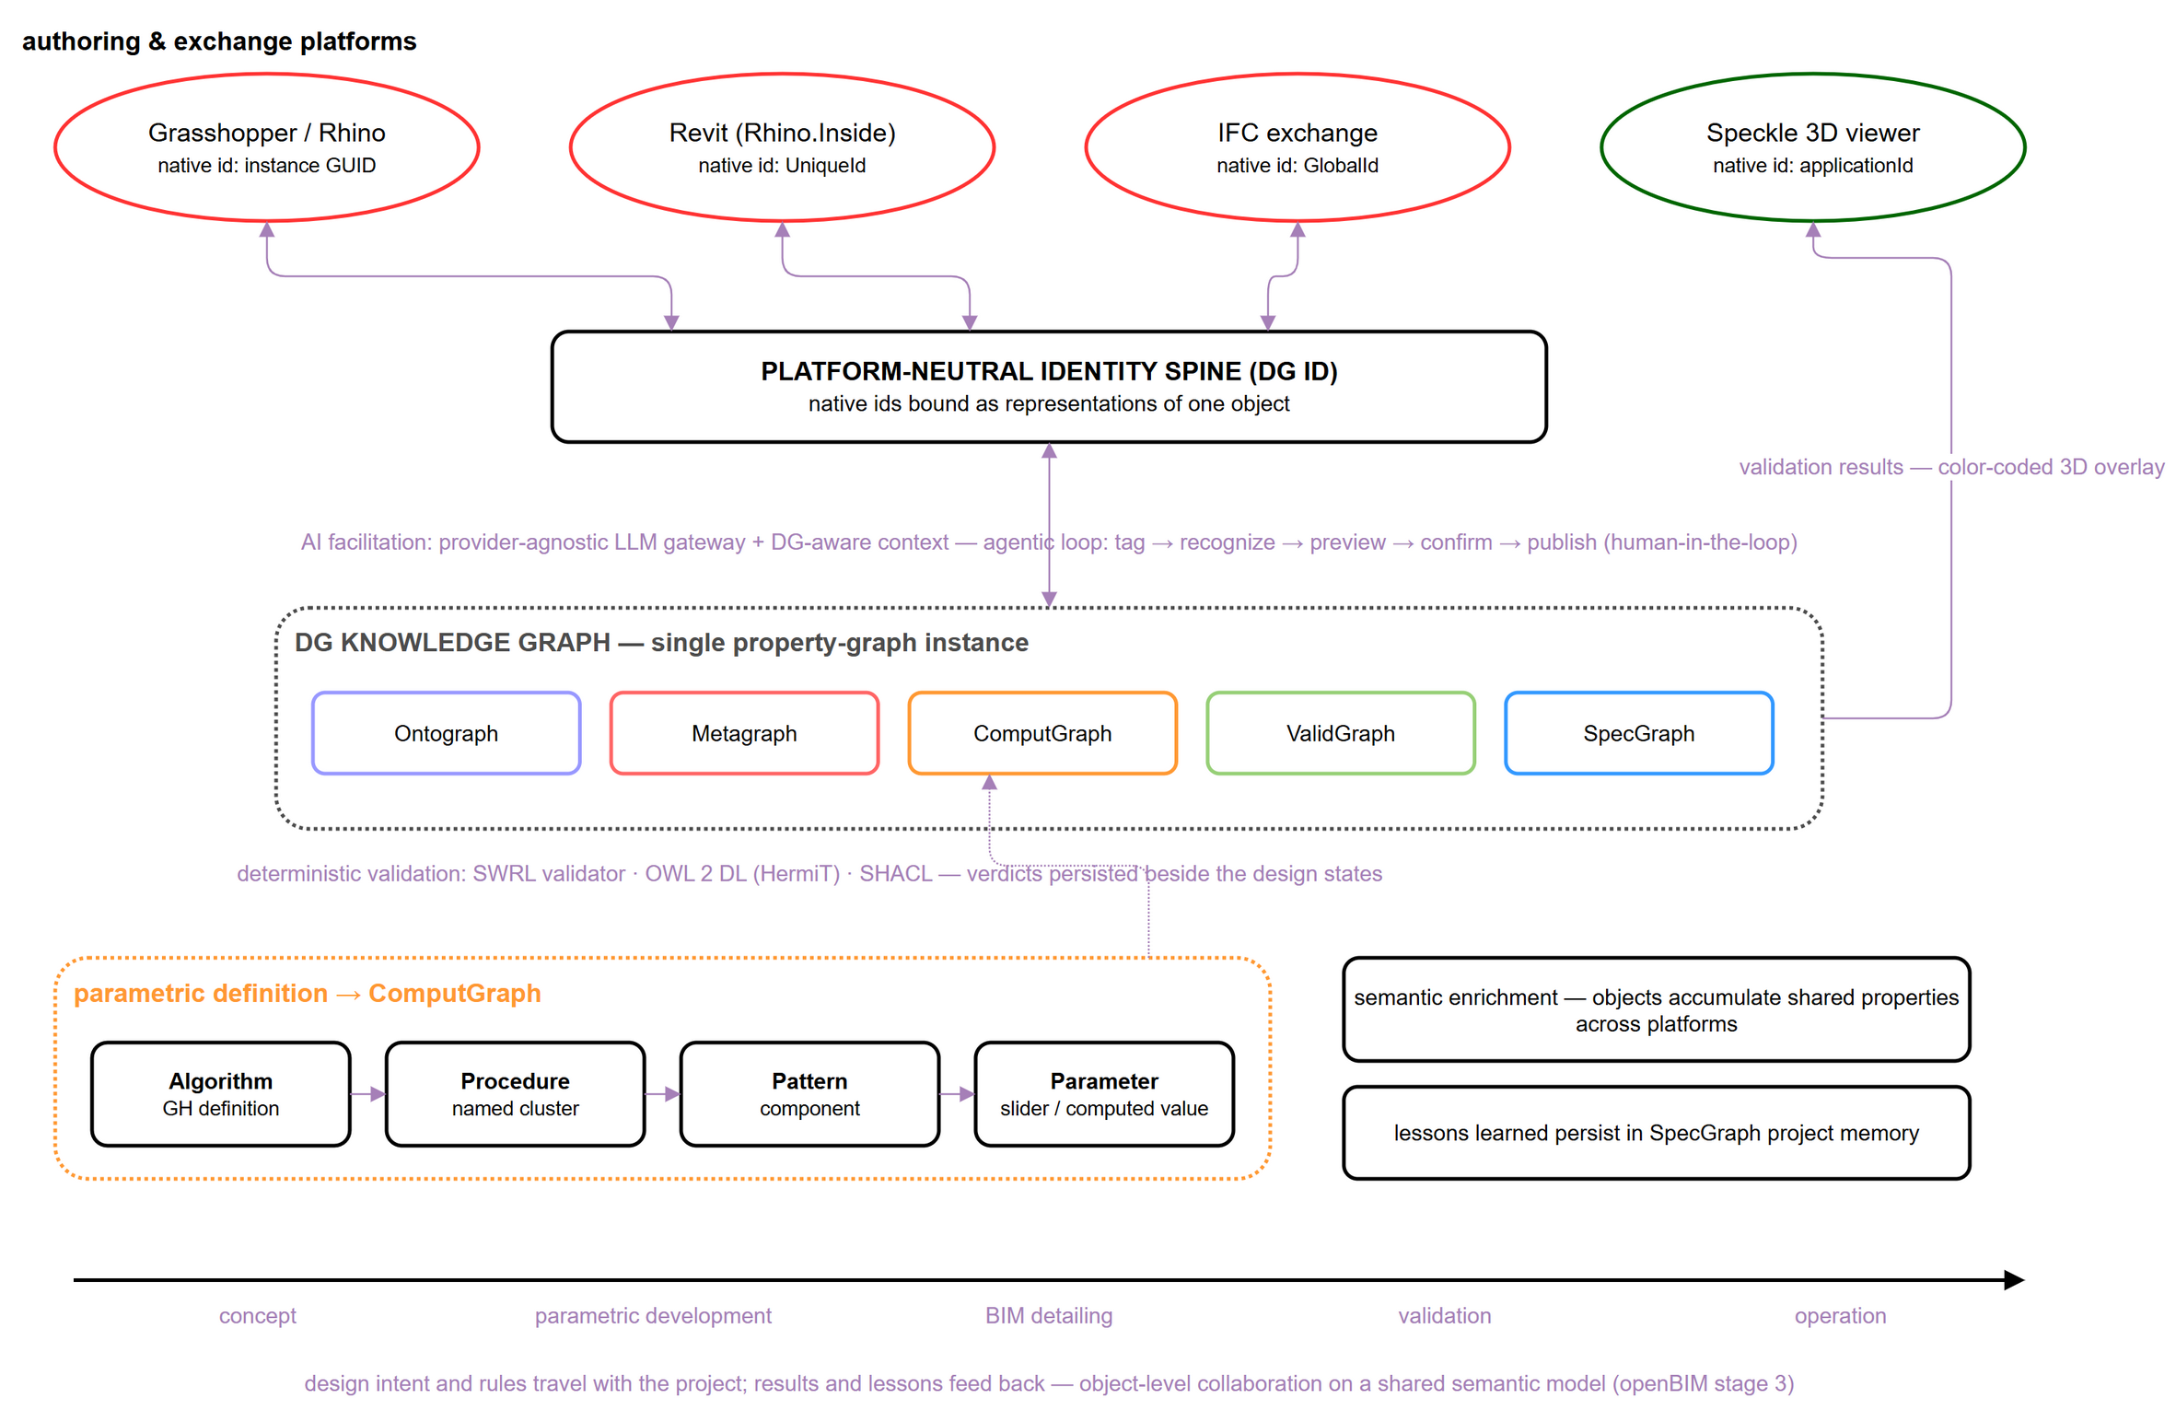
Figure 6:The knowledge graph as the hub of a cross-platform lifecycle: platform representations bound to a platform-neutral identity; AI facilitation above, deterministic validation below; the parametric definition mapped onto the ComputGraph.
The ComputGraph acquires its content through serialization of the live parametric canvas, following an annotation convention that architects apply as ordinary group labels. Recognition of untagged canvas regions is delegated to a large language model behind a provider-agnostic gateway (Anthropic, OpenAI-compatible, or local models), reflecting the emerging pattern of protocol-mediated agentic BIM interaction (Heimig-Elschner et al., 2026). Every call is prepared by a context assembler — a service that compiles the current ontology catalog, the SWRL conventions, and a versioned library of parameterized query templates into the model's context — and every generated statement is schema-validated before it reaches the graph, the graph-grounded discipline that distinguishes reliable text-to-Cypher systems (Gusarov et al., 2025). The interaction contract is deliberately conservative: tag → recognize → preview → confirm → publish. The model proposes on-canvas, as temporary groups and annotations; the architect disposes; nothing is written without confirmation — matching the emerging consensus for conversational design agents in architecture (Cheung et al., 2025). On the same substrate, the definition's node-and-wire topology is persisted so that any two snapshots are diffable — the evolution of the generative process itself, not only of its outputs, becomes queryable — and a rule-aware consulting agent answers design questions against the graph, proposing but never executing canvas actions. In parallel, the SpecGraph accumulates decisions, debugging notes, and conventions beside the formal rules they explain, addressing the knowledge-loss problem long documented for design rationale in the AEC industry (Wyke & Lindhard, 2025).

5. ONTOLOGY EVALUATION THROUGH USE CASES
Because this paper concerns the ontology rather than a deployed system, evaluation is framed through three formalized use cases derived from the competency questions of section 2.2, complemented by implementation evidence from the co-developed runtime (section 5.4). Each use case states the design question, identifies the ontology constructs that answer it, and indicates the intended application; quantitative, system-level evaluation is reserved for subsequent work.

5.1 Natural-language design-rule communication
The first use case asks whether a design rule expressed in natural language can be communicated unambiguously to all stakeholders and to the machine, and later inspected and revised at the level of its parts. The Metagraph decomposition answers this need: every SWRL atom is individually addressable; the rule carries its natural-language description, its structured identifier, and its SWRL expression side by side; and each atom is grounded in shared Ontograph vocabulary rather than in duplicates created per rule. Sessions record who ingested or edited the rule, from which prompt, and with what result. The intended application is shared, versioned rule libraries communicated across offices and disciplines, with atom-level audit of every revision.

5.2 Master-plan design-state validation
The second use case asks whether the current design state of a mixed-use master plan satisfies the planning constraints defined for each zone — for example, maximum building height per zone, minimum street-wall height, and maximum floor-plate area. Each planning constraint maps to a separate rule node following the rule-separation principle, and range constraints decompose into lower- and upper-bound pairs. Project-scoped isolation lets several zones and design scenarios coexist within one graph, while the violation-pattern semantics makes the absence of violations a positive statement of compliance, provided the graph has been fully populated with the relevant model objects. The intended application is longitudinal comparison of design states across iterative development cycles.

5.3 Spatial-programme-driven layout generation
The third use case asks whether a design space of plan configurations can be generated according to the spatial programme and constraints defined at the conceptual stage. The ComputGraph models the generative definition whose parameters span the design space; the ATTRIBUTE_OF bridge attaches programme constraints, encoded as Metagraph rules, to exactly the parameters they govern; and each generated candidate is captured as a Design State, so the explored region of the design space persists as an ordered, comparable set of states. The intended application is systematic design-space exploration in which constraint-violating candidates are filtered by the same validator that governs compliance.

5.4 Implementation evidence
The schema's implementability is evidenced by its co-developed runtime. The ontology has passed through three formalization versions (Figure 7), stabilizing at 62 native classes, 43 object properties, and 67 datatype properties, with the core band and layer partition unchanged since the previous version — an indication that the conceptual structure has converged while the property vocabulary continues to grow additively. Every schema change propagates under regression: the runtime stack holds over 370 automated tests across the authoring-tool plugin, the graph data service, and the reasoner sidecar, and each formalization milestone was verified against the competency questions of section 2.2 before release. The ontology, its extensions, and the SHACL shape set are versioned artifacts released alongside the schema documentation.

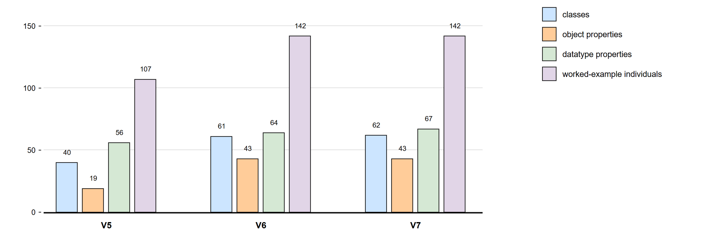
Figure 7:Growth of native schema elements across the last three formalisation versions (classes, object properties, datatype properties, worked-example individuals - ABoxes).

6. DISCUSSION

6.1 Expressiveness and limitations
The current schema encodes a subset of OWL 2 + SWRL expressiveness sufficient for quantitative threshold constraints — minimum, maximum, range, equality, cardinality — through three atom types (ClassAtom, DataPropertyAtom, BuiltinAtom). It does not yet support disjunctive rules, complex class expressions, or temporal constraints, which are common in building energy codes and fire-safety regulations; extending the schema toward these patterns, most likely through a connector node type representing logical operators between atoms, is a priority for future work. The violation-pattern semantics also operates under an open-world assumption: if no building object is present in the graph, a height rule will not fire, irrespective of whether the constraint is satisfied — counterintuitive for practitioners expecting closed-world compliance semantics. The mitigation is twofold: the graph is pre-populated with all model objects before rule evaluation, so that the absence of a violation genuinely indicates compliance rather than an empty graph, and the SHACL layer closes the world for structural completeness — a shape violation reports exactly the missing population that would otherwise silence a rule.

6.2 Positioning and scalability
Compared with IfcOWL + SPARQL-based compliance checkers (Pauwels et al., 2017), the proposed ontology does not require a full IfcOWL serialisation of the BIM model, reducing the data-transformation burden on the authoring-tool side; compared with rule systems built on proprietary languages, it stores rules in an open, queryable graph that can be inspected and audited independently of the checking tool. Compared with LLM-first compliance checkers (Iversen & Huang, 2026; Madireddy et al., 2025), it occupies the opposite end of a persistence spectrum: LLM-first systems minimize modelling effort but leave the interpreted rule implicit in the model's context window, whereas here every rule is a first-class graph artifact — auditable atom-by-atom, versioned, and executable deterministically. The two approaches are converging: recent agentic architectures ground LLM interaction in property graphs and protocol-mediated tool access (Gusarov et al., 2025; Heimig-Elschner et al., 2026), and the DG system embodies this synthesis — LLMs where they are strong, deterministic validation wherever verdicts matter. Relative to SHACL-only validation of linked building data (Hagedorn et al., 2023), the rule-partition policy keeps design-intent rules in SWRL, where their violation-pattern decomposition remains legible to practitioners, and reserves SHACL for structural integrity. Taken together, these mechanisms address the defining requirements of openBIM maturity stage 3: a single shared semantic model, object-level rather than file-level collaboration, lifecycle-wide information management, and open-standards alignment (Palihakkara et al., 2025; buildingSMART, 2025, 2026).
Regarding scalability, project isolation via a property filter within a single graph suits the pilot scale defined in section 3.2 but should be revisited for multi-tenant settings, where sharding or per-project databases may be preferable; city-scale models and national regulatory libraries will additionally require query-indexing strategies. The property-graph commitment is future-proofed by standardization: the GQL standard (ISO/IEC, 2024) defines graph types as a schema layer for property graphs, providing a vendor-neutral migration path for the normative schema beyond any single database product.

7. CONCLUSION
This paper has presented the Design Grammar ontology: a shared semantic substrate for cross-platform management of design intent and design rules throughout the project lifecycle. Developed through a systematic ontology-engineering methodology with explicit reuse of established design and topology ontologies, the schema organises an object-centred FBS core — in which Function is externalised into the graph as queryable design intent — over five modular knowledge-graph layers that remain open to extension. Parametric configurations of design objects persist as time-stamped Design States for longitudinal validation; a violation-pattern SWRL encoding with OWL 2 DL and SHACL reasoning services provides auditable, deterministic verdicts; design objects carry a platform-neutral identity that binds their representations across authoring tools and lets them share semantic properties; and a provider-agnostic, human-in-the-loop LLM workflow makes the ontology operable by practitioners without formal ontology expertise.
Three formalised use cases — natural-language design-rule communication, master-plan design-state validation, and spatial-program-driven layout generation — illustrate the ontology's applicability across checking, interaction, and generation. Future work will (1) extend the rule schema to disjunctive and temporal constraints; (2) deepen the standards bridges toward full topological reasoning and requirement-driven exchange workflows (IfcOWL/IDS); and (3) formalise the design-space layer that the persisted Design States already populate, toward surrogate-assisted, data-driven design exploration. The ontology, its extension modules, and the supporting artifacts will be released as open source to support community adoption and comparative evaluation.

ACKNOWLEDGEMENTS
This work is supported by national funds through FCT — Foundation for Science and Technology under grant agreement 2024.03763.BD attributed to the first author, and by the R2U Technologies | modular systems project (ref.: C644876810-00000019) funded by PRR — Plano de Recuperação e Resiliência — and by European Funds Next Generation EU. Additional support was provided through the Multiannual Funding of Lab2PT (UID/04509), FCT R&D Unit ISISE (UID/4029/2025; UID/PRR/04029/2025), and Associate Laboratory ARISE (LA/P/0112/2020).

REFERENCES
Beirão, J. N., Duarte, J. P., & Stouffs, R. (2011). Creating Lisbon: Urban design with a city grammar. In Proceedings of the 2011 Symposium on Simulation for Architecture and Urban Design (SimAUD).
buildingSMART International. (2025). Global openBIM mandates: 2025 edition. https://www.buildingsmart.org/wp-content/uploads/2025/03/IFC-Mandate_2025.pdf
buildingSMART International. (2026). Embracing challenges and opportunities of using openBIM for construction: Industry insight report. https://www.buildingsmart.org/wp-content/uploads/2026/03/Construction-openBIM_Industry_Insight_bSI_final.pdf
Chen, N., Lin, X., Jiang, H., & An, Y. (2024). Automated building information modeling compliance check through a large language model combined with deep learning and ontology. Buildings, 14(7), 1983. https://doi.org/10.3390/buildings14071983
Cheung, L. H., Lombardi, D., & Di Marco, G. (2025). Agentic, multimodal large language model (LLM) with behavioural parameters and self-iterative capabilities for conversational architectural design processes. Architectural Science Review, 1–21. https://doi.org/10.1080/00038628.2025.2586655
Dorst, K. (2011). The core of 'design thinking' and its application. Design Studies, 32(6), 521–532. https://doi.org/10.1016/j.destud.2011.07.006
Dorst, K., & Cross, N. (2001). Creativity in the design process: Co-evolution of problem–solution. Design Studies, 22(5), 425–437. https://doi.org/10.1016/S0142-694X(01)00009-6
Duarte, J. P. (2005). Towards the mass customization of housing: The grammar of Siza's Malagueira houses. Environment and Planning B: Planning and Design, 32(3), 347–380. https://doi.org/10.1068/b3144
Eastman, C., Lee, J.-m., Jeong, Y.-s., & Lee, J.-k. (2009). Automatic rule-based checking of building designs. Automation in Construction, 18(8), 1011–1033. https://doi.org/10.1016/j.autcon.2009.07.002
Ermolenko, E., Figueiredo, B., & Azenha, M. (2026). Management of the design knowledge core in a cross-platform environment of the BIM project. In Proceedings of the ptBIM 2026 Conference. University of Minho.
Fortune Business Insights. (2026). Building information modeling (BIM) market size, share & industry analysis, with forecast to 2034 (Report No. 102986). https://www.fortunebusinessinsights.com/building-information-modelling-software-market-102986
Fu, K., Murphy, J., Yang, M., Otto, K., Jensen, D., & Wood, K. (2015). Design-by-analogy: Experimental evaluation of a functional analogy search methodology for concept generation improvement. Research in Engineering Design, 26(1), 77–95. https://doi.org/10.1007/s00163-014-0186-4
Gero, J. S. (1990). Design prototypes: A knowledge representation schema for design. AI Magazine, 11(4), 26–36.
Gero, J. S. (1992). What's in a design case and how it can be used. In AID'92 Workshop on Case-Based Design Systems (pp. 27–28).
Gero, J. S., & Kannengiesser, U. (2004). The situated function–behaviour–structure framework. Design Studies, 25(4), 373–391. https://doi.org/10.1016/j.destud.2003.10.010
Gusarov, A., Volkova, A., Khrulkov, V., Kuznetsov, A., Maslov, E., & Oseledets, I. (2025). Multi-agent GraphRAG: A text-to-Cypher framework for labeled property graphs. arXiv. https://doi.org/10.48550/arXiv.2511.08274
Hagedorn, P., Pauwels, P., & König, M. (2023). Semantic rule checking of cross-domain building data in information containers for linked document delivery using the shapes constraint language. Automation in Construction, 156, 105106. https://doi.org/10.1016/j.autcon.2023.105106
Heimig-Elschner, T., Du, C., Scheuvens, A., Borrmann, A., & Beetz, J. (2026). A modular reference architecture for MCP-servers enabling agentic BIM interaction. arXiv. https://arxiv.org/abs/2601.00809
ISO/IEC. (2024). ISO/IEC 39075:2024 — Information technology — Database languages — GQL. International Organization for Standardization.
Iversen, O., & Huang, L. (2026). Leveraging large language models for BIM-based automated compliance checking. Automation in Construction, 182, 106707. https://doi.org/10.1016/j.autcon.2025.106707
Jabi, W., & Chatzivasileiadi, A. (2021). Topologic: Exploring spatial reasoning through geometry, topology, and semantics. In Formal Methods in Architecture (pp. 277–285). Springer. https://doi.org/10.1007/978-3-030-57509-0_25
Janowicz, K., Haller, A., Cox, S. J. D., Le Phuoc, D., & Lefrançois, M. (2019). SOSA: A lightweight ontology for sensors, observations, samples, and actuators. Journal of Web Semantics, 56, 1–10. https://doi.org/10.1016/j.websem.2018.06.003
Lin, C.-J. (2016). Design criteria modeling — Use of ontology-based algorithmic modeling to represent architectural design criteria at the conceptual design stage. Computer-Aided Design and Applications, 13(4), 549–557. https://doi.org/10.1080/16864360.2015.1131551
Madireddy, S., Gao, L., Din, Z. U., Kim, K., Senouci, A., Han, Z., & Zhang, Y. (2025). Large language model-driven code compliance checking in building information modeling. Electronics, 14(11), 2146. https://doi.org/10.3390/electronics14112146
Mubarak, K. (2004). Case-based reasoning for design composition in architecture [Doctoral dissertation, Carnegie Mellon University].
Noy, N. F., & McGuinness, D. L. (2001). Ontology development 101: A guide to creating your first ontology. Stanford Knowledge Systems Laboratory Technical Report KSL-01-05.
Palihakkara, A. D., Osorio-Sandoval, C. A., & Tizani, W. (2025). A review of the application of ontologies and semantic web for building information modelling and digital twins based construction management. Journal of Information Technology in Construction (ITcon), 30, 1208–1243. https://doi.org/10.36680/j.itcon.2025.049
Pauwels, P., & Terkaj, W. (2016). EXPRESS to OWL for construction industry: Towards a recommendable and usable ifcOWL ontology. Automation in Construction, 63, 100–133. https://doi.org/10.1016/j.autcon.2015.12.003
Pauwels, P., Zhang, S., & Lee, Y. C. (2017). Semantic web technologies in AEC industry: A literature overview. Automation in Construction, 83, 145–165. https://doi.org/10.1016/j.autcon.2017.03.009
Poon, J., & Maher, M. L. (1997). Co-evolution and emergence in design. Artificial Intelligence in Engineering, 11(3), 319–327. https://doi.org/10.1016/S0954-1810(96)00047-7
Rasmussen, M. H., Lefrançois, M., Schneider, G. F., & Pauwels, P. (2020). BOT: The building topology ontology of the W3C linked building data community group. Semantic Web, 12(1), 143–161. https://doi.org/10.3233/SW-200385
RIBA. (2020). RIBA Plan of Work 2020 overview. Royal Institute of British Architects.
Sack, H. (2019). Knowledge engineering with semantic web technologies: Ontological engineering [MOOC]. openHPI.
Sacks, R., Brilakis, I., Pikas, E., Xie, H. S., & Girolami, M. (2020). Construction with digital twin information systems. Data-Centric Engineering, 1, e14. https://doi.org/10.1017/dce.2020.16
Schön, D. A. (1992). Designing as reflective conversation with the materials of a design situation. Research in Engineering Design, 3(3), 131–147. https://doi.org/10.1007/BF01580516
Stiny, G., & Gips, J. (1972). Shape grammars and the generative specification of painting and sculpture. In C. V. Freiman (Ed.), Information Processing 71 (pp. 1460–1465). North-Holland.
Wyke, S., & Lindhard, S. M. (2025). Understanding design rationale and intent through natural language processing analysis: A search for consensus. Journal of Information Technology in Construction (ITcon), 30, 631–649. https://doi.org/10.36680/j.itcon.2025.026
Zhou, Y., Braun, A., & Borrmann, A. (2022). Knowledge graph-based automated code compliance checking for building design. In Proceedings of the European Conference on Computing in Construction (EC3). https://doi.org/10.35490/EC3.2022.188

