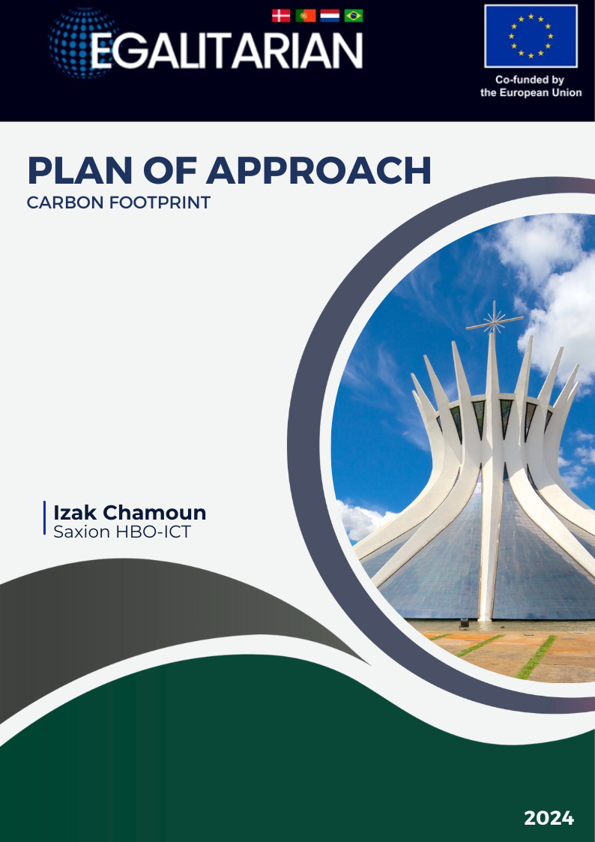
Content
Abstract 3
Introduction 4
Stakeholders 5
Development team 5
Egalitarian Project 5
Saxion 5
Clients 6
Saxion 6
Egalitarian team 6
Background 7
Project content 8
Business requirement 8
User requirements 8
System requirements 9
Planning 10
Sprint 1 11
Sprint 2 11
Sprint 3 11
Sprint 4 11
Sprint 5 11
Sprint 6 11
Role Assignment 12
Definition of Done 13
Code of Conduct 14
Conclusion 15
Bibliography 16

Abstract

This document outlines how the application will be developed, including the time management process, involvement of stakeholders, and the application’s use-case.
The initiative for the development of this application was created to reduce the carbon footprint. Additional benefits will be in the form of cleaner streets and more awareness of a cleaner world. To achieve this the Egalitarian project’s assignment was to create an application that will be used by locals and cooperatives to register waste for pick-up and further processing. This will lead to less decomposing organic waste (Chiras, 2020). Meaning less methane gases will be emitted and waste in general will be reduced for cleaner streets. The aim of where this application will (hopefully) be launched is in Brasília.

Introduction

In the workweek from the 25th of August 2024 to 31st of August a use-case would be defined in Copenhagen. On the first day the groups will be introduced. This project will be developed with a leading SDG goal in mind, Carbon reduction. Software engineering will oversee the development of this application and a couple other of deliverables. Deliverables at the end of this semester 25th of January will be this Plan of Approach, Technical design, functional design, The requirements, the MVP, and a related research document of about blockchain and what role it can play within this project. At the date of the deadline the development team will hold a presentation to highlight the application in a sprint review meeting to the egalitarian team.
Brasília has a couple of crucial problems that require improvements such as data inefficiencies, awareness for the health of the waste pickers working on the landfills and incentive for locals to support a global goal.
This application will be to incentivize locals to register (and collect) waste for cooperatives to pick it up. A reward for collecting waste will be discussed as a future implementation to urge the population to use the application.

Stakeholders

The organizations and individuals who will be interested in this project and who’s interest will be guiding the definition of the application will be listed here.

Development team
- Izak Chamoun

Egalitarian Project
- Erik Lopes
- Pedro Prazeres
- Brasília

Saxion
- Jan Jaap Sandee

The development team will consist of only Izak Chamoun, making it one of the stakeholders. From the Egalitarian perspective, the stakeholders will be Erik Lopes and Pedro Prazeres, who will meet with the development team to coordinate the steps taken and those that need to be taken for future sprints. Brasília will also be a stakeholder, as the application is specifically being developed for this location.
Jan Jaap Sandee will serve as the S3 tutor, primarily responsible for grading the development team's performance.

Clients

Saxion
Saxion has two locations that are interested in this semester's Smart Solutions project: Deventer and Enschede. I will be representing Enschede, along with my tutor, Jan Jaap Sandee. Also present, but not involved in this case, was Oleksandr Kuprii, who is working on a different SDG goal. From Saxion Deventer, three students and an S3 tutor were present. One of the students from Deventer, Ivo van Hurne, was assigned to my SDG group, which main objective was focusing on the carbon footprint reduction.

Egalitarian team
Throughout the workweek in Copenhagen, collaboration within the designated SDG group was mandatory to define the use-case for the upcoming semester. For the carbon footprint goal, a team was formed, consisting solely of me. For the weekly (or monthly) meetings to define the application, Erik Lopes and Pedro Prazeres were designated as the stakeholders. I will primarily be in contact with Erik and Pedro, alongside my S3 tutor, Jan Jaap Sandee, to avoid unexpected or undesired outcomes.

Background

The waste pickers have a harsh life and are often undervalued for their work in Brazil as a whole. Although in recent years a significant growth has been achieved such as formalizing being done for waste pickers by cooperatives for social protections and better income (Pickers, 2010). Cooperatives still have room to improve, but this application will not have its focus on optimizing the recycle process. The main objective of this project is to gather and capture any waste around the landfills, so waste that is not being recycled or managed properly can still be saved whilst incentivizing the locals.
With first-hand experience from the Brazilian team regarding the situation in Brasília, made the call to need much clearer. Real life pictures and video segments as to make an example of why improvements must be made for waste pickers. Brutal living conditions for waste pickers are unwanted, but this application attempts at reducing human caused pollution.

Project content

This application will be created then branded as a module within the ECO Link application. ECO Link has several modules created during previous semesters of the Egalitarian project. This application will be apart of it.
Through the workweek in Copenhagen and the meetings scheduled with the stakeholders, functional- and non-functional requirements were being defined. The project will be developed through the methods of Agile Scrum. (Sean Peek, 2024)This will aid with developing the application flexibly through working in iterations called sprints. Each sprint signifies a 4 week period and will be bring the application in a much clearer scope towards the final result.

Business requirement
Business requirements represent the high-level needs and goals of the organization or stakeholders that the project are expected to address. (Parker, 2012)
Requirement | Source | Description
BR-1 | Meeting | Looking to expand the ECO Link application with an additional module
BR-2 | Meeting | The aim to incentivize locals and cooperatives to make way for cleaner streets

User requirements
User requirements describe what users need to do with a system and it gives a clear view of what the user should be able to do with the application. (Parker, 2012)
Requirement | Source | Description
UR-1 | Interview | The application must have the functionality and design where users can register waste for pick-up
UR-2 | Interview | Documentation documents must be provided to explain the steps taken towards development of this application
UR-3 | Interview | Geolocation functionality for locals to register waste for pick-up
UR-4 | Interview | Payment options can be selected based on the users preference
UR-5 | Interview | Orders can also be cancelled by the user
UR-6 | Interview | A dashboard must be available to view user information and pick-ups
UR-7 | Interview | User can fill in amount and type of material for pick-up
UR-8 | Interview | User can also provide additional pictures to clarify waste

System requirements
System requirements define what a system must do, including functional requirements for user tasks and supplemental requirements like performance and security. Functional needs guide system design, while supplemental needs shape the system architecture. (Parker, 2012)
SR-1-NF | Meeting | The language the application will be available is in Portuguese. Development is in English.
SR-2-NF | Meeting | The geolocation stored will be acclimated to conform to the GDPR mandates
SR-3-F | Meeting | Database to facilitate data storage for order information and user information
SR-4-NF | Meeting | CI/CD pipelines for merge requests
SR-5-NF | Interview | Write tests for frontend and backend
SR-5-NF | Interview | Documentation documents must be provided to explain the steps taken towards development of this application

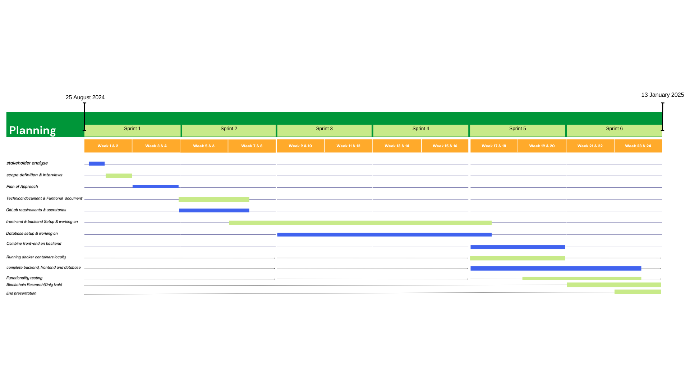
Planning

Sprint 1
First sprint will be focusing mainly on documenting the project and defining the stakeholders needs and interest from this project. Plan of Approach will be written to justify the application that will be created. Meetings will be held with stakeholders to obtain the details.

Sprint 2
The focus will be on the documentation regarding the application. The functional document and the technical document will have their use when defining the application for the development team. Technologies and choices made will be written down to have the whole team on the same page as to what will be used and what has been used to create the application.

Sprint 3
After writing the documents. A start will be made in terms of the application where the development team can start working on. Requirements will be designated to each member and realized until that requirement meets the conditions for the definition of done.

Sprint 4
Further development of the application will be done in this sprint. Requirements will be added and refined towards the end result of this project.

Sprint 5
The development team working on the application will just continue, but a subgroup will be working on setting up the deployment of this application, most likely using docker and connecting it all using docker compose.

Sprint 6
Modules will be tested then merged to view whether the application works as intended. Additional test will be created and a presentation of the application has to be made to display the application.

Definition of Done

As means to develop the project the development team will have a method to designate requirements as done. After completing a requirement the merge request will be available for review. This review is done be a member of the development team to verify whether the task has been done successfully. Upon review and no problems have been localized the merge request can be approved and implemented in either branch it was supposed to be meant for.

Conclusion

This Plan of Approach outlines a clear and structured pathway for the development of an application aimed at reducing Brasília's carbon footprint and improving the conditions for waste pickers. By engaging local communities and cooperatives, the application seeks to incentivize the collection and proper disposal of waste, contributing to cleaner streets and a healthier environment.
The initiative aligns with the broader goals of the Egalitarian project, focusing on sustainability and social impact. Through collaborative efforts, stakeholder engagement, and a commitment to innovation, this project aspires to not only address immediate environmental challenges but also to create lasting value for the community.
As the project progresses, the continued involvement of all stakeholders will be crucial to ensure the successful deployment and adoption of the application. The anticipated deliverables, including the MVP, technical and functional designs, and research on blockchain's potential role, will serve as key milestones towards achieving the project’s objectives.
In conclusion, this application represents a significant step forward in the fight against environmental degradation, and its successful implementation could serve as a model for other cities facing similar challenges. The Egalitarian project team is committed to delivering a solution that not only meets the technical requirements but also contributes to a more sustainable and equitable world.

Bibliography
Chiras, D. (2020). Environmental Science & Technology. In D. Chiras, Environmental Science & Technology (pp. 9200-9209). America: Environ. Sci. Technol. 2020, 54, 15, 9200–9209.
Parker, J. (2012, February 18). Business, User, and System Requirements. From https://enfocussolutions.com/: https://enfocussolutions.com/business-user-and-system-requirements/
Pickers, I. A. (2010). Waste Pickers in Brazil. Brazil: WIEGO.
Sean Peek. (2024, June 24). What is Agile Scrum Methodology. From https://www.businessnewsdaily.com: https://www.businessnewsdaily.com/4987-what-is-agile-scrum-methodology.html

