# Izak Chamoun

Contents

1

Abstract 3

Introduction 4

Design pages 5

Landing page 5

Dashboard 6

Pickup 7

Scheduled Pickup 9

# Abstract

This functional design document provides a comprehensive overview of the main functionalities of the application, aiming to guide developers and other stakeholders through the development process. The document describes the initial version of the application, including the design of the user interface, the requirements at both the business and user levels, and the technical system requirements. Key aspects such as defining the process of waste registering, managing questions and answers, and ensuring privacy and data protection are addressed. The functional design serves as a blueprint for developing an application that meets the needs and expectations of both the organization and the end users.

# Introduction

This document will outline the functionality of the application and will serve as a guide for developers and other stakeholders during the developmental process of this application.

# Design Screens

Frontend mockup of the application.

## Login Screen

Figure 1 - Login page

Login page with the branding of the sustainable hub app. Social buttons leading to facebook, email or X platforms to log in using those platform’s user details. Mandatory link leading to a screen for registering an account

Registration Screen

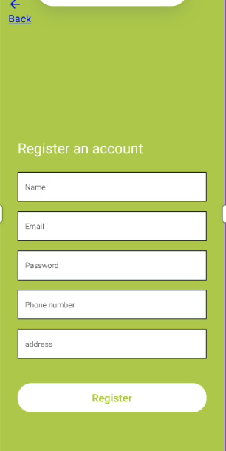

Figure 2 – Registration screen

On this screen you can register an account through filling in the details provided by the form.

Regex used to conform to actual data being submitted.

## Pickup Maps

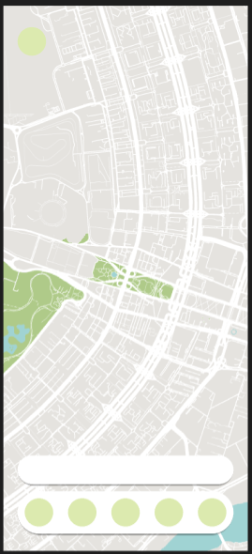

Figure 3 - pickup page

Through this map ‘Pins’ or markers will be available representing donations from locals retrieved from the database. These can be selected and accepted for actual pick up.

This pop-up will be viewed when a pickup is selected. User can select whether to accept it or not.

## Donation Registration screens

Figure 4 - page to add materials and amounts

This screen shows the beginning of registering a donation to the public.

Figure 5 - pop-up material form

When pressing the + button on the card this pop-up will show. You must select material and amount

Figure 6 - End result of materials added

How it should look on the application after adding several materials with respective amounts.

Figure 7 - final step

This screen shows up when you press continue on the donation registration screen. Here you can attach a description to your donation and upload additional images.

## Overview screen

Figure 8 - Overview screen

This screen displays on the left tab “donations” the donations you created and gives the opportunity to edit materials on that donation.

The right tab displays the information of the user that created the donation you accepted. It shows their contact number to give access for communication through either phone calling or WhatsApp.

# Conclusion

These Figma screens will flesh out the first resemblances of this MVP. These screens contain all the necessary functionality a user must be able to make to fully realize the stakeholders vision. A slick design conforming to the branding provided by a previous Saxion student whose task was to create a pleasing and legal colour palette with naming conventions and preferred lexicon.