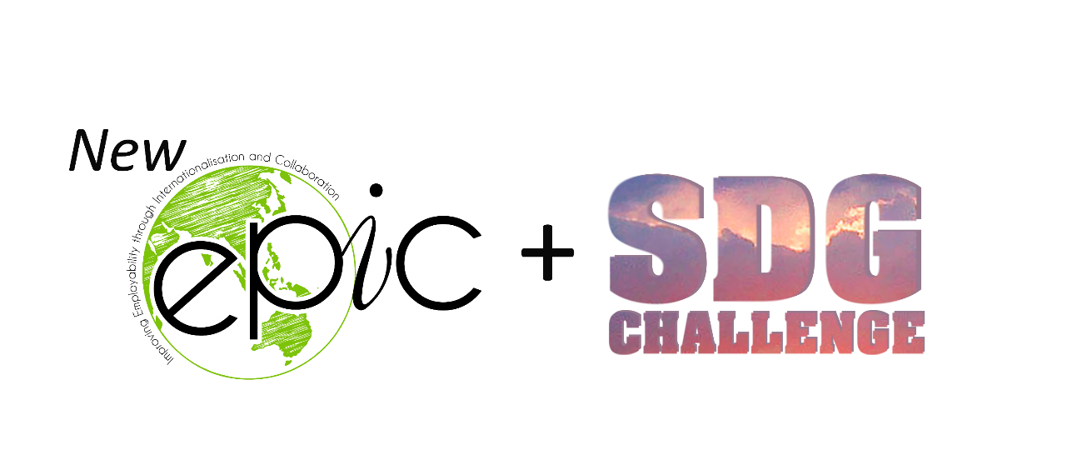

**PROJECT PROPOSAL TEMPLATE**

[Isabel Brito and Julia Brito]

In the next semester, we are going to have many students, with many backgrounds, looking for project themes for their semesters in many of our partner universities (Brazil, Denmark, Netherlands, Tunisia, Norway). We will have the privilege to have them working**\*** on our proposals, as our partners on the fight in some battlefronts of our SDG initiatives. However, in order to do that, we must provide proposals as clear and precise as possible so they can go in the right direction! So, with your background, you must think: if I had many students to work on the next steps of my project (or a correlated project that you would propose), how would this future project be? [Find the titles of the main possible future projects here!](https://www.sdgchallenge.com.br/sdg-v-command-sheet) Describe it using the template below and let’s do this!

**\***Consider that students won’t have much possibility to do field work and face-to-face meetings (due to COVID-19) and also that they’ll have scarce budget. However, consider as well that they are qualified and can design products, make intensive researches and investigation and solve problems in engineering, computer science and humanities.

The goal of the event is to have your best version of it until Wednesday on the EPIC + SDG email [contactsdgchallenge@gmail.com](mailto:contactsdgchallenge@gmail.com).

[**BUSINESS CASE:**](https://pt.wikipedia.org/wiki/Business_case)

1. **Project Title**: Mobile Education
2. **Problem (delimitation):** Brazilian waste pickers not being able to manage their finances
3. **Background/Context**: Introduce the project; where in the world are we, whom are we dealing with? What are the root causes of the problem? The waste pickers were used to earn money every day, but now, in the recycling cooperatives, they only receive once a month and, in most cases, their income was reduced. Most of them are semi-illiterate and some are illiterate. Additionally, the majority do not have an interest in learning and were not able to conclude their studies.
4. **Target group, needs assessment, benefits plan*:*** Our target group is the Brazilian waste pickers that are financially illiterate, due to their busy schedule they are usually not able to study, so our main priority is to give them a mobile app that can help them manage better their finances and offers classes so they can study no matter where they are.
5. **In which of the** [**17 SDGs**](https://sustainabledevelopment.un.org/content/documents/21252030%20Agenda%20for%20Sustainable%20Development%20web.pdf) **the project fits the most**:

Goal 4. Ensure inclusive and equitable quality education and promote lifelong learning opportunities for all:

4.5 By 2030, eliminate gender disparities in education and ensure equal access to all levels of education and vocational training for the vulnerable, including persons with disabilities, indigenous peoples and children in vulnerable situations

4.6 By 2030, ensure that all youth and a substantial proportion of adults, both men and women, achieve literacy and numeracy

1. **Problem fronts**:
   1. Include the waste picker’s family in the app;
   2. Keep the waste pickers and their family engaged with the app.
2. **Project Objectives**:
   1. **Requirements** 🡪 Must:
      1. Validate the prototype with the waste pickers (check if it attends their needs);
      2. Understand how can we better include the waste pickers family in the app;
      3. Create a gamification so the users can be engaged with the app;
   2. **Desire 🡪** Can:
      1. Find stakeholders;
      2. Create financial management content to the app.
   3. **Optional 🡪** May:
      1. Study new possible names for the app (now it is called EFA)
3. **First solution ideas and possible deliverables/results:**

* Keep the waste pickers and their family engaged with the App: A possible solution would be to create a gamification of the app with virtual currency, so every time a user does its chores they receive a X number of coins and at the end of the month they can exchange their coins to a food basket, for instance.
* Include the waste picker’s family in the app: A possible solution would be to create a platform in order to integrate what the app offers and new frameworks for the waste picker’s family. Also, in the gamification, the family could join their coins so they can get an award;
* The prototype developed has a more practical approach regarding the management of the waste picker’s income, for that reason, it would be interesting to provide financial management learning in a way that could contribute, in a more theoretical way, to the classes that they are obligated to attend.

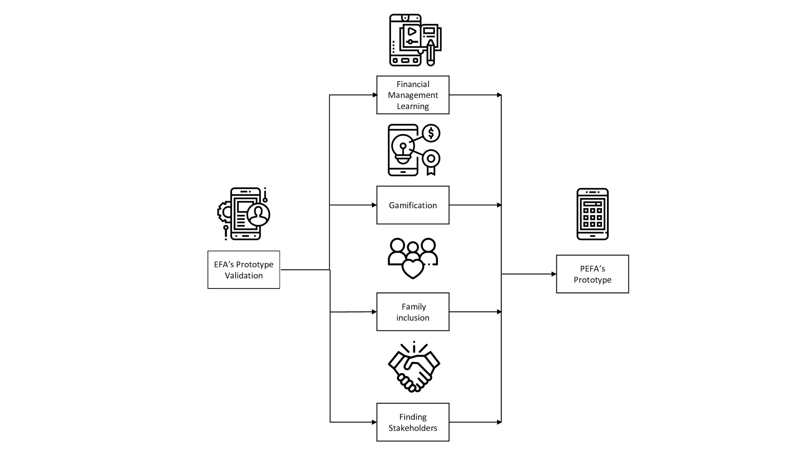

1. **Contact / Key Stakeholders:**
   1. [contactsdgchallenge@gmail.com](mailto:contactsdgchallenge@gmail.com)
   2. [juliabritobsb@gmail.com](mailto:juliabritobsb@gmail.com)
   3. [isabel.5800@gmail.com](mailto:isabel.5800@gmail.com)
   4. [emma3mortensen@gmail.com](https://meet.google.com/linkredirect?authuser=1&dest=mailto%3Aemma3mortensen%40gmail.com)
   5. [irasmu17@student.aau.dk](mailto:irasmu17@student.aau.dk)
   6. [amejer17@student.aau.dk](mailto:amejer17@student.aau.dk)
2. **Hard Skills required in the project:**
   1. Back-end developer;
   2. Front-end designer;
   3. Financial content creator.
3. **Other information:**
4. **References:**