ZEBA ACADEMY / zeba.academy / Instructor – Sufyan bin Uzayr

Lab Practicum 01: Empirical Parallel Computing

Silicon Profiling, Multi-Core Scaling Limits, and Concurrency Hazards
Duration: 90 Minutes Format: Solo In-Class Lab Weight: 5% of Course Grade

STUDENT NAME  Yerassyl Torebek | STUDENT ID  230103222 | HOST CPU / SOC MODEL  Intel core i5 11400H | OPERATING SYSTEM & KERNEL  Windows 11
Generative AI & Tooling Policy: You are explicitly authorized to use LLMs (ChatGPT, Claude, GitHub Copilot) to generate code scripts in any language (C, C++, Python, Go, Rust, Java). However: All execution timings, memory counters, and hardware cache metrics must be physically benchmarked on your host machine. Fabricated numbers receive zero credit.
15 Minutes | 20 Points
TASK 1: Host Silicon Audit & Flynn’s Taxonomy Mapping
Query your operating system and CPU registers to document physical core topology, cache boundaries, and vector math extensions.

Terminal Audit Commands: Linux: lscpu && lscpu --caches | macOS: sysctl -a | grep machdep.cpu | Windows: Run wmic cpu get /format:list and inspect
Task Manager > Performance > CPU.
Hardware Property | Local Measured Value | Hardware Property | Local Measured Value
CPU Model & Architecture | Core i5 11400H | Base & Max Boost Clock | 2.7 GHz0 GHz
Physical Hardware Cores | 6 | Logical Cores (SMT/Threads) | 12
L1 Data / Instruction Cache | L1d: 480KB | L1i:480KB | L2 Cache (Per Core / Total) | 1.25 MB/7.5MB
L3 Shared Last-Level Cache | [ 12 MB ] | SIMD Vector Extensions | [ SSE4.2,AVX-2, AVX-512 ]
Q1.1: Map your host machine's execution modes into Flynn's Taxonomy:
SISD:Single-threaded sequential code, where a single core executes a single instruction on scalar data in general-purpose registers.
SIMD: Vector computations using AVX-2 and AVX-512 extensions. A single instruction per clock cycle processes a data vector when working with matrices, NumPy, or ML models.
MIMD: Parallel task execution across 6 physical cores / 12 threads. Different cores simultaneously execute independent instruction streams on decomposable datasets.

TASK 2: Multi-Thread Scaling Benchmark & Contention Wall 35 Minutes | 30 Points

Write or prompt an AI to generate a compute-bound CPU benchmark parameterized by thread count N. Run 3 iterations per thread count and log wall-clock execution time.

Workload Algorithm: [ e.g., Prime Sieve to 5,000,000 / Matrix Multiply ] |  |  |  | Language & Runtime: [ e.g., C OpenMP / Python multiprocessing / Go ]
Threads (N) | Run 1 (s) | Run 2 (s) | Run 3 (s) |  | Avg Time TN (s) | Speedup SN = T1/TN | Efficiency EN = SN/N
N = 1 (Baseline) | 13.3090 | 13.2048 s | 13.5230 s |  | 13.346 | 1.00 | x | 100
N = 2 | 10.308 | 8.979 | 10.374 |  | 9.887 | 1.35 | x | 67
N = 4 |  |  |  |  |  |  | x | 100
N = 8 |  |  |  |  |  |  | x | 100
N = 16 |  |  |  |  |  |  | x | 100
N = 32 |  |  |  |  |  |  | x | 100
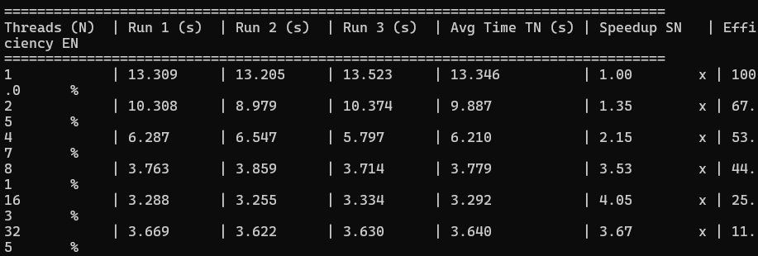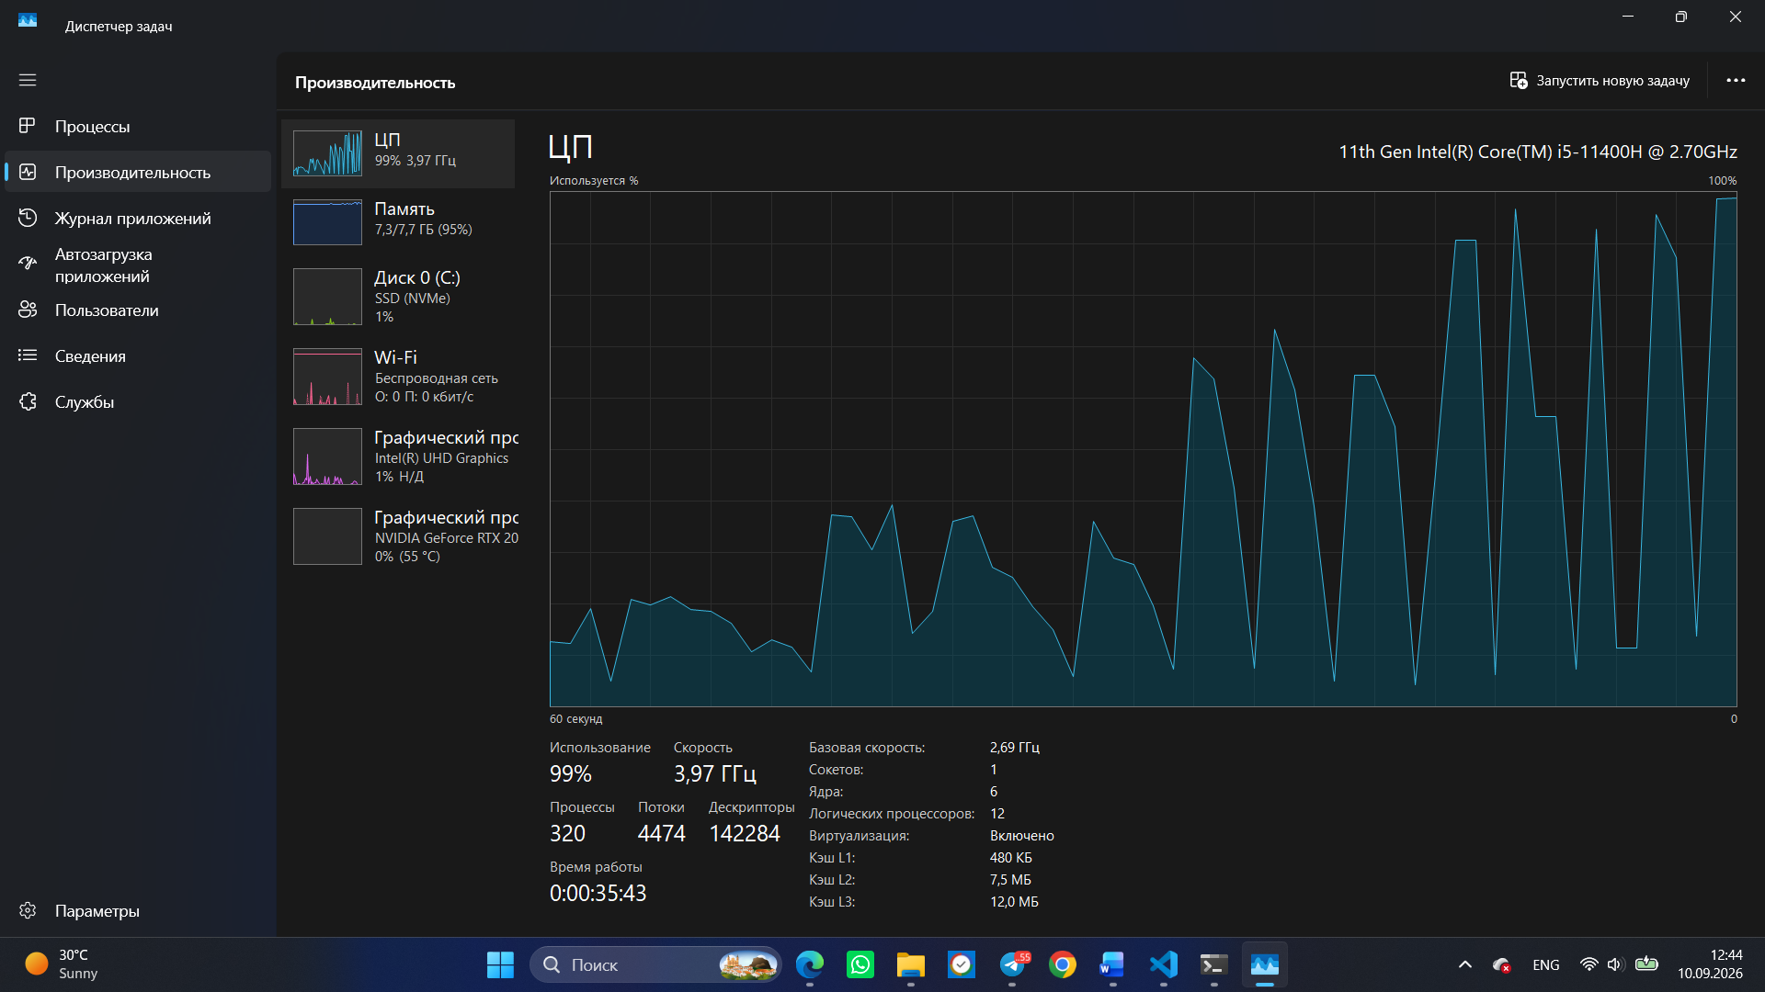
Q2.1: Scaling Saturation & Hardware Contention Analysis:
• Sub-linear Saturation Point ($N=2$): Efficiency drops immediately from $100\%$ at $N=1$ to $67.5\%$ at $N=2$ (Speedup is only $1.35\text{x}$ instead of ideal $2.0\text{x}$). Diminishing returns compound at $N=16$ where doubling threads from 8 to 16 yields only a tiny gain (Speedup goes from $3.53\text{x}$ to $4.05\text{x}$, dropping efficiency to $25.3\%$).
• Reversal Point ($N=32$): Speedup explicitly reverses/regresses at $N=32$. The execution time increases from $3.292\text{ s}$ (at $N=16$) to $3.640\text{ s}$ (at $N=32$), dropping speedup from $4.05\text{x}$ down to $3.67\text{x}$ and efficiency to $11.5\%$.

TASK 3: The Unsynchronized Shared Counter & Race Condition Trap 25 Minutes | 25 Points
Spawn 10 parallel threads. Each thread executes a loop incrementing a shared global integer 1,000,000 times without atomic operations or locks. Theoretical expected total: 10 × 1,000,000 = 10,000,000. Execute 10 consecutive runs.

Run | Measured Output | Error (10^7 - Act) | Run | Measured Output | Error (10^7 - Act)
#1 |  |  | #6
#2 |  |  | #7
#3 |  |  | #8
#4 |  |  | #9
#5 |  |  | #10
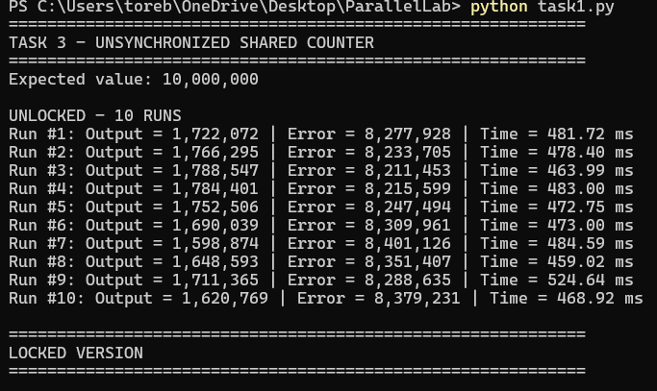
Q3.1: Read-Modify-Write (RMW) Window  Deconstruct why value corruption occurs at the machine instruction level (Load → Add → Store) when two cores interleave execution on shared memory: | Q3.2: The Synchronization Penalty  Wrap the counter in a Mutex/Lock. Record execution time: Unlocked = 479.00ms vs. Locked = 60617.67ms.  Why is race-free synchronized code substantially slower?
TASK 4: Empirical Amdahl Verification vs. Gustafson Scaling Horizon 15 Minutes | 15 Points
Use your empirical single-thread time (T1) and two-thread time (T2) from Task 2 to derive the parallel fraction p of your workload, then evaluate theoretical performance bounds.

1. Parallel Fraction Derivation (p)  Formula: p = 2 × (T1 - T2) / T1  T1 = 13.346 ss | T2 = 9.887 s  Calculated p = 0.5183(decimal between 0.0 and 1.0) | 2. Amdahl Theoretical Speedup Ceiling  Formula: Smax = 1 / (1 - p)  Sequential fraction (1 - p) = 0.4817  Max Theoretical Speedup (N → ∞) = 2.08×
3. Amdahl 64-Core Projection  Formula: S64 = 1 / [(1 - p) + (p / 64)]  Projected Speedup on 64 Cores = 2.04× | 4. Gustafson Scaled Speedup (Weak Scaling)  Formula: SGustafson = (1 - p) + (p × 64)  Projected Scaled Speedup (64× Problem) = 33.65×
Q4.1: Strong vs. Weak Scaling Analysis:
Submission Guidelines & Deliverables Checklis
- Complete all 4 tables and technical reflection prompts directly on this document (or submit as an annotated Word / PDF).
- Attach a single terminal screenshot verifying Task 2 executing across active threads (e.g., htop, top, or Task Manager CPU pane).
- Upload the final .docx / PDF to the course portal before the conclusion of the 90-minute lab period.
Why does Gustafson Amdahl's Law assumes a fixed problem size (Strong Scaling), where the sequential portion ($\left(1-p\right)≈48.17\%$) rapidly creates a hard bottleneck as hardware scales. Regardless of adding more cores, the sequential execution time dominates, capping maximum speedup at $≈2.08\text{x}$.
Gustafson's Law assumes the problem size scales proportionally with the core count (Weak Scaling). As parallel resources increase, the parallel workload grows while the sequential overhead remains fixed in size relative to the expanded problem, allowing speedup to scale nearly linearly up to 33.65x on 64 cores.
's model predict near-linear scaling on a 64-core node, whereas Amdahl's formula predicts a hard bottleneck for the exact same algorithm?

