Module -1: Understanding of Hardware and Its Components

**Section 1: Multiple Choice**

**1. Which of the following is NOT a component of the CPU?**

* **RAM**

**2. What is the function of RAM in a computer?**

* RAM (Random Access Memory) is a type of primary storage in a computer
* Temporary Data Storage
* RAM holds data and instructions that the CPU (Central Processing Unit) needs while doing tasks. This includes:
  + **Currently running programs**
  + **Operating system processes**
  + **Files being actively used**
* RAM is volatile, which means that all data is lost when the computer is turned off.
* Fast Data Access
* RAM offers much faster read and write speeds than hard drives (HDDs) or even SSDs. This speed allows the CPU to access data quickly, which greatly improves system performance.
* Multitasking Support
* Having more RAM enables a computer to run several applications at once without slowing down. For instance, you can browse the web, edit a document, and listen to music at the same time without any performance issues.
* Buffering and Caching

**RAM serves as a buffer for activities like:**

* Streaming videos
* -Loading large files
* Gaming

**3. Which of the following is a primary storage device?**

* **RAM**

**4. What is the purpose of a GPU?**

* A GPU is a special processor built to quickly handle and create images, videos, and animations.
* It is crucial for managing graphics-heavy tasks and doing many calculations at once.

|  |
| --- |
| **Function Explanation** |
| ------------------------------------ ---------------------------------------------------------------------------- |
| Graphics Rendering | Renders 2D and 3D images, textures, lighting, and effects in games, videos, and more. |
| Parallel Processing | Executes thousands of threads at the same time, which is great for large data sets. |
| Video Playback Acceleration | Improves HD and 4K video playback by sharing the workload with the GPU. |
| Machine Learning & AI | Trains neural networks and does computations much faster than a CPU. |
| Scientific & Engineering Simulations | Used in simulations such as weather modelling, physics, and molecular analysis. |

**Section 2: True or False**

**5. The motherboard is the main circuit board of a computer where other components are attached.**

* **True**

**6. A UPS (Uninterruptible Power Supply) is a hardware device that provides emergency power to a load when the input power source fails.**

* **True**

**7. An expansion card is a circuit board that enhances the functionality of a component.**

* **True**

**Section 3: Short Answer**

**8. Explain the difference between HDD and SSD.**

* HDD (Hard Disk Drive) and SSD (Solid State Drive) are both storage devices, but they differ in speed, structure, and performance.
* HDD uses spinning magnetic disks to read and write data. It is slower, cheaper, and provides more storage at a lower cost.
* SSD uses flash memory with no moving parts. This makes it faster, more durable, and quieter, but usually more expensive per GB.
* In short, SSDs are faster and more reliable. HDDs are cheaper and offer more storage space.

**9. Describe the function of BIOS in a computer system.**

* BIOS, or Basic Input/Output System, is firmware that sets up and tests hardware when the computer starts. It also loads the operating system and offers low-level control for hardware settings.

**10.Three Common Input Devices:**

* Keyboard - Used to enter text, numbers, and commands into the computer.
* Microphone – Captures audio input, enabling voice commands, recording, and communication.
* Webcam- Captures video input, enabling video conferencing and recording.

**Section 4: Practical Application**

**11. Identify and label the following components on a diagram of a motherboard:**

* **● CPU**
* **● RAM slots**
* **● SATA connectors**
* **● PCI-E slot**

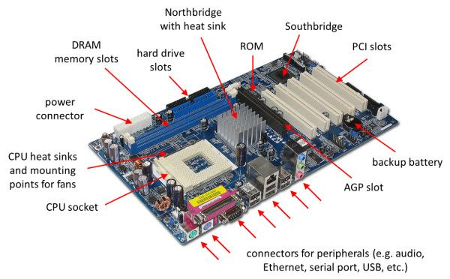

**12.Demonstrate how to install a RAM module into a computer.**

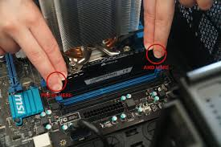

* To install a RAM module, first, power down and unplug your computer. Then, ground yourself to prevent static discharge, locate the RAM slots on the motherboard, and open the retaining clips. Align the notch on the RAM module with the notch in the slot, then firmly press down on both ends of the module until the clips snap into place. Finally, close the computer case and power it on to verify the installation.

**Section 5: Essay**

**13. Discuss the importance of proper cooling mechanisms in a computer system. Include examples of cooling methods and their effectiveness.**

**->The Value of Appropriate Computer System Cooling Mechanisms**

For a computer system to continue operating at peak efficiency, avoid overheating, and prolong the life of its hardware, proper cooling is crucial. The CPU, GPU, and power supply are examples of parts that can overheat without proper cooling, resulting in system crashes, decreased performance, or irreversible damage.

**->The Value of Cooling**

Prevents Overheating: Guards against heat damage to delicate parts.

Assures Performance: Preserves steady system functioning while performing demanding tasks (e.g., video editing, gaming).

Enhances Lifespan: Lessens internal component wear and tear.

Prevents Throttling: Prevents CPU/GPU slowdown brought on by elevated temperatures.

|  |  |  |
| --- | --- | --- |
| **Cooling Method** | **Description** | **Effectiveness** |
| Air Cooling (Fans) | Uses fans to move air across heat sinks and out of the case. | Cost-effective, good for general use. |
| Heat Sinks | Metal components that absorb and disperse heat from chips. | Passive cooling; often paired with fans. |
| Liquid Cooling | Circulates coolant through tubes and radiators to cool components. | Highly effective for gaming, overclocking. |
| Thermal Paste | Paste applied between CPU and heat sink to improve heat transfer. | Essential for effective heat dissipation. |
| Case Ventilation | Ensures proper airflow within the case using intake/exhaust fans. | Helps maintain overall system temperature. |

**14. Explain the concept of bus width and its significance in computer architecture.**

**->Bus Width: Overview and Importance**

The number of bits that a computer's data bus can transfer at once is referred to as bus width. It establishes the maximum amount of data that can be transferred in a single operation between the CPU, memory, and other parts.

**Bus** **Types:**

Data Bus: Transports real data.

Memory addresses are carried by the Address Bus.

Control signals are carried by the control bus.