final-assignment

Eray Ferah

26 04 2022

## Warning: package 'ggplot2' was built under R version 4.1.1

## Warning: package 'lmtest' was built under R version 4.1.1

## Loading required package: zoo

## Warning: package 'zoo' was built under R version 4.1.1

##   
## Attaching package: 'zoo'

## The following objects are masked from 'package:base':  
##   
## as.Date, as.Date.numeric

## Warning: package 'scales' was built under R version 4.1.1

## Warning: package 'lubridate' was built under R version 4.1.1

##   
## Attaching package: 'lubridate'

## The following objects are masked from 'package:base':  
##   
## date, intersect, setdiff, union

## Warning: package 'stargazer' was built under R version 4.1.2

##   
## Please cite as:

## Hlavac, Marek (2022). stargazer: Well-Formatted Regression and Summary Statistics Tables.

## R package version 5.2.3. https://CRAN.R-project.org/package=stargazer

## Warning: package 'readxl' was built under R version 4.1.1

## [1] "C:/Users/erayf/Desktop/DataScience/Repo/The-Classical-Linear-Regression-Model/data/input"

## Plotting Prices

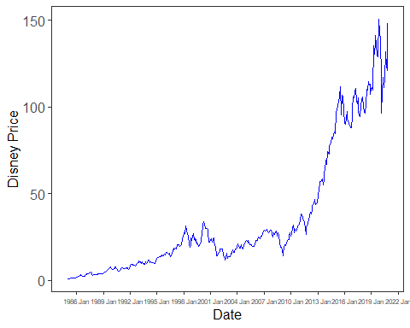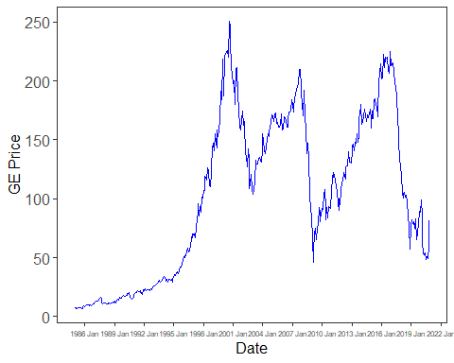

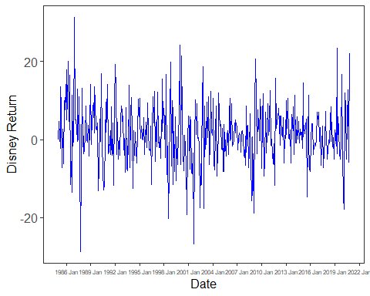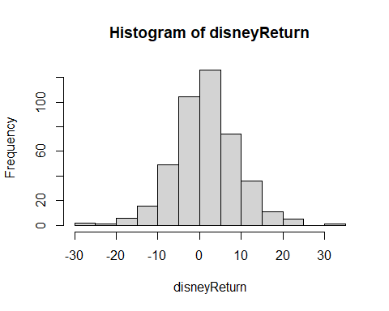

## $breaks  
## [1] -30 -25 -20 -15 -10 -5 0 5 10 15 20 25 30 35  
##   
## $counts  
## [1] 2 1 6 16 49 104 126 74 36 11 5 0 1  
##   
## $density  
## [1] 0.0009280742 0.0004640371 0.0027842227 0.0074245940 0.0227378190  
## [6] 0.0482598608 0.0584686775 0.0343387471 0.0167053364 0.0051044084  
## [11] 0.0023201856 0.0000000000 0.0004640371  
##   
## $mids  
## [1] -27.5 -22.5 -17.5 -12.5 -7.5 -2.5 2.5 7.5 12.5 17.5 22.5 27.5  
## [13] 32.5  
##   
## $xname  
## [1] "disneyReturn"  
##   
## $equidist  
## [1] TRUE  
##   
## attr(,"class")  
## [1] "histogram"

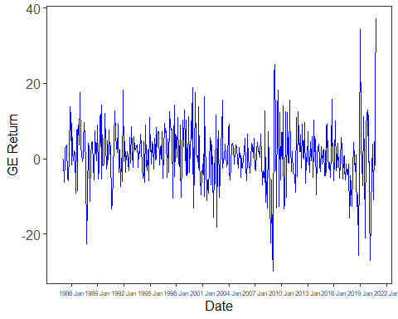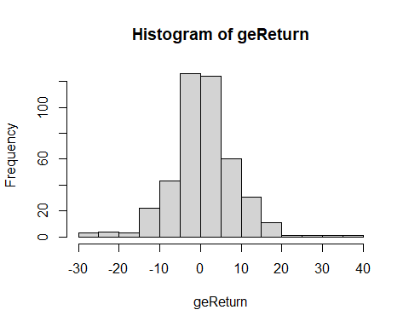

## $breaks  
## [1] -30 -25 -20 -15 -10 -5 0 5 10 15 20 25 30 35 40  
##   
## $counts  
## [1] 3 4 3 22 43 126 124 60 31 11 1 1 1 1  
##   
## $density  
## [1] 0.0013921114 0.0018561485 0.0013921114 0.0102088167 0.0199535963  
## [6] 0.0584686775 0.0575406032 0.0278422274 0.0143851508 0.0051044084  
## [11] 0.0004640371 0.0004640371 0.0004640371 0.0004640371  
##   
## $mids  
## [1] -27.5 -22.5 -17.5 -12.5 -7.5 -2.5 2.5 7.5 12.5 17.5 22.5 27.5  
## [13] 32.5 37.5  
##   
## $xname  
## [1] "geReturn"  
##   
## $equidist  
## [1] TRUE  
##   
## attr(,"class")  
## [1] "histogram"

##   
## t test of coefficients:  
##   
## Estimate Std. Error t value Pr(>|t|)   
## (Intercept) 0.323897 0.279328 1.1596 0.2469   
## mktrf 1.134783 0.061361 18.4934 <2e-16 ***  
## ---  
## Signif. codes: 0 '***' 0.001 '**' 0.01 '*' 0.05 '.' 0.1 ' ' 1

##   
## ===============================================  
## Dependent variable:   
## ---------------------------  
## Excess_Returns   
## -----------------------------------------------  
## mktrf 1.135***   
## (0.061)   
##   
## Constant 0.324   
## (0.279)   
##   
## -----------------------------------------------  
## Observations 431   
## R2 0.444   
## Adjusted R2 0.442   
## Residual Std. Error 5.720 (df = 429)   
## F Statistic 342.007*** (df = 1; 429)   
## ===============================================  
## Note: *p<0.1; **p<0.05; ***p<0.01

##   
## t test of coefficients:  
##   
## Estimate Std. Error t value Pr(>|t|)   
## (Intercept) -0.267957 0.289492 -0.9256 0.3552   
## mktrf 1.153052 0.063594 18.1315 <2e-16 ***  
## ---  
## Signif. codes: 0 '***' 0.001 '**' 0.01 '*' 0.05 '.' 0.1 ' ' 1

##   
## ===============================================  
## Dependent variable:   
## ---------------------------  
## Excess_Returns   
## -----------------------------------------------  
## mktrf 1.153***   
## (0.064)   
##   
## Constant -0.268   
## (0.289)   
##   
## -----------------------------------------------  
## Observations 431   
## R2 0.434   
## Adjusted R2 0.433   
## Residual Std. Error 5.928 (df = 429)   
## F Statistic 328.750*** (df = 1; 429)   
## ===============================================  
## Note: *p<0.1; **p<0.05; ***p<0.01

##   
## t test of coefficients:  
##   
## Estimate Std. Error t value Pr(>|t|)   
## (Intercept) 0.285019 0.278578 1.0231 0.30683   
## mktrf 1.168912 0.063334 18.4564 < 2e-16 ***  
## smb -0.074603 0.094553 -0.7890 0.43054   
## hml 0.197425 0.095406 2.0693 0.03912 *   
## ---  
## Signif. codes: 0 '***' 0.001 '**' 0.01 '*' 0.05 '.' 0.1 ' ' 1

##   
## ===============================================  
## Dependent variable:   
## ---------------------------  
## Excess_Returns   
## -----------------------------------------------  
## mktrf 1.169***   
## (0.063)   
##   
## smb -0.075   
## (0.095)   
##   
## hml 0.197**   
## (0.095)   
##   
## Constant 0.285   
## (0.279)   
##   
## -----------------------------------------------  
## Observations 431   
## R2 0.451   
## Adjusted R2 0.447   
## Residual Std. Error 5.695 (df = 427)   
## F Statistic 116.932*** (df = 3; 427)   
## ===============================================  
## Note: *p<0.1; **p<0.05; ***p<0.01

##   
## t test of coefficients:  
##   
## Estimate Std. Error t value Pr(>|t|)   
## (Intercept) -0.351725 0.281673 -1.2487 0.21246   
## mktrf 1.235583 0.064037 19.2948 < 2.2e-16 ***  
## smb -0.245369 0.095603 -2.5665 0.01061 *   
## hml 0.385338 0.096465 3.9946 7.632e-05 ***  
## ---  
## Signif. codes: 0 '***' 0.001 '**' 0.01 '*' 0.05 '.' 0.1 ' ' 1

##   
## ===============================================  
## Dependent variable:   
## ---------------------------  
## Excess_Returns   
## -----------------------------------------------  
## mktrf 1.236***   
## (0.064)   
##   
## smb -0.245**   
## (0.096)   
##   
## hml 0.385***   
## (0.096)   
##   
## Constant -0.352   
## (0.282)   
##   
## -----------------------------------------------  
## Observations 431   
## R2 0.468   
## Adjusted R2 0.465   
## Residual Std. Error 5.758 (df = 427)   
## F Statistic 125.374*** (df = 3; 427)   
## ===============================================  
## Note: *p<0.1; **p<0.05; ***p<0.01

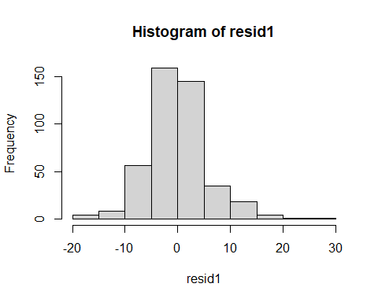

## $breaks  
## [1] -20 -15 -10 -5 0 5 10 15 20 25 30  
##   
## $counts  
## [1] 4 8 56 159 145 35 18 4 1 1  
##   
## $density  
## [1] 0.0018561485 0.0037122970 0.0259860789 0.0737819026 0.0672853828  
## [6] 0.0162412993 0.0083526682 0.0018561485 0.0004640371 0.0004640371  
##   
## $mids  
## [1] -17.5 -12.5 -7.5 -2.5 2.5 7.5 12.5 17.5 22.5 27.5  
##   
## $xname  
## [1] "resid1"  
##   
## $equidist  
## [1] TRUE  
##   
## attr(,"class")  
## [1] "histogram"

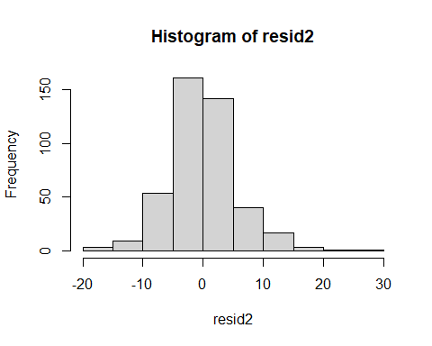

## $breaks  
## [1] -20 -15 -10 -5 0 5 10 15 20 25 30  
##   
## $counts  
## [1] 3 9 54 161 142 40 17 3 1 1  
##   
## $density  
## [1] 0.0013921114 0.0041763341 0.0250580046 0.0747099768 0.0658932715  
## [6] 0.0185614849 0.0078886311 0.0013921114 0.0004640371 0.0004640371  
##   
## $mids  
## [1] -17.5 -12.5 -7.5 -2.5 2.5 7.5 12.5 17.5 22.5 27.5  
##   
## $xname  
## [1] "resid2"  
##   
## $equidist  
## [1] TRUE  
##   
## attr(,"class")  
## [1] "histogram"

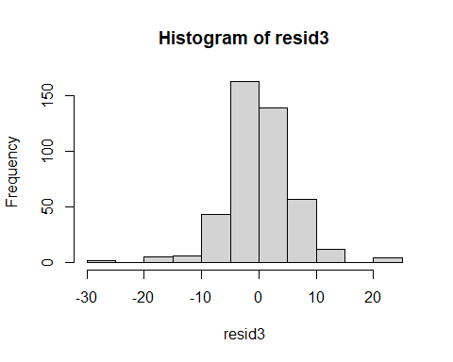

## $breaks  
## [1] -30 -25 -20 -15 -10 -5 0 5 10 15 20 25  
##   
## $counts  
## [1] 2 0 5 6 43 163 139 57 12 0 4  
##   
## $density  
## [1] 0.0009280742 0.0000000000 0.0023201856 0.0027842227 0.0199535963  
## [6] 0.0756380510 0.0645011601 0.0264501160 0.0055684455 0.0000000000  
## [11] 0.0018561485  
##   
## $mids  
## [1] -27.5 -22.5 -17.5 -12.5 -7.5 -2.5 2.5 7.5 12.5 17.5 22.5  
##   
## $xname  
## [1] "resid3"  
##   
## $equidist  
## [1] TRUE  
##   
## attr(,"class")  
## [1] "histogram"

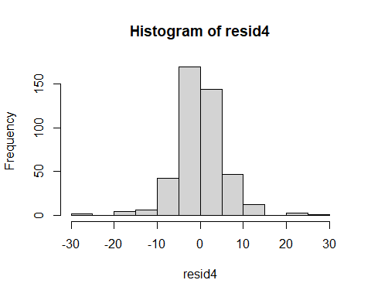

## $breaks  
## [1] -30 -25 -20 -15 -10 -5 0 5 10 15 20 25 30  
##   
## $counts  
## [1] 2 0 4 6 42 170 144 47 12 0 3 1  
##   
## $density  
## [1] 0.0009280742 0.0000000000 0.0018561485 0.0027842227 0.0194895592  
## [6] 0.0788863109 0.0668213457 0.0218097448 0.0055684455 0.0000000000  
## [11] 0.0013921114 0.0004640371  
##   
## $mids  
## [1] -27.5 -22.5 -17.5 -12.5 -7.5 -2.5 2.5 7.5 12.5 17.5 22.5 27.5  
##   
## $xname  
## [1] "resid4"  
##   
## $equidist  
## [1] TRUE  
##   
## attr(,"class")  
## [1] "histogram"