final-assignment

Eray Ferah

26 04 2022

## 

## Plotting Prices

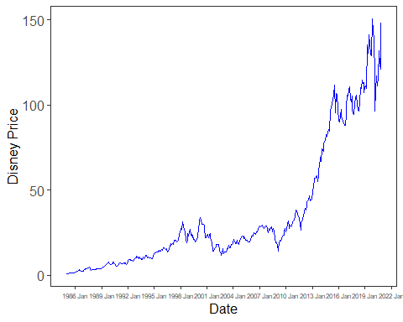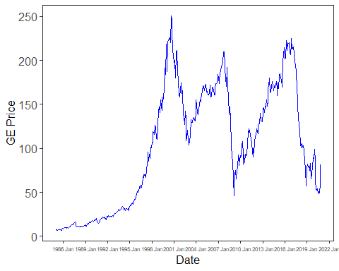

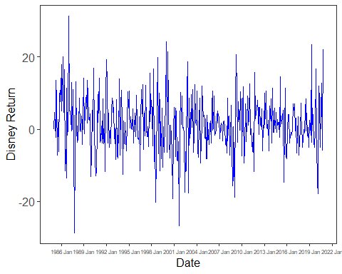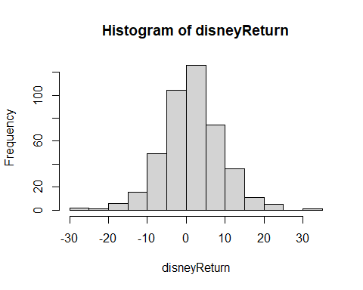

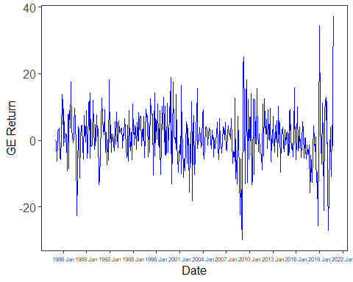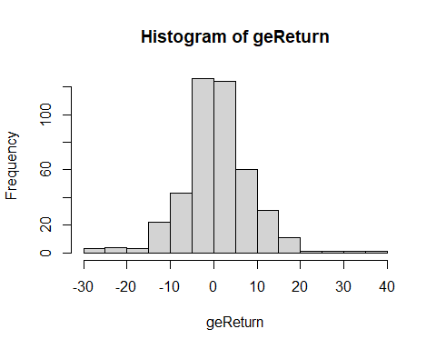

## t test of coefficients:  
##   
## Estimate Std. Error t value Pr(>|t|)   
## (Intercept) 0.323897 0.279328 1.1596 0.2469   
## mktrf 1.134783 0.061361 18.4934 <2e-16 ***  
## ---  
## Signif. codes: 0 '***' 0.001 '**' 0.01 '*' 0.05 '.' 0.1 ' ' 1

##   
## ===============================================  
## Dependent variable:   
## ---------------------------  
## Excess_Returns   
## -----------------------------------------------  
## mktrf 1.135***   
## (0.061)   
##   
## Constant 0.324   
## (0.279)   
##   
## -----------------------------------------------  
## Observations 431   
## R2 0.444   
## Adjusted R2 0.442   
## Residual Std. Error 5.720 (df = 429)   
## F Statistic 342.007*** (df = 1; 429)   
## ===============================================  
## Note: *p<0.1; **p<0.05; ***p<0.01

## t test of coefficients:  
##   
## Estimate Std. Error t value Pr(>|t|)   
## (Intercept) -0.267957 0.289492 -0.9256 0.3552   
## mktrf 1.153052 0.063594 18.1315 <2e-16 ***  
## ---  
## Signif. codes: 0 '***' 0.001 '**' 0.01 '*' 0.05 '.' 0.1 ' ' 1

##   
## ===============================================  
## Dependent variable:   
## ---------------------------  
## Excess_Returns   
## -----------------------------------------------  
## mktrf 1.153***   
## (0.064)   
##   
## Constant -0.268   
## (0.289)   
##   
## -----------------------------------------------  
## Observations 431   
## R2 0.434   
## Adjusted R2 0.433   
## Residual Std. Error 5.928 (df = 429)   
## F Statistic 328.750*** (df = 1; 429)   
## ===============================================  
## Note: *p<0.1; **p<0.05; ***p<0.01

## t test of coefficients:  
##   
## Estimate Std. Error t value Pr(>|t|)   
## (Intercept) 0.285019 0.278578 1.0231 0.30683   
## mktrf 1.168912 0.063334 18.4564 < 2e-16 ***  
## smb -0.074603 0.094553 -0.7890 0.43054   
## hml 0.197425 0.095406 2.0693 0.03912 *   
## ---  
## Signif. codes: 0 '***' 0.001 '**' 0.01 '*' 0.05 '.' 0.1 ' ' 1

##   
## ===============================================  
## Dependent variable:   
## ---------------------------  
## Excess_Returns   
## -----------------------------------------------  
## mktrf 1.169***   
## (0.063)   
##   
## smb -0.075   
## (0.095)   
##   
## hml 0.197**   
## (0.095)   
##   
## Constant 0.285   
## (0.279)   
##   
## -----------------------------------------------  
## Observations 431   
## R2 0.451   
## Adjusted R2 0.447   
## Residual Std. Error 5.695 (df = 427)   
## F Statistic 116.932*** (df = 3; 427)   
## ===============================================  
## Note: *p<0.1; **p<0.05; ***p<0.01

## t test of coefficients:  
##   
## Estimate Std. Error t value Pr(>|t|)   
## (Intercept) -0.351725 0.281673 -1.2487 0.21246   
## mktrf 1.235583 0.064037 19.2948 < 2.2e-16 ***  
## smb -0.245369 0.095603 -2.5665 0.01061 *   
## hml 0.385338 0.096465 3.9946 7.632e-05 ***  
## ---  
## Signif. codes: 0 '***' 0.001 '**' 0.01 '*' 0.05 '.' 0.1 ' ' 1

##   
## ===============================================  
## Dependent variable:   
## ---------------------------  
## Excess_Returns   
## -----------------------------------------------  
## mktrf 1.236***   
## (0.064)   
##   
## smb -0.245**   
## (0.096)   
##   
## hml 0.385***   
## (0.096)   
##   
## Constant -0.352   
## (0.282)   
##   
## -----------------------------------------------  
## Observations 431   
## R2 0.468   
## Adjusted R2 0.465   
## Residual Std. Error 5.758 (df = 427)   
## F Statistic 125.374*** (df = 3; 427)   
## ===============================================  
## Note: *p<0.1; **p<0.05; ***p<0.01

