**MUDining  
By**

**Thitiwut Chamornmarn 5888010 Section 1**

**Dawit Chusetthagarn 5888032 Section 1**

**Weerawat Pawanawiwat 5888125 Section 1**

**Thatchapon Unprasert 5888220 Section 1**

**ITCS210 – Web Programming**

**Faculty of ICT, Mahidol University**

**Introduction**

“MUDining” is a restaurant review and recommender website that focuses on the restaurants near Mahidol University (Salaya campus). The main feature of this site is the restaurant recommender system, which will recommend interesting restaurant for the user based on the user’s food preferences. The users can also see the list of popular in the area, and they can choose to write their own reviews and rate each restaurant for the other users to see.

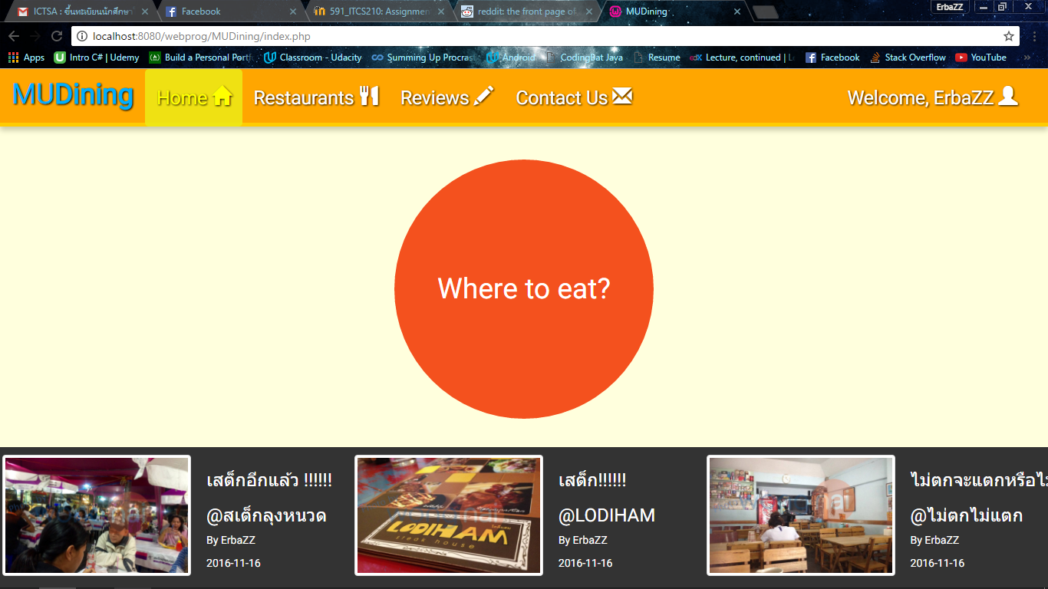

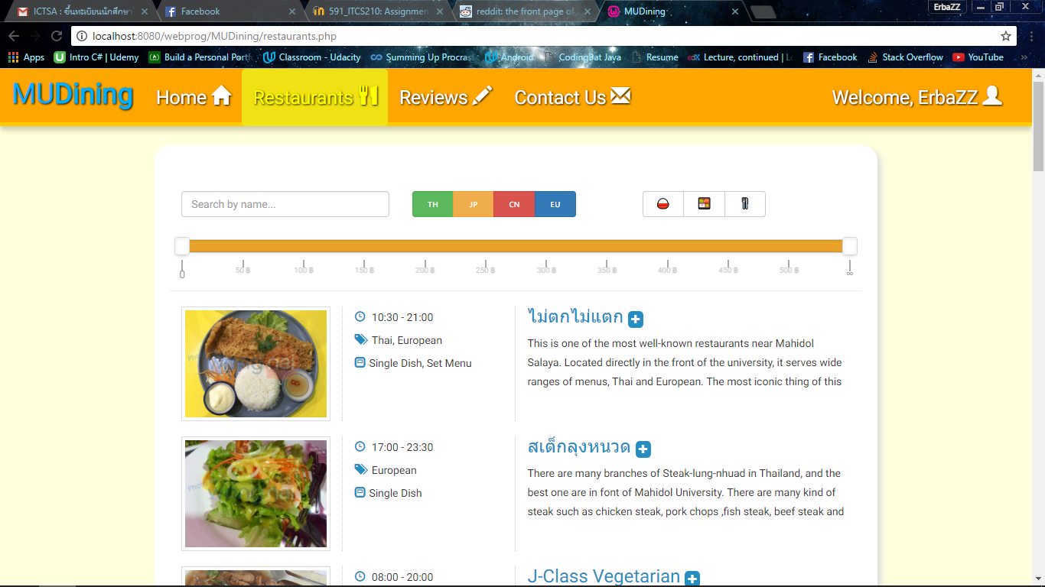

**Web Accessibility Concerns**

The target users surely are people around Salaya campus, especially students and staffs. Our concern of Web Accessibility is for the people who have vision problem. We use colors with high contrast between the text and the background, so that it will be easy to read. Also, the main navigations and the main functionalities are large in size, such as the recommender button, the restaurant pictures, or the review thumbnails, making the website easier to see and used by people with low vision.

**Client-Side Components**

|  |  |
| --- | --- |
| **HTML/HTML5** | It is used for constructing most elements in our web pages. Fundamental configurations of elements like inputs, buttons, and images are made here. |
| **CSS/CSS3** | It drives web page decoration. The style, animation and transition of elements are set here. The interactive recommend button is the CSS3 featuring example: scale, border and shadow. More, it has the fade transition across pages and general user interface you see. |
| **Bootstrap** | In order to achieve responsiveness, Bootstrap is organizing the display of every web page element, in terms of sizing, spacing and also enhancing the CSS. To picture, search results in Restaurants page are responsive to the change of browser window size – establishing the best layout for the current screen. It allows the navigation bar to stick to the top and the latest reviews scroll to stick to the bottom. Alerts that you see when you delete a review also count. |
| **JavaScript** | Our website needs it for programming certain elements like the price range slider in Restaurants page and the rating panel in each restaurant page. Sometimes, it is useful for having the same code on every page by means of document.write(). |
| **jQuery** | Often, events must be achieved on elements so that they can react to the user. For instance, we show the recommendation page after the user click the recommend button. In a complex case, we even use it to highlight the menu based on which page that the user located to. Most of the time, jQuery helps JavaScript code to run with eases, as can be seen from the implementation of horizontal scrollable latest reviews pane, the presentation of the price range slider, and the functionality of the rating panel. |

**Server-Side Component**

We use PHP for almost all pages as the method to access the database for retrieving and storing the data. For example, we fetch data from the restaurant database to show in the restaurants.php and fetch the data from the user database to authenticate the user login to the website.

**Database Structure**

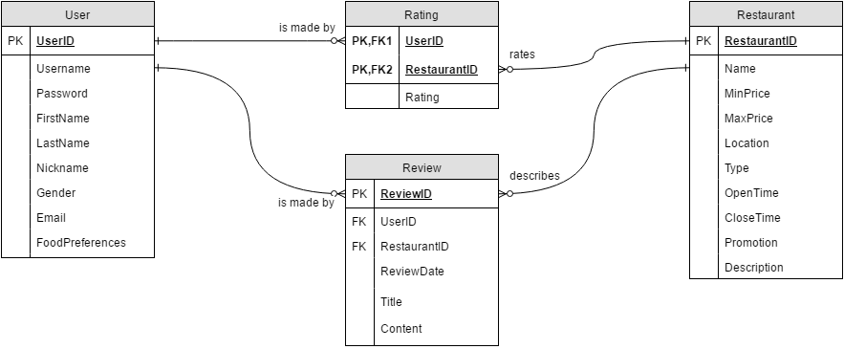

| **Operation** | **Related DB(s)** | **Purpose** | **Explanation** |
| --- | --- | --- | --- |
| **Insert** | User | Register | After registration, entered user information will be inserted into the user database. |
| Review | Write review | A user can write a review for each restaurant |
| Rate | A user can rate any restaurant. |
| **Select** | User | Log in | A login request satisfies when the user database contains its data. |
| Edit profile | A user can edit its profile e.g. change food preferences. |
| User/Review | Edit review | A review can be altered if its maker is the current user. |
| Restaurant | Search | A user can search for restaurants using a query and filters we provided in Restaurants page. |
| User/Restaurant | Recommend | Restaurants will be selectively chosen based on criteria we have set regarding information we know about restaurants and/or users. |
| Review | Show | A user can view all restaurants reviews shown in Reviews page. |
| Fetch images | Images by a user in the review can be fetched and be displayed in Reviews page. |
| Rating | View | All ratings of a restaurant are fetched to calculate their average, then display in each restaurant page. |
| **Update** | Rating/User | Show/Rate | A restaurant page displays current rating value of a user if logged in. |
| Rating | Re-rate | It also allows a user to change the rating value of any rated restaurant. |
| Review | Edit review | A user can edit the review at any time. |
| **Delete** | Review/User | Remove | A user can delete any review made. |
| Rating | Remove | A user can remove own rating. |