

**Microprocessors (COME322/1)**

**Project Report**

**Project Name:** Macro Keyboard

Ercan Enes KARACA

A Keyboard like [Elgato Stream Deck](https://www.elgato.com/en/stream-deck) which is generally using by streamers. This keyboard is based on same idea but in cheaper way, so it’s don’t have the same features but does the same things.

So, if we press a button, we will receive a message which is shown on 16x2 LCD and store the data (which button is pressed and when it’s pressed) to the microSD card at the same time it will give information about microSD card so we can understand it is storing the data.

I am going to use Arduino Pro Micro because it has 32u4 microprocessor and we can use it like keyboard or mouse. You can use Leonardo and Arduino Micro etc. I will add buttons to computer between F13 and F24 (they are included) so we can use them separately from our main keyboard and its complexity about shortcuts.

**Materials & Costs:**

[Arduino Pro Micro](https://www.direnc.net/arduino-pro-micro) 152,64 ₺

[SD card module](https://www.direnc.net/arduino-micro-sd-kart-modulu) 9,54 ₺

[3x4 Membrane Keypad](https://www.direnc.net/3x4-membran-tus-takimi) 10,41 ₺

[RTC module](https://www.direnc.net/ds1302-pil-yuvali-saat-modulu) 13,88 ₺

[16x2 LCD Display](https://www.direnc.net/2x16-karakter-lcd-ekran-sol-alt-mavi-tc1602b) 78,06 ₺

[I2C/IIC Serial interface adapter module](https://www.robotistan.com/2x16-lcd-i2ciic-donusturucu-karti-lcd1602-adapter-board-w-iic-i2c-int?language=tr&h=754182cd&gclid=CjwKCAjwo8-SBhAlEiwAopc9W0ORjODcwQqEqztnRlyM7Uv2r-2ribenPfe0s-71gcXCZhmqfoGrdxoCKYQQAvD_BwE) 17,40 ₺

[5x5 Perforated Pertinax](https://www.robolinkmarket.com/5x5-delikli-pertinaks?gclid=CjwKCAjwo8-SBhAlEiwAopc9W7I2b8QEqPNSNgfA8i6jgvJi_J4zRH5hSzhpKiopjHgleYbnYlvKXhoCwrAQAvD_BwE) 2,36 ₺

[Some headers (Male)](https://www.robolinkmarket.com/40-pin-erkek-header?gclid=CjwKCAjwo8-SBhAlEiwAopc9WwdItend6n__ye0wlrDmUIdhoGgqVDpH4F783-jHDqF0Y0-hGcPw4RoCQLgQAvD_BwE) 1,18 ₺

[Some header (Female)](https://www.robolinkmarket.com/40-pin-disi-header?gclid=CjwKCAjwo8-SBhAlEiwAopc9W_aWYXg1ttPYyYPdl_mUsnjvLgMxfDmyoR5-pOm2VBUFQWKbzts_9BoC8PMQAvD_BwE) 3,54 ₺

3D printed Box 30 ₺

Soldering materials ??

Hot silicon ??

**Total:**  319,01 ₺+??

**Schematic:** 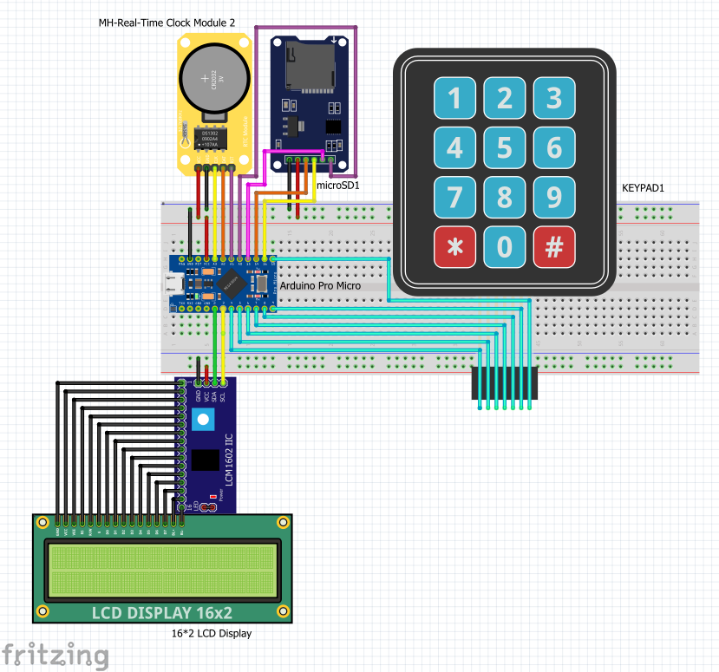

**Code:**

**Note:** Before installing code, you must disconnect microSD card module because it's blocking the IDE to upload the code. If it's still don't upload the code u must Burn the Bootloader again to Arduino Pro Micro (With ISP Programmer or another Arduino board like Nano, Uno, Leonardo etc. You can use them as ISP Programmer if you don't have an ISP Programmer.) After Burning Bootloader, you can use it like before.

I have uploaded the codes to the [Google Drive](https://drive.google.com/drive/folders/1dNw8WkMIIvsEm195FXbUSzR-msEJ_AiH?usp=sharing) you can reach them as txt and ino file.

**Libraries:**

[**<Keyboard.h>**](https://www.arduino.cc/reference/en/language/functions/usb/keyboard/) **🡪** For adding extra keys (Between F13-F24)

[**<Keypad.h>**](https://www.arduino.cc/reference/en/libraries/keypad/) **🡪** For to be able to use keypad and its matrix

[**<Wire.h>**](https://www.arduino.cc/en/reference/wire) **🡪** For communicate with I2C / TWI devices

[**<LiquidCrystal_I2C.h>**](https://www.arduino.cc/reference/en/libraries/liquidcrystal-i2c/) **🡪** For I2C LCD displays.

[**<virtuabotixRTC.h>**](https://github.com/yemreeke/ArduinoLibrarys/blob/main/virtuabotixRTC.zip) **🡪** For RTC DS1302 RTC module

[**<SPI.h>**](https://www.arduino.cc/en/reference/SPI) **🡪** ForSPI communication library which used by microSD card

[**<SD.h>**](https://www.arduino.cc/en/reference/SD) **🡪** SD card library

**Images & Short Descriptions:**

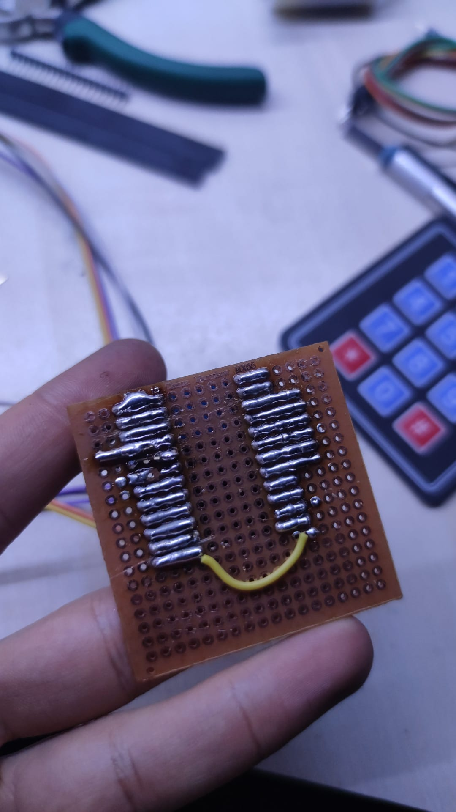

Soldered pertinax and headers for making the assembly easier. (and a board for Pro Micro so I can use it later for another project)

After that I have installed the materials to the 3D printed box and connected them to the board which is prepared for assemblying easier.

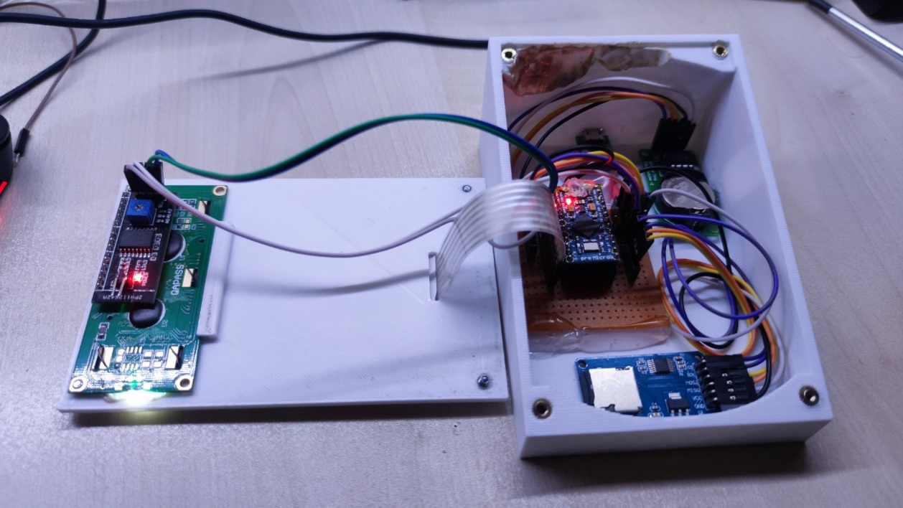

**elektronik eşyalar içeren bir resim

Açıklama otomatik olarak oluşturuldu**

When the keyboard plugged in to the computer, it gives a feedback about SD card so we can understand that the SD card working.

iç mekan içeren bir resim

Açıklama otomatik olarak oluşturuldu**iç mekan içeren bir resim

Açıklama otomatik olarak oluşturuldu**

elektronik eşyalar, birkaç içeren bir resim

Açıklama otomatik olarak oluşturuldu

First line gives information about which button is pressed.

Second line gives information about time of RTC and situation of SD card (if it's saved successfully writes done. If not, there is no feedback)

metin, bilgisayar içeren bir resim

Açıklama otomatik olarak oluşturuldu

The LOG.txt saved to SD card.

,,

References

<https://www.thingiverse.com/thing:2822140> 🡪 main idea from this product.

<https://www.arduino.cc/>

<https://maker.robotistan.com/etiket/arduino-dersleri/>

<https://akademi.robolinkmarket.com/>

<https://lezzetlirobottarifleri.com/>

The other links goes to where I searched for the learning modules logics.