PathWise

REQUIREMENTS SPECIFICATION DOCUMENT
March 27th, 2026.

 | Student ID | Student Name & Surname
#1 | 150122050 | Ömer Ercan DAYAN
#2 | 150123025 | Furkan Eren GÜLÇAY
#3 | 150123028 | Mustafa Haktan YAKUT

Prepared for
CSE3044 Software Engineering Term Project

TABLE OF CONTENTS
1. INTRODUCTION 5
2. GENERAL DESCRIPTION 5
3. SPECIFIC REQUIREMENTS 6
3.1. EXTERNAL INTERFACE REQUIREMENTS 6
3.1.1. USER INTERFACES 6
3.1.1.1. LOGIN PAGES 6
3.1.1.2. REGISTRATION PAGE 7
3.1.1.3. ADMIN PANEL PAGE 7
3.1.1.4. USER DASHBOARD 8
3.1.1.5. OWNER DASHBOARD 9
3.1.1.6. RECOMMENDATION PAGE 9
3.1.1.7. BUSINESS VIEW PAGE 10
3.1.1.8. VENUE ADDING PAGE 10
3.1.1.9. VENUE SEARCH PAGE 11
3.1.2. HARDWARE INTERFACES 11
3.1.3. SOFTWARE INTERFACES 12
3.1.3.1. FRONTEND INTERFACES 12
3.1.3.2. BACKEND INTERFACES 12
3.1.3.3. DATABASE INTERFACES 12
3.1.4. COMMUNICATION INTERFACE 12
3.2. FUNCTIONAL REQUIREMENTS 13
3.2.1. USER AUTHENTICATION, ROLE-BASED ACCESS CONTROL 13
3.2.1.1. DESCRIPTION 13
3.2.1.2. INPUTS 13
3.2.1.3. PROCESSING 13
3.2.1.4. OUTPUTS 13
3.2.1.5. CONSTRAINTS 13
3.2.1.6. ERROR HANDLING 13
3.2.2. REQUIREMENT #1 13
3.2.2.1. DESCRIPTION 13
3.2.2.2. INPUTS 13
3.2.2.3. PROCESSING 13
3.2.2.4. OUTPUTS 14
3.2.2.5. CONSTRAINTS 14
3.2.2.6. ERROR HANDLING 14
3.2.3. REQUIREMENT #1 14
3.2.3.1. DESCRIPTION 14
3.2.3.2. INPUTS 14
3.2.3.3. PROCESSING 14
3.2.3.4. OUTPUTS 14
3.2.3.5. CONSTRAINTS 14
3.2.3.6. ERROR HANDLING 14
3.2.4. REQUIREMENT #1 14
3.2.4.1. DESCRIPTION 14
3.2.4.2. INPUTS 14
3.2.4.3. PROCESSING 14
3.2.4.4. OUTPUTS 14
3.2.4.5. CONSTRAINTS 14
3.2.4.6. ERROR HANDLING 14
3.2.5. REQUIREMENT #1 14
3.2.5.1. DESCRIPTION 14
3.2.5.2. INPUTS 14
3.2.5.3. PROCESSING 14
3.2.5.4. OUTPUTS 14
3.2.5.5. CONSTRAINTS 14
3.2.5.6. ERROR HANDLING 14
3.3. . 14
4. UML DIAGRAMS 15
4.1. USE CASES 15
4.1.1. USE CASE #1 15
4.1.2. USE CASE #2 18
4.1.3. USE CASE #3 20
4.1.4. USE CASE #4 22
4.1.5. USE CASE #5 22
4.1.6. USE CASE #6 22
4.1.7. USE CASE #7 22
4.1.8. USE CASE #8 22
4.1.9. USE CASE #9 22
4.2. . 22
4.3. . 22
4.4. . 23
4.5. . 23
4.6. . 23
5. APPENDICES 23

- INTRODUCTION

- GENERAL DESCRIPTION
  - Product Perspective
PathWise is an independent, standalone web-based system. It is not a sub-component of a large existing software product. It is designed to replace traditional, manual travel planning methods by introducing a dynamic, intelligent ecosystem The system operates on a client-server architecture, utilizing a centralized relational database to ensure persistent data management and execute complex recommendation algorithms.
  - Product Functions
This system provides several core functions designed to automate and personalize travel management:
- Role Management: Secure authentication and role-specific interfaces for travelers, business owners, and administrators.
- Dynamic Itinerary Generation: Processing user inputs (budget, duration destination etc.) to create optimized travel schedules.
- Smart Alternative Selection: Providing personalized venues alternatives using a tag-based weighting system derived from user history and preferences.
- Inventory Management: Allowing business owners to create, update, and manage their venue details, capacities, and descriptive tags.
- Ecosystem Moderation: Enabling administrators to approve or reject submitted venues to maintain data quality.
  - User Characteristics
The system is designed for three distinct user groups with varying levels of technical expertise:
- Standard Users: Everyday travelers seeking customized trip plans. They are assumed to possess basic digital literacy. The user interface for this group must be highly intuitive, requiring no prior training to navigate the planning templates.
- Business Owner: Hospitality and dining managers who provide venue data. They are expected to have moderate computer skills, sufficient to operate data-entry forms, manage pricing and assign tags to their venues.
- Administrator: System moderators overseeing the platform. They are expected to have a higher level of technical proficiency t handle data validation, monitor user accounts, and maintain system integrity.
  - General Constraints
- The system must be implemented and tested within the constraints of a single academic semester.
- The recommendation algorithm must produce functional and calid trip plans without excessive hardware resource consumption.
- All major business logic components must be highly modular to ensure unit testability.
  - Assumptions and Dependencies
- The system relies on a continuous internet connection for user interaction and database updates
- It is assumed that business owners will input accurate and up-to-date capacity, price and tag information.
- The platform depends on a reliable relational database to maintain persistent records of users, venues and historical recommendation weights.

- SPECIFIC REQUIREMENTS
This section provides a detailed and structured description of the requirements for the PathWise system. It focuses on defining the essential functionalities and operational constraints necessary for the development.
  - EXTERNAL INTERFACE REQUIREMENTS
This subsection defines the logical and physical connections between the PathWise system and its external environment. It specifies the requirements for user interaction, hardware dependencies, and integration with existing software or communication protocols.
    - USER INTERFACES
This subsection describes the essential user interfaces that facilitate the core operations of the PathWise system. Each interface is defined by its requirements and design elements, supported by visual mockups aimed at optimizing user interaction and accessibility across the platform.
      - LOGIN PAGES
The login page allows users to access the system using their registered credentials. The system provides separate login interfaces for administrators and standard users/business owners. Main interface components include followings:
- Username or e-mail input field
- Password input field
- Login button
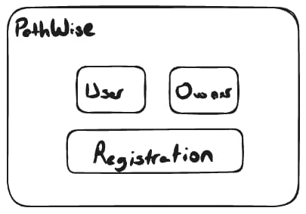
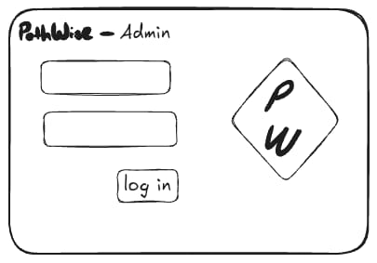
- Navigation options for user or business owner login
Figure 2: Admin Login Screen
Figure 2: Login Screen
The system verifies user credentials and redirects the user to appropriate dashboard based on their role.
      - REGISTRATION PAGE
The registration page allows new users to create an account in the system. Users must provide the required personal information to register. After successful registration, the user account is stored in the system database. Main interface components include followings:
- Name or username field
- Email field
- Password field
- User type selection (e.g., Standard User or Business Owner)
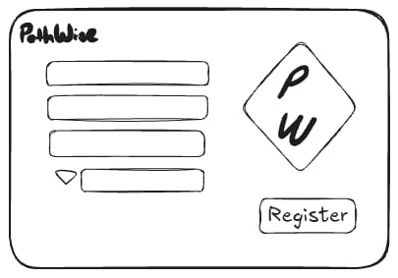
- Registration button
Figure 3: Registration Screen

      - ADMIN PANEL PAGE
The admin panel provides administrators with tools to manage the platform and monitor system activity. Main functionalities include followings:
- Viewing and managing user accounts
- Viewing and managing business owner accounts
- Reviewing and moderating venue submissions
- Accessing system notifications
- Registration button
The administrator can perform moderation actions such as approving or rejecting venue enties.
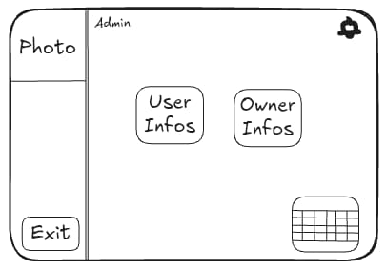
Figure 4: Admin Panel
      - USER DASHBOARD
The User Dashboard is the main interface for standard users after logging into the system. This page allows users to manage their travel plans and interact with the recommendation system. Main components include followings:
- Search bar for travel destinations
- Area for stared venues
- Display section for previously generated trips
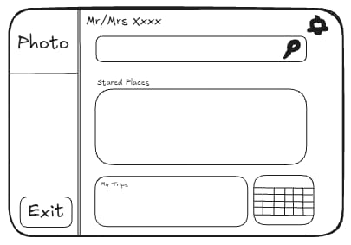
- Navigation options to other system pages
Figure 5: User Dashboard

      - OWNER DASHBOARD
The Owner Dashboard provides business owners with access to venue management functionalities. Main features include followings:
- Viewing previously submitted venues
- Applying to add new venues to the system
- Managing venue information and updates
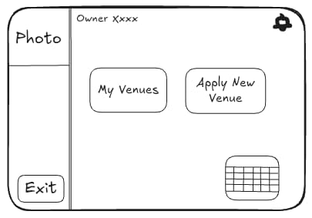
Business owners can submit new venue entries which will later be reviewed by administrators.
Figure 6: Owner Dashboard

      - RECOMMENDATION PAGE
The Recommendation Page allows users to generate personalized travel recommendations. Users can enter travel-related parameters to receive suggested venues. Main interface components include followings:
- Destination input field
- Travel date inputs
- Budget input field
- Number of travelers
- Recommendation search button
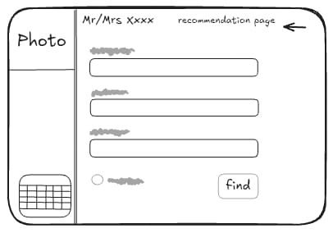
The system processes these inputs and generates personalized travel suggestions.
Figure 7: Recommendation Page

      - BUSINESS VIEW PAGE
The Business View Page allows administrators to review business-related information within the system. Main functionalities include followings:
- Viewing submitted business entries
- Monitoring notifications related to businesses
- Managing approval status of submitted venues
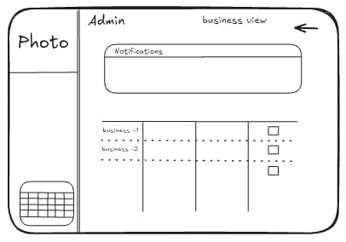
This interface helps administrators maintain system data quality.
Figure 8: Business View Page

      - VENUE ADDING PAGE
The Venue Adding Page allows business owners to submit new venues to the system. Main components include followings:
- Venue information fields
- Image upload section
- Venue description inputs
- Submission button
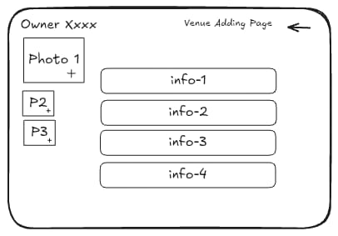
After submission, the venue will be sent to the administrator for approval.
Figure 9: Venue Adding Page
      - VENUE SEARCH PAGE
The Venue Search Page allows users to search for venues. Main interface components include followings:
- Search input field
- List of available and relevant venues
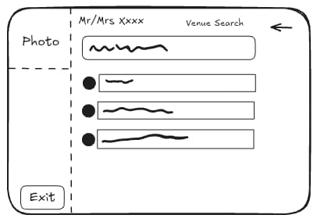
- Venue selection options
Figure 10: Venue Search Page

    - HARDWARE INTERFACES
The PathWise system does not require specialized hardware components. The system is designed as a web-based application and can operate on standard personal computing devices. Users access the system through common devices such as:
- Desktop computers
- Laptop computers
- Tablets or smartphones with a web browser
Minimum recommended hardware specifications include:
- Processor: Dual-core CPU or equivalent
- Memory: Minimum 4 GB RAM
- Storage: At least 500 MB available space
The server-side components of the system may run on a standard development machine capable of running the backend framework and database system.

    - SOFTWARE INTERFACES
The PathWise system interacts with several software components that support the operation of the application.
      - FRONTEND INTERFACES
The user interface is implemented using React, a JavaScript library used for building interactive web interfaces. The frontend application runs in a web browser and communicates with the backend server using HTTP requests.
      - BACKEND INTERFACES
The backend services are implemented using ASP.NET Core Web API written in C#. This backend component handles user authentication, business logic, travel recommendation processing and venue management operations.
      - DATABASE INTERFACES
The system stores persistent data in a relational database management system. The backend communicates with the database through Entity Framework Core, which provides an object-relational mapping layer. The database stores user accounts, venue information travel preferences and it records related to recommendations.

    - COMMUNICATION INTERFACE
Communication between system components occurs through standard web communication protocols. The frontend and backend components communicate using the HTTP/HTTPS protocol through RESTful API endpoints. Data exchanged between the client and server is structured using the JSON format. The typical communication flow is as following:
- The user interacts with the React-based frontend interface.
- The frontend sends an HTTP request to the backend API.
- The backend processes the request and performs necessary operations such as database queries or recommendation processing.
- The backend returns a response to the frontend in JSON format.
- The frontend displays the processed information to the user.
The system may also use secure HTTPS connections to ensure safe communication between the client and server.
  - FUNCTIONAL REQUIREMENTS
This subsection defines the specific services, tasks, or functions that the system must perform. It describes how the software should respond to particular inputs and how it should behave in specific situations to meet user needs.
    - FR #1: USER AUTHENTICATION AND AUTHORIZATION
      - DESCRIPTION
The system shall authenticate users via their registered credentials and authorize access to specific functionalities based on their assigned role as a Standard User, Business Owner, or Administrator.
      - INPUTS
- User Identifier: The e-mail of the user.
- Security Credential: The password of the user.
- System Trigger: A UI action, specifically clicking the “Login” button.
      - PROCESSING
- Validation: Format of the credentials are validated.
- Data Retrieval: Corresponding user data is retrieved from the database.
- Verification: Input and the retrieved data is compared and accordingly decide to grant access if they match or generate an authentication error if they do not match.
- Authorization: Grant access to the user based on the role and the account status of the user.
- Session Management: Create an authenticated session and issue a token.
- Redirection: Redirect the user to the corresponding dashboard based on the role.
      - OUTPUTS
- Authentication Token: A secure session token that contains user identity and role information.
- Redirection: Redirection to appropriate user dashboard on success.
- Error Message: A descriptive notification to the user in case of failure.
      - CONSTRAINTS
- Encryption: Passwords shall never be stored or transmitted in plain text, they must be stored as salted hashes using a strong algorithm.
- Latency: The entire authentication process shall be completed within 2 seconds under normal network connections.
- Security Lockout: The system shall temporarily lock the account after 5 consecutive failed login attempts with a rate-limiting mechanism to prevent brute-force attacks.
- Session Timeout: Authenticated sessions shall automatically expire after 15 minutes of inactivity.
      - ERROR HANDLING
- Invalid Credentials: If the input e-mail and password combination is not matching with the corresponding user data, system displays an error message.
- Missing Fields: If the user does not fill in the e-mail or password field, system displays an error message.
- Locked Account: If the account is locked due to security lockout, system displays an error message.
- Unauthorized Access: If the system detects an unauthorized access attempt, system displays an error message.
- Expired Session: If the user attempts an action with an expired token, system displays an error message and redirects the user to login page.
- Database Connection Failure: If the system can not access the database, system displays an error message.

    - FR #2: TRAVEL PLAN GENERATION
      - DESCRIPTION
The system shall generate a chronological set of travel recommendations by analyzing venue data and user preference tags against specific parameters, including destination, travel dates, budget, and the number of travelers, to assist the user in travel planning.
      - INPUTS
- Destination:
- Travel start and end dates:
- Budget:
- Number of travelers:
- User preference tags:
      - PROCESSING

      - OUTPUTS
      - CONSTRAINTS
      - ERROR HANDLING
    - REQUIREMENT #1
      - DESCRIPTION
      - INPUTS
      - PROCESSING
      - OUTPUTS
      - CONSTRAINTS
      - ERROR HANDLING
    - REQUIREMENT #1
      - DESCRIPTION
      - INPUTS
      - PROCESSING
      - OUTPUTS
      - CONSTRAINTS
      - ERROR HANDLING
    - REQUIREMENT #1
      - DESCRIPTION
      - INPUTS
      - PROCESSING
      - OUTPUTS
      - CONSTRAINTS
      - ERROR HANDLING
  - NON-FUNCTIONAL REQUIREMENTS
This subsection defines the quality attributes, design constraints, and external interface requirements that the system must adhere to. These requirements specify the criteria used to judge the operation of the system as a whole.
    - PERFORMANCE
The PathWise system shall provide efficient and responsive system performance during user interactions.
- The system shall respond to standard user actions such as login, venue search, and profile access within 2 seconds under normal operating conditions.
- The dynamic travel plan generation function shall produce a personalized travel plan within 3 seconds after receiving user parameters such as destination, travel dates, and budget.
- Requests for alternative venue recommendations shall return results within 3 seconds.
- The system shall support multiple simultaneous user operations such as travel plan generation and venue submission without noticeable performance degradation.
    - RELIABILITY
The system shall operate consistently and preserve system data integrity.
- User accounts, venue entries, and travel preference profiles shall be stored persistently in the system database.
- System failures shall not cause loss of critical user data such as stored venue information or user profiles.
- Operations such as venue approval, venue deletion, and user account deletion shall be executed as atomic transactions.
- The system database shall be backed up at least once every 24 hours.
    - AVAILABILITY
The PathWise system shall remain accessible to users during system operation.
- The system shall maintain at least 95% system availability during operational periods.
- The system shall continue functioning when multiple users simultaneously request travel plans or submit venue data.
- After a system restart or maintenance event, the system shall become operational again within two minutes.
    - SECURITY
The PathWise system shall ensure secure access control and protection of user information.
- The system shall authenticate users using registered credentials and assign them roles such as Standard User, Business Owner, or Administrator.
- Access to system functions shall be restricted based on the permissions associated with each user role.
- User passwords shall be stored using secure cryptographic hashing mechanisms and shall not be stored in plain text.
- Administrative operations such as venue approval or rejection shall only be accessible to authorized administrators.
- The system shall validate all user inputs to prevent invalid or malicious data from entering the system.
    - MAINTAINABILITY
The PathWise system shall be designed to support future updates and system improvements.
- The system architecture shall follow a modular design, separating components such as user management, venue management, recommendation logic, and administrative functions.
- System components shall be loosely coupled to allow modifications without affecting unrelated modules.
- Source code shall follow consistent documentation and naming conventions to facilitate maintenance.
    - PORTABILITY
The PathWise system shall operate across common computing environments.
- The system shall run on commonly used operating systems including Windows, Linux, and macOS.
- The system shall be accessible through modern web browsers such as Google Chrome, Mozilla Firefox, and Microsoft Edge.
- The web interface shall adapt to common desktop screen resolutions.
  - INVERSE REQUIREMENTS
This subsection specifies the constraints and boundaries of the system by defining what the system shall not do. These inverse requirements are essential to prevent scope creep, ensure data security, and maintain the integrity of the business logic by explicitly excluding unauthorized actions or unintended system behaviors.
- The system shall not store user passwords in plain text; all credentials must be salted and hashed using industry-standard algorithms.
- The system shall not allow a Standard User to access or modify any data belonging to the Administrator or Business Owner panels.
- The system shall not suggest venues or hotels that are located outside the user's specifically selected destination area.
- The system shall not share or sell user-provided preference tags to any third-party services without explicit user authorization.
- The system shall not process a reservation if the user's selected dates overlap with an existing booking in the same account.
  - DESIGN CONSTRAINTS
This subsection outlines the specific technical limitations, technology stack requirements, and architectural standards that must be strictly followed during the development of the PathWise system. These constraints ensure that the software remains maintainable, secure, and compatible with the intended local development and web-based runtime environments.
    - TECHNOLOGY STACK CONSTRAINTS
The system must be implemented using the following technologies:
- React for the frontend user interface
- ASP.NET Core Web API for backend services
- C# programming language
- A relational database management system (RDBMS)
These technologies are selected to ensure compatibility between system components.
    - WEB-BASED ARCHITECTURE
The system must operate as a web-based application accessible through standard web browsers. No dedicated desktop software installation should be required for users.
    - LOCAL DEVELOPMENT ENVIRONMENT
The system will initially operate in a local development environment using a local server and local database. This constraint allows the development team to test and demonstrate the system without requiring cloud deployment.

    - DATA INTEGRITY
All system data must be stored in a structured relational database to maintain consistency between users, venues, and recommendation data.
    - SECURITY CONSTRAINTS
Basic authentication mechanisms must be implemented to ensure that:
- only registered users can access personalized recommendations
- only business owners can manage their venue data
- only administrators can approve newly added venues
  - LOGICAL DATABASE REQUIREMENTS
  - OTHER REQUIREMENTS
- UML DIAGRAMS
This section presents the core artifacts produced during the system analysis phase. These models provide a comprehensive view of the system’s functional requirements, behavioral dynamics and structural organization through various diagrams and detailed specifications.
  - USE CASES
This subsection outlines the functional requirements of the system through fully dressed use cases and their corresponding UML diagrams. These artifacts define the interactions between the actors and the system to achieve specific goals.
    - USE CASE #1
Use Case UC1: User Registration
Scope: PathWise System.
Level: User Goal.
Primary Actors: User.
Stakeholders and Interests:
- Prospective Guest: Wants to access the PathWise system in order to be able to search for destinations and generate personalized travel plans.
- Business Owner: Wants to access the PathWise system in order to be able to list their hotel details, making them discoverable by prospective guests and to manage bookings efficiently.
- Administrator: Wants Business Owner registration requests to be routed for review so that only verified businesses gain access to listing capabilities.
- System: Must ensure that only valid and unique accounts created and secured.
Preconditions:
- PathWise system is operational and accessible.
- User has accessed the registration page of the website.
Success Guarantees:
- User is notified about the outcome (success, failure or pending approval) of the registration process.
- On Business Owner registration, the request is queued for Administrator review.
Main Success Scenario:
- System requests the required registration information.
- User provides the required registration information: name, surname, e-mail, password and registration type (Standard User or Business Owner).
- System validates the entered information.
- System creates the user account.
Extensions:
- User provides incomplete registration information.
- System displays a warning message and highlights the missing fields with using inline validation.
- User provides an e-mail address that is already associated with an existing account.
- System displays an error message to the user and highlights the e-mail field.
- User provides the required information in an invalid format (e.g. missing ‘@’ character in e-mail field, a password that is too short).
- System displays an error message to the user and highlights the invalid fields.
- In the case of “Business Owner” was selected as the registration type, system creates the user account as a pending approval account.
- The registration request of the pending approval account is forwaded to the Administrator’s dashboard for review.
- If the Administrator approves the request, the account is fully activated.
- If the Administrator rejects the request, the account is not created and user is notified.
Special Requirements:
- Performance: The inline validation feedback provided by the UI must appear within 750 milliseconds of the user finishing input in a field, ensuring a responsive and non-disruptive experience.
- Reliability: If the registration fails, system must not create a corrupted account record.
- Availability: The registration page must be available 99.9% of the time.
- Security: Passwords should have a strength policy and they must never be stored in a plain text, they must be stored as salted hashes using a strong algorithm.
- Maintainability: Validation rules must be configurable without requiring major code changes.
- Portability: The registration form must be visually consistent across modern browsers such as Chrome and Edge.
Technology and Data Variations List:
- Registration type: Standard User, Business Owner.
- E-mail validation: RFC 5322-compliant format check.
- Password storage: BCrypt, MD5, SHA-256.
Frequency of Occurrence: Could be nearly continuous.
Miscellaneous:
- Should business owner registration require supplementary documentation to be uploaded during registration to make it easy to review for administrators?
- How business owners will be informed when their registrations are approved by the administrator?

Use Case Diagram UCD1: User Registration
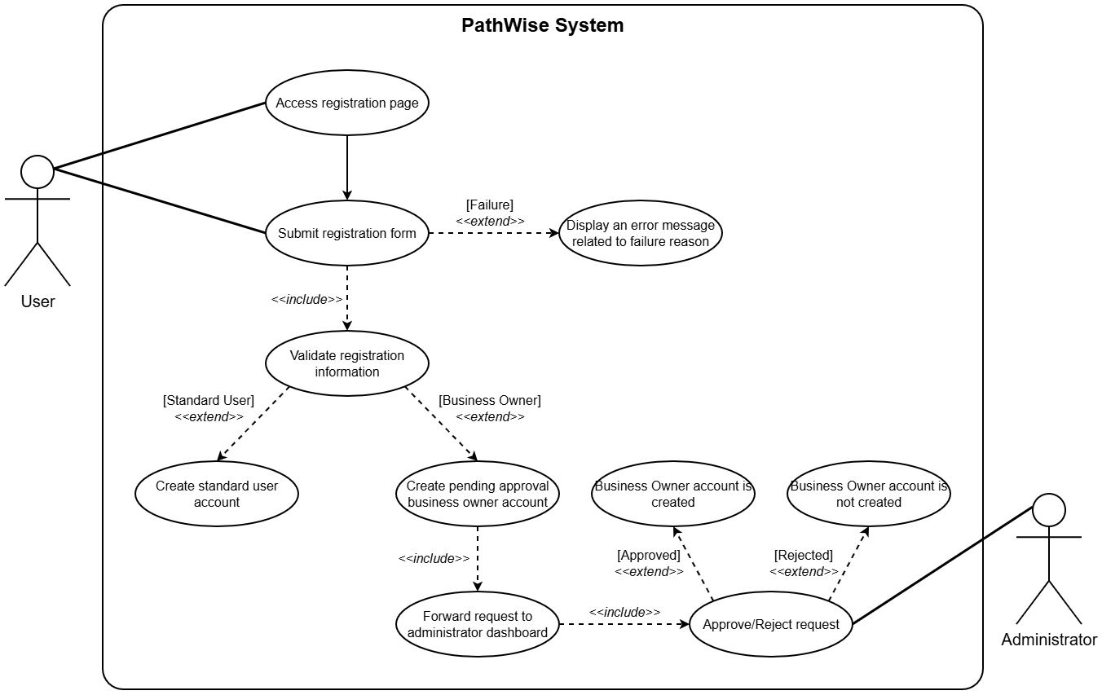
Figure 11: Use Case Diagram #1

    - USE CASE #2
Use Case UC2: User Login
Scope: PathWise System.
Level: User Goal.
Primary Actors: User.
Stakeholders and Interests:
- User: Wants to login their PathWise accounts to access the provided features by the PathWise system (includes all of the standard users, business owners and administrators).
- System: Must allow registered users to authenticate and access the system securely.
Preconditions:
- PathWise system is operational and accessible.
- User has accessed the login page of the website.
Success Guarantees:
- Users redirected to their dashboards.
Main Success Scenario:
- System requests the required login information: e-mail and password.
- User provides the required login information.
- System forwards credentials to the authentication service.
- Authentication service verifies the credentials.
- Session manager creates a new authenticated session and issues a token.
Extensions:
- User provides incomplete login information.
- System displays a warning message and highlights the missing fields with using inline validation.
- User provides an e-mail address that is not associated with an existing account or a password that is not matching with the e-mail.
- System forwards credentials to the authentication service.
- Authentication service can not verify the credentials.
- User is informed about the e-mail and password are not matching.
- The failed login attempts counter is incremented. If it exceeds a threshold, like 5, the user will not be able to attempt another login request temporarily for a minute.
- Authentication service verifies the credentials, but the user is a Business Owner and the user’s account is not approved by the Administrator yet.
- The business owner is informed about the account creation request is still pending.
Special Requirements:
- Performance: The inline validation feedback must appear within 750 milliseconds of the user finishing input in a field, ensuring a responsive and non-disruptive experience.
- Availability: The login page must be available 99.9% of the time.
- Security: There must be a rate-limiting mechanism to prevent brute force attacks.
- Portability: The registration form must be visually consistent across modern browsers such as Chrome and Edge.
Technology and Data Variations List:
- Session Management: JWT, Traditional Session Cookies.
Frequency of Occurrence: Could be nearly continuous.
Miscellaneous:
- Is it necessary to have multi-factor authentication?

Use Case Diagram UCD2: User Login
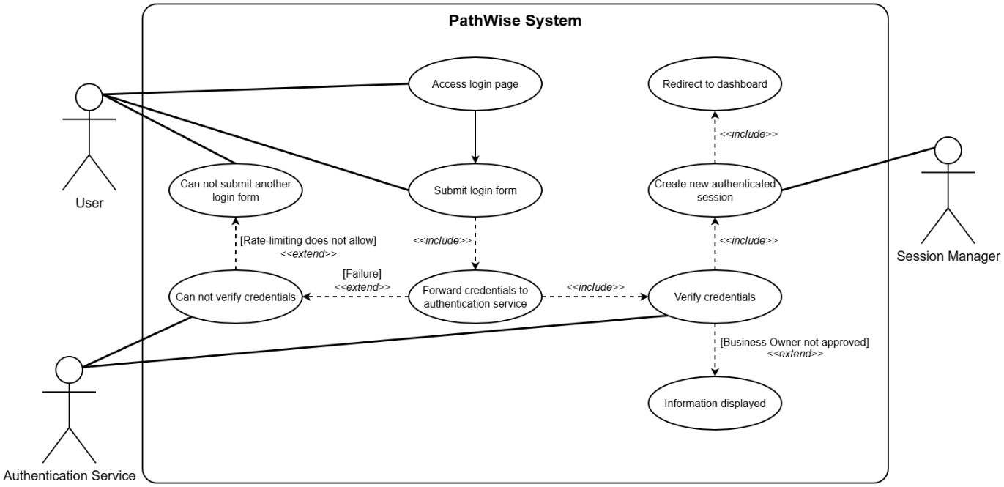
Figure 12: Use Case Diagram #2

    - USE CASE #3
Use Case UC3: Travel Plan Recommendation
Scope: PathWise System.
Level: User Goal.
Primary Actors: User.
Stakeholders and Interests:
- Prospective Guest: Wants to receive personalized hotel and venue recommendations based on their preferences, budget, travel dates, group size, and optionally based on their histories, without needing to manually search and compare options.
- Business Owner: Wants to their listings to appear in results when they match user criterias.
- System: Must collect user preferences accurately and list ranked, constraint-satisfying travel plans to prospective guests.
Preconditions:
- PathWise system is operational and accessible.
- User is authenticated and has accessed the recommendation page of the website.
- Hotel and venue data is available and up to date in the system.
Success Guarantees:
- User receives at least one ranked travel plan containing at least a hotel and a venue suggestion that satisfy their constraints and preferences.
Main Success Scenario:
- dgsg
Extensions:
- fdgsfgsd
Special Requirements:
- Performance: The system shall generate and present suggestions to the user within a 10 second response time.
- Availability: The recommendation page must be available 99.9% of the time.
- Security: There must be a rate-limiting mechanism to prevent brute force attacks.
- Portability: The registration form must be visually consistent across modern browsers such as Chrome and Edge.
Technology and Data Variations List:
- Session Management: JWT, Traditional Session Cookies.
Frequency of Occurrence: Could be nearly continuous.
Miscellaneous:
- Is it necessary to have multi-factor authentication?

Use Case Diagram UCD3: User Logindgdsgafsdfgdgda

Figure 13

    - USE CASE #4
    - USE CASE #5
    - USE CASE #6
    - USE CASE #7
    - USE CASE #8
    - USE CASE #9

  - CLASSES/OBJECTS
To ensure a highly cohesive and loosely coupled architecture, the system’s core functionalities are divided into distinct high-level modules. This modular approach aligns with the separation of concerns principle, isolating business logic from data representation and user interface coordination.

- Entity Module (Domain Models)
This module represents the core data structures and domain objects of the system.
- User: Manages demographic information, role assignments and account states.
- Venue: Represents the accommodation and dining locations, encapsulating attributes such as capacity, base price and availability.
- Tag: Defines the descriptive labels associated with users and venues, serving as the primary metric for the recommendation algorithm’s weight calculations.
- TripPlan (Itinerary): Encapsulates the final generated travel plan, linking a specific user to a series of venues over a defined timeline and budget constraint
- Algorithm Module (Business Model)
This module contains complex processing units isolated from standard data management.
- RecommendationEngine: The core processing class responsible for dynamically matching user constraints (budget, dates, traveler count etc.) with venue attributes and historical tag weights to generate optimal itinerary combinations.
- Organization Module (Coordination & UI)
This module acts as the intermediary between the backend logic and the user interfaces.
- PageController: Manages user session routing, input handling, and the presentation of dynamic form (e.g. comprehensive planning templates)
- NotificationManager: Coordinates system-wide alerts, such as warning standard users about budget limits or notifying admins of pending venue approvals.
- Security & Access Module
- AuthManager: Manages secure login operations, password hashing and strict role-based authorization to ensure users only access their designated dashboard.
- Data Access Module
- DataBaseManager/Repository: Acts as an abstraction layer for persistent data storage, managing all database queries and transactions independently from the domain entities.
- Log Module (Monitoring)
- Tracing: Records system activities, algorithm decision logs and error states to facilitate debugging and support the project’s technical decision-tracking requirements
  - .
  - .
  - .
  - .
- APPENDICES

