MULTIMEDIA

EMBEDDED SYSTEMS

IDEA REPORT

------------------------

DANCING ROBOT

2019

EMBEDDED SYSTEMS

Bills of materials **IN THIS SECTION:** 1x Arduino NANO Shield I/O 

1x USB-A to Mini-USB Cable

1x HC-SR04 Ultrasound sensor

4x Micro servo SG90 9g

1x Buzzer

6x Female/Female Jumper Wires 1x 4xAA battery holder (stack 2x 4AA Battery)

Tab1

4x AA Batteries Alkaline (must be new or have 1.5V each) 1x 8x8mm Micro Switch Self lock

1xMicrophone sensor

PROJECT BRIEFING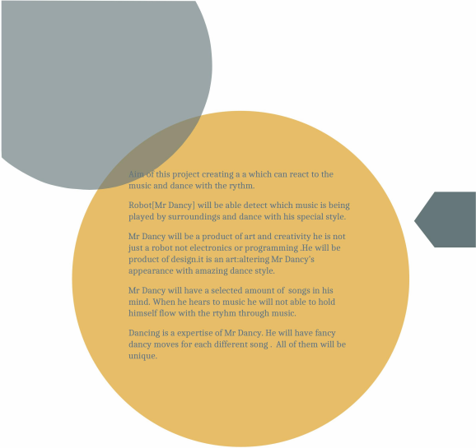

Amazing team friends of Mr Dancy

Tab2

● ERDEM DURMAZ -245907

● MUHAMEMED ASIL KARAKULAK-245872

● CAN VURAL -231964-[PASSIVE]

MORE ABOUT MR DANCY

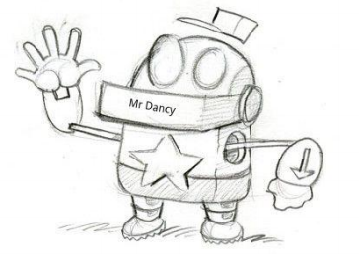Tab3

**Some of the songs selected**

Single ladies-Beyonce

MarioBros dance

Criminal- Britney Spears

More will be coming soonTab4



THANK YOU FOR READING Tab5