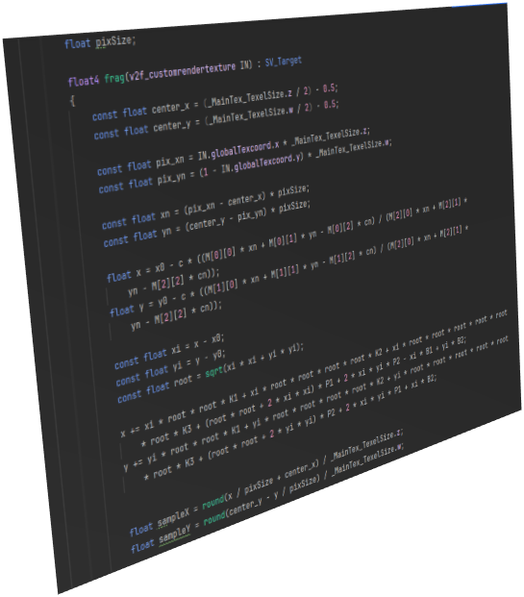 | Comp 4687 Computer Vision Software Development Contest
1) A GUI based computer vision software will be developed which is limited to use the algorithms taught in the Comp4687 lecture.
2) The programming language is Java. Available Computer Vision libraries can be used provided that the proper citations are given. ChatGPT or other kind of AI coding tools are not allowed.
3) Teams with 4, 5 or 6 persons will be established. Each team will be given a name.
4) Each team will designate one member as the Contest Committee (CC) member. The CC is responsible to manage the contest, to collect the votes and to announce the result.
5) The contest will be held in the last week of the semester at the Comp4687 classroom.
6) The contest consists of the two parts. In the first part, each Team will give a pitch presentation which is a short presentation (10-12 slides) in which the team members, idea, design considerations, target user group, implementation details, functionalities and reference to the used libraries are introduced.
7) In the second part, each team will introduce the source code and executable of their software.
8) Each team will be ranked according to their collected votes.
Grading:
All members of the 1st team: 100
All members of the 2nd team: 95
All members of the 3rd team: 90
All members of the 4th team: 85
All members of the 5th team: 80

9) Students who are not members of a team will receive a grade of '10'.

