Exploratory Data Analysis
Financial news and market data for meme stocks GME, AMC and BB (2009–2023)
Text-driven Investor Sentiment Indicators on Meme Stocks · Deep Learning Bootcamp project · Prepared by Bianca Li · October 7, 2026

1. Summary
This report describes the news and price data that the sentiment models will be built on, and flags data issues that need to be fixed first. The main findings:
- News volume peaks in 2021. The 2021 meme episode accounts for 2,647 of 9,538 relevant articles (28%), about 3× the 2020 level.
- The language of the news changed. Headlines moved from earnings, sales and dividends (2015–2019) to meme, Reddit, short squeeze and Robinhood (2021), which supports building a meme-specific sentiment model.
- Returns have extremely fat tails and volatility clusters. Kurtosis is 79 (GME), 103 (AMC) and 26 (BB), against 3 for a normal distribution. Large moves follow large moves, while the direction of returns is not predictable.
- News volume tracks trading activity. In 2021 the daily article count correlates 0.55–0.58 with log trading volume for all three stocks, and news rises in the days before the largest price moves.
- The keyword ambiguity signal is mostly a proxy for article count (correlation 0.75), so later tests must control for text volume.
- Three data issues need fixing: no BlackBerry news before 2017, 754 duplicate headlines, and publisher information missing for 73% of articles.

2. Data overview
News comes from FNSPID (Financial News and Stock Price Integration Dataset, Nasdaq news file, 15.5 million articles). Articles tagged GME, AMC or BB were extracted, deduplicated by URL and filtered for relevance: the headline names the company, or the body mentions it at least three times, and generic market round-ups are excluded. Daily prices come from Yahoo Finance.
Dataset | Type | Rows | Coverage
Raw ticker-tagged news | Text | 14,772 | 2009–2023
Relevant news (after filtering) | Text | 9,538 (GME 5,170 · AMC 3,229 · BB 1,139) | 2009–2023
Daily prices and volume | Time series | 3,774 days (AMC 2,525) | GME, BB from 2009; AMC from Dec 2013
Keyword sentiment signals | Numeric panel | 3,745 ticker-days with news | 2009–2023

Timestamps are date-only. Only 0.1% of articles carry a time of day, so it is impossible to tell whether an article came out before or after the market close. All predictive work therefore links news dated D to the next trading day (D+1).

3. Text data: news articles

3.1 Volume over time
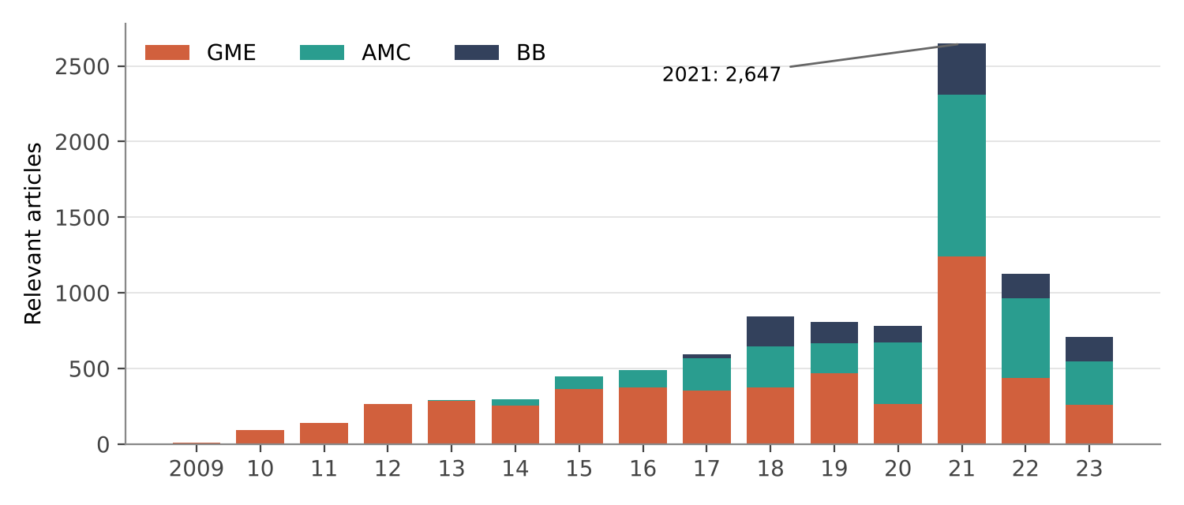
Figure 1. Relevant articles per year by stock.
Coverage grows steadily from 2009 and spikes in 2021, when all three stocks became meme stocks. GME is covered throughout, AMC from its 2013 IPO, and BB only from 2017 (see Section 7).

3.2 Text characteristics
- Headlines are short: median 9–10 words.
- Article bodies are often missing. A body exists for 68% of raw articles overall, rising from roughly 10–20% before 2014 to almost 100% from 2021. Early years are mostly headline-only, so the type of text changes over time.
- Publisher is missing for 73% of relevant articles (100% for BB), so it cannot be used as a feature. Among known sources, Seeking Alpha, Zacks and Benzinga are the largest.
- Duplicates: 39 repeated (stock, URL) pairs were removed, but 754 headlines still appear more than once within a stock under different URLs (syndicated copies).
- Relevance filter: about 55–80% of raw articles are kept each year; the rest are market round-ups or articles mainly about other companies.

3.3 Vocabulary shift
The most frequent headline terms show how the coverage changed during the meme episode:
Stock | Top terms 2015–2019 | Top terms 2021
GME | gamestop, earnings, sales, dividend, report, eps | meme, amc, reddit, short, robinhood, squeeze, rally, avoid
AMC | entertainment, earnings, holdings, moviepass, dividend, imax | gamestop, meme, reddit, short, robinhood, rally, avoid
BB | earnings, technology, options, sector update | meme, reddit, options, amc, gamestop

In 2021 each stock's headlines mention the other meme stocks, and words such as “squeeze”, “reddit” and “robinhood” appear that do not exist in standard financial sentiment dictionaries. This is the main motivation for a domain-adapted (meme-specific) sentiment model.

4. Financial time series: prices and volume

4.1 Return distribution
Stock | Period | Daily std (%) | Skew | Kurtosis | Days |return| > 10%
GME | 2009–2023 | 5.27 | 0.83 | 78.6 | 124
GME | 2021 | 14.75 | 0.41 | 18.1 | 43
AMC | 2013–2023 | 6.59 | 3.04 | 103.4 | 147
AMC | 2021 | 14.32 | 3.10 | 42.6 | 49
BB | 2009–2023 | 3.68 | −0.98 | 25.5 | 73
BB | 2021 | 6.52 | −1.24 | 24.5 | 14
Table 1. Daily log-return statistics. A normal distribution has kurtosis 3.
All three stocks have extremely fat tails. In 2021 a typical daily move for GME and AMC was about 15%, roughly three times their long-run level. The largest single-day moves all fall in January–June 2021, for example AMC +301% and GME +135% on January 27, 2021, and GME −60% on February 2, 2021.

4.2 Volatility clustering
The autocorrelation of absolute returns at lag 1 is about 0.41 for GME, 0.37 for AMC and 0.22 for BB, and it decays slowly over 20 days. Raw returns have close to zero autocorrelation. In other words, the size of tomorrow's move is partly predictable from recent moves, but its direction is not. This supports the project's focus on predicting volatility and trading volume rather than price direction, and explains why HAR-type models are the right baseline.

5. News and market activity

5.1 News volume and trading volume
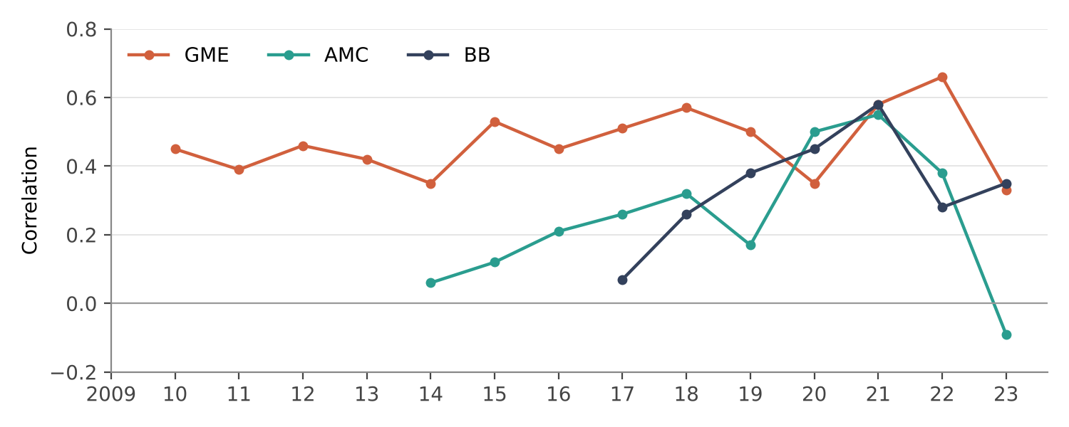
Figure 2. Correlation between log(1 + daily articles) and log trading volume, by year. Years with fewer than 30 articles for a stock are omitted (GME 2009, AMC before 2014, BB before 2017).
The link between news volume and trading volume is positive in almost every year and strengthens over time. In 2021 it reaches 0.55–0.58 for all three stocks.

5.2 News around large price moves (event study)
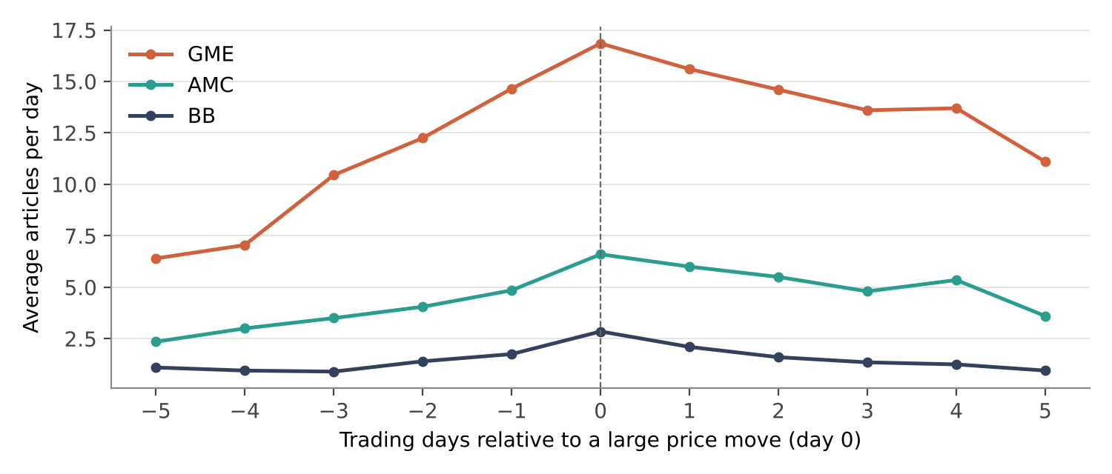
Figure 3. Average articles per day from 5 trading days before to 5 days after each stock's 20 largest absolute-return days.
News volume rises steadily in the five days before a large move (GME: 6.4 → 16.9 articles per day), peaks on the day of the move, and decays afterwards. This pattern is consistent with news attention building up before big moves.
Caveat: most of these large moves happened within a few weeks of each other in early 2021, so the event windows overlap. The rise before day 0 may simply reflect earlier large moves nearby. This chart is descriptive and is not yet evidence that news leads prices; that question is tested in the modelling stage with proper controls.

6. Engineered sentiment signals (keyword baseline)
The keyword baseline labels each article bearish, neutral or bullish with the Loughran-McDonald financial dictionary and aggregates the labels per stock and trading day into sentiment, clarity, ambiguity, uncertainty rate and text volume.
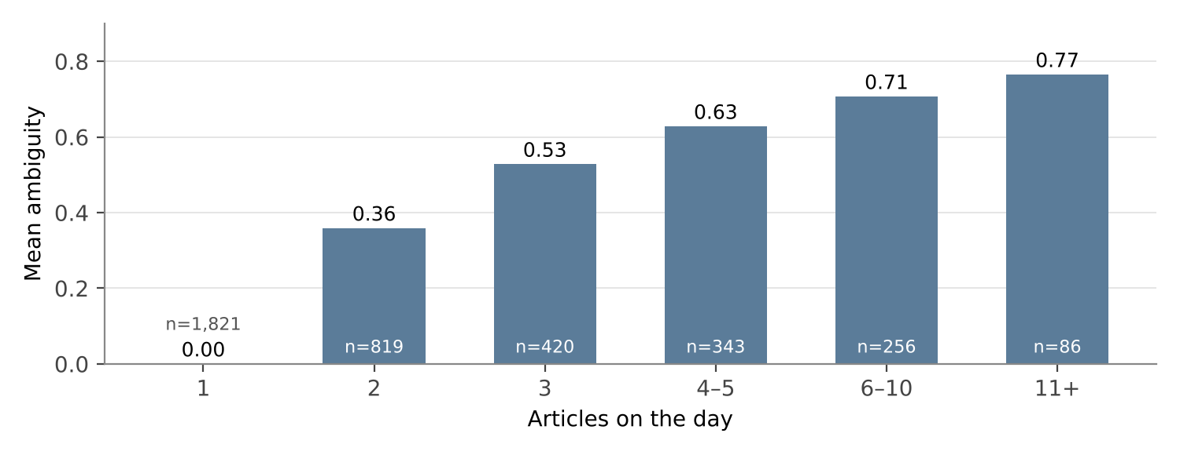
Figure 4. Mean ambiguity by number of articles on the day (n = number of ticker-days).
- About half of news days (1,821 of 3,745) have only one article.
- Ambiguity rises mechanically with article count. A single article with a hard label always has ambiguity 0. The correlation with log article count is 0.75, so any test of ambiguity must control for text volume. Soft probabilities from a trained model (FinBERT) should reduce this problem.
- The uncertainty rate is almost uncorrelated with the other signals, so it carries separate information.

7. Data quality issues and next steps
Issue | Impact | Action
No BB news before 2017 | BB history is short; pre-2017 BlackBerry news is missing | BlackBerry traded as BBRY until 2016; rescan FNSPID for BBRY
754 repeated headlines within a stock | Inflates article counts and signal weights | Also deduplicate on (stock, headline, date)
Publisher missing for 73% | Cannot weight or filter by source | Do not use publisher as a feature
Date-only timestamps | Cannot split pre- and post-close news | Keep using D+1 as the target date
Bodies missing in early years | Text type changes over time | Score headlines separately, or check results by period
Fat-tailed returns | Squared-error losses dominated by a few days | Use QLIKE / log targets; consider winsorizing
Ambiguity tied to article count | Spurious ambiguity effects | Control for article count; use soft probabilities

Next step: fix the deduplication and BBRY issues in the extraction notebook, then build the meme-specific sentiment model (domain-adapted FinBERT) and compare it with the keyword baseline.

Appendix: notebooks
All analysis is reproducible in Google Colab (data folder: MyDrive/Colab Notebooks/dl-quant_project/PythonNoteBook):
- 01_fnspid_meme_news_extraction — download, filtering, cleaning
- 01b_eda_meme_news_prices — the analysis in this report
- 02_keyword_baseline_sentiment — keyword (Loughran-McDonald) sentiment signals

