Exploratory Data Analysis
r/wallstreetbets comments for meme stocks GME, AMC and BB (2021)
Text-driven Investor Sentiment Indicators on Meme Stocks · Deep Learning Bootcamp project · Prepared by Keng Lin· October 8, 2026

Summary
This report describes the text data collected from the subreddit r/wallstreetbets using Arctic Shift API. The selected text are comments mentioning the following meme stocks: GME, AMC, BB, and SMR from some chosen periods. We will provide a brief description of the tools and methods for data collection, features of the raw data, and summary of the processing performance of selected tickers.

Q: What tools to use for data scrapping?
A: Arctic Shift API: https://github.com/ArthurHeitmann/arctic_shift
It searches comments in a given subreddit community from Reddit. It is an open source tool from GitHub owned by https://github.com/ArthurHeitmann
We can parametrize the scrapping rules by specifying the subreddit community, key words within the “body” (comments), time period.
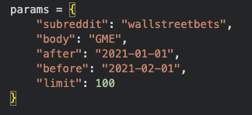
This API limits inquiry limits to 100 comments per search, but we can collect more comments by using multiple inquiries, and the method is implemented in SocialMediaCommentScraper.ipynb

There are alternative methods:
- PRAW (Python Reddit API Wrapper), a Reddit API that allows users to directly access their data, but it requires a Reddit account with approved credentials. Comments in https://www.reddit.com/r/redditdev/comments/1s0j1sq/retrieve_client_id_secret/ show concern of the difficulty on the approval process and opinions that Reddit’s plan to encourage users to use the official developer webpage, rather than using API from other platforms (like us using jupyter notebook).
- Arizona State University has provided a copy of all posts from Jan. 2021 to Feb. 2021, and it is available at https://dataverse.asu.edu/dataset.xhtml?persistentId=doi%3A10.48349%2FASU%2FWLV8JA&utm_source=chatgpt.com
This could be a back-up resource, in case the Arctic Shift API fails.

Q: What data will I use?
A:Discussions from r/wallstreetbets mentioning a stock ticker during periods of unusually high trading volume and extreme, temporary price volatility without sustained momentum or clear fundamental support. The following periods are chosen based on the historical price data from Yahoo!finance:

- GME 1/4/2021 - 4/12/2021
- AMC 1/4/2021 - 4/5/2021; 5/3/2021 - 7/5/2021
- BB 11/30/2020 - 12/9/2020; 1/13/2021 - 2/9/2021; 2/25/2021 - 6/21/2021
- SMR 2/19/2024 - 4/15/2024; 9/2/2024 - 4/14/2025
- SMTC 3/10/2025 - 3/31/2025 (? this one looks less meme-like, as trading volume seems stable overtime)
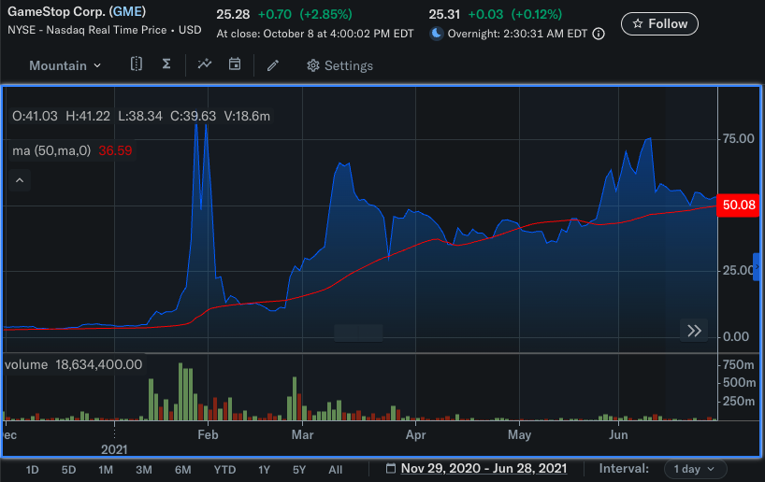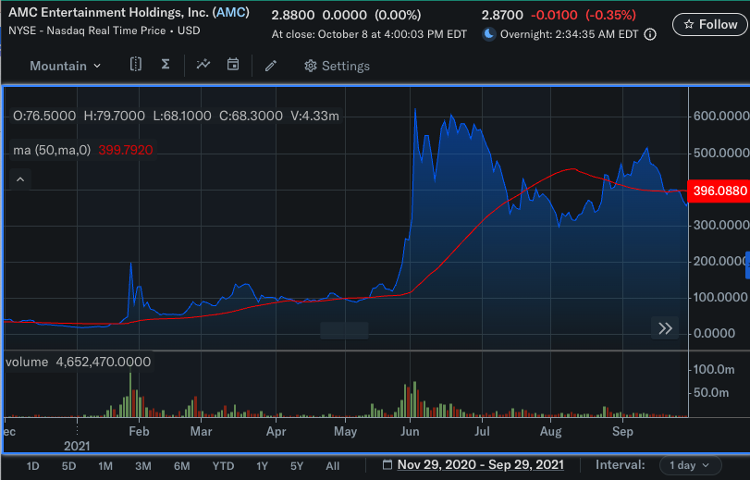
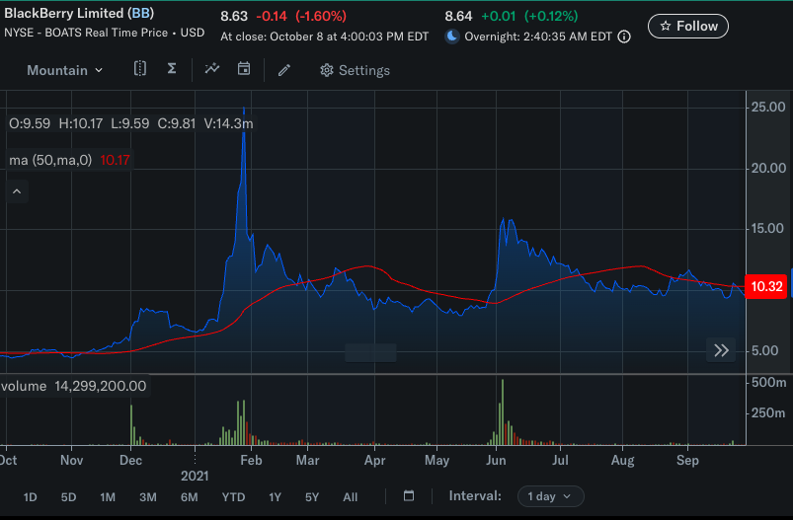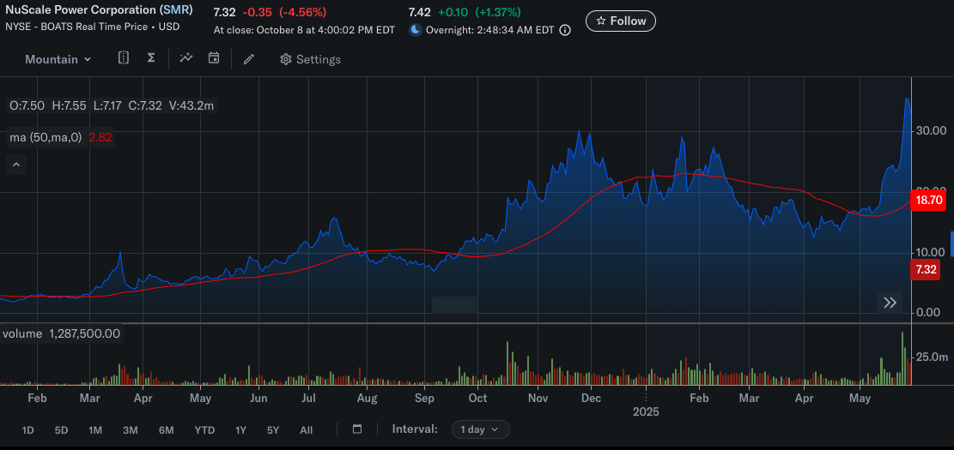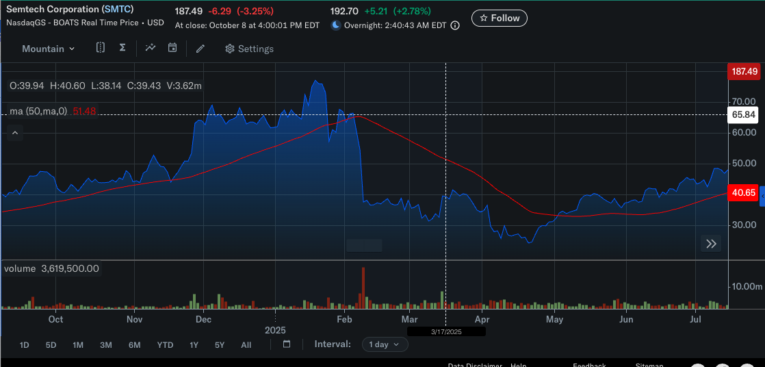

Q: What does the text data contain?
A: The raw data originally comes in JSON format, each comment contains many fields, and many of them are only useful for webpage development. We need to remove them and only keep the relevant fields of each comment:
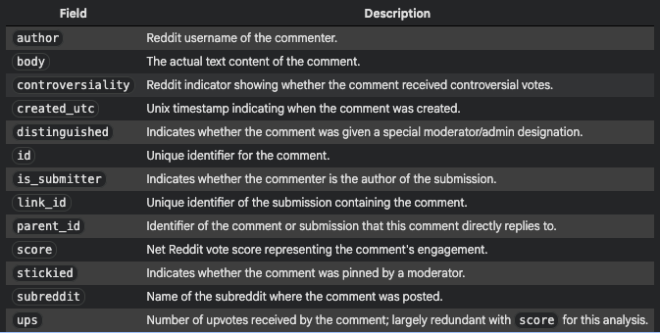
This information is available in SocialMediaCommentScraper_ExploratoryNotes.ipynb

Q: What features do the data have?
A: Currently, we can show some features of AMC and BB comments over time, as these two sets of data are collected with the same method. We show per day feature of # of comments collected, voting scores, unique users' involvement. See SocialMediaComment_DataDescription.ipynb
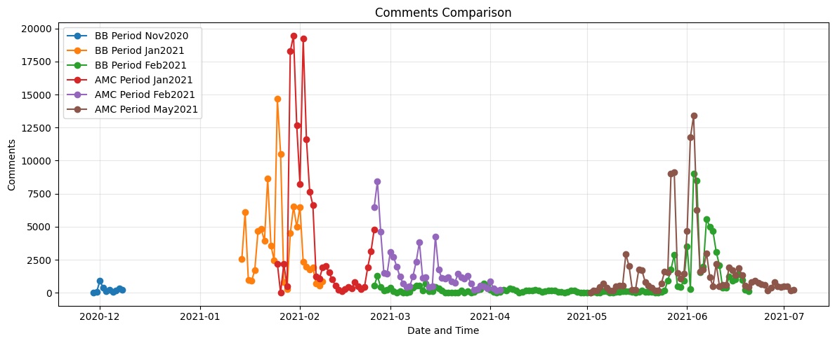
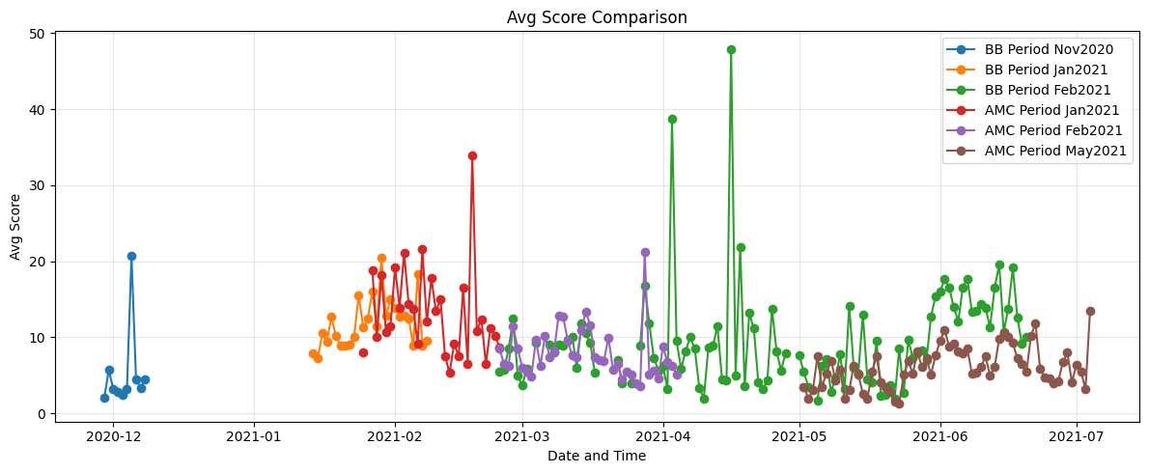
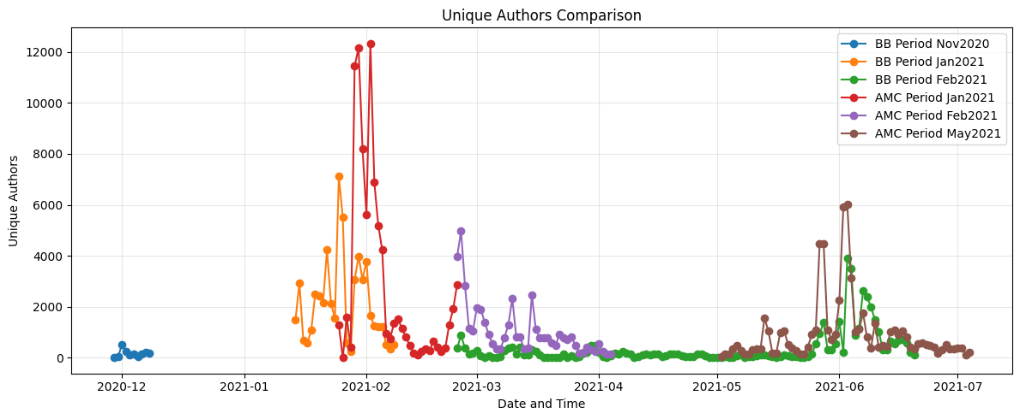

Q: How much data goes to train/valid/test?
A: We can separate data in terms of numeric id, N, with the following method (normal k-fold):
- Assume we set the ratio of train:valid:test=x:y:z, we can define the following criteria for each dataset:
- Training data : N mod (x+y+z) < x
- Valid data : x <= N mod (x+y+z) < x+y
- Test data : x+y <= N mod (x+y+z) < x+y+z
One choice we can have is X:y:z = 3:1:2 (this ratio is subjected to change)
The following table describe how much data are available in each dataset
Stock | Period | Number of Comments Collected | Processing Time (minute) | Note
GME | 1/4/2021 - 4/12/2021 | 9,800 | 15 | Only contain 100 comments per day
GME | 1/4/2021 - 4/12/2021 | In-progress |  | Updated collection method with backward timestamp search
AMC | 1/4/2021 - 2/25/2021 | 131,300 | 203 | Updated collection method with backward timestamp search
AMC | 2/24/2021 - 4/5/2021 | 64,000 | - | Updated collection method with backward timestamp search
AMC | 5/3/2021 - 7/5/2021 | 105,578 | 145 | Updated collection method with backward timestamp search
BB | 11/30/2020 - 12/9/2020 | 2,556 | 6 | Updated collection method with backward timestamp search
BB | 1/13/2021 - 2/9/2021 | 99,300 | 145 | Updated collection method with backward timestamp search
BB | 2/25/2021 - 6/21/2021 | 74,213 | 180 | Updated collection method with backward timestamp search
SMR | 2/19/2024 - 4/15/2024 | 0? Didn’t get anything at the moment |  | Updated collection method with backward timestamp search
SMR | 9/2/2024 - 4/14/2025 | 0? Didn’t get anything at the moment (Server Error) |  | Updated collection method with backward timestamp search

*The updated collection method will search backward following the time stamp, for every 100 comments, it will update the ending time frame accordingly to search within an earlier time period.
Data folder: MyDrive/Colab Notebooks/dl-quant_project/PythonNoteBook/DataSource/wallstreetbets_<Ticker>_<Start>_<End>.csv):

Appendix: notebooks
All analysis is reproducible in Google Colab (data folder: MyDrive/Colab Notebooks/dl-quant_project/PythonNoteBook):
- SocialMediaCommentScraper_ExploratoryNotes.ipynb — Preliminary inspection of Arctic Shift API outputs
- SocialMediaCommentScraper.ipynb - Fetch data using Arctic Shift API and save output as a csv file.
- SocialMediaComment_DataDescription.ipynb - Load and inspect elements in the text data in csv format.

