Week 1: miRNA-mRNA human – chimp brain development
Goals: 1.) assemble the core PFC expression and metadata resources
2.) confirm the matched subjects

1.) PFC dataset summary from article
Prefrontal cortex sample sizes and retained expression features in the human, chimpanzee and rhesus macaque comparison.
Dataset | Human n | Chimpanzee n | Macaque n | Total n | Retained PFC features
mRNA microarray | 23 | 12 | 26 | 61 | 12,447 expressed genes
miRNA microarray | 8 | 11 | 8 | 27 | 198 detected miRNAs
Selection notes
- mRNA: probes were restricted to sequences matching the human, chimpanzee and macaque genomes perfectly and uniquely; 12,447 genes were expressed in the PFC dataset.
- miRNA: 866 array features were reduced to 500 mature miRNAs conserved across all three species and then to 198 miRNAs detected in the PFC after expression filtering.
- The mRNA and miRNA experiments used different, only partially overlapping sets of individuals and should not be treated as a completely paired cohort.

Data downloaded (prefrontal cortex (PFC) and cerebellum (CBC))
Source | Download | Decscription
GSE29356 | Processed PFC and CBC miRNA file and series metadata | Processed PFC miRNA expression.  198 detected in PFC
GPL10850 | Platform annotation table | Annotations for individuals in expression data PFC and CBC
GSE22521 | Processed PFC mRNA expression or series matrix | PFC mRNA expression. 12447 genes expressed in PFC
GSE22569 | Processed CBC mRNA expression or series matrix | CBC mRNA expression. 12853 genes expressed in CBC
GPL6244 | Platform annotation table | Map Affymetrix probes to genes
Somel et al. | Table S1 and Text S1 | Sample metadata and methods
Naming note. The article cites GSE22570, the complete mRNA data. GSE22521 is its PFC component and is therefore the appropriate starting dataset for the PFC-only analysis.
Normalization note. The authors' processed expression values were log2 transformed and quantile normalized. They are suitable for learning and for reproducing downstream analyses without beginning with raw microarray preprocessing.
Data files:
- series_matrix.txt.gz = expression matrix;
- family.soft.gz = detailed metadata and documentation, sometimes including another representation of the processed values;

Sources
1. Somel M et al. MicroRNA-Driven Developmental Remodeling in the Brain Distinguishes Humans from Other Primates. PLOS Biology 9(12): e1001214. https://doi.org/10.1371/journal.pbio.1001214
2. NCBI Gene Expression Omnibus GSE29356. https://www.ncbi.nlm.nih.gov/geo/query/acc.cgi?acc=GSE29356
3. NCBI Gene Expression Omnibus GSE22521. https://www.ncbi.nlm.nih.gov/geo/query/acc.cgi?acc=GSE22521
4. NCBI Gene Expression Omnibus GPL6244. https://www.ncbi.nlm.nih.gov/geo/query/acc.cgi?acc=GPL6244
5. TargetScanHuman Release 8.0 data download. https://www.targetscan.org/cgi-bin/targetscan/data_download.vert80.cgi

Week 2: miRNA-mRNA human PFC – chimp brain development
2.) PFC mRNA sample reconciliation
Notebook used: 1a_PFC_mRNA_check_data.ipynb
Comparison of GEO GSE22521 microarray measurements, Table S1 subject annotations, and the published PFC mRNA sample counts.
Sample counts
Source / selection | Human n | Chimpanzee n | Macaque n | Total n
GEO arrays (original) | — | — | — | 68 arrays
GEO after five repeat pairs are removed | 23 | 12 | 28 | 63*
Table S1 PFC mRNA subjects | 23 | 12 | 27 | 62
Published PFC mRNA analysis | 23 | 12 | 26 | 61
*The 63-subject count is provisional: it assumes the five identified pairs exhaust repeated measurements.
Identified repeated measurements
Species | Age (days) | Measurement 1 | Measurement 2 | Batch
Human | 2 | GSM559193 | GSM559194 | b1 / b2
Human | 35,770 | GSM559198 | GSM559199 | b1 / b2
Macaque | 10,220 | GSM559208 | GSM559209 | b1 / b2
Macaque | 16 | GSM559215 | GSM559216 | b1 / b2
Macaque | 2,936 | GSM559223 | GSM559224 | b2 / b2_2

Selection note. Omit Measurement 2, as measurements are highly correlated. This convention is not a verified reconstruction of the original authors’ choices.
Additional macaque sample and unresolved omission
GSM559211: rhesus macaque, superior frontal gyrus, age 1,487 days (~4.1 years). This GEO sample has no species-and-age match among the PFC mRNA subjects in Table S1; its absence from the table is unexplained. One further macaque remains unidentified: Table S1 lists 27 PFC mRNA macaques, but the publication reports 26. The excluded subject’s Table S1 number and GSM accession cannot be established.
Working data and remaining checks
Original matrix: 13,042 features × 68 arrays.
Working matrix: 13,042 × 61 after removing five repeat-array partners, GSM559211 (unmatched in Table S1), and prenatal macaque GSM559214 (−15 days). This is an exploratory selection, not a reconstruction of the published 61-subject cohort.

Exploratory expression-correlation filtering
Filtering rule. For each individual, calculate the Pearson correlation of its 13,042-feature mRNA expression profile with every other individual of the same species. Exclude self-correlation, take the median, and retain samples only when their within-species median correlation is strictly greater than 0.90 (90%).
Samples flagged by the 0.90 cutoff (*GSM559225 is prenatal, −30 days in Table S1):
Species | Age (days) | GEO sample | Median correlation
Human | 2 | GSM559193 | 0.845729
Human | 19 | GSM559186 | 0.877110
Rhesus macaque | −30* | GSM559225 | 0.883975
Dataset counts: 61 pre-filter samples after the explicit exclusions → 58 retained after the 0.90 correlation cutoff (21 human, 12 chimpanzee, 25 macaque).

3.) Annotation of the filtered PFC mRNA data.
Notebook used: 1a_PFC_mRNA_check_data.ipynb
Feature-to-gene mapping using GPL6244
Selection stage | Count | Interpretation
Starting expression matrix | 13,042 features | 58 samples; one row per Affymetrix feature
No identified gene | 354 features | N_genes = 0; exclude from primary gene matrix
Ambiguous gene mapping | 772 features | N_genes >= 2; exclude from primary gene matrix
Exactly one gene per feature | 11,916 features | N_genes = 1; retain for gene-level screening
Distinct identifiable genes | 11,783 genes | Some genes are represented by multiple features
Genes with multiple features | 116 genes | Exclude all under the one-feature-per-gene rule
Final gene-expression matrix | 11,667 genes × 58 samples | One unambiguous feature per gene; no averaging
Filtering rules and quality checks
Gene mapping. The GPL6244 gene_assignment field was parsed into distinct gene symbols. Only features mapping to exactly one symbol were eligible. Genes with two or more eligible features were removed, rather than averaging their measurements. Multiple features assigned to the same gene may represent different transcripts, alternative splice variants, or measurements of different regions of the same gene. That was a conservative choice.

4.) PFC miRNA annotation
Notebook used: 2_PFC_miRNA_check_data.ipynb
Processed miRNA expression and annotation
Property | Result | Notes
GEO expression series | GSE29356 | Processed prefrontal cortex (PFC) file, separate from CBC
Expression matrix | 198 miRNAs × 27 profiles | Published processed subset; values are log2-scale and normalized
Species distribution | 8 human; 11 chimpanzee; 8 macaque | Species coded Hsa, Ptr, Mml in processed column labels
Feature labels | Mature miRNA names | Retain original historical names, including * passenger-strand suffixes
Platform annotation | GPL10850 | Platform record available for verifying historical probe-to-miRNA assignments
Missing/constant features | No exclusion based on variability | SD across profiles ranged from 0.200 to 2.547

Sample annotations and GEO accession reconciliation
The 27 processed columns encode species, brain region, and age (e.g., Hsa_PFC_3days). Comparing these names with original GEO family-SOFT metadata revealed a systematic one-day offset: processed age = original age in days + 1. Matching on species, PFC region, and this adjusted age recovered 22 profiles with one candidate GSM and five chimpanzee profiles with two GSM records (batch 1 and batch 2); none remained unmatched. Batch pairs are repeated measurements.
Processed chimpanzee profile | Original GSM pair (batch 1 / batch 2)
Ptr_PFC_1days | GSM725625 / GSM725626
Ptr_PFC_2days | GSM725632 / GSM725631
Ptr_PFC_40days | GSM725636 / GSM725635
Ptr_PFC_526days | GSM725624 / GSM725623
Ptr_PFC_16132days | GSM725678 / GSM725677

5.) Files saved during data processing
Filename | Contents / role
pfc_mrna_gene_expression.csv | Filtered mRNA gene-symbol expression matrix: 11,667 genes × 58 profiles, after excluding GSM559214 and the three correlation outliers.
pfc_mrna_gene_annotation.csv | GPL6244 feature-to-gene annotation for uniquely mapped features and traceability of retained mRNA measurements
pfc_mirna_sample_info.csv | Metadata for 27 processed PFC miRNA profiles, including age, species, and mapped GSM accessions (one or two per profile)

6.) mRNA and miRNA regression analysis in PFC and age distribution
Notebook used: 1a_PFC_mRNA_check_data.ipynb, 2_PFC_miRNA_check_data.ipynb, 3_PFC_miRNA_mRNA_regression_plots.ipynb
Model specification and interpretation
Species model. Categorical species indicators (chimpanzee reference); age model: log2(age in days + 1); combined model: both predictors, with a common age slope across species.
a.) mRNA: Exploratory linear regression of 11,667 retained PFC genes across 58 individuals (21 human, 12 chimpanzee, 25 rhesus macaque).
Explanatory power of species and developmental age
Regression model | Mean R² | Median R²
Species only | 0.2582 (25.82%) | 0.1957 (19.57%)
Age only | 0.1298 (12.98%) | 0.0601 (6.01%)
Species + age | 0.3824 (38.24%) | 0.3642 (36.42%)
Age added after species | 0.1242 (12.42 pp) | 0.0525 (5.25 pp)
Species added after age | 0.2526 (25.26 pp) | 0.1920 (19.20 pp)

Interpretation. Across genes, the mean in-sample R² was 25.8% for species, 13.0% for age, and 38.2% for the combined model in the 58-sample cohort. Adding age after species improved R² by 12.4 percentage points on average.
b) miRNA: Exploratory linear regresssion of 198 miRNAs across 27 individuals. The models predict processed log2 expression from species alone, log2(age in days + 1) alone, or both predictors (common age slope across species).
Explanatory power of species and developmental age
Regression model | Mean R² | Median R²
Species only | 0.2477 (24.77%) | 0.1673 (16.73%)
Age only | 0.2386 (23.86%) | 0.1432 (14.32%)
Species + age | 0.4966 (49.66%) | 0.5174 (51.74%)
Additional age after species | 0.2489 (24.89 pp) | 0.1652 (16.52 pp)
Additional species after age | 0.2580 (25.80 pp) | 0.1843 (18.43 pp)
Interpretation. Species-only explanatory power was comparable between mRNA and miRNA datasets (mean R² ≈ 0.258 versus 0.248), while age was associated with more of the observed miRNA variation (0.239 versus 0.130). The combined model explained on average 49.66% per miRNA versus 38.24% per gene.
Age distributions
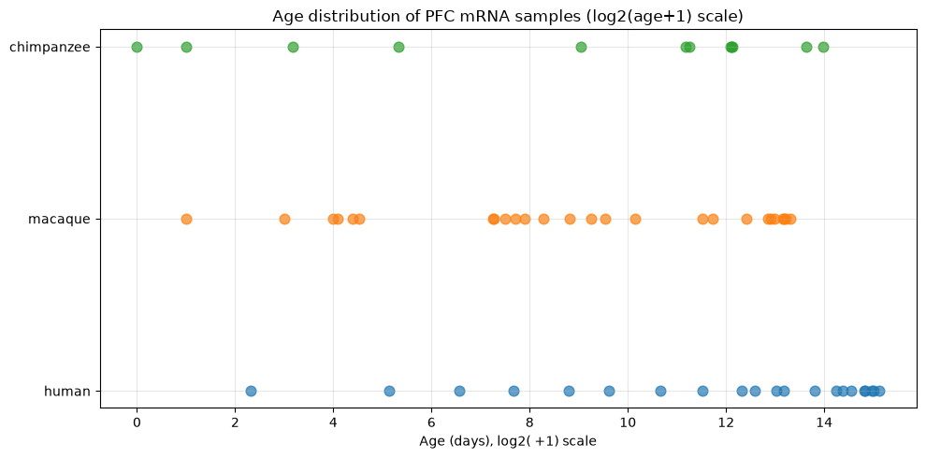
a) mRNA – PFC
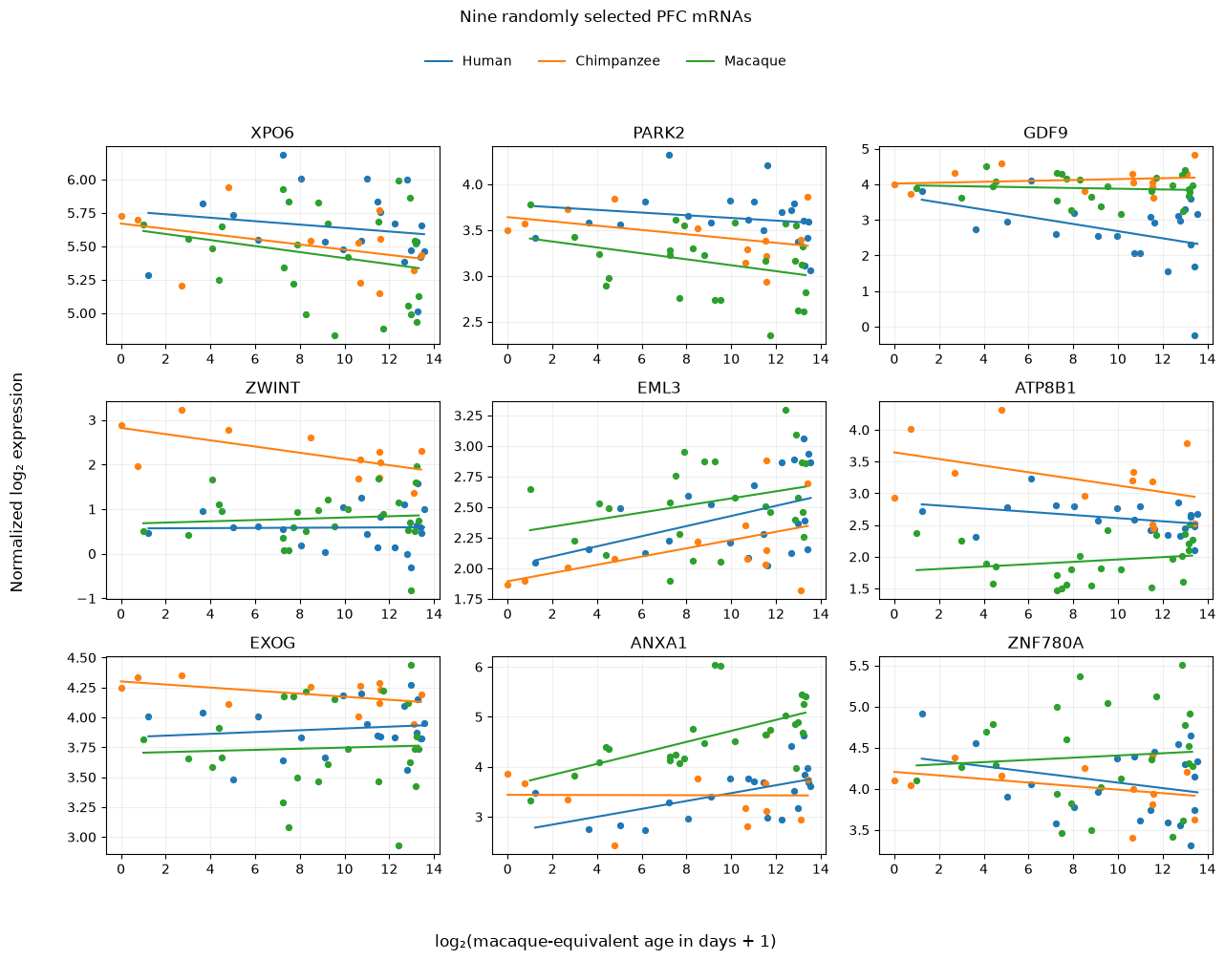
b.) miRNA – PFC
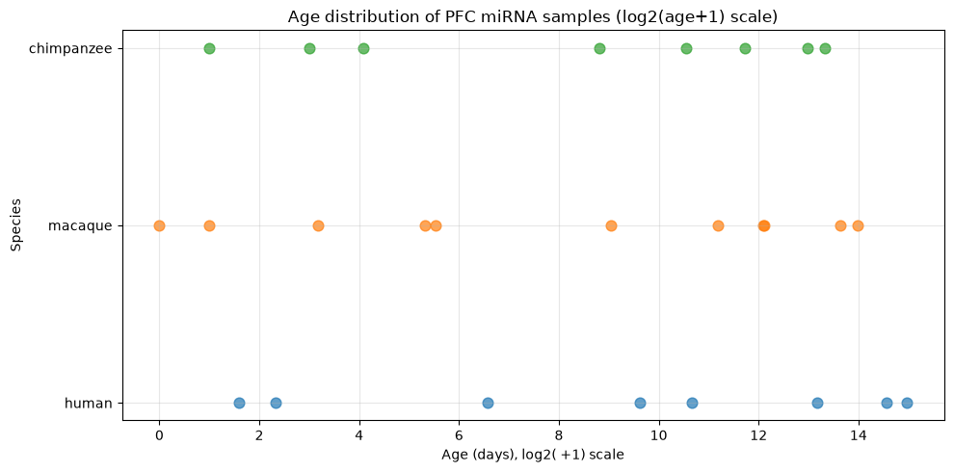
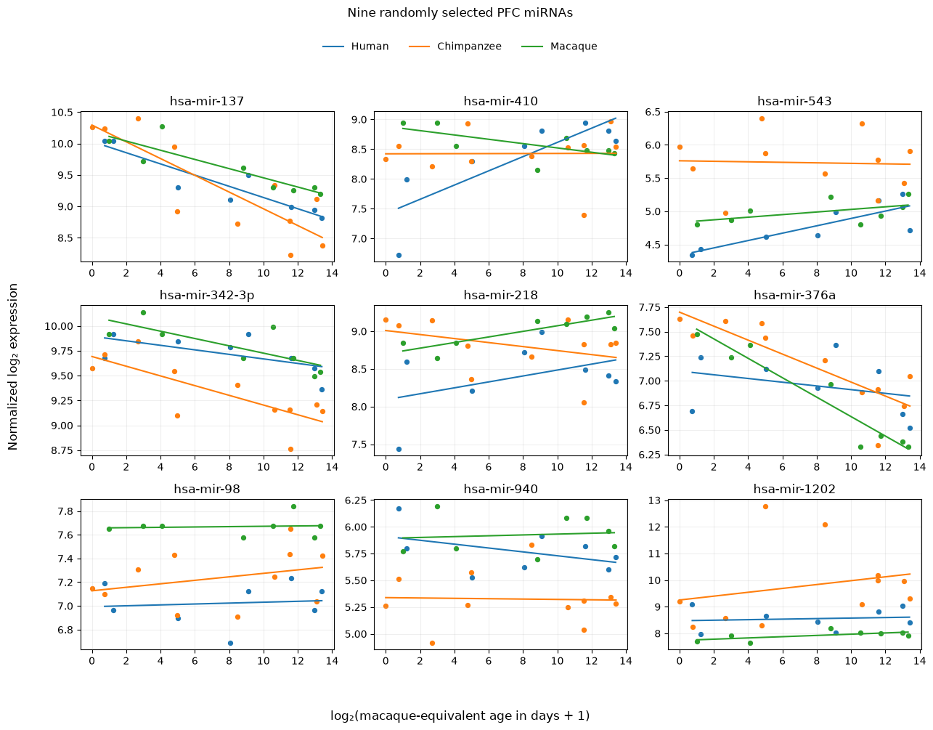

Week 3: miRNA–mRNA seed annotation and miRDB target matching
Goals: 1.) match historical PFC miRNAs to current seed-family annotations;
2.) construct a miRDB-based, high-confidence seed–target-gene network;
3.) document the limited coverage of the alternative target databases.
1.) Expression resources and analysis strategy
Data sources. The PFC miRNA expression data (GSE29356) contain historical mature-miRNA names. Human miRBase release 12 (miRBase12_human.csv) supplies their stable MIMAT accessions; the human annotation in TargetScan 8.0 (miR_Family_Info.txt) supplies updated names and seven-nucleotide Seed+m8 families. miRDB v6.0 supplies predicted miRNA–target interactions, and the GRCh38.p14 human RefSeq feature table supplies transcript-to-gene identifiers.
Primary network. TargetScan is used only for miRNA identifier and seed-family matching, not for predicted target edges. miRDB predictions are mapped to genes measured in the processed PFC mRNA dataset (GSE22521).
2.) Historical miRNA annotation and seed-family assignment
Notebook used: 4a_miRNA_seed_matching.ipynb
Identifier matching. The historical microarray labels, including * passenger-strand names, were matched to miRBase 12 and then to TargetScan 8.0 through stable MIMAT accessions. All 198 measured PFC miRNA names matched miRBase 12; 197 also received a current identifier and Seed+m8 annotation. These correspond to 157 distinct seed families.
Unmatched annotation. Only hsa-mir-886-3p (MIMAT0004906) lacked a TargetScan seed assignment. The resulting data/pfc_mirna_annotation.csv retains the original name, MIMAT accession, current miRNA name, descriptive family and seven-nucleotide seed. This file is the input to notebook 4b.
3.) Coverage limitations of TargetScan predictions and miRTarBase
TargetScan prediction coverage. In the earlier exploratory TargetScan default human target-prediction file, 49 of the 157 measured seed families (31.2%, approximately one third) had no predicted entries. This does not mean the seeds lacked TargetScan family annotations; it is a limitation of that particular prediction file.
miRTarBase coverage. The earlier, strict miRTarBase 10.0 subset (functional interactions with reporter-assay evidence) matched 177 measured miRNAs and only 3,786 distinct mature-miRNA–gene edges. This is too sparse to represent all plausible miRNA–mRNA interactions in this exploratory network analysis. Neither the TargetScan target predictions nor the restricted miRTarBase interaction set is used in the final miRDB network.
4.) miRDB high-confidence target prediction and matching
Notebook used: 4b_miRNA_targets_matching_miRDB.ipynb
Prediction source and cutoff. The miRDB v6.0 input contains computationally predicted mature-miRNA–RefSeq-transcript interactions. We restricted it to human hsa- records and scores ≥80 (the executed filter, although the notebook heading says ≥85). This retained 812,240 human predictions. miRDB prediction scores are not direct experimental validation.
Transcript-to-gene mapping. Using GCF_000001405.40_GRCh38.p14_feature_table.txt.gz, 37,928 of 38,380 needed RefSeq accessions mapped to human genes (452 unmatched), covering 16,527 genes. The table mapped 807,022 high-confidence predictions to gene symbols and left 5,218 unmapped.
Measured miRNA matching. Eight miRNA-name version differences were reconciled before joining predictions to the measured-miRNA seed annotation. The join retained 90,081 prediction records for 195 measured miRNAs, covering 156 seed families and 10,318 mapped genes before PFC-gene restriction. Two seed-annotated miRNAs lacked a matching miRDB prediction: hsa-mir-137 and hsa-mir-320a.
Final PFC seed–gene network. We restricted target genes to the 11,667-gene PFC mRNA matrix and collapsed transcript- and mature-miRNA-level records into unique (Seed, Gene) pairs. Each edge retains the maximum miRDB score and the names and number of contributing measured mature miRNAs. The final graph contains 24,111 pairs, 7,039 target genes and 156 seed families, with no duplicate edges.
miRDB: selection, matching and network counts
Selection stage | Result / count
miRDB v6.0 predictions (all species) | 6,831,595 prediction records
Human (hsa-) predictions | 3,375,741 prediction records
Human predictions with miRDB score ≥80 | 812,240 predictions; 2,638 miRNAs; 38,380 RefSeq transcripts
RefSeq records assigned to human genes | 37,928 RefSeq accessions; 16,527 genes (452 accessions unmatched)
High-confidence predictions mapped to genes | 807,022 mapped; 5,218 unmapped
Measured PFC miRNAs with seed annotation | 197 mature miRNAs; 157 distinct seeds
Predictions after measured-miRNA matching | 90,081 records; 195 miRNAs; 156 seeds
Measured, seed-assigned miRNAs without matched predictions | 2: hsa-mir-137 and hsa-mir-320a
Target genes after miRNA matching (before PFC restriction) | 10,318 genes
Final network after PFC-gene restriction | 24,111 seed–gene edges; 7,039 genes; 156 seeds; 0 duplicate edges
Interpretation. The vertices used for the later network analysis are measured seed families and their predicted target genes. Different mature miRNAs can share a seed. The matched_miRNAs and n_matched_miRNAs fields preserve their identities without duplicating seed–gene edges.
5.) Files saved during seed annotation and miRDB matching
Analysis files. The two notebooks export the following CSV files to data/. The first two document identifier matching; the final seed–gene network is used with the expression matrices and sample metadata in Week 5.
Saved analysis files (relative to the data/ directory)
Filename | Contents / purpose
pfc_mirna_annotation.csv | 4a output: 198 measured historical miRNA names, MIMAT accessions, updated names and seven-nt Seed+m8 families.
mirdb_refseq_to_gene_symbol.csv | 4b output: RefSeq-to-gene mapping for 37,928 accessions, covering 16,527 genes.
pfc_network_mirdb_high_confidence.csv | 4b output: 24,111 unique seed–gene edges (156 seeds, 7,039 genes); columns Seed, Gene, miRDB_score, matched_miRNAs and n_matched_miRNAs.
Week 4: Early human–chimpanzee PFC differential expression
Goals: 1.) Find genes expressed differently between humans and chimpanzees during early development.
2.) Test whether autism-associated genes are overrepresented among the identified genes.
3.) Profile the functions of the identified genes using Gene Ontology (GO).
Progress recorded here: data selection, differential expression (Goal 1), SFARI autism enrichment (Goal 2), and Gene Ontology functional profiling (Goal 3).
1.) PFC mRNA gene-expression cohort
Notebook used: 1b_PFC_mRNA_human_specific.ipynb
Starting data and annotation. We used the processed GSE22521 prefrontal cortex mRNA profiles and GPL6244 gene annotation prepared in Week 2. The gene-level matrix contains 11,667 genes, each represented by one uniquely assigned microarray feature. The processed expression values were already log2-transformed and normalized; they were not transformed again.
Cohort selection. Notebook 1b selected 24 postnatal individuals with species-adapted age below 1,095 days: 8 humans, 5 chimpanzees and 11 macaques. It retained the 2-day human GSM559193 and 19-day human GSM559186, which had been flagged by the earlier correlation screen, while excluding the technical repeat GSM559194 and prenatal macaques GSM559214 and GSM559225. This is an exploratory cohort choice.
Species | Selected 1b profiles | Age multiplier | Early test (Age_days < 100)
Human | 8 | 1.000 | 5: 2, 4, 19, 34, 94 days
Chimpanzee | 5 | 2.025 | 4: 0, 1, 8, 39 days
Rhesus macaque | 11 | 2.970 | Not included in this test
Total | 24 | — | 9 early human/chimpanzee profiles

Life-history alignment. Species-adapted age = chronological age × species multiplier; chimpanzee multiplier = (30/44)/(33/98) and macaque multiplier = 1/(33/98). The analysis uses log2(species-adapted age + 1) as a continuous predictor, but applies the early-development cutoff to chronological age.
Input files from 1b: data/pfc_mrna_gene_expression_human_spec.csv (11,667 genes × 24 samples) and data/pfc_mrna_selected_sample_info_human_spec.csv (24 metadata records). The nine-sample early subset is formed within the subsequent pylimma notebook.
2.) Differential-expression model and selection rules
Notebook used: 6_PFC_early_dev_human_chimp_diff.ipynb
Chimpanzee is the reference species; a common age slope is fitted to both species.
For each gene g, the model is Y_gi = α_g + β_g [log2(adapted age_i + 1) − mean(log2(adapted age + 1))] + δ_g I(Human_i) + ε_gi. Here δ_g is the age-adjusted human-minus-chimpanzee log2 expression difference. Centering is over the nine included individuals.

Variance moderation and significance. The model was fitted gene by gene using pylimma.lm_fit, followed by empirical-Bayes moderation with trend=True and robust=True. The primary pylimma.treat test evaluates whether |δ_g| exceeds 0.30 log2 units; the Benjamini–Hochberg adjustment is applied across all 11,667 genes. The standardized effect is δ_g divided by the posterior residual standard deviation.
Stability. Each of the nine individuals was omitted in turn and the common-slope model refitted. The coefficient sign must agree with the complete-data sign in at least eight of nine refits. The same full-data centering is retained in these fits.
Parameter | Value / role
AGE_CUTOFF_DAYS | 100; retain Human and Chimpanzee with Age_days < 100
MIN_ABS_LOG2_DIFFERENCE | 0.30; minimum absolute adjusted difference and TREAT threshold
MAX_TREAT_FDR | 0.15; strict upper limit on BH-adjusted TREAT p-value
MIN_ABS_STANDARDIZED_EFFECT | 0.80; minimum absolute posterior-SD-standardized effect
MIN_LOO_DIRECTION_FRACTION | 8 / 9; at least eight matching signs across nine refits
MAX_PROFILE_GENES | 12; upper bound for displayed gene profiles

Gene selection. For each gene, the age-adjusted species coefficient was estimated by a common-slope linear regression. Empirical-Bayes moderation stabilizes gene-wise residual variance estimates using information across all tested genes. The TREAT test asks whether the absolute species difference exceeds 0.30 log2 units; Benjamini–Hochberg adjustment controls the false-discovery rate across 11,667 gene tests. The final candidates must also satisfy the effect-size and stability thresholds.
Minimum absolute posterior-SD-standardized effect (0.80). We divided the fitted human-minus-chimpanzee coefficient by the empirical-Bayes posterior residual standard deviation for that gene. A value of at least 0.80 in absolute magnitude means that the adjusted species difference is at least 0.8 times this residual standard deviation. It measures effect size, not a second p-value.
Leave-one-out direction (8/9). We refitted the regression nine times, each time excluding one individual. At least eight of the nine resulting species coefficients had to retain the same sign as the coefficient fitted to all nine individuals. This checks the direction of the effect; each refit was not required to remain statistically significant.

3.) Early human–chimpanzee results
Outcome | Result
Genes tested | 11,667
Genes meeting LOO direction criterion | 9,421
Genes passing all selection criteria | 140
Selected genes higher in humans | 62
Selected genes higher in chimpanzees | 78

The 140 genes (about 1.2% of tested genes) passed all four requirements: TREAT FDR < 0.15, absolute adjusted difference ≥ 0.30, absolute standardized effect ≥ 0.80, and concordant direction in at least 8 of 9 leave-one-out fits. Among the selected genes, 62 have positive and 78 negative human-minus-chimpanzee coefficients.

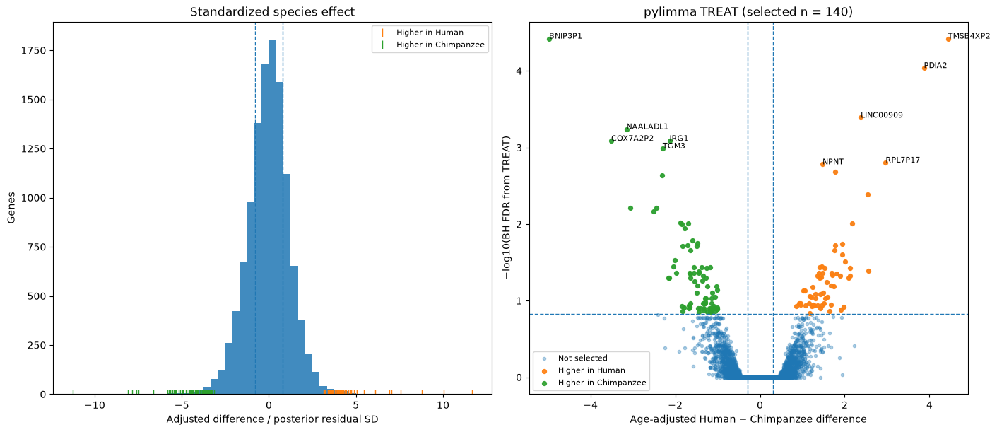
Figure 1. Distribution of standardized species differences and TREAT FDR versus the adjusted log2 difference (pylimma notebook output).
4.) Files produced by the pylimma analysis
File in data/ | Purpose
early_human_chimp_pylimma_results_human_spec.csv | All 11,667 gene-level estimates, TREAT p-values, FDR and leave-one-out summaries
early_human_chimp_pylimma_candidates_human_spec.csv | 140 genes passing all requested criteria
early_human_chimp_pylimma_sample_table_human_spec.csv | Nine early samples and centered age covariate
early_human_chimp_pylimma_distribution_human_spec.png | Standardized-effect histogram and TREAT FDR distribution
early_human_chimp_pylimma_top_gene_profiles_human_spec.png | Twelve selected gene-expression profiles and model fits

5.) SFARI autism-gene enrichment among early human–chimpanzee differences
Notebook used: 7_PFC_early_dev_autism_genes_enrichment_with_Fisher.ipynb
Gene sets and background. We matched SFARI gene symbols to the 11,667 genes tested by pylimma, using uppercase exact-symbol matching. Of 245 SFARI Category 1 genes, 217 were represented in the tested set; of 957 Category 1 + 2 genes, 732 were represented. We compared the 140 selected genes with the remaining 11,527 tested genes.
Testing procedure. We performed two one-sided Fisher exact tests for overrepresentation (alternative = greater): Category 1 high-confidence autism genes and Categories 1 + 2 combined. The tables show the observed gene counts. The reported p-values are not adjusted for testing both sets.
SFARI Category 1 (high-confidence autism genes)
Gene group | Category 1 gene | Other tested gene
Selected (140) | 0 | 140
Not selected (11,527) | 217 | 11,310
Fisher exact test (one-sided enrichment): p = 1.0000; odds ratio = 0.000.
SFARI Categories 1 + 2 (high-confidence and strong-candidate genes)
Gene group | Category 1 + 2 gene | Other tested gene
Selected (140) | 4 | 136
Not selected (11,527) | 728 | 10,799
Fisher exact test (one-sided enrichment): p = 0.978922; odds ratio = 0.4363.
Interpretation. No Category 1 gene and only four Category 1 + 2 genes were found among the 140 selected genes. These overlaps are below the expectations under no association (approximately 2.6 and 8.8 genes, respectively). Both odds ratios are below 1, pointing descriptively toward underrepresentation, not enrichment. Neither one-sided test provides evidence for overrepresentation; these tests alone do not establish statistically significant underrepresentation. Exact symbol matching may miss unconverted gene aliases.
6.) Gene Ontology analysis of early human–chimpanzee expression
Notebook used: 8_PFC_GeneOntology_analysis.ipynb
Method. Using GOfuncR in R, we ranked all 11,667 genes by the signed pylimma moderated t-statistic and tested GO Biological Process terms with the Wilcoxon method. Higher ranks indicate higher age-adjusted expression in humans; lower ranks indicate higher expression in chimpanzees. Permutation-based family-wise error rates (FWER) correct for testing many related GO terms. The completed run used 10,000 random sets and FWER <= 0.05.
Annotation coverage. GOfuncR accepted 10,386 of the 11,667 tested genes and evaluated 13,796 Biological Process terms. It identified 76 human-higher and 106 chimpanzee-higher significant terms before GO hierarchy refinement.
Analysis | Genes with GO annotation | Terms at FWER <= 0.05
All-gene ranking: human-higher | 10,386 | 76
All-gene ranking: chimpanzee-higher | 10,386 | 106
Selected-gene set: hypergeometric | 116 selected genes | 0
Selected-gene analysis. A separate hypergeometric test compared the 140 selected genes with the tested-gene background. Of the selected genes, 116 had usable GO annotations. No GO term was significantly overrepresented at FWER <= 0.05. Thus, the ranked genome-wide analysis showed functional associations not detected by the thresholded 140-gene test.
GO hierarchy refinement. GOfuncR refine uses an elim-like procedure: contributions from significant child terms are removed before retesting broader parent terms. This reduces redundancy and highlights more specific biological processes.
Expression direction | Original significant terms | Retained after refinement | Representative themes
Human-higher | 76 | 10 | Transcriptional regulation; RNA splicing; DNA-related processes
Chimpanzee-higher | 106 | 30 | Synaptic signaling and plasticity; ion transport; mitochondrial electron transport
Refined categories (10,000-random-set analysis). The tables below give all 10 human-higher and 30 chimpanzee-higher GO Biological Process categories retained after the hierarchy refinement (signif = TRUE in the exported GOfuncR files). FWER values are from the original ranked Wilcoxon test, before refinement.
Human-higher refined categories (10 terms)
GO ID | Refined Biological Process category | Original FWER
GO:0019219 | regulation of nucleobase-containing compound metabolic process | <0.0001
GO:2000112 | regulation of cellular macromolecule biosynthetic process | <0.0001
GO:0006357 | regulation of transcription by RNA polymerase II | <0.0001
GO:0000398 | mRNA splicing, via spliceosome | 0.0004
GO:0019827 | stem cell population maintenance | 0.0025
GO:0006974 | cellular response to DNA damage stimulus | 0.0054
GO:0006259 | DNA metabolic process | 0.0099
GO:0098813 | nuclear chromosome segregation | 0.0107
GO:0045892 | negative regulation of transcription, DNA-templated | 0.0169
GO:0006323 | DNA packaging | 0.0225
Chimpanzee-higher refined categories (30 terms)
GO ID | Refined Biological Process category | Original FWER
GO:0007416 | synapse assembly | 0.0488
GO:0042775 | mitochondrial ATP synthesis coupled electron transport | 0.0391
GO:0031644 | regulation of nervous system process | 0.0384
GO:0019646 | aerobic electron transport chain | 0.0366
GO:0070588 | calcium ion transmembrane transport | 0.0278
GO:0007215 | glutamate receptor signaling pathway | 0.0273
GO:0030073 | insulin secretion | 0.0273
GO:0050905 | neuromuscular process | 0.0170
GO:0048667 | cell morphogenesis involved in neuron differentiation | 0.0108
GO:0016082 | synaptic vesicle priming | 0.0107
GO:0060996 | dendritic spine development | 0.0083
GO:0060291 | long-term synaptic potentiation | 0.0081
GO:0006874 | cellular calcium ion homeostasis | 0.0076
GO:0035249 | synaptic transmission, glutamatergic | 0.0053
GO:0099505 | regulation of presynaptic membrane potential | 0.0047
GO:1902600 | proton transmembrane transport | 0.0046
GO:0007186 | G protein-coupled receptor signaling pathway | 0.0044
GO:0001508 | action potential | 0.0042
GO:0046928 | regulation of neurotransmitter secretion | 0.0034
GO:0017157 | regulation of exocytosis | 0.0020
GO:0007613 | memory | 0.0010
GO:0007612 | learning | 0.0010
GO:0048812 | neuron projection morphogenesis | 0.0009
GO:1904062 | regulation of cation transmembrane transport | <0.0001
GO:0071805 | potassium ion transmembrane transport | <0.0001
GO:0060078 | regulation of postsynaptic membrane potential | <0.0001
GO:0048167 | regulation of synaptic plasticity | <0.0001
GO:0099504 | synaptic vesicle cycle | <0.0001
GO:0050808 | synapse organization | <0.0001
GO:0007268 | chemical synaptic transmission | <0.0001
FWER note. Values displayed as <0.0001 indicate zero exceedances at the resolution of the 10,000 random-set procedure; they are not exact zero probabilities. Original FWER is shown for context; the refined categories are those flagged as significant by GOfuncR after hierarchical refinement.
Interpretation. Human-higher expression was associated mainly with transcriptional and RNA/DNA-related functions, whereas chimpanzee-higher expression emphasized neural signaling, ion handling and mitochondrial processes. These are associations with expression-rank shifts across many genes, not evidence that a process is absent in either species or causally altered.
Final notebook. 8_PFC_GeneOntology_analysis.ipynb reads data/early_human_chimp_pylimma_results_human_spec.csv and uses N_RANDSETS = 10000, RANDOM_SEED = 42 and FWER_CUTOFF = 0.05. The executed analysis reported 76 human-higher and 106 chimpanzee-higher GO terms at FWER <= 0.05, with 10 and 30 retained after hierarchy refinement.
Final GO output files. The finalized notebook exports the ranked and selected-set GO tables to data/gofuncr_ranked_all_terms_human_spec.csv, data/gofuncr_ranked_significant_human_spec.csv, data/gofuncr_selected_all_terms_human_spec.csv and data/gofuncr_selected_significant_human_spec.csv; retained refined terms are saved as results/gofuncr_refined_human_significant.csv and results/gofuncr_refined_chimp_significant.csv. The ranked result object is results/gofuncr_ranked_complete.rds.

Week 5: miRNA–mRNA network analysis with miRDB
Goals: 1.) Construct sample-specific miRNA–mRNA network activity scores from matched
PFC expression profiles.
2.) Compare developmental trends in network-level features between humans and chimpanzees.
3.) Export gene-level network scores for subsequent analysis.
1.) Input data, sample matching and network
Notebook used: 5_miRNA_mRNA_network_analysis_miRDB.ipynb
Source data. The analysis uses the processed PFC miRNA and mRNA expression matrices (GSE29356 and GSE22521), the sample metadata, historical miRNA-to-seed annotation and the high-confidence miRDB seed–gene interaction file. It aligns miRNA and mRNA profiles by species and original chronological age. A one-day offset in processed miRNA sample names is corrected using Original_age_days.
Matched species | Profiles (n) | Chronological ages represented (days)
Human | 7 | 4 – 32,120
Chimpanzee | 10 | 0 – 16,131
Rhesus macaque | 7 | 1 – 10,220
Total | 24 | Across infancy through adulthood

Matching note. Three miRNA profiles lacked a matching retained mRNA sample (human at 2 days, chimpanzee at 45 days, and macaque at 1,487 days). The network comparison therefore uses 24 paired profiles; the inferential human–chimpanzee tests use 17 of these (7 humans and 10 chimpanzees).
Network construction. Each miRNA expression trajectory and mRNA expression trajectory was standardized across the 24 paired profiles (row-wise z-scores). The 197 seed-annotated miRNAs were averaged within their 157 seed families after standardization. The miRDB interaction table was restricted to measured seeds and genes. The notebook’s executed output reports 156 families, 7,032 target genes and 24,133 unique seed–gene edges.
Network consistency. The supplied executed notebook loads the finalized Week 3 miRDB network with 24,111 unique edges, 7,039 target genes and 156 seed families. It starts from the 58-sample filtered PFC mRNA dataset and subsequently matches 24 miRNA–mRNA profiles.
2.) Construct the edge scores and six network features
For every profile and predicted miRNA-seed → mRNA-target edge, an activity score was computed from standardized expression as sigmoid(z_seed − z_gene) = 1 / [1 + exp(−(z_seed − z_gene))]. High scores indicate relatively high seed expression and low target expression. These scores are expression-derived proxies, not direct measurements of miRNA-mediated repression. Scores are summarized across the same predicted network for all 24 profiles.
Network feature | Definition (per profile)
Mean edge score | Average logistic activity score across all seed–target edges.
Active-edge fraction | Proportion of edge scores ≥ 0.75.
Edge-score dispersion | Standard deviation of scores across all network edges.
Family out-strength CV | SD/mean of mean edge scores, computed across seed families.
Target in-strength CV | SD/mean of mean incoming edge scores, computed across target genes.
Family out-strength entropy | Normalized Shannon entropy of seed-family mean edge scores.

Age alignment. Developmental time was converted to macaque-equivalent days using human × (33/98), chimpanzee × (30/44) and macaque × 1. The analysis used log2(macaque-equivalent age + 1). This alignment is approximate and intended to compare life-history stages rather than equal chronological ages.
3.) Human–chimpanzee developmental interaction tests
Statistical model. Each network feature was regressed on species, log2-aligned age and the species × age interaction: feature = intercept + species + aligned age + species × aligned age + error. Chimpanzee is the reference species; the interaction coefficient is the human-minus-chimpanzee slope difference. Freedman–Lane tests permuted the residuals of the reduced model without interaction 5,000 times (seed 29356), refitted the full model and computed two-sided permutation p-values. Benjamini–Hochberg FDR correction was applied across the six features.
Feature | Human − chimp slope | Perm. p | BH FDR | R²
Target in-strength CV | −0.009985 | 0.002200 | 0.0132 | 0.524
Edge-score dispersion | −0.005439 | 0.015397 | 0.0462 | 0.445
Family out-strength CV | −0.010388 | 0.143371 | 0.2454 | 0.236
Family out-strength entropy | +0.000879 | 0.163567 | 0.2454 | 0.210
Active-edge fraction | −0.006404 | 0.248350 | 0.2980 | 0.180
Mean edge score | +0.001407 | 0.653869 | 0.6539 | 0.057

Results. Two of six features were significant at BH FDR < 0.05: target in-strength CV (interaction t = −3.70; FDR = 0.0132) and edge-score dispersion (interaction t = −2.75; FDR = 0.0462). In both cases the developmental trend was more negative in humans than in chimpanzees. Specifically, the target in-strength CV slopes were −0.00697 (human) and +0.00302 (chimpanzee); the edge-score dispersion slopes were −0.00460 (human) and +0.00084 (chimpanzee). No other feature passed the stated threshold.
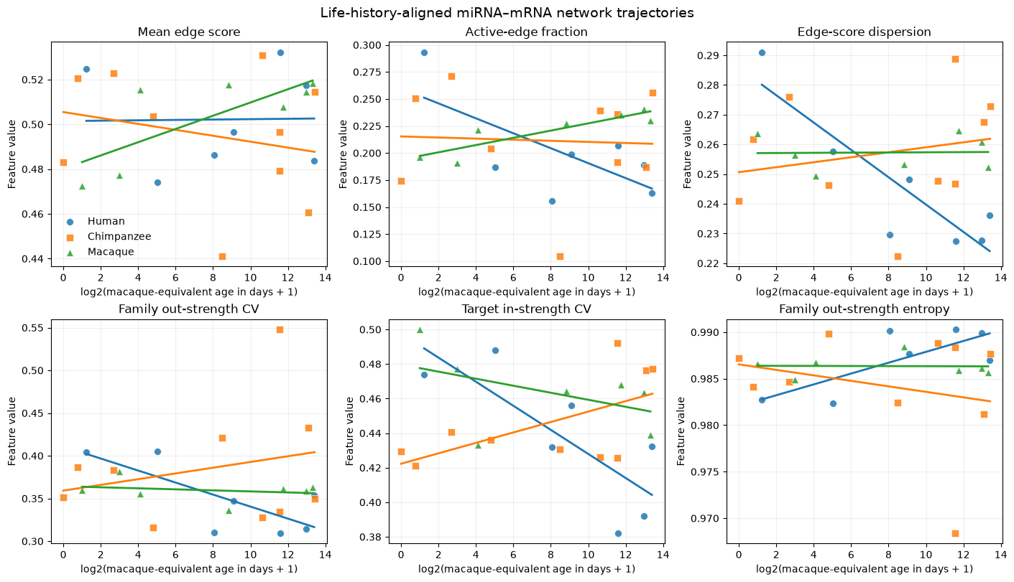
Figure 2. Six sample-level miRNA–mRNA network features across log2 life-history-aligned age, including descriptive linear fits for human, chimpanzee and macaque profiles (executed notebook output).
4.) Interpretation and exported file
Interpretation. Target in-strength CV and edge-score dispersion declined more steeply with developmental age in humans than in chimpanzees. These aggregate scores describe a computational prediction network, not direct regulation; the matched sample size limits inference. The notebook also exports data/gene_level_network_scores_mirdb.csv (168,936 rows = 7,039 genes × 24 profiles), with gene-level in-strength, dispersion, target degree and individual metadata.

